Assignment 5
Java Programming

Submitted by
Drishti Thakur
Roll No. 25SCS1003002554

Problem 1: Find the sum of numbers from 1 to N
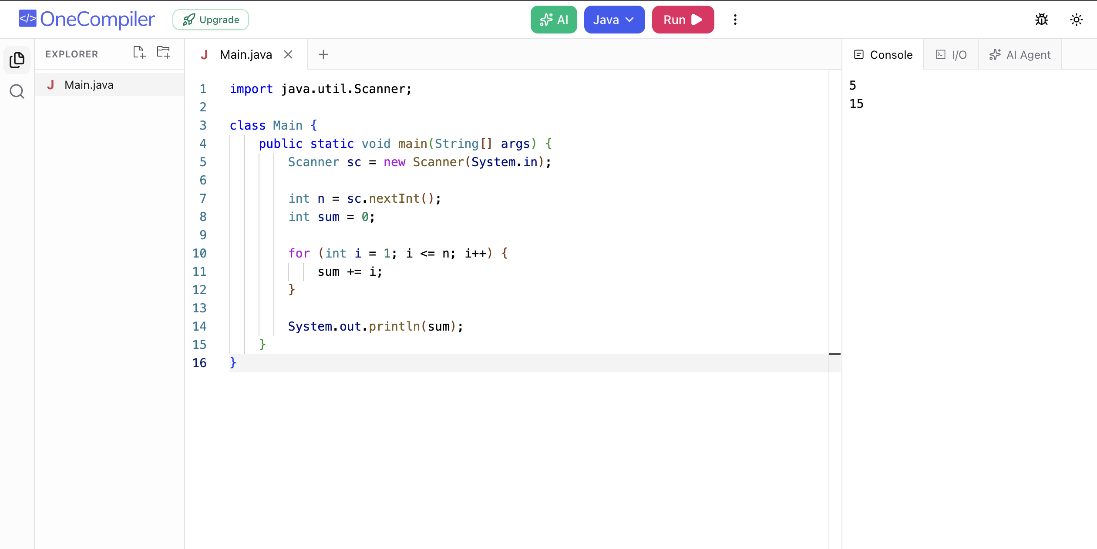

Problem 2: Print multiples of 5 from 1 to 100
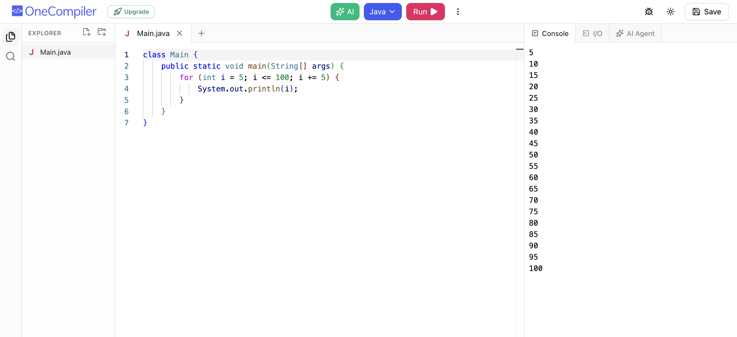

Problem 3: Count how many numbers are divisible by 3 between 1 and N
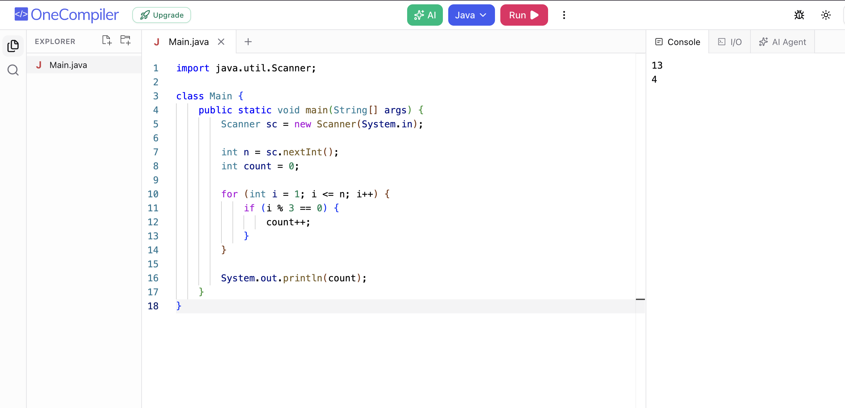

Problem 4: Check whether a number is prime or not
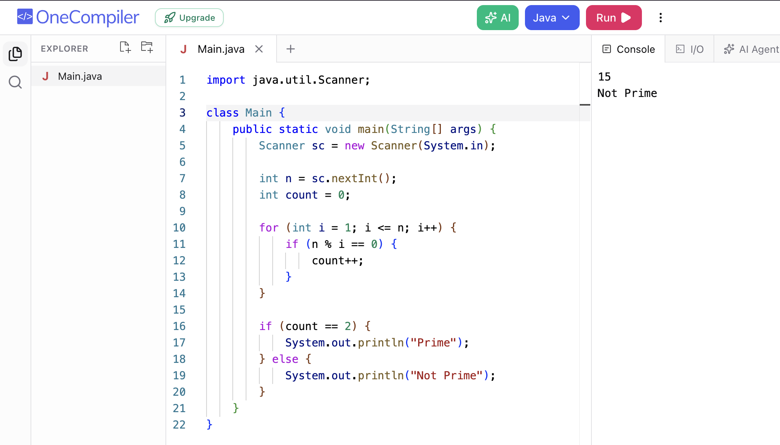

Problem 5: Reverse of a given number
