Assignment 6
Java Programming

Submitted by
Drishti Thakur
Roll No. 25SCS1003002554

Problem 1: Find Sum of Array Elements
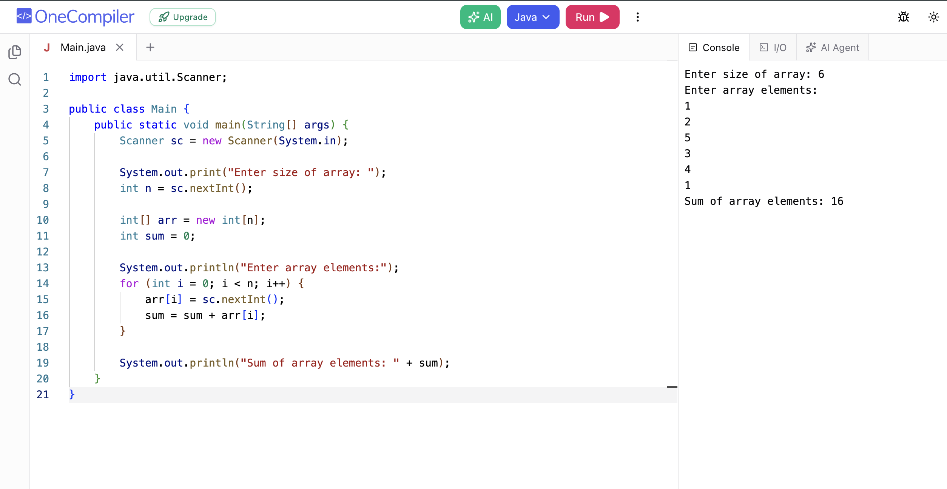

Problem 2: Find Largest Element in an Array
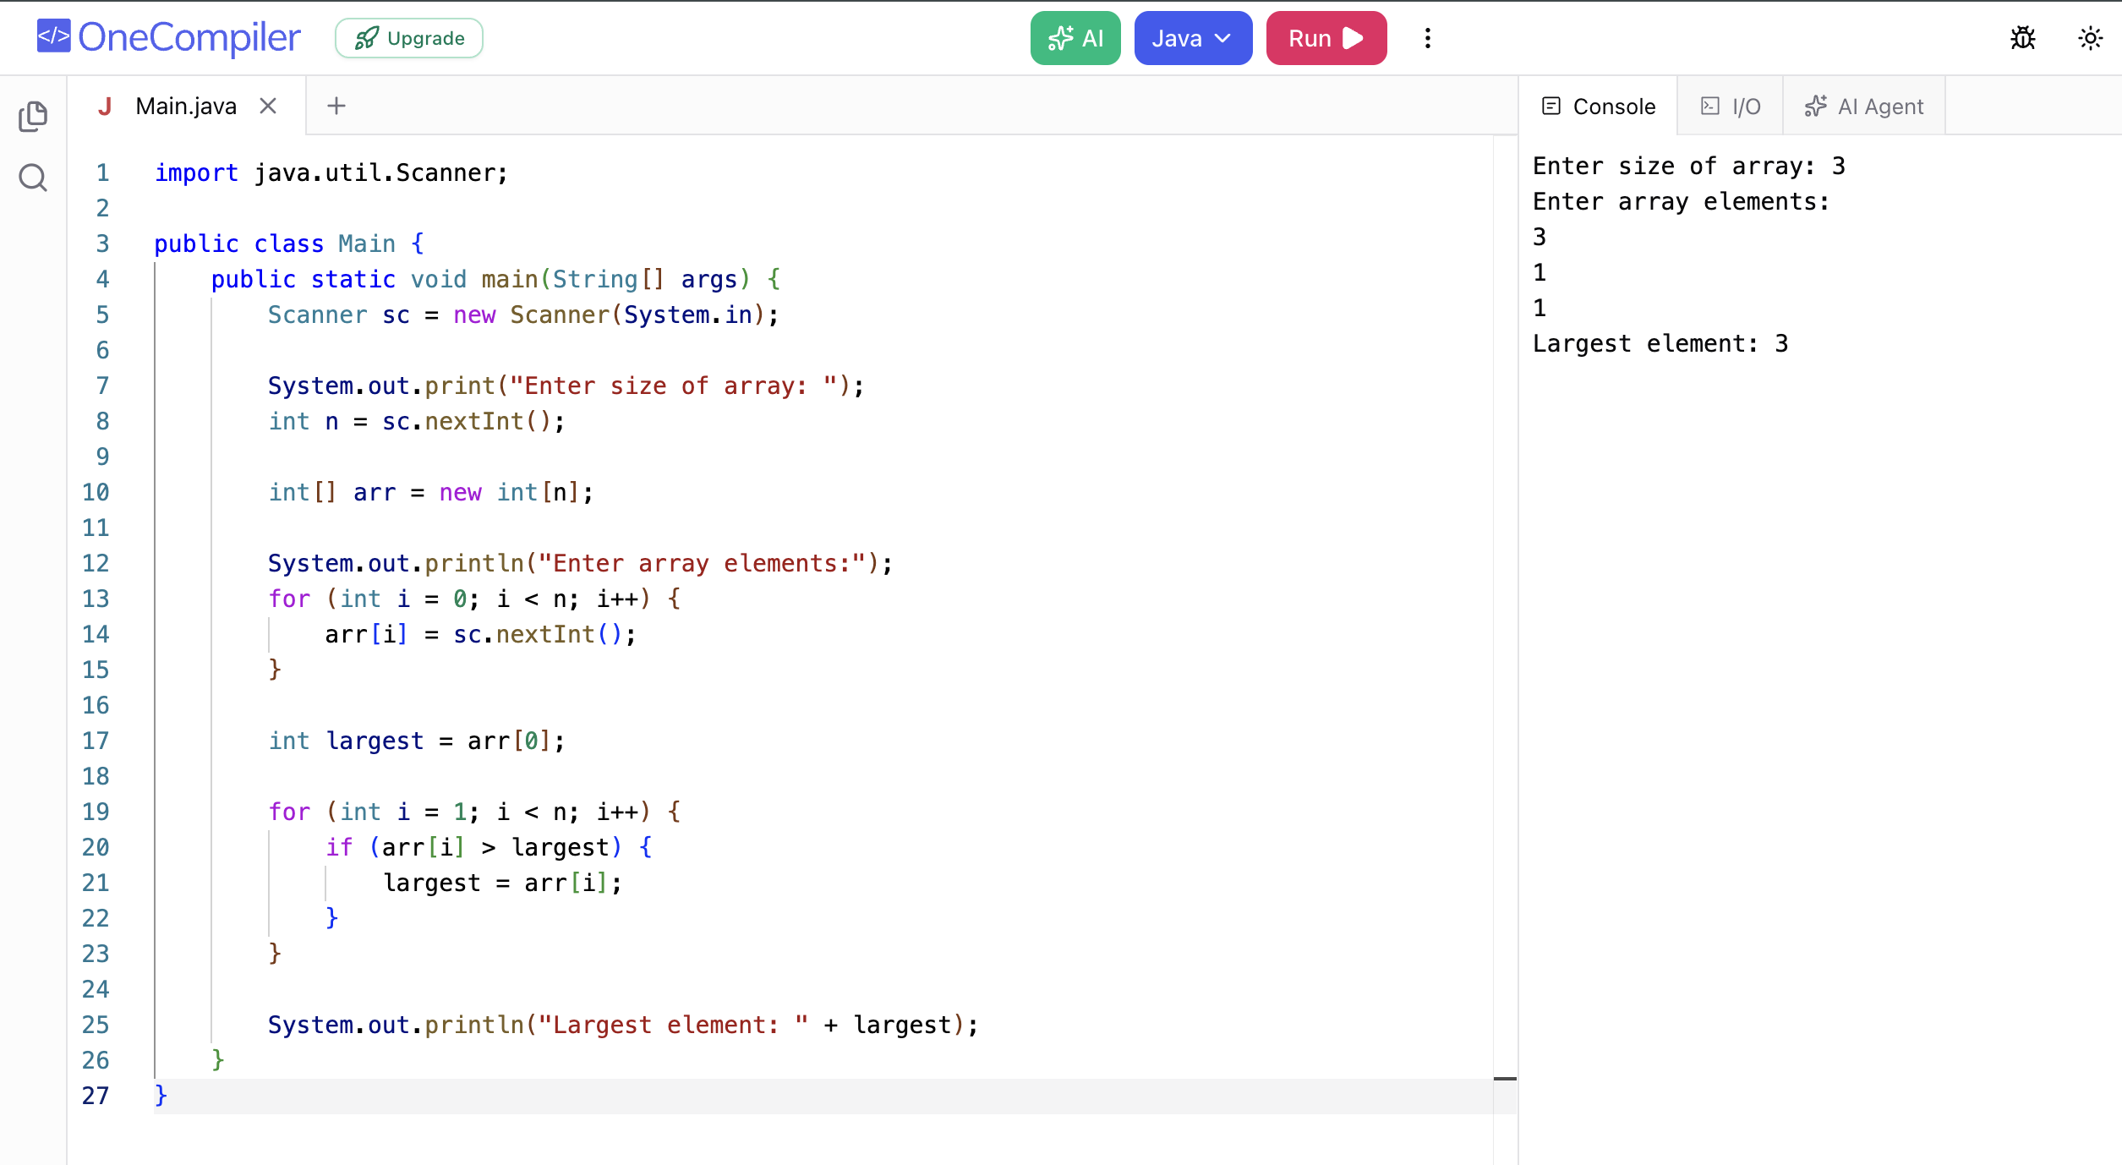

Problem 3: Search an Element in an Array
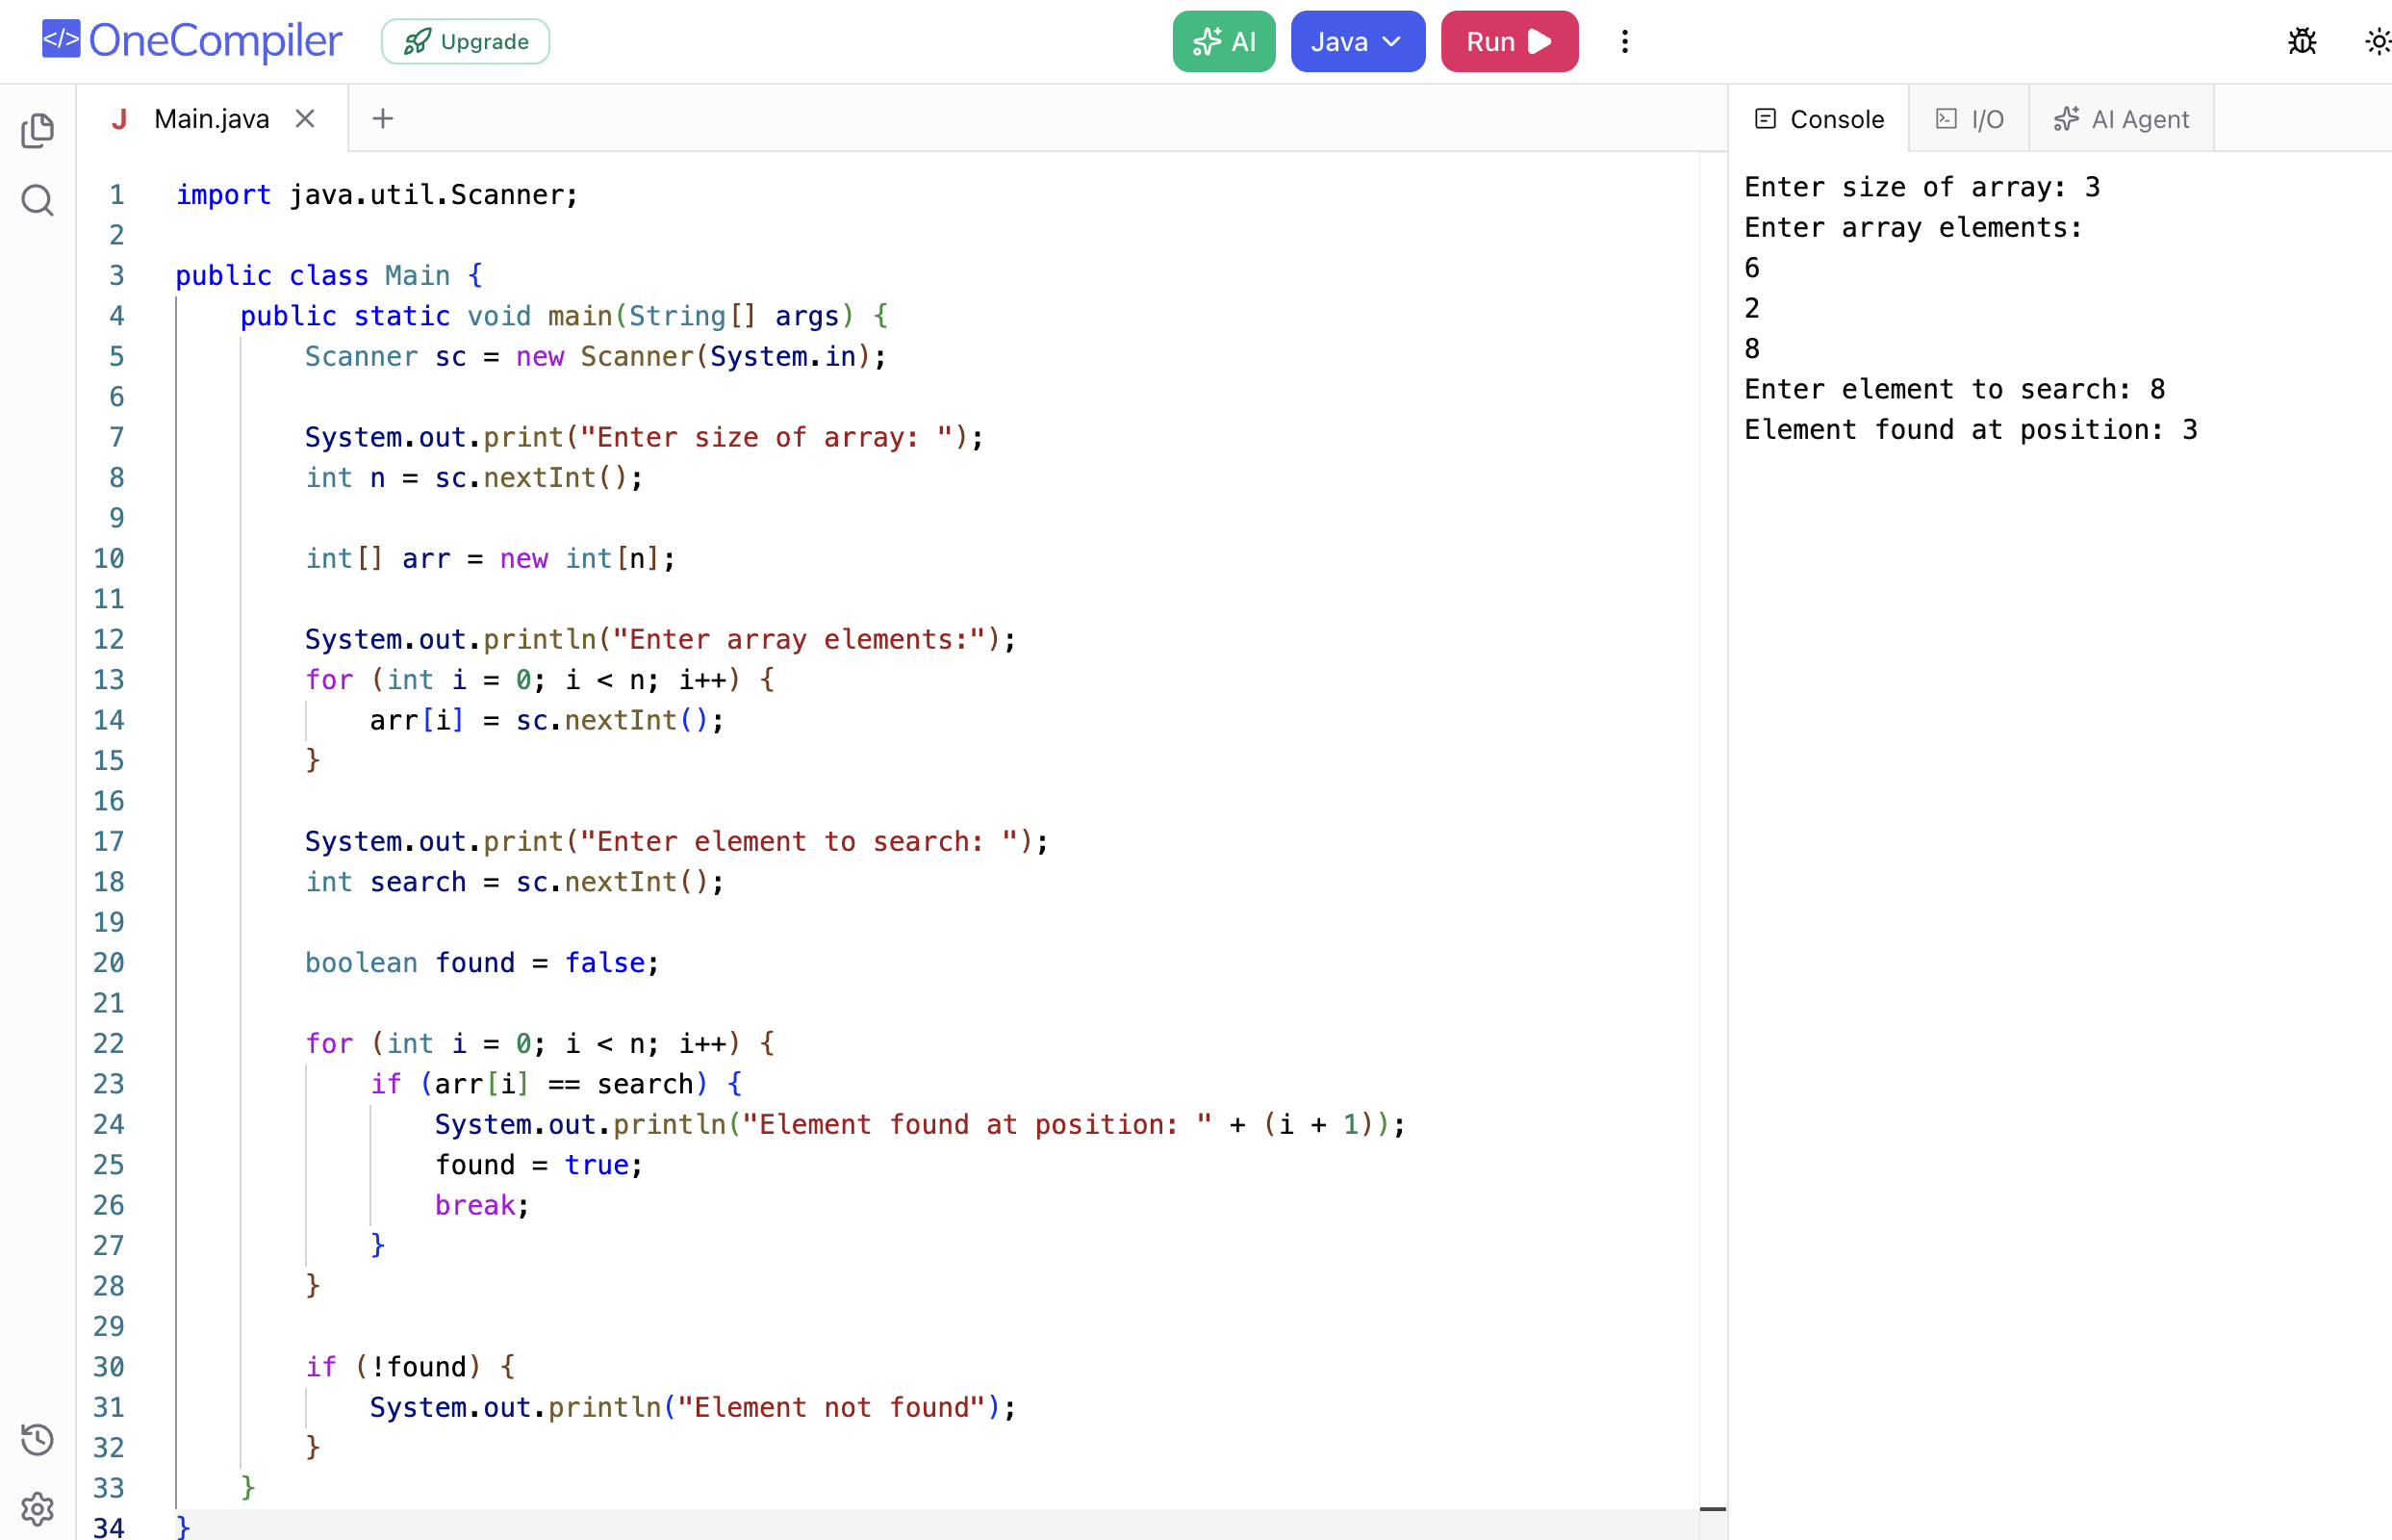

Problem 4: Reverse an Array
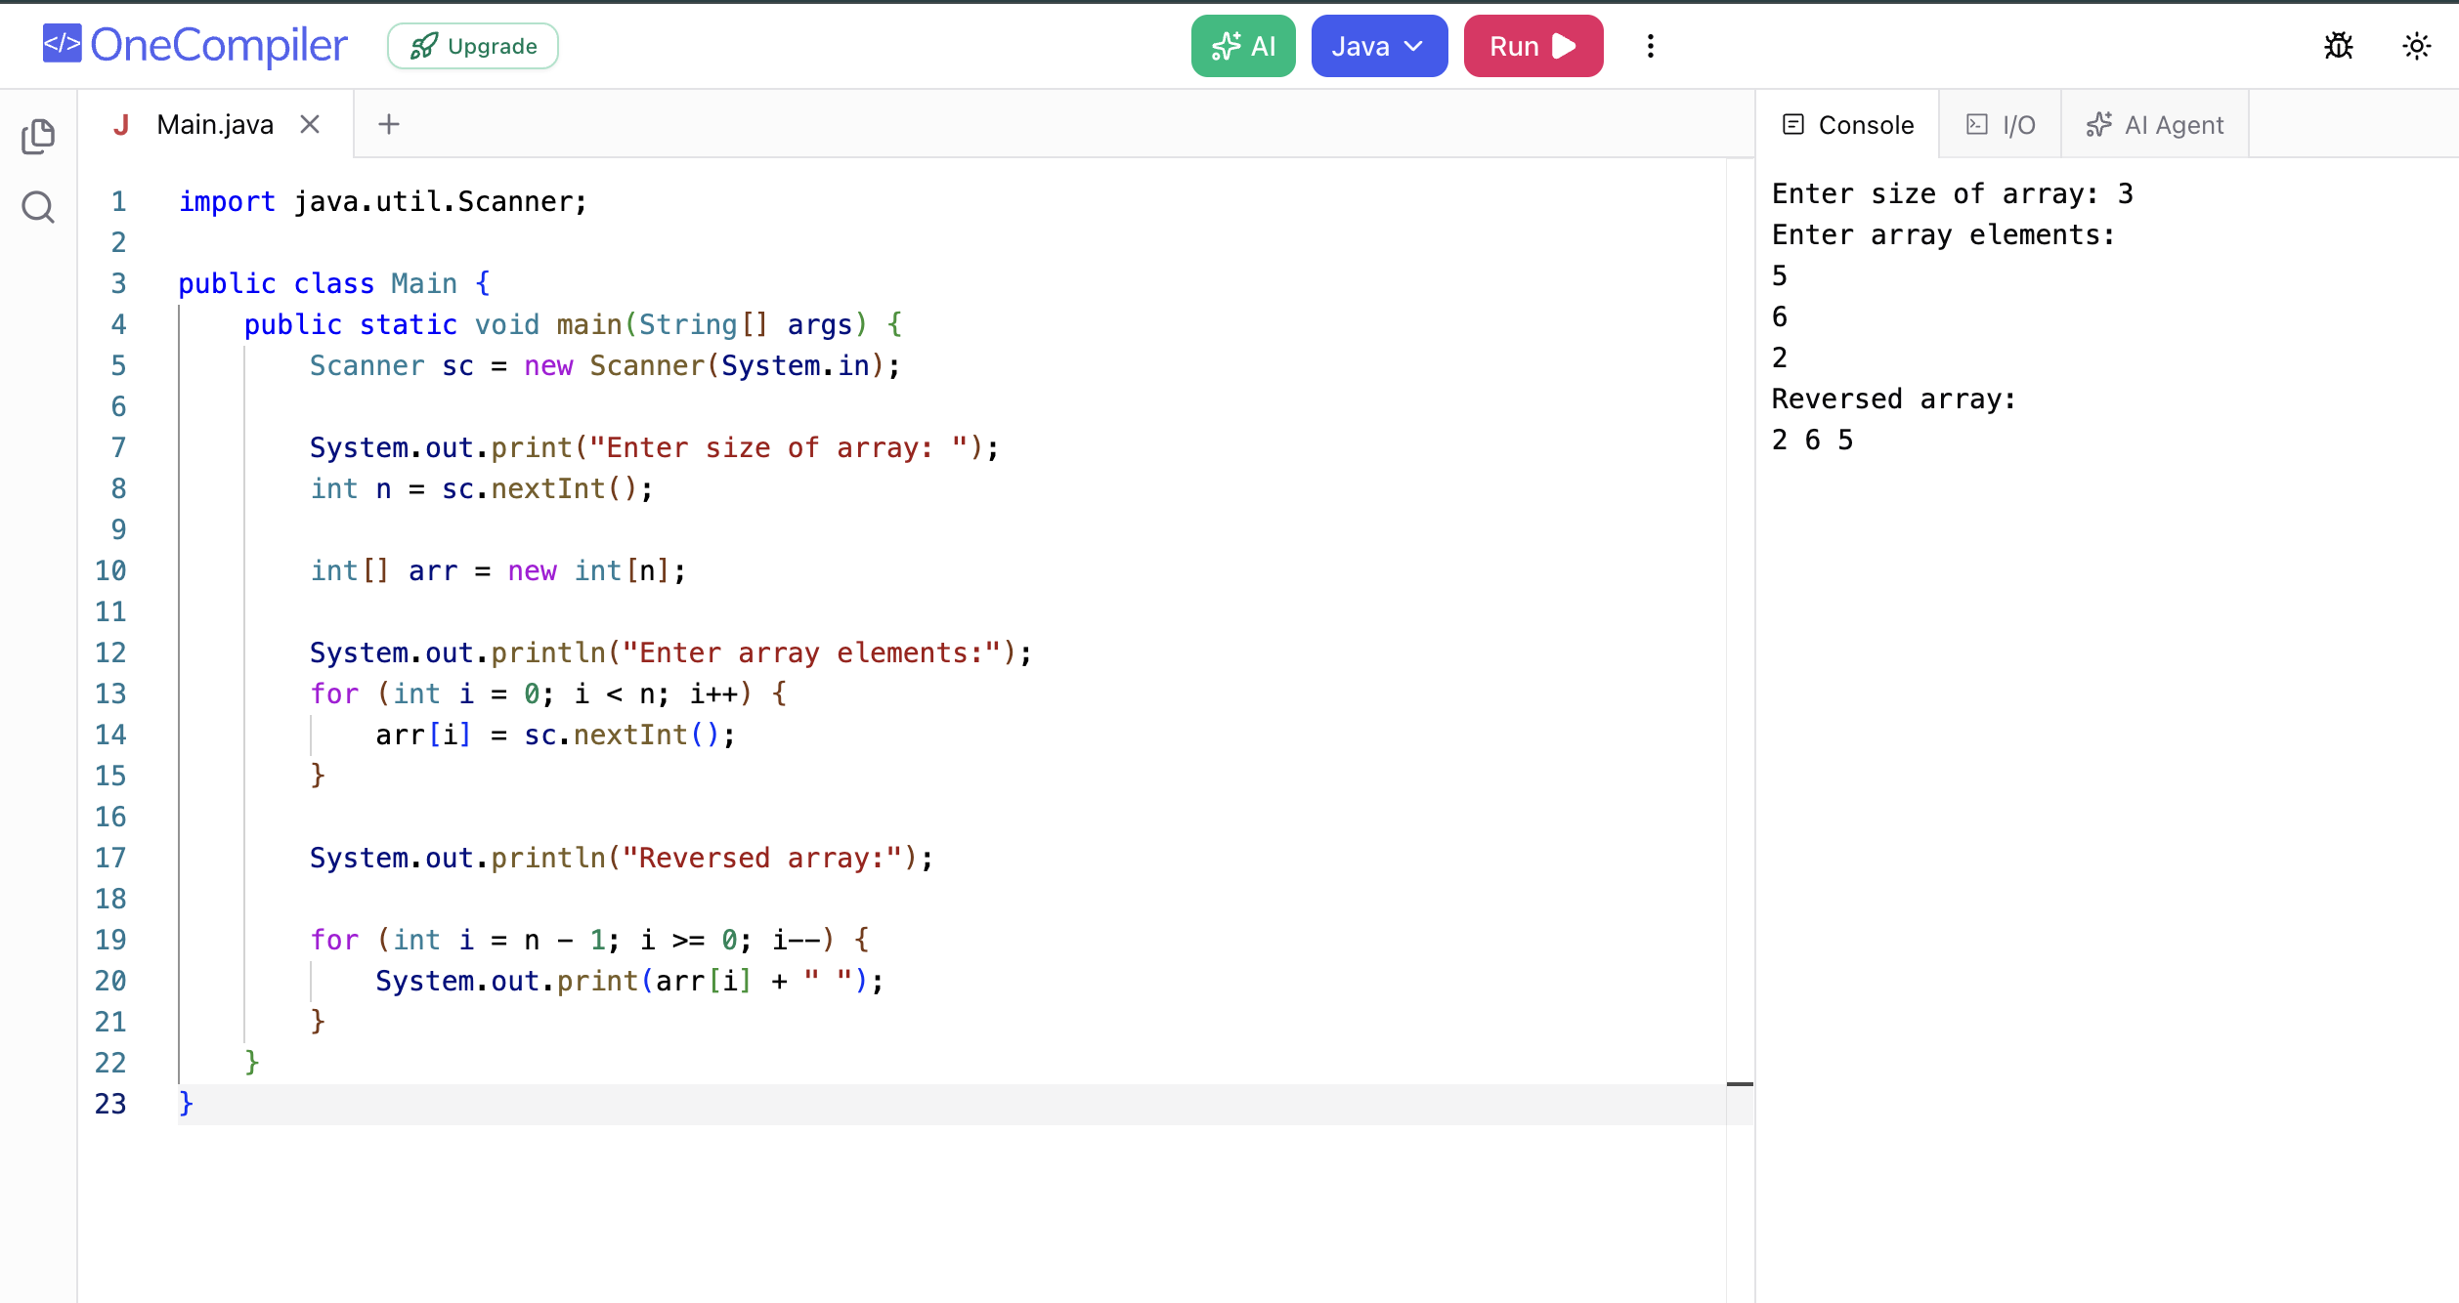

Problem 5: Count Occurrence of an Element in an Array
