Assignment 8
Java Programming — Polymorphism

Submitted by
Drishti Thakur
Roll No. 25SCS1003002554

Part A: Understanding of Theory Concept

1. Explain Polymorphism in Java
Polymorphism is an important concept of Object-Oriented Programming in which a single method, object, or operation can behave in different ways. The word polymorphism means “many forms.” In Java, polymorphism allows us to use the same method name for performing different tasks.
Polymorphism is important because it makes programs more flexible, reusable, and easier to maintain. It also allows the same code to work with different types of objects.
Java mainly supports two types of polymorphism:
- Compile-Time Polymorphism
- Run-Time Polymorphism

2. Explain the Types of Polymorphism
Compile-Time Polymorphism
Compile-Time Polymorphism is also called Static Polymorphism. It is achieved using Method Overloading. In method overloading, multiple methods have the same name but different parameters. The compiler decides which method should be called during compilation.
class Calculator {
int add(int a, int b) {
return a + b;
}
int add(int a, int b, int c) {
return a + b + c;
}
}

Here, both methods have the same name add() but different numbers of parameters.
Run-Time Polymorphism
Run-Time Polymorphism is also called Dynamic Polymorphism. It is achieved using Method Overriding. In method overriding, a child class provides its own implementation of a method that is already present in the parent class. The method that will be executed is decided at runtime.
class Animal {
void sound() {
System.out.println("Animal makes a sound");
}
}
class Dog extends Animal {
void sound() {
System.out.println("Dog barks");
}
}
public class Main {
public static void main(String[] args) {
Animal a = new Dog();
a.sound();
}
}

Output: Dog barks
Here, the reference is of type Animal, but the object is of type Dog. Therefore, the sound() method of Dog is executed at runtime.

3. Explain Method Overloading
Method Overloading means having more than one method with the same name but different parameters in the same class. For example:
class Test {
void display(int a) {
System.out.println(a);
}

void display(int a, int b) {
System.out.println(a + b);
}
}

Here, the display() method is overloaded.
Rules of Method Overloading
- The method name must be the same.
- The parameter list must be different.
- The number of parameters can be different.
- The data types of parameters can be different.
- The order of parameters can be different.
- Changing only the return type is not enough for method overloading.
Different Ways to Overload a Method
A method can be overloaded by changing:
1. Number of parameters
void show(int a)
void show(int a, int b)

2. Data type of parameters
void show(int a)
void show(double a)

3. Order of parameters
void show(int a, double b)
void show(double a, int b)

Why Changing Only Return Type is Not Method Overloading
Changing only the return type does not create method overloading because the compiler identifies a method using its method name and parameter list. For example:
int add(int a, int b)
double add(int a, int b)

This is not allowed in Java because both methods have the same name and same parameters. The compiler cannot differentiate them only using the return type.
Difference between Method Overloading and Method Overriding
Method Overloading | Method Overriding
Same method name with different parameters | Same method name with same parameters
Usually occurs within the same class | Occurs between parent and child classes
Provides Compile-Time Polymorphism | Provides Run-Time Polymorphism
Inheritance is not required | Inheritance is required
Decided during compilation | Decided during runtime

Part B: Programming Questions

Problem 1: Calculator Addition (Method Overloading)
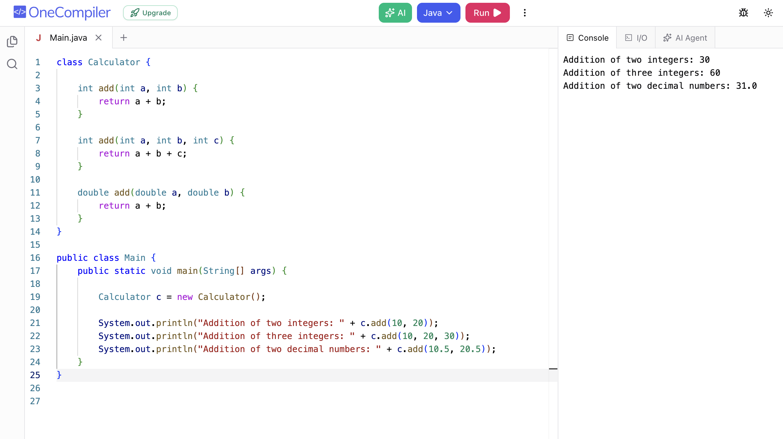

Problem 2: Display Method (Method Overloading)
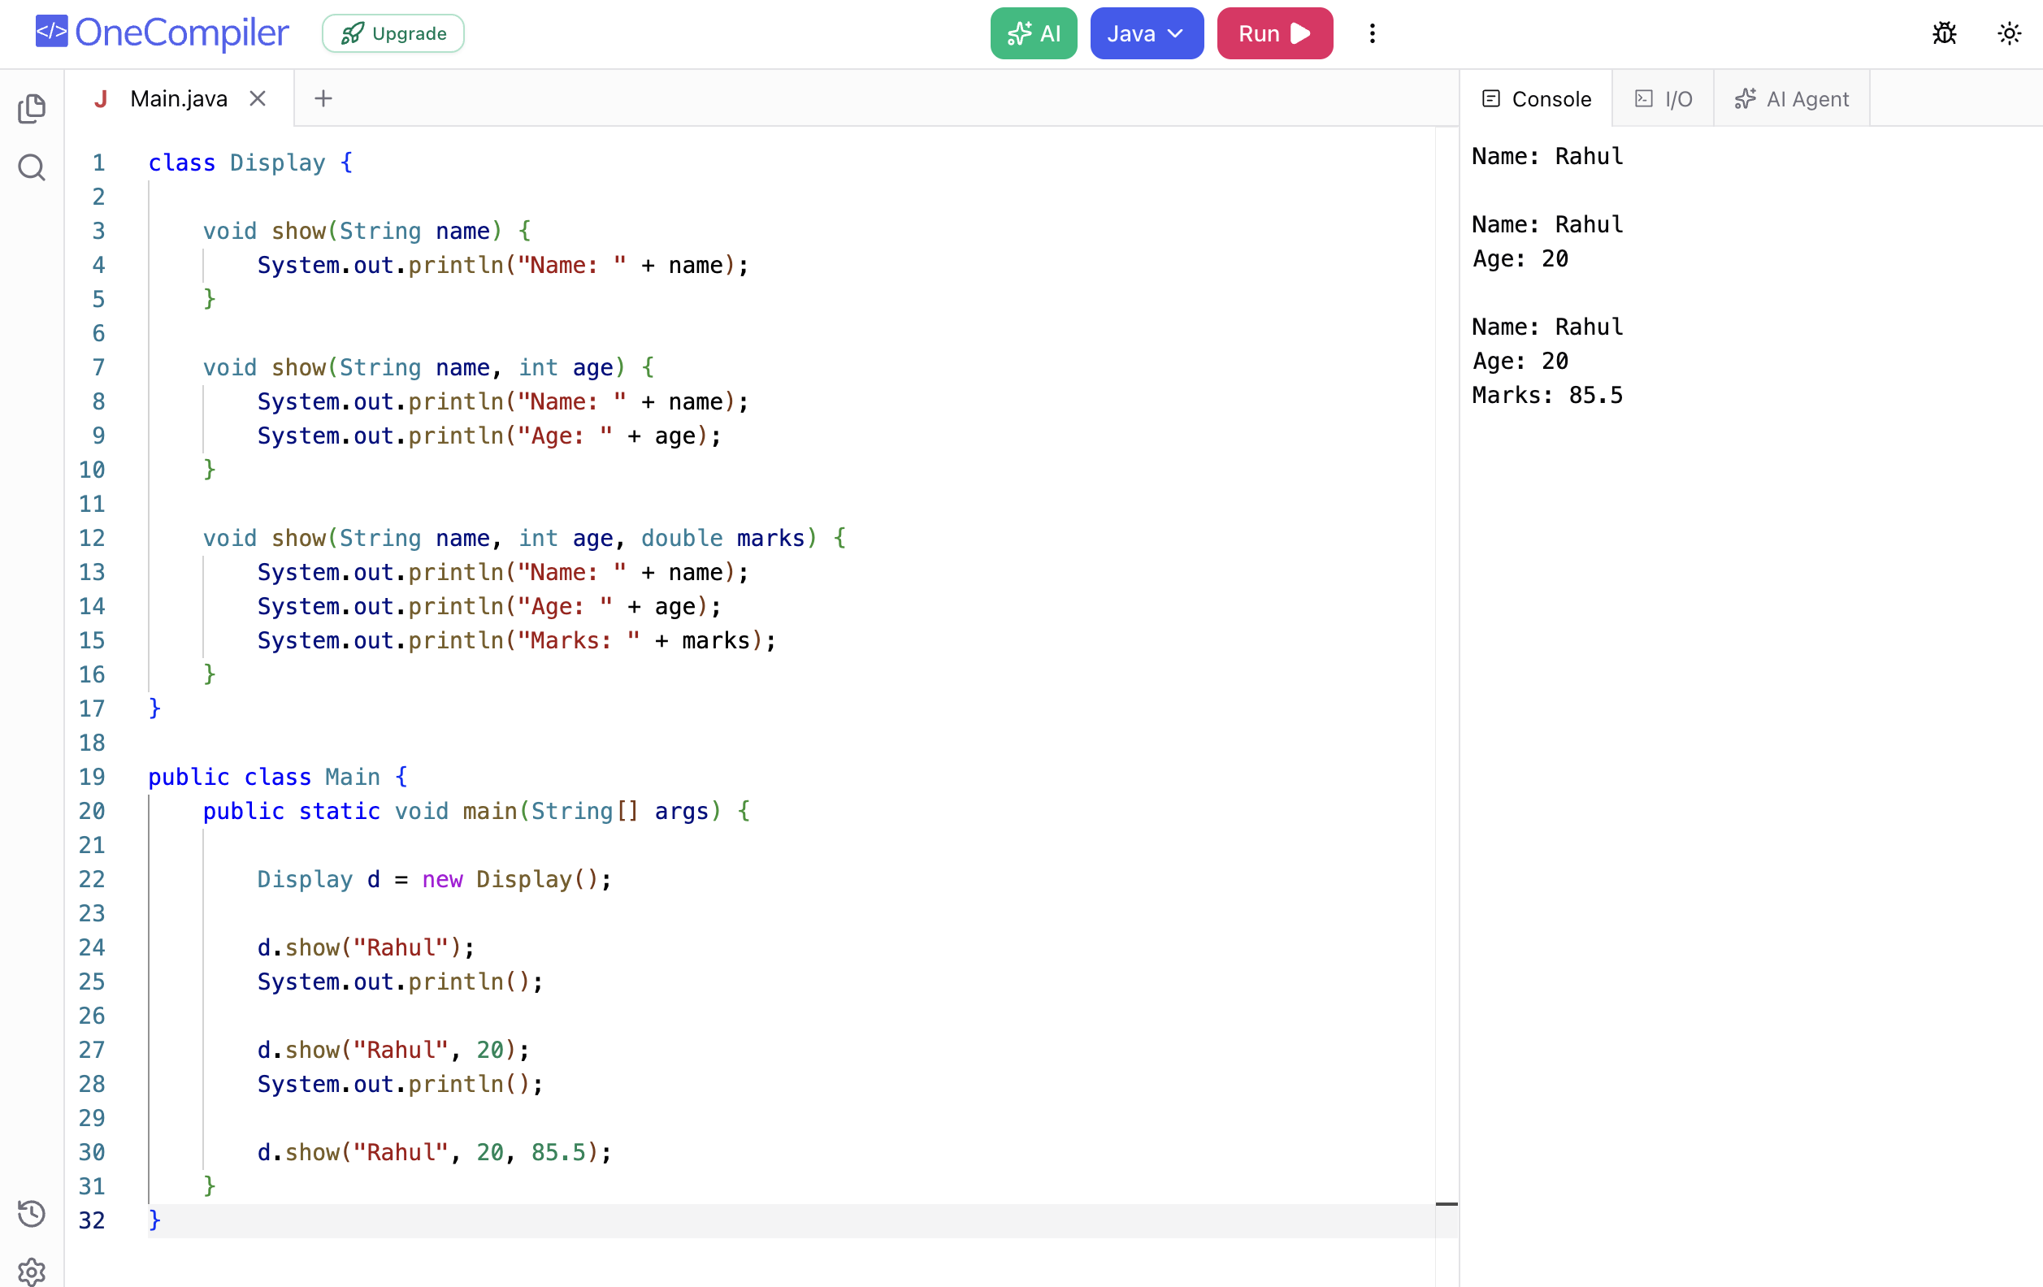

Problem 3: Find Maximum (Method Overloading)
