Assignment 10
Java Programming — Wrapper Classes

Submitted by
Drishti Thakur
Roll No. 25SCS1003002554

Part A – Conceptual Questions
1. What are Wrapper Classes in Java? Explain why Java provides Wrapper Classes.
Wrapper classes in Java are built-in classes that "wrap" a primitive value inside an object. Every primitive data type has a corresponding wrapper class (for example, Integer for int and Double for double), and an object of a wrapper class stores the primitive value inside it along with useful methods to work with that value.
Java provides wrapper classes for the following reasons:
- Use in Collections: Collection classes such as ArrayList, HashMap and HashSet can store only objects, not primitive values. Wrapper classes allow primitives to be stored in them (e.g. ArrayList<Integer>).
- Generics: Generic types work only with reference types, so wrapper classes are needed when primitive values are used with generics.
- Utility Methods: Wrapper classes provide helpful methods and constants such as parseInt(), valueOf(), compare(), Integer.MAX_VALUE and Integer.MIN_VALUE.
- Null Values: A wrapper object can hold null to show that a value is missing, whereas a primitive variable must always hold a value.

2. Write the corresponding Wrapper Class for each primitive data type.
- byte → Byte
- short → Short
- int → Integer
- long → Long
- float → Float
- double → Double
- char → Character
- boolean → Boolean

3. Differentiate between Primitive Data Type and Wrapper Class. Give at least two examples.
A primitive data type is a basic data type built into the Java language that stores a simple value directly, whereas a wrapper class is a class that wraps a primitive value into an object.
- Nature: A primitive is not an object. A wrapper class variable is an object (reference type).
- Memory: A primitive stores its value directly in memory. A wrapper variable stores a reference to an object created in heap memory.
- Null Value: A primitive cannot be null. A wrapper object can be null.
- Methods: A primitive has no methods. A wrapper class provides many useful methods.
- Collections: A primitive cannot be stored in collections or used with generics. A wrapper object can.
- Speed: Primitives are faster and use less memory. Wrapper objects are slightly slower and use more memory.
Example 1: int x = 10; is a primitive, whereas Integer y = Integer.valueOf(10); is a wrapper object.
Example 2: double a = 5.5; is a primitive, whereas Double b = Double.valueOf(5.5); is a wrapper object. Here b can also be assigned null, but a cannot.

4. What is Autoboxing? Explain with a suitable example.
Autoboxing is the automatic conversion of a primitive value into an object of its corresponding wrapper class. The Java compiler performs this conversion automatically, so the programmer does not need to write code to create the wrapper object manually.
For example, in the statements int number = 100; Integer obj = number; the primitive int value 100 is automatically converted into an Integer object and stored in obj. Internally, the compiler converts this to Integer.valueOf(number).
5. What is Unboxing? Explain with a suitable example.
Unboxing is the automatic conversion of a wrapper class object back into its corresponding primitive value. It is the opposite of autoboxing and is also performed automatically by the Java compiler.
For example, in the statements Integer obj = 100; int number = obj; the Integer object obj is automatically converted into a primitive int value and stored in number. Internally, the compiler converts this to obj.intValue(). If the wrapper object is null, unboxing throws a NullPointerException.
6. What is the difference between Integer.parseInt() and Integer.valueOf()?
- Return Type: Integer.parseInt() returns a primitive int value, whereas Integer.valueOf() returns an Integer object.
- Input: Integer.parseInt() accepts a String, whereas Integer.valueOf() accepts either a String or an int.
- Caching: Integer.parseInt() creates no object. Integer.valueOf() may reuse cached Integer objects for values between -128 and 127.
- Use: parseInt() is used when a primitive value is needed for calculations. valueOf() is used when an object is needed, such as when storing values in a collection.
For example, int a = Integer.parseInt("25"); gives a primitive int, whereas Integer b = Integer.valueOf("25"); gives an Integer object. Both throw a NumberFormatException if the string is not a valid integer.

Part B – Programming Questions
1. Primitive and Wrapper Variables
Create a Java program that declares variables for all 8 primitive data types and their corresponding Wrapper Classes. Display the values of both primitive and Wrapper variables.
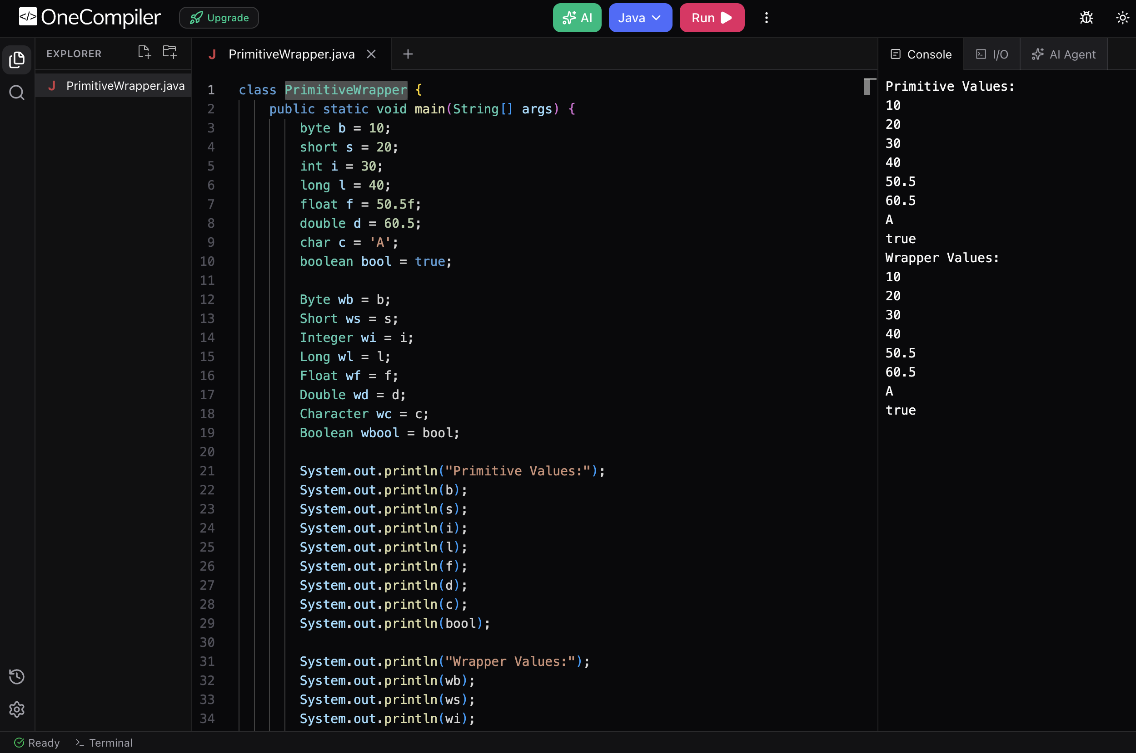

2. Autoboxing Demonstration
Create a program to demonstrate Autoboxing. Convert the following primitive values into Wrapper objects: int, double, char, boolean. Display the values after conversion.
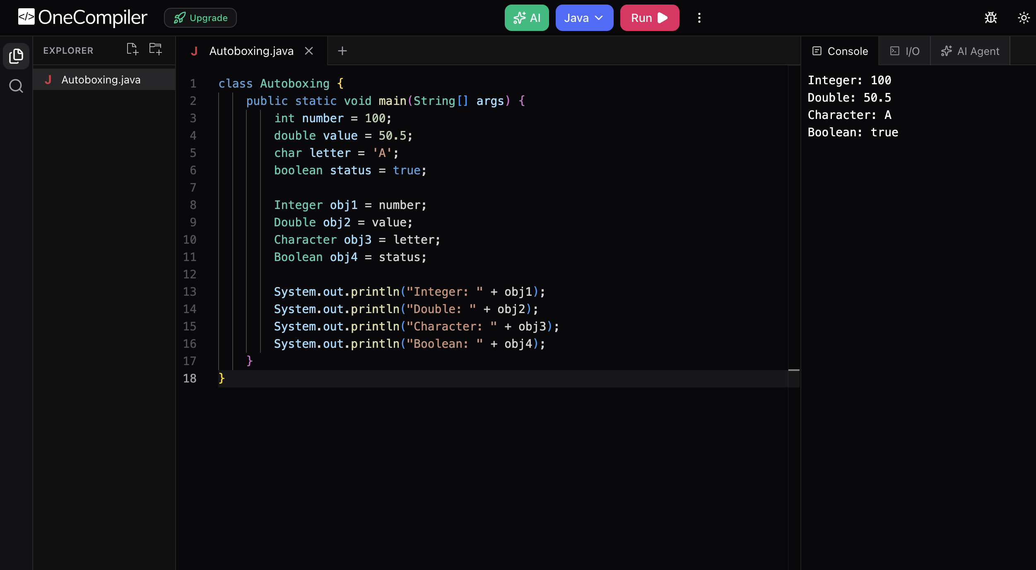

3. Unboxing Demonstration
Create a program to demonstrate Unboxing. Convert the following Wrapper objects into primitive values: Integer → int, Double → double, Character → char, Boolean → boolean. Display the converted values.
