**RESUME**

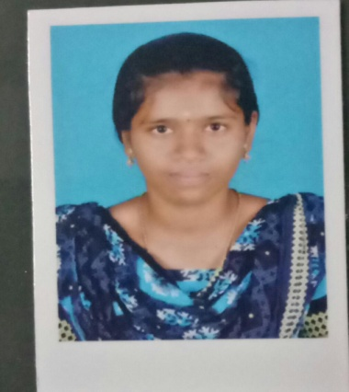

**P.Nithya,**

**D\O K. Pugalraj,**

***8\140A, NORTH STREET,***

***POOVANOOR,***

***TENKASI(TK)-627 808,***

***TENKASI(DIST).***

***EMAIL ID:nithyapukal@gmail.com***

***MOBILE NUMBER: 8344830568 \ 9751726340***

**OBJECTIVE:**

***To enhance my new skills and utilize them to the full extent of the setterment of the***

***Organization and to be part of them that works towards the growth of in organization.***

**EDUCATIONAL DETAILS:**

|  |  |  |  |  |
| --- | --- | --- | --- | --- |
| **QUALIFICATION** | **INSTITUTION** | **UNIVERSITY\BOARD** | **DURATION** | **PERCENTAGE** |
| **HSC** | ***Avvaiyar government Girls Hr. Secondary School,Pavoorchatram.*** | ***State Board*** | ***2021*** | **87.63** |
| **SSLC** | ***Avvaiyar Government Girls Hr Sec School,Pavoorchatram.*** | ***State Board*** | **2019** | **84.2** |

**COMPUTING SKILL:**

* **COA**

**TECHNICAL QUALIFICATION:**

***Type writing in English - Junior and Senior***

***KEY STRENGTH:***

* **Good communication skill.**
* **Improving own learning and performance.**
* **Good coding creative *skill.***

***PERSONAL DETAILS:***

***Father’s Name : K.Pugalraj***

***Date of Birth : 1th June 2004***

***Gender : Female***

***Marital Status : Unmarried***

***Nationality : Indian***

***Religion : Hindu***

***Language Known : Tamil and English***

**DECLARATI*ON:***

**I hereby declare that the information furnished here is true and I promise to do my duties with responsibility to the best of my knowledge and belief.**

***Place: Poovanoor Signature***

***Date:17.03.2023***

***P.Nithya***