**TASK-13**

**Name: Varsha Gupta**

**Referral id: DIRSS3129**

Q1. Try to locate the file which is starting with the letter {a} and ending with the letter {t}  
        - N number of characters can be in between  
  - Find out any file which starting with the letter { s } & last second character can be {z} only & size should be 5 character  
 - Finding all the file & folder only in the current directory don't have to list subdirectory contents & letter {am} in between the filenames  
    - Get files starting with a letter { a } & second letter can be { l or t } only   eg algo.txt   atno.txt  
    - Get all the files starting with letter {A-T} or {a-z} or {0-7}  
    - Get file whose second letter is {d} & last character can be from { o to z} only

 Hint : [wildcard]

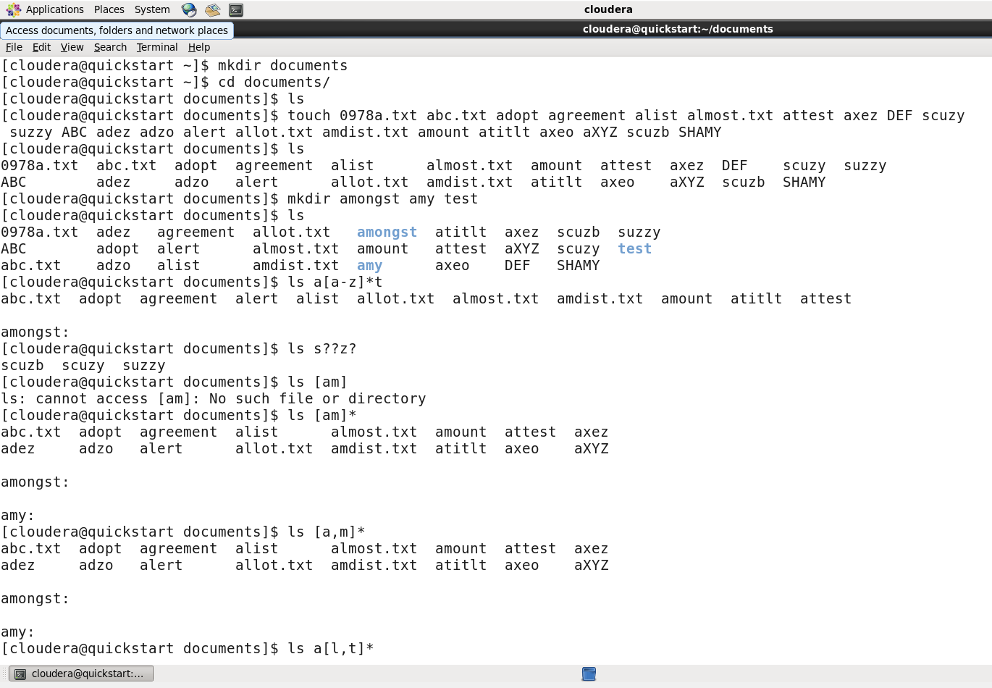

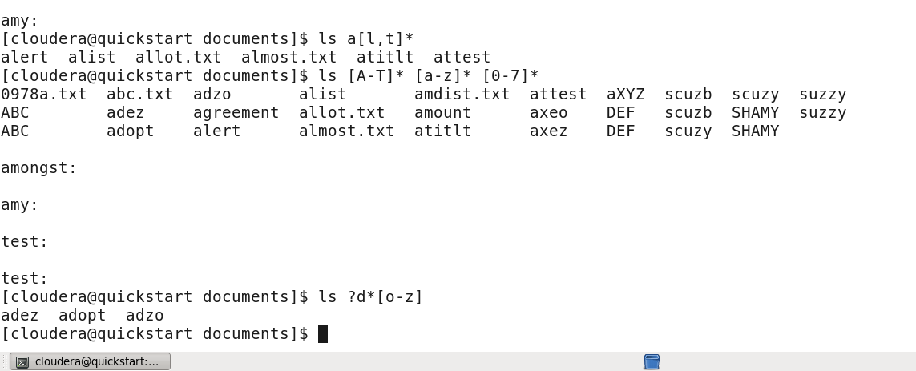

Q2. Create a range of folder with the names as [ emp1 , emp2 , emp3  .....emp100 ] inside the source folder  [using single command]  
    - Try to create to backup of this folder inside the Desktop with the name as backup  
    - Delete all the folder which lies in range 70 to 85 inside the emp70 and emp85 values  
      - At time of deletion it should ask for prompt to delete the folder or not  
      - If you done the above step  
      - Try to delete all folder with value of range 50 to 100 for emp50 to emp100 folder wihout asking for prompt

[Hint : use the -i]

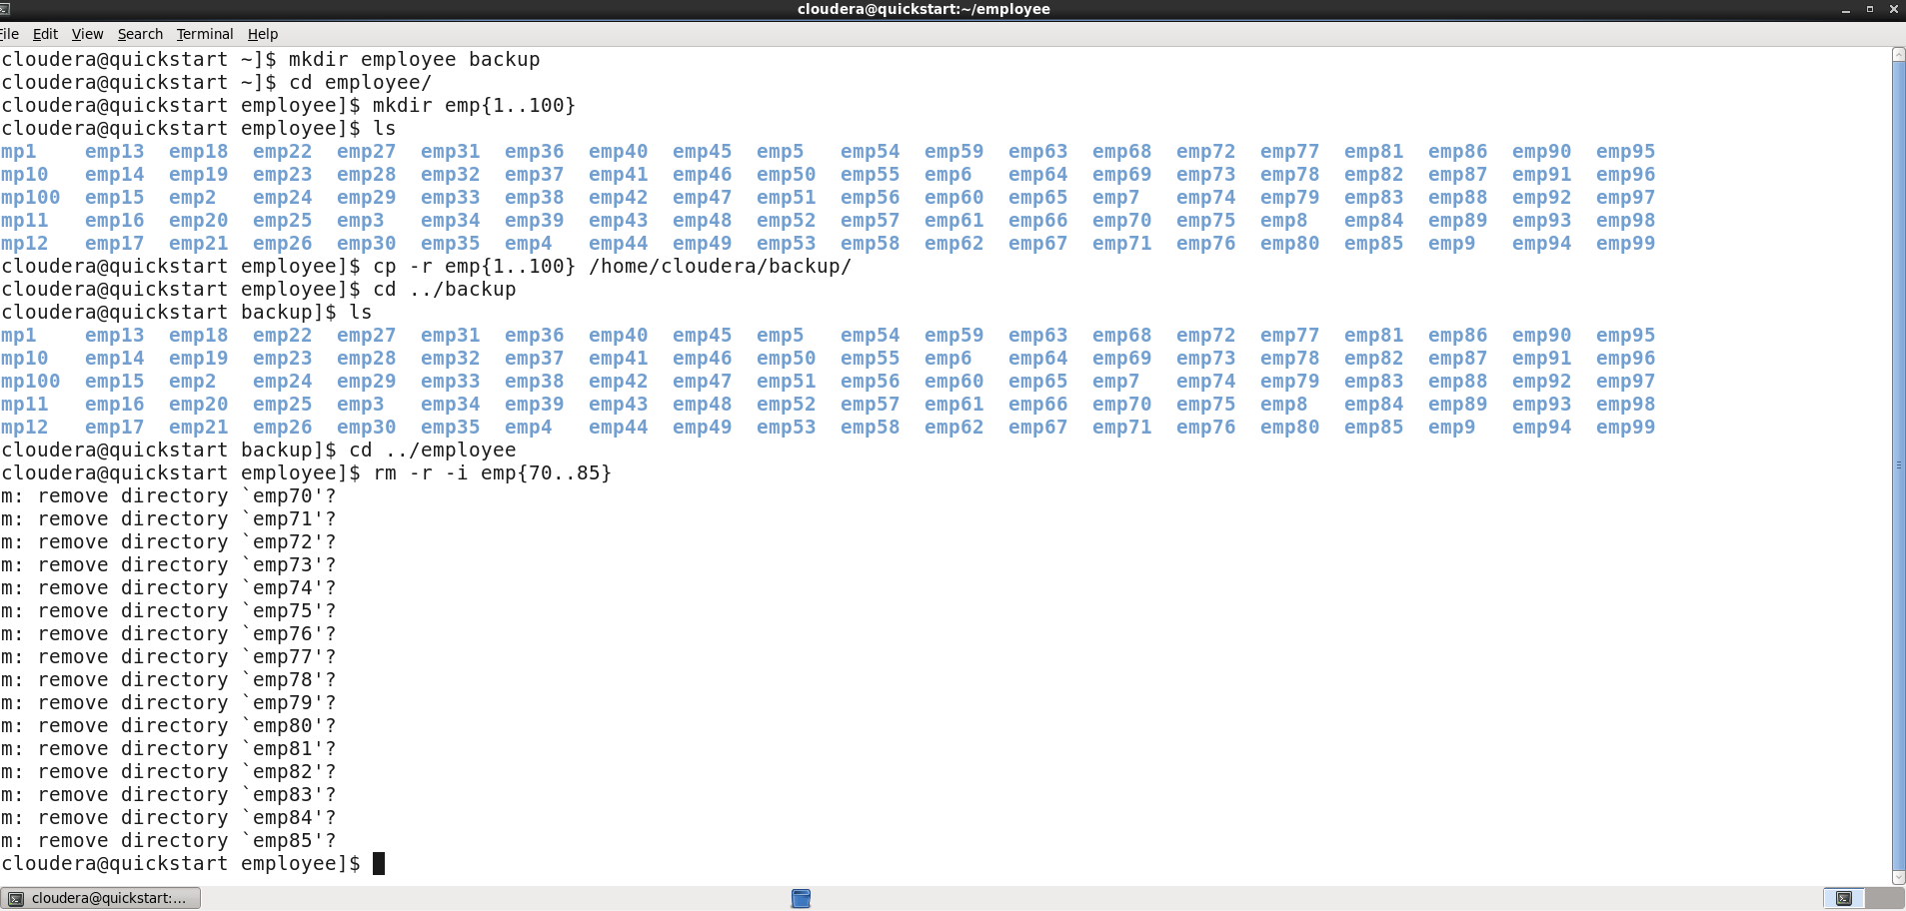

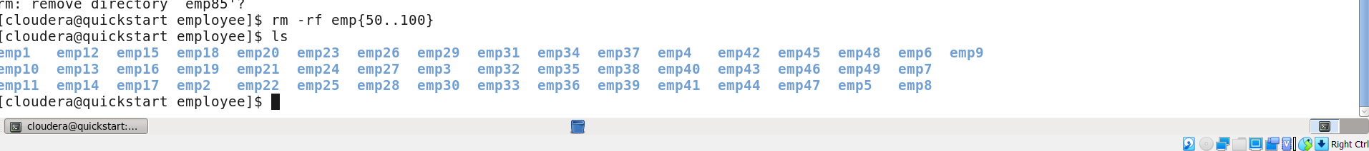

Q3. Try to find out any files & folder having size less than 20 MB inside the /home directory  
  - Only try to find out files (files only) inside the /home/user directory with created by the user your are currently working  
  - Create a file on Desktop with names as data.txt & Data.txt & DATA.txt & try to find all the data.txt files as case insensitive letters  
    - find out any files updated or created in last 30 min

