DJANGO PROJECT CREATION

I WENT TO F DRIVE

C:\USERS\TRAINING:F:

F:\>python –m venv PythonAIBasedImageGenerator

F:\ PythonAIBasedImageGenerator>cd scripts

F:\ PythonAIBasedImageGenerator\scripts>activate

(PythonAIBasedImageGenerator) F:\PythonAIBasedImageGenerator\scripts>py –m pip install Django

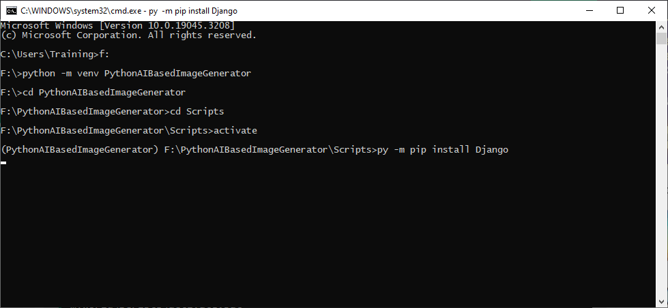

Django installed

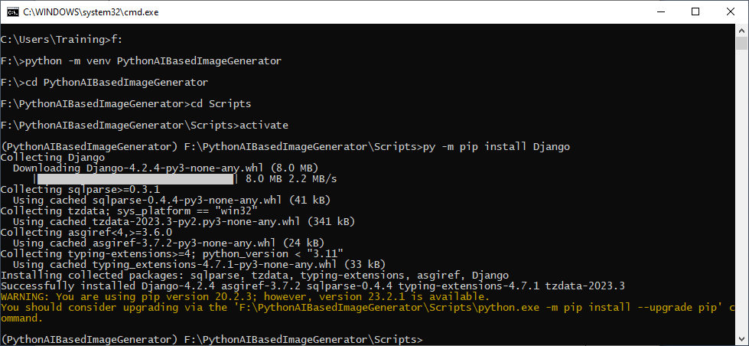

(PythonAIBasedImageGenerator) F:\PythonAIBasedImageGenerator\scripts>py –-version

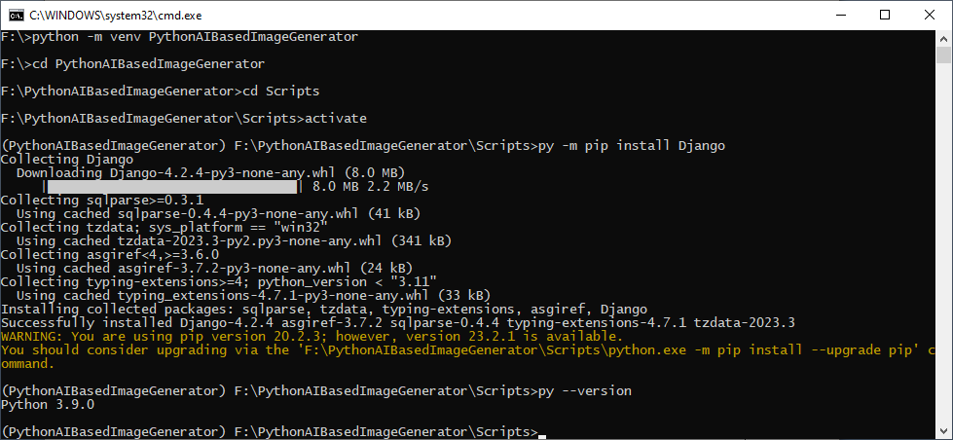

What's Next?

Now you are ready to create a Django project in a virtual environment on your computer.

(PythonAIBasedImageGenerator) F:\PythonAIBasedImageGenerator\scripts>cd..

(PythonAIBasedImageGenerator) F:\PythonAIBasedImageGenerator> django-admin startproject PythonAIBasedImageGenerator

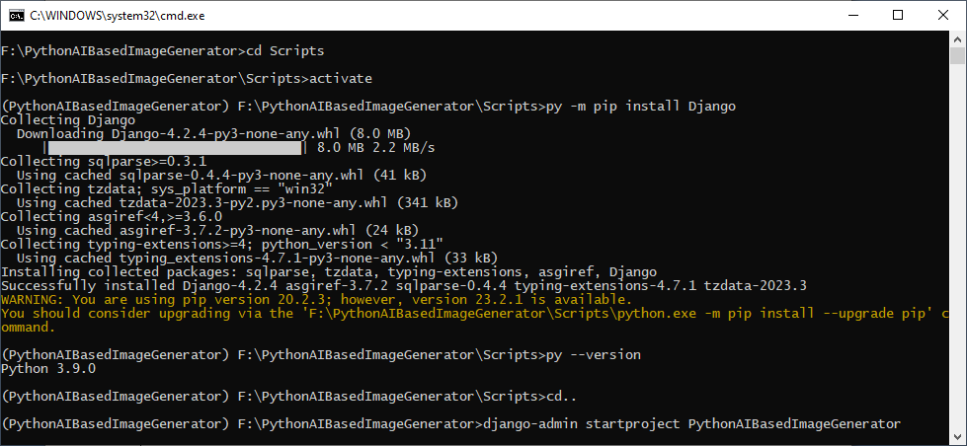

Project created

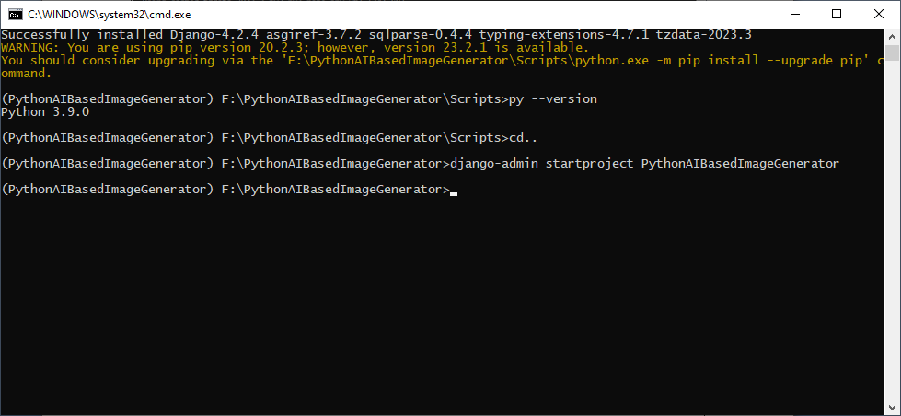

Folder structure:

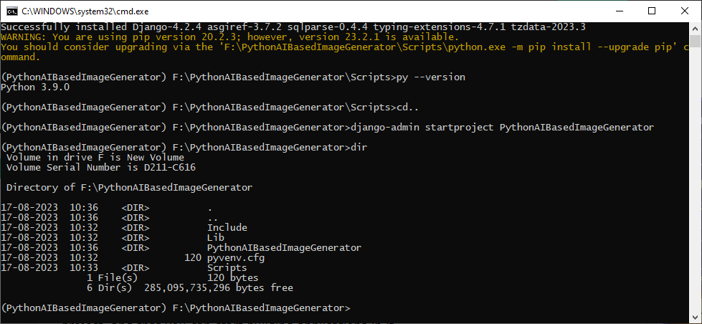

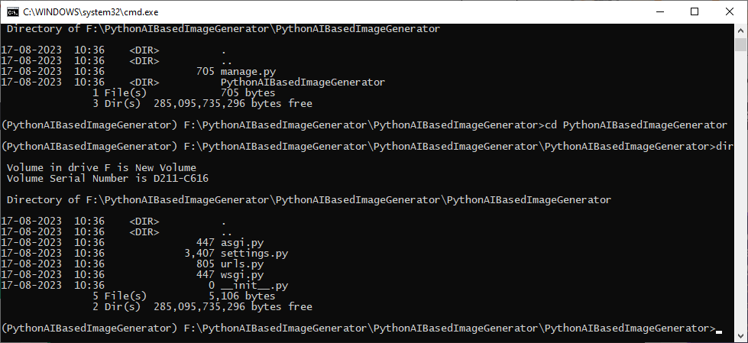

RUNNING THE SERVER

(PythonAIBasedImageGenerator) F:\PythonAIBasedImageGenerator\ PythonAIBasedImageGenerator >python manage.py runserver

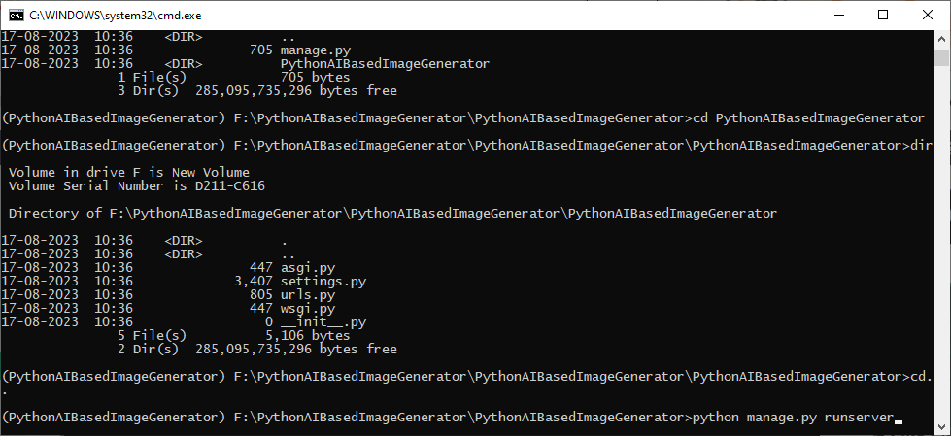

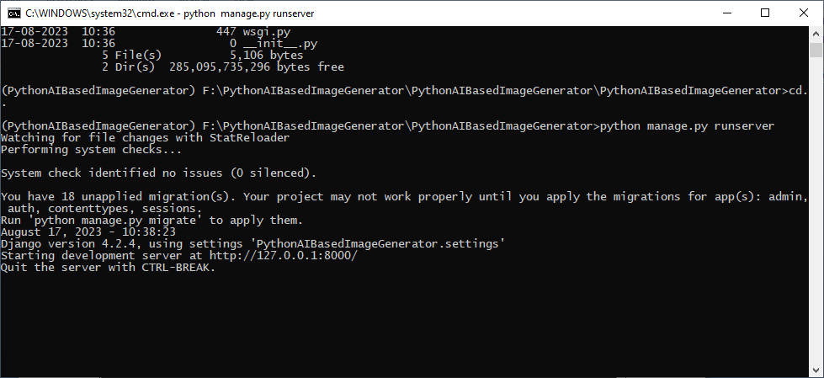

Server is running

In the browser: type 127.0.0.1:8000

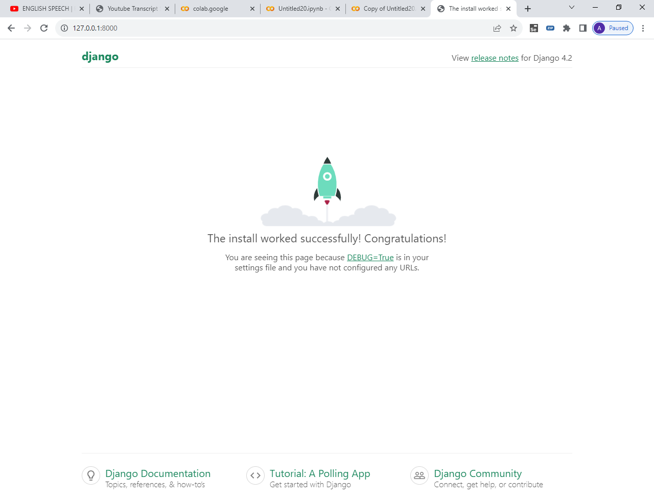

TO CREATE AN APP:

OPEN ANOTHER COMMAND PROMPT

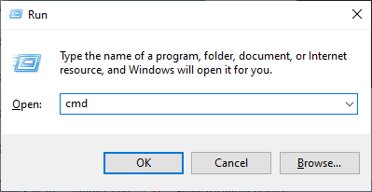

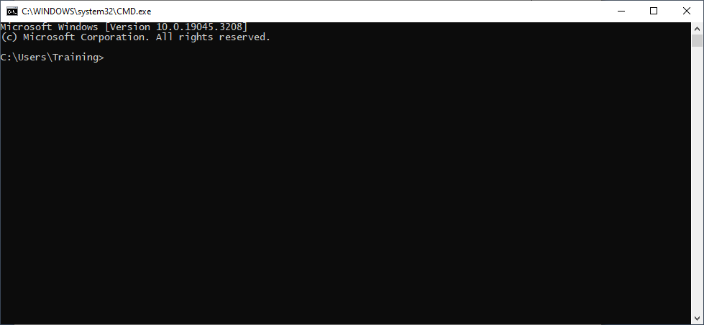

C:\users\training\>F:

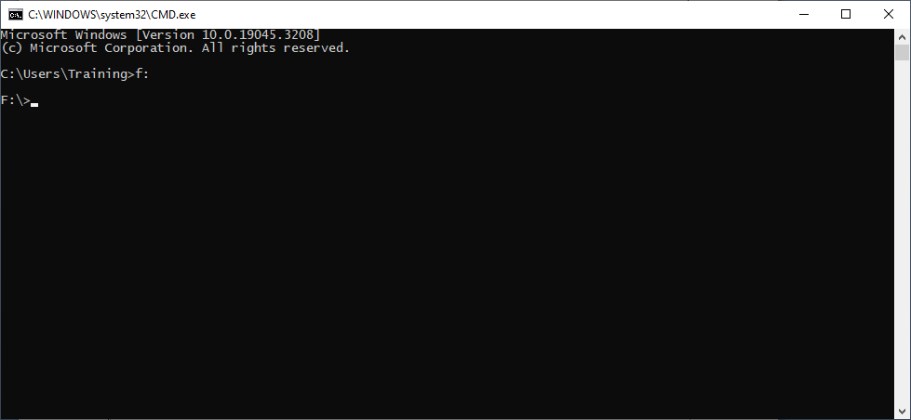

F:\PythonAIBasedImageGenerator>

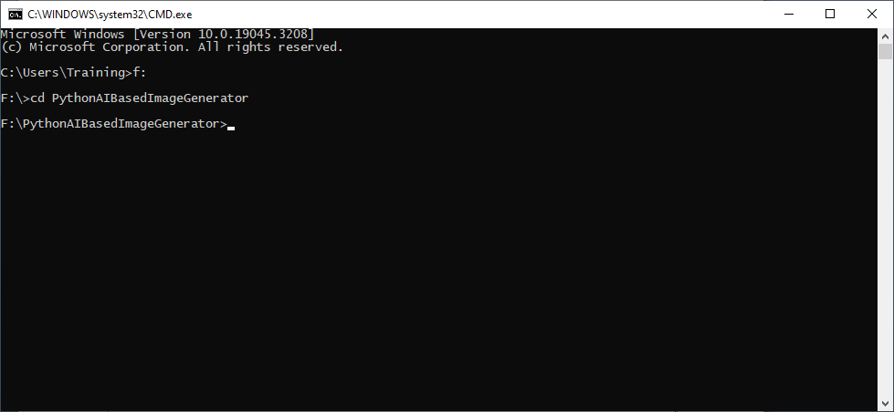

F:\PythonAIBasedImageGenerator>dir

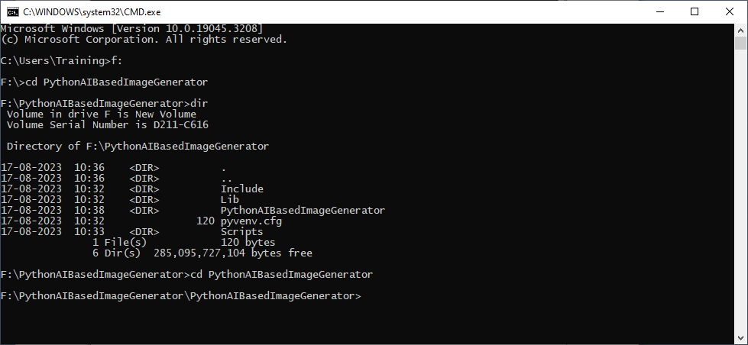

F:\PythonAIBasedImageGenerator>cd PythonAIBasedImageGenerator

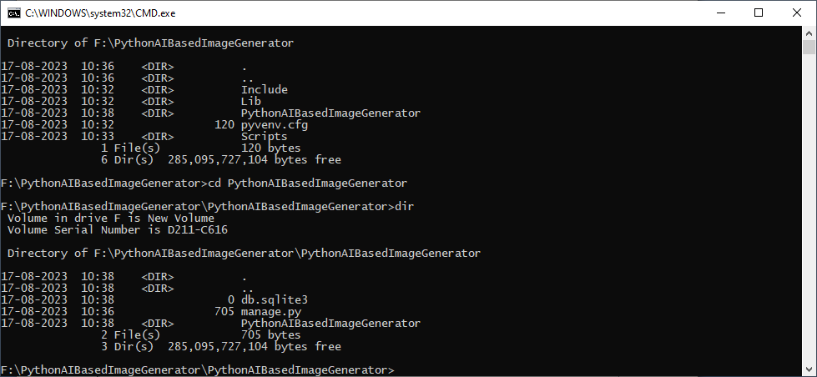

Give any name for app : I gave imgapps

F:\PythonAIBasedImageGenerator\ PythonAIBasedImageGenerator>python manage.py startapp imgapps

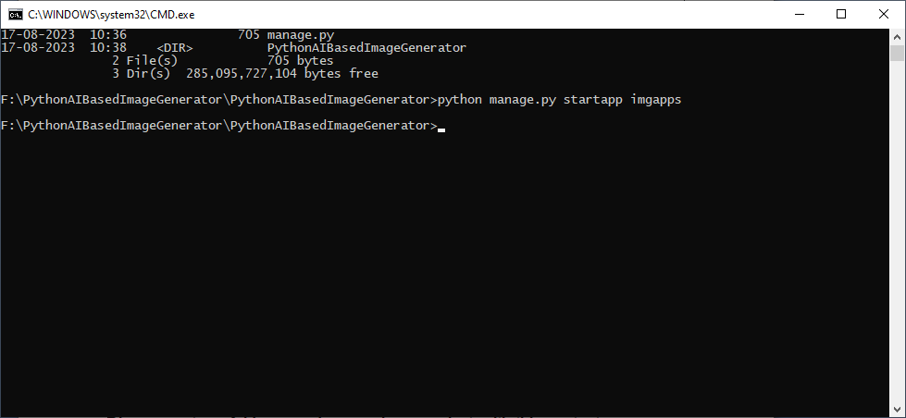

Django creates a folder named imgapps in my project, with this content:

F:\PythonAIBasedImageGenerator\ PythonAIBasedImageGenerator>cd imgapps

F:\PythonAIBasedImageGenerator\ PythonAIBasedImageGenerator\imgapps\>dir

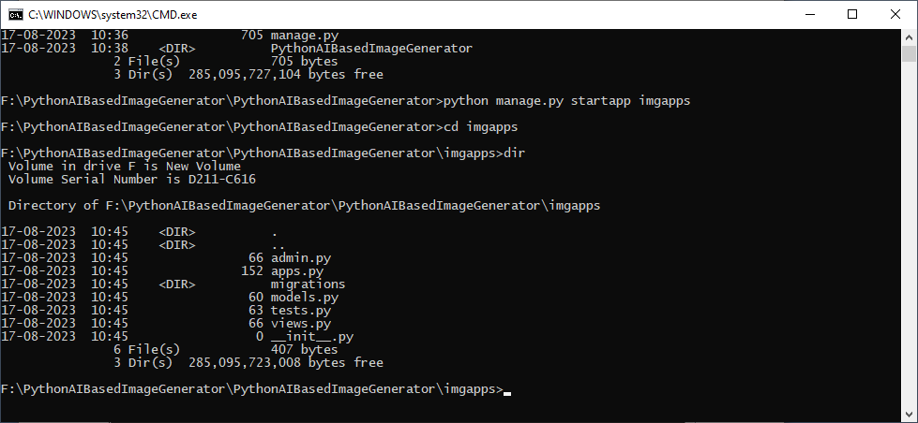

Django views are Python functions that takes http requests and returns http response, like HTML documents.

A web page that uses Django is full of views with different tasks and missions.

Views are usually put in a file called views.py located on your app's folder.

There is a views.py in your imgapps folder that looks like this:

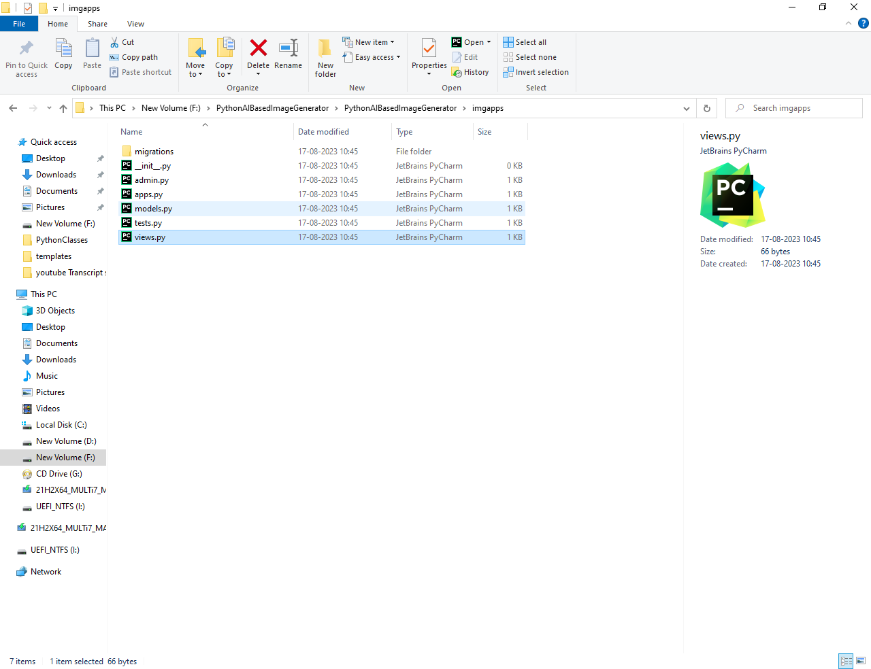

**Find it and open it, and replace the content with this:**

from django.shortcuts import render

from django.http import HttpResponse

def members(request):

return HttpResponse("Hello world!")

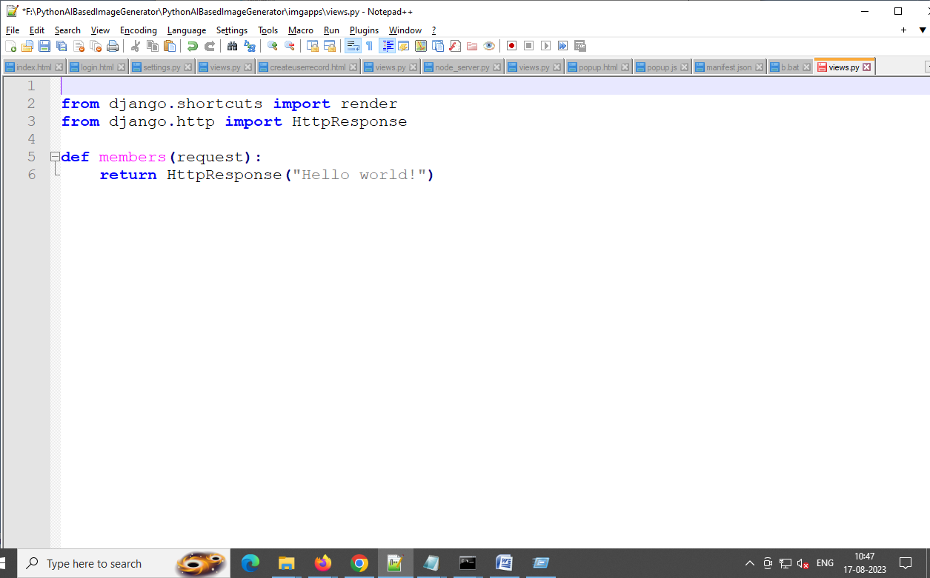

## URLs

Create a file named urls.py in the same folder as the views.py file, and type this code in it:

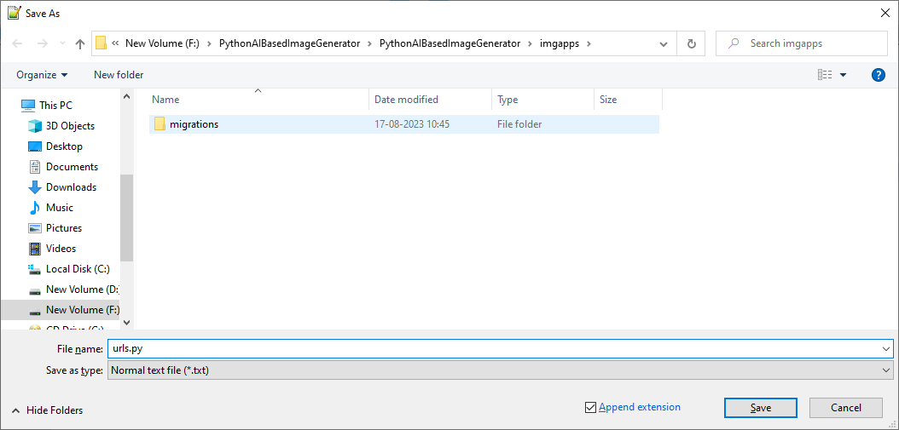

**Paste this code**

from django.urls import path

from . import views

urlpatterns = [

path('members/', views.members, name='members'),

]

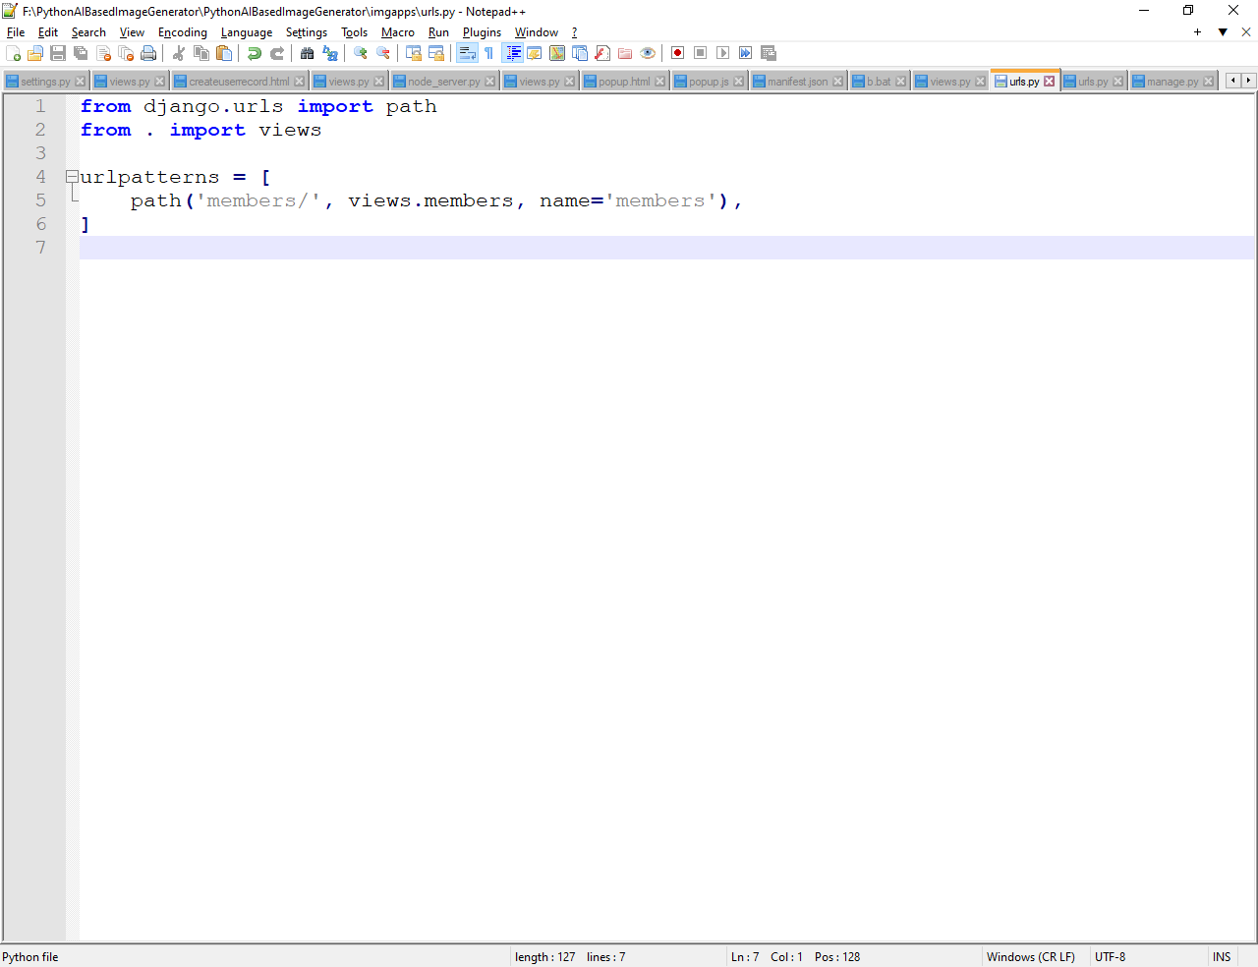

Open the urls.py in F:\PythonAIBasedImageGenerator\ PythonAIBasedImageGenerator

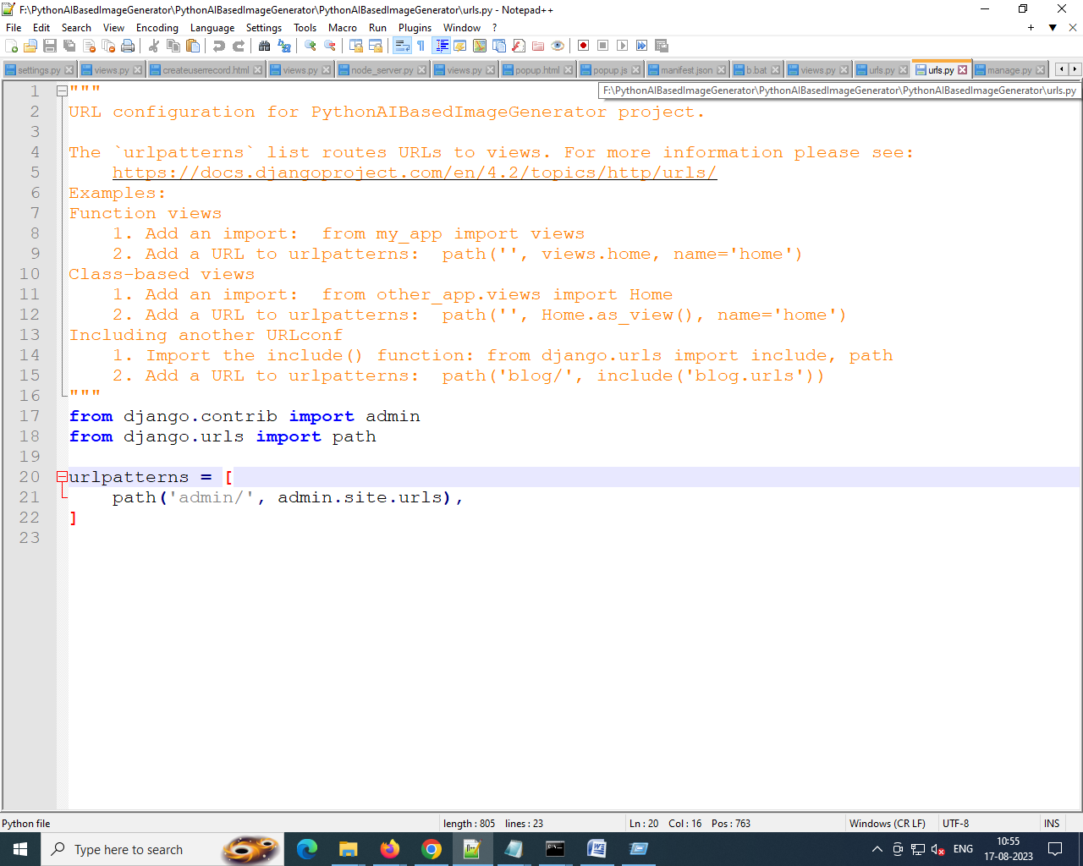

Paste this code

from django.contrib import admin

from django.urls import include, path

urlpatterns = [

path('', include('imgapps.urls')),

path('admin/', admin.site.urls),

]

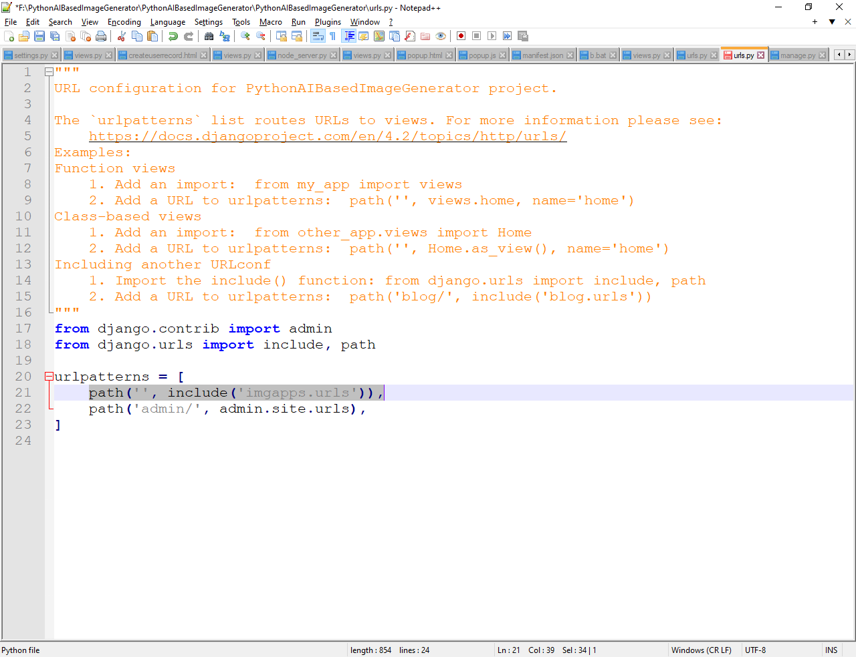

Run the following command

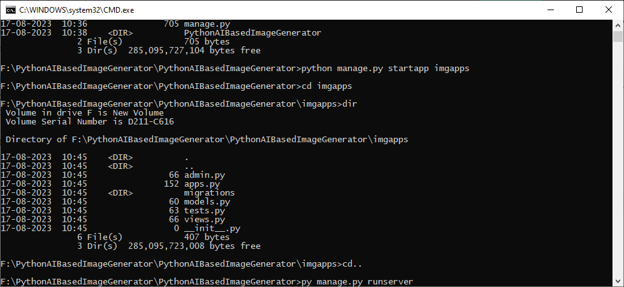

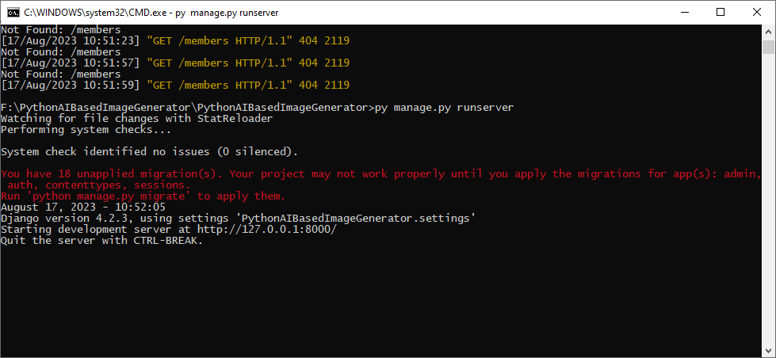

In the browser, enter: 127.0.0.1:8000

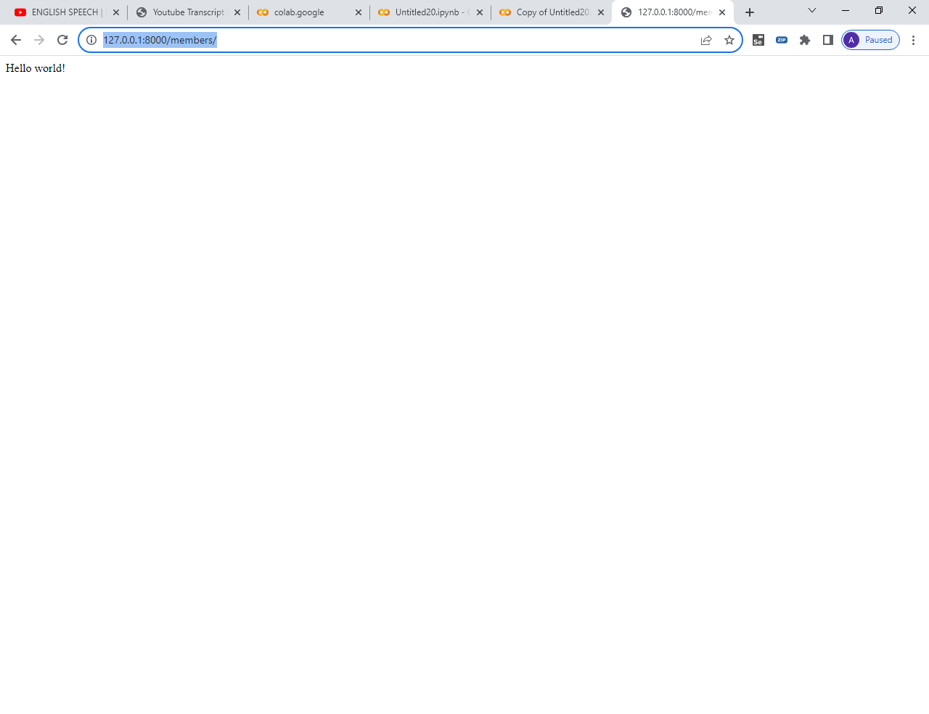

See the result

Chapter 2

# Django Templates

Create a templates folder inside the imgapps folder, and create a HTML file named index.html.

The file structure should be like this:

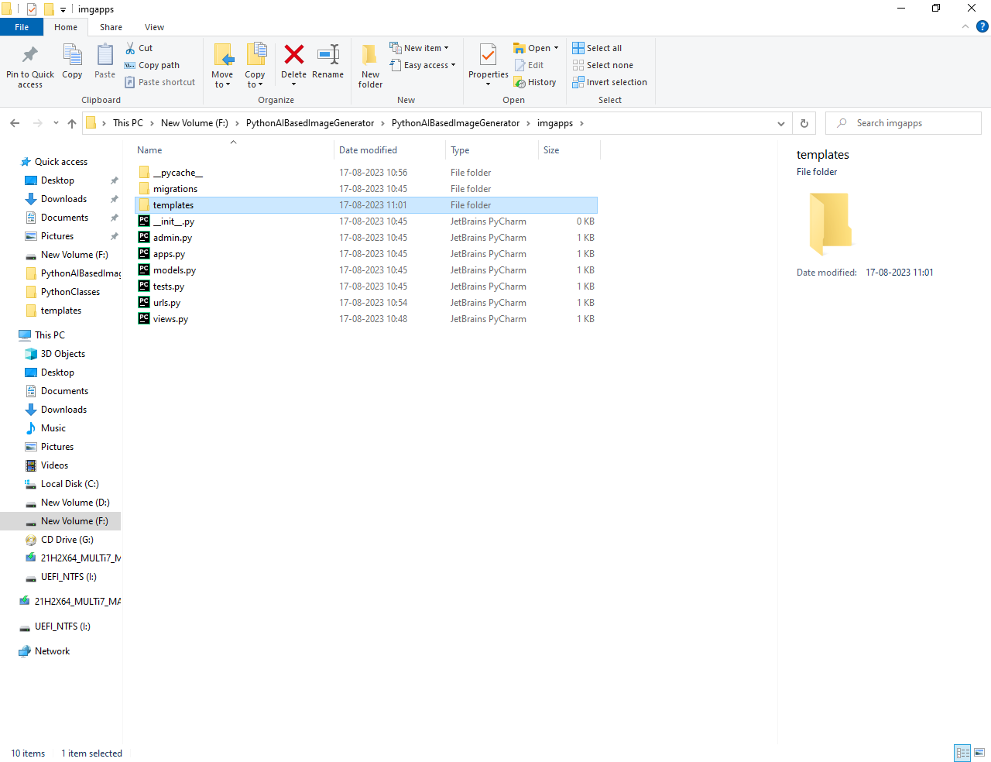

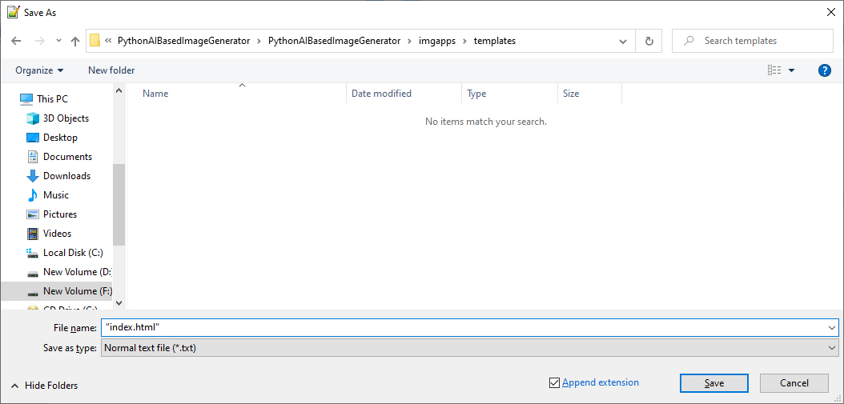

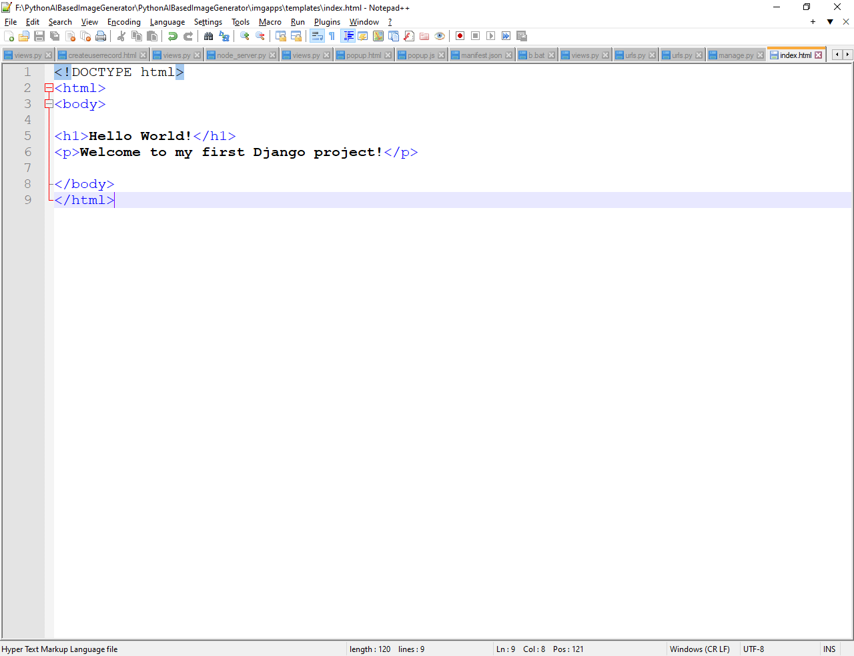

Modify the View

Open the views.py file and replace the members view with this:

from django.http import HttpResponse

from django.template import loader

def members(request):

template = loader.get_template(index.html')

return HttpResponse(template.render())

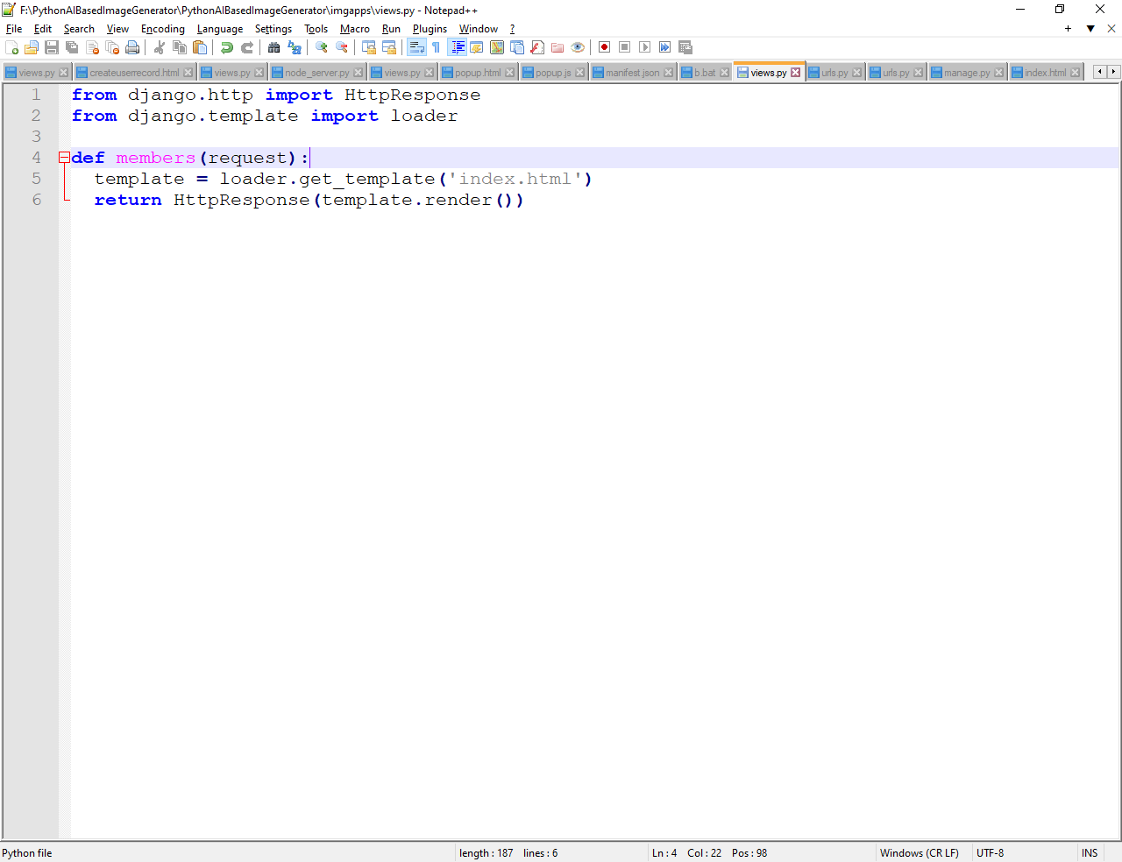

Change Settings

To be able to work with more complicated stuff than "Hello World!", We have to tell Django that a new app is created.

This is done in the settings.py file in the F:\PythonAIBasedImageGenerator\PythonAIBasedImageGenerator\PythonAIBasedImageGenerator folder.

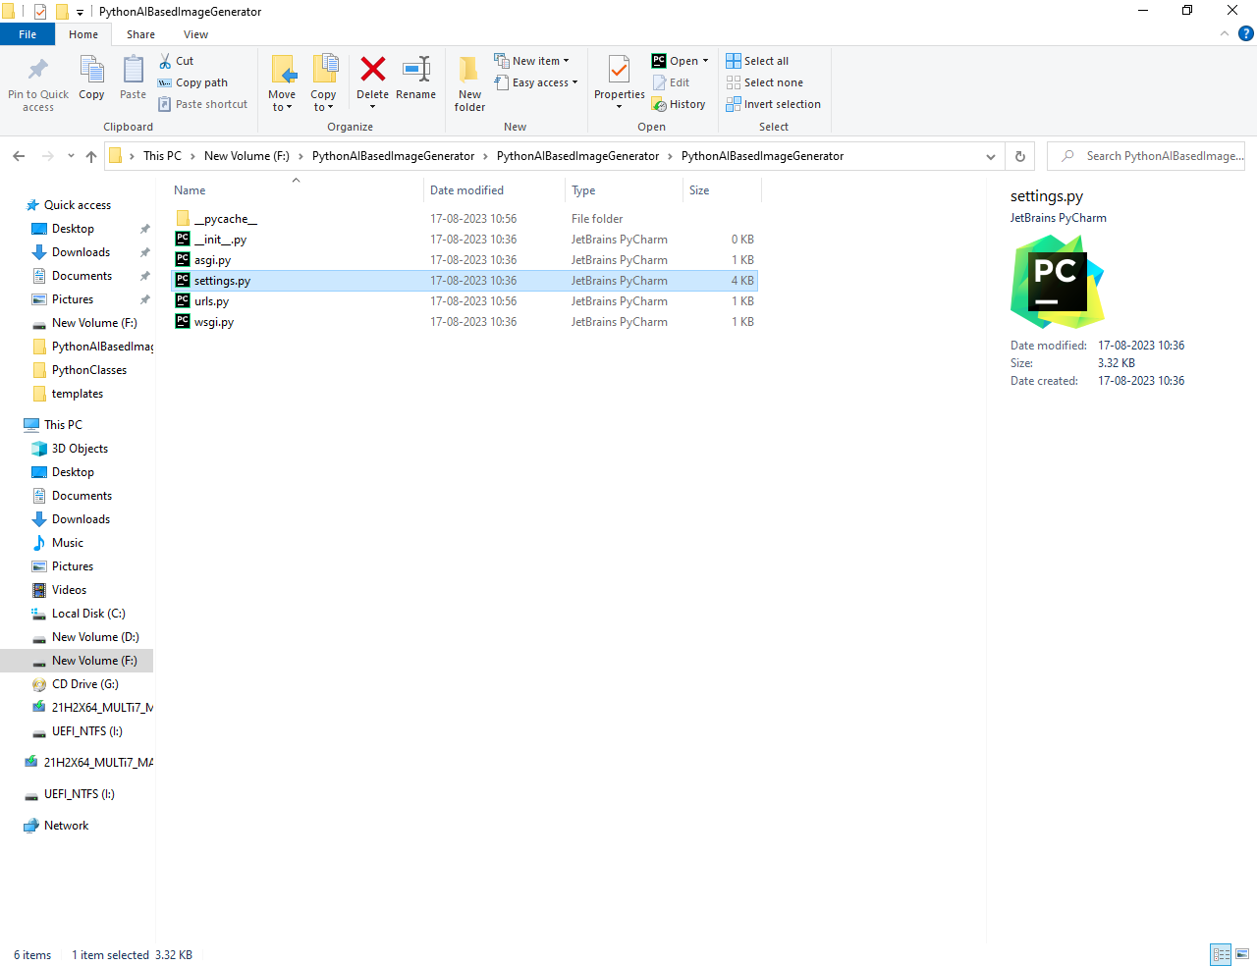

Look up the INSTALLED_APPS[] list and add the imgapps app like this:

In settings.py file

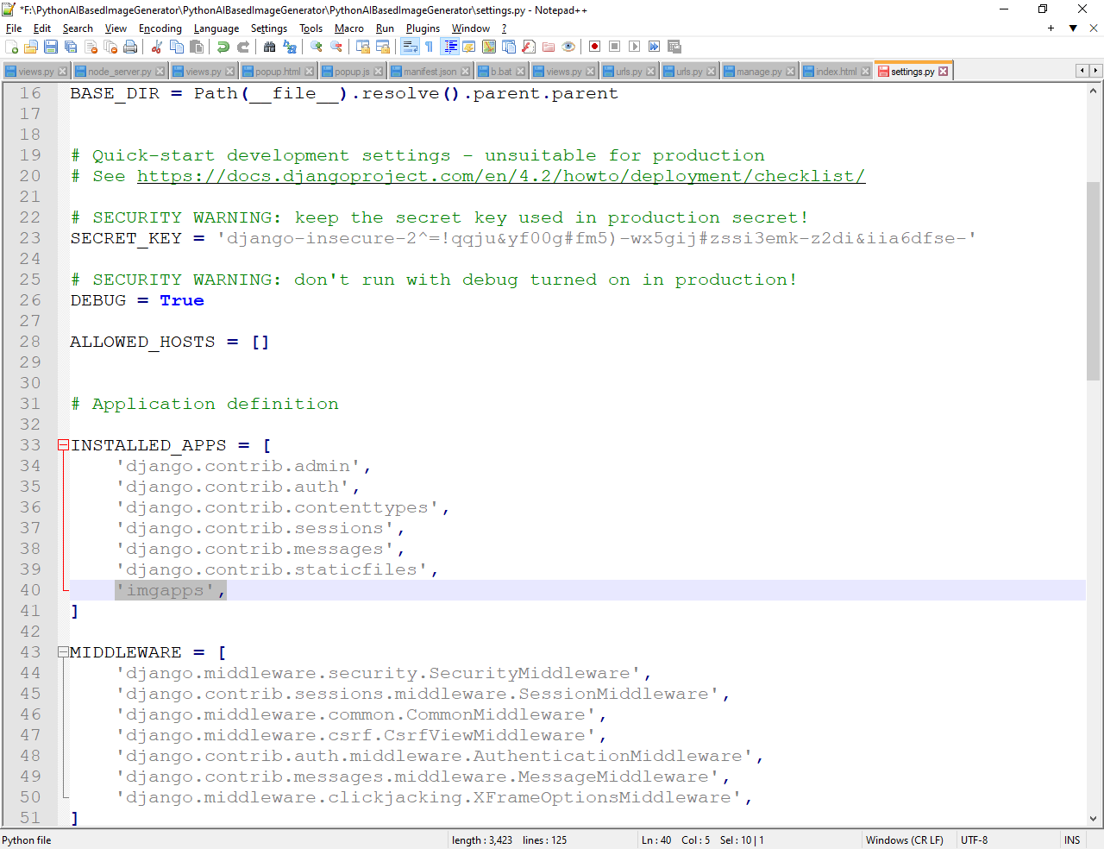

Then give the command

F:\PythonAIBasedImageGenerator\PythonAIBasedImageGenerator/>py manage.py migrate

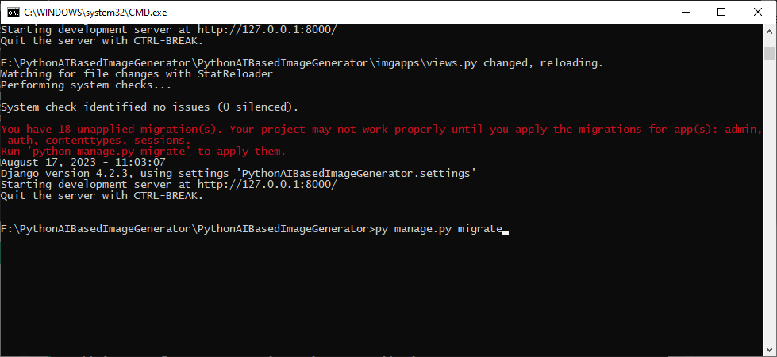

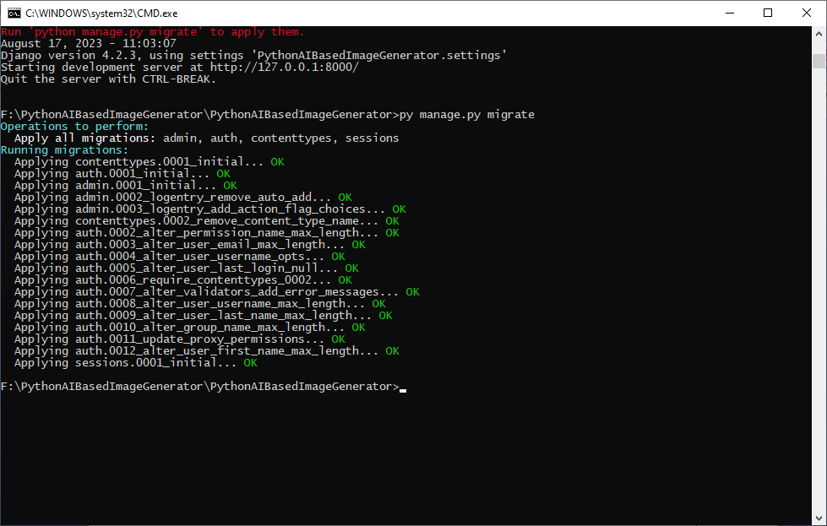

Start the server by

F:\PythonAIBasedImageGenerator\PythonAIBasedImageGenerator/>py manage.py runserver

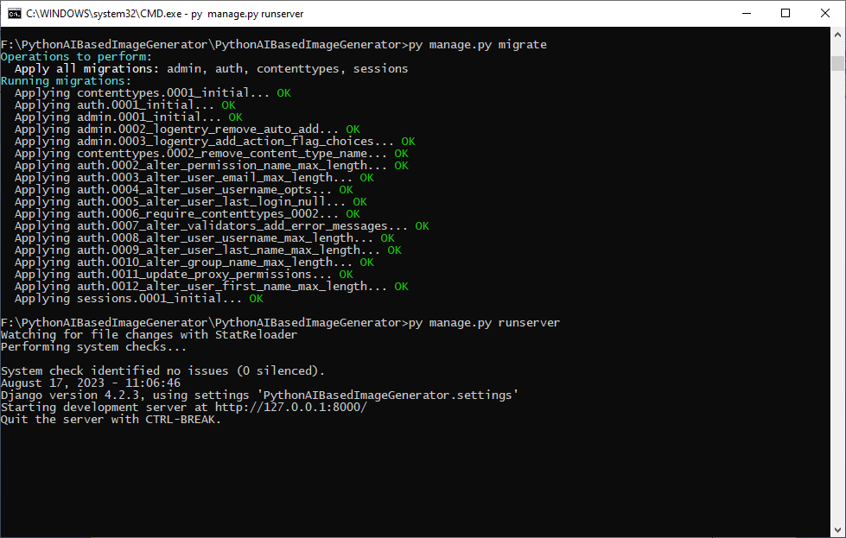

In the browse, enter: 127.0.0.1:8000/members

