



ASSIGNMENT 2

Learner’s name: Tran Gia Huy

ID: GCS190255

Class: GCS0805

Subject code: 1644

Assessor name: **NGUYEN XUAN SAM**

Assignment due: Assignment submitted:

Assessment 2

|  |  |
| --- | --- |
| Student Name/ID Number |  |
| **Unit Number and Title** | **14: Business Intelligence** |
| Academic Year | 2022 |
| Unit Tutor |  |
| **Assignment Title** | * Show your data set and describe basic information and statistical information related to the data set. * List and describe different type of charts for the variable in the data ser. * Apply data preprocessing steps (clean/scrub/filter, so on) for the data set (if have). Why do we need the steps? * Using tableau desktop to transform your dataset to a tableau dashboard. |
| **Issue Date** |  |
| Submission Date |  |
| IV Name & Date |  |

|  |
| --- |
| **Submission Format** |
| Part I: Project submission. This should be a zip / rar folder of your project, including all necessary files to run your project.  Part II: all students must present their writing report for the second assignment. This report should be written in a concise, formal business style using single spacing and font size 12. You are required to make use of headings, paragraphs and subsections as appropriate, and all work must be supported with research and referenced using the Harvard referencing system. Please also provide a bibliography using the Harvard referencing system.  Part III: an oral presentation and public speaking are not required for all students, but it is an important aspect for student who want to get high score for the 2nd assessment. Moreover, your presentation must explain the reasons why you select the tools and techniques to transform data to useful information in your topic. |

**ASSIGNMENT 2’S ANSWER**

P3 Determine, with examples, what business intelligence is and the tools and techniques associated with it.

1.General about BI

1.1.Definition about BI

The use of computing technology for the identification, discovery, and analysis of business data, such as sales revenue, products, costs, and incomes, is known as business intelligence (BI).

Through functions such as online analytical processing (OLAP), reporting, predictive analytics, data/text mining, benchmarking, and Business Performance Management, BI technologies provide current, historical, and predictive views of internally structured data for products and departments, allowing for more effective decision-making and strategic operational insights (BPM). Information management is the term used to describe these technologies and operations.

Modern BI emerged from 1960s-era decision support systems (DSS), which assisted with planning and decision-making using computer-aided models, leading to executive information systems (EIS), data warehouses (DW), OLAP, and BI. It wasn't until the late 1990s that business intelligence gained mainstream recognition.

Data is gathered via BI software applications from data warehouses or data marts, which are independent but linked BI architectural stack segments for data preparation and utilization.

Business intelligence is utilized for a variety of objectives, including:

* Performance evaluation and benchmarking against corporate objectives
* Predictive analytics, predictive modeling, business process modeling, and statistical analysis are all examples of quantitative analysis.
* Data visualization, EISs, and OLAP reporting from departmental/divisional and enterprise perspectives
* Internal and external collaboration programs and through electronic data interchange (EDI) and data sharing, external corporate entities can collaborate.
* Learning management and regulatory compliance can both benefit from the use of knowledge management programs to find and produce insights and experiences.

Specific strategies and procedures for deploying interactive information gathering techniques are included in BI, including:

* Choosing interview groups
* Organizational research
* Interviewee selection and preparation
* Making up interview questions
* Interview scheduling and sequencing

Competitive intelligence (CI), a subset of BI, is considered interchangeable. BI, like CI, is seen as a decision-making aid (DSS). CI monitors competitor information, whereas BI performs similar duties (and more) by focusing on internal corporate goods and departments. According to Merrill Lynch research, unstructured or semi-structured data makes up 85 percent of all company information and emails, news, reports, Web sites, presentations, phone conversation notes, image files, video files, and marketing information are all examples of electronic documents. The management of such data is seen as a major unsolved problem in the IT industry.

1.2. Examples about how BI works on business

The purpose of business intelligence is to gather and analyze data in order for a forward-thinking company like yours to make better business decisions. The following are a few of the current business intelligence trends:

* Increased investment in artificial intelligence (AI) technology
* a lot of data
* Data governance is becoming increasingly important.
* Self-service business intelligence applications and technologies are becoming more popular.
* Storytelling as a means of data interpretation
* Collaboration in the field of business intelligence
* Embedded business intelligence is a type of business intelligence that is built into a
* Analytics on the cloud

For example, a restaurant owner wants to know what his customers like, what kind of cuisine they like, and why they appreciate that particular cuisine. The restaurant then conducted a survey utilizing business intelligence tools, collecting comments from consumers on various cuisines. The restaurant owner studies the consumer mindset and learns useful insights about the cuisines supplied in the restaurant using prominent features in the software. He then crafts business tactics that are appealing as well as satisfying for his consumers and profitable for his firm, armed with knowledge about what cuisine is preferred by what people and what cuisine is requested most on what day, and so on.

2.BI techniques

Techniques in Business Intelligence

1. These are some BI techniques to consider:

* Forecasting probability and trends using predictive modeling.
* Using multiple statistical models, predict the value of a certain data item attribute.

1. Data mining for characterization and descriptive data:

* The term "characterization" refers to a short summary of a set of facts.
* Data and analysis are used to construct database models and forecast trends in descriptive data mining.

1. Used in cluster analysis and segmentation.
2. Identifying a link between Attributes through association and correlation.
3. Classification is the process of determining the kind of data item.
4. OLAP (Online Analytical Processing):

* Allows multidimensional data to be analyzed in multiple dimensions.

1. Pattern Analysis:

* Deviations and Patterns
* Transforming found facts into charts, graphs, histograms, and other visual techniques is known as model visualization.
* Clustering and outlier analysis involve dividing data into segments and grouping things that have similar properties together.

1. Prescriptive Analysis is the process of determining the optimum course of action in a specific situation. Optimization and simulation are included.

2.1. BI tools

BI tools are types of application software that collect and process large amounts of unstructured data from internal and external systems, such as books, journals, documents, health records, images, files, email, video, and other business sources. While not as flexible as business analytics tools, BI tools allow users to collect data and use queries to obtain information. These technologies also assist in the preparation of data for analysis so that reports, dashboards, and data visualizations can be created. Employees and management can use the data to improve decision making, increase operational efficiency, create new income prospects, identify market trends, report genuine KPIs, and find new business opportunities.

Business intelligence tools can combine a wide range of data analysis applications, including ad hoc analysis and querying, enterprise reporting, online analytical processing (OLAP), mobile BI, real-time BI, operational BI, cloud and software as a service BI, open-source BI, collaborative BI, and location intelligence. They are typically used for more straightforward querying and reporting of business data. It can also contain tools for creating BI dashboards and performance scorecards that present business measurements and KPIs in easy-to-understand visuals, as well as data visualization software for making charts.

P4 Design a business intelligence tool, application or interface that can perform a specific task to support problem-solving or decision-making at an advanced level.

3.Dataset(s)

OLAP (On-line analytical processing): This is a term that describes how business users can slice and dice data using sophisticated tools that enable navigation of dimensions such as time and hierarchy. OLAP, or Online Analytical Processing, provides multidimensional, summarized views of company data and is used for corporate reporting, analysis, modeling, and planning. Data warehouses or data marts developed for advanced enterprise intelligence systems can benefit from OLAP techniques and technologies. These systems handle the queries needed to spot trends and analyze key parameters. To keep management informed about the health of their firm, reporting software creates aggregated views of data.

Here are some examples of datasets:

* Data Planet (SAGE) EZ: Standardized and structured statistical data repository
* Economic Data Series prepared for R from the Federal Reserve Bank of St. Louis. Select a dataset from the list and click Export, then save as an XSL file.
* Experiments in Agriculture Inside R has a dataset prepared in R that you can use.
* Gapminder Datagraphic Information is accessible in Excel, with a visual datagraphic to go along with it.
* Amazon Web Services Massive volumes of data in the terabyte range in public data sets
* Data.world "A non-profit organization dedicated to finding, indexing, and working on datasets from all over the internet." To download and examine the data.
* UC Irvine Machine Learning Repository search through a variety of datasets related to machine learning.
* The SNAP Stanford Large Network Dataset Collection includes datasets for social media, Wikipedia networks, Amazon networks, online communities, and online reviews, among other topics.

3.1. Pre-process steps on dataset(s)

The "house price.csv" dataset contains information on whether or not a user purchased the goods. Id, date, price, bedrooms, bathrooms, sqft living, sqft lot, floors, waterfront, view, and so on are some of the fields in the dataset.

Step 1: Get the data ready to work with.

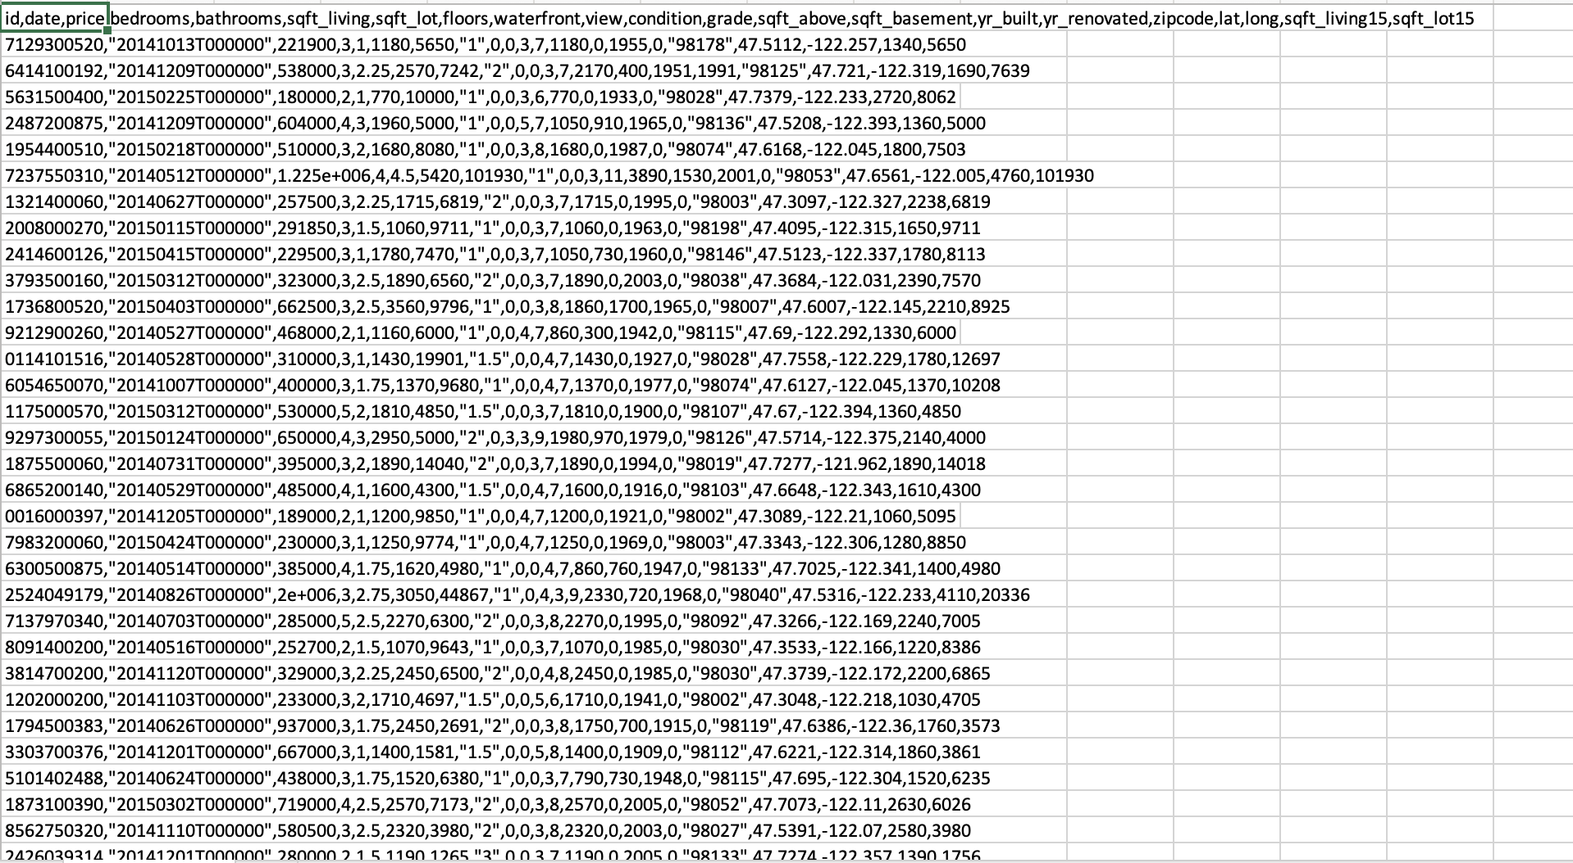

Step 2: Open Tableau and import the data.

Tableau's interface is divided into three parts, as seen in Figure. Connect is the first part, and it involves uploading data from existing files. Tableau allows you to import data from a number of different sources, including Excel, Text, Json, and others. Part 2 is Tableau's main interface, where you'll find product and data information, as well as visuals from my project. The third section, Discover, contains tutorials on how to construct a data analytics solution as well as how and where to acquire data from other sources. The UI for creating a new Workbook in Tableau looks like this: 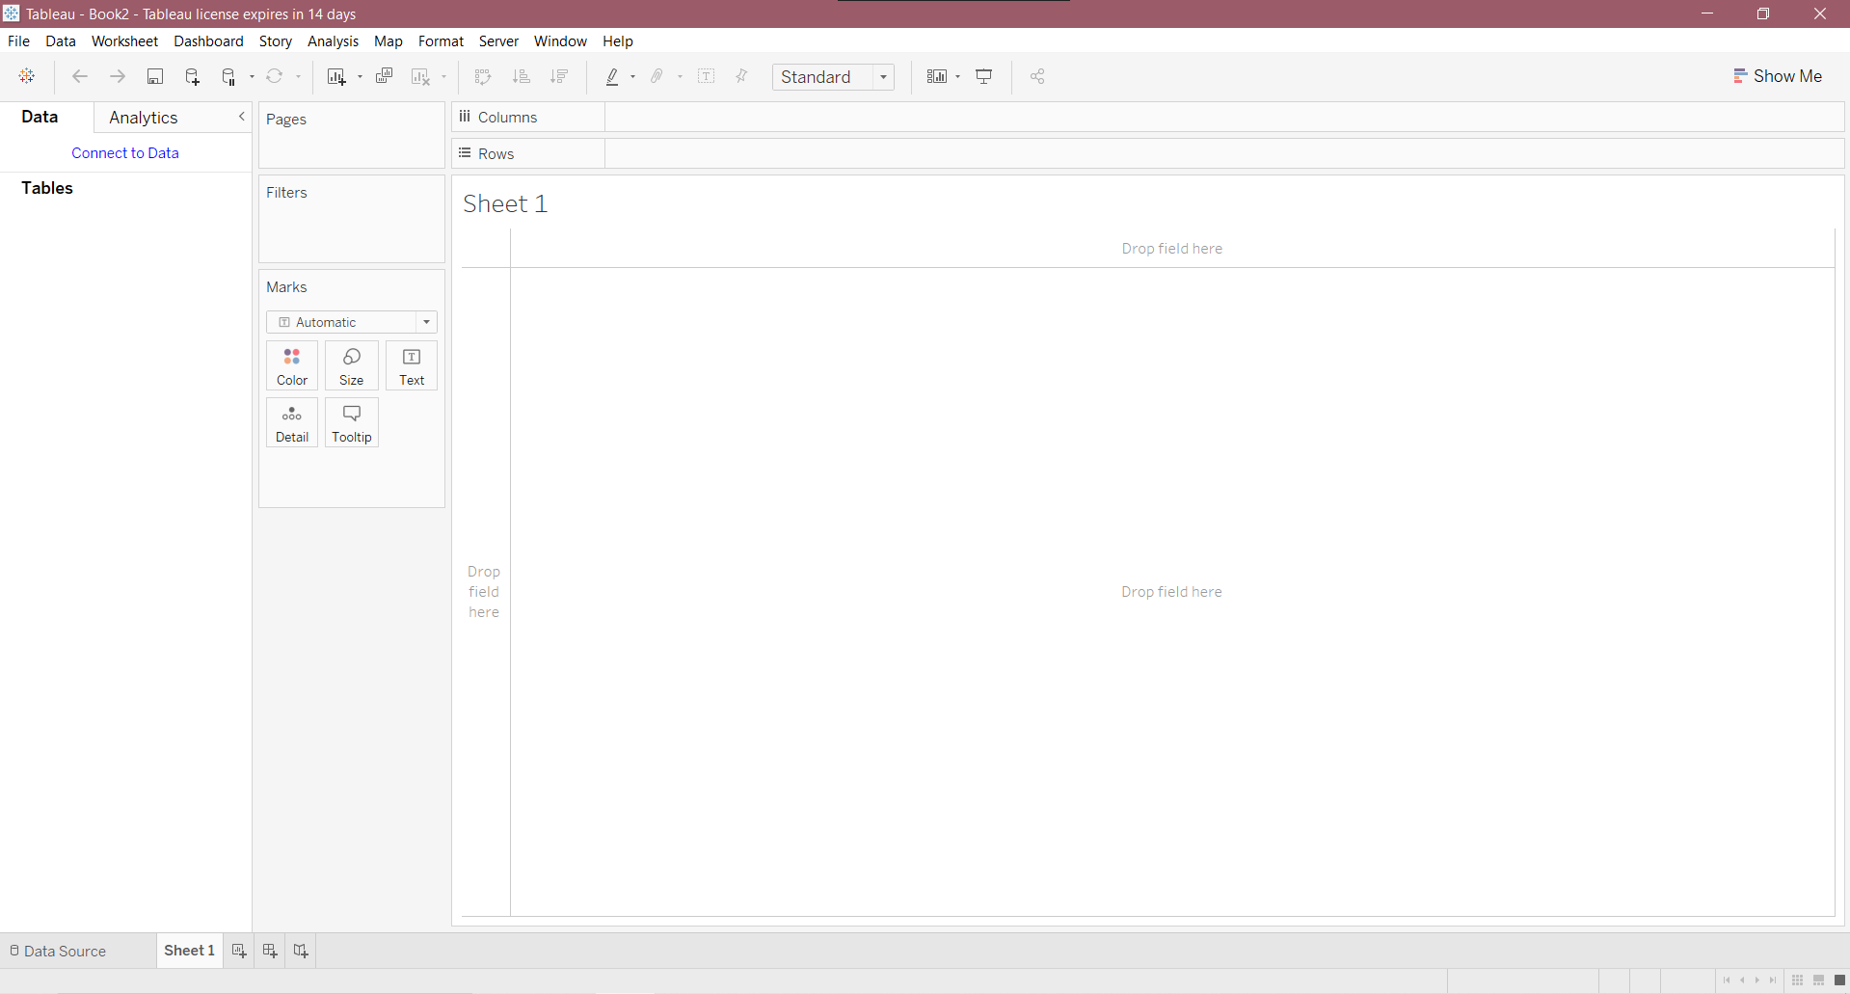

For example, we can utilize the table graph to quickly see all of the housing prices as well as the qualities of each one. When working with Excel data, the user can open Tableau and choose Microsoft Excel from the file drop-down option. Because the dataset was saved in a csv file in my case, I imported it using a TXT file. Select the type of data you want to include in the dataset next. The csv file's data will be imported into the dataset and displayed on the screen.

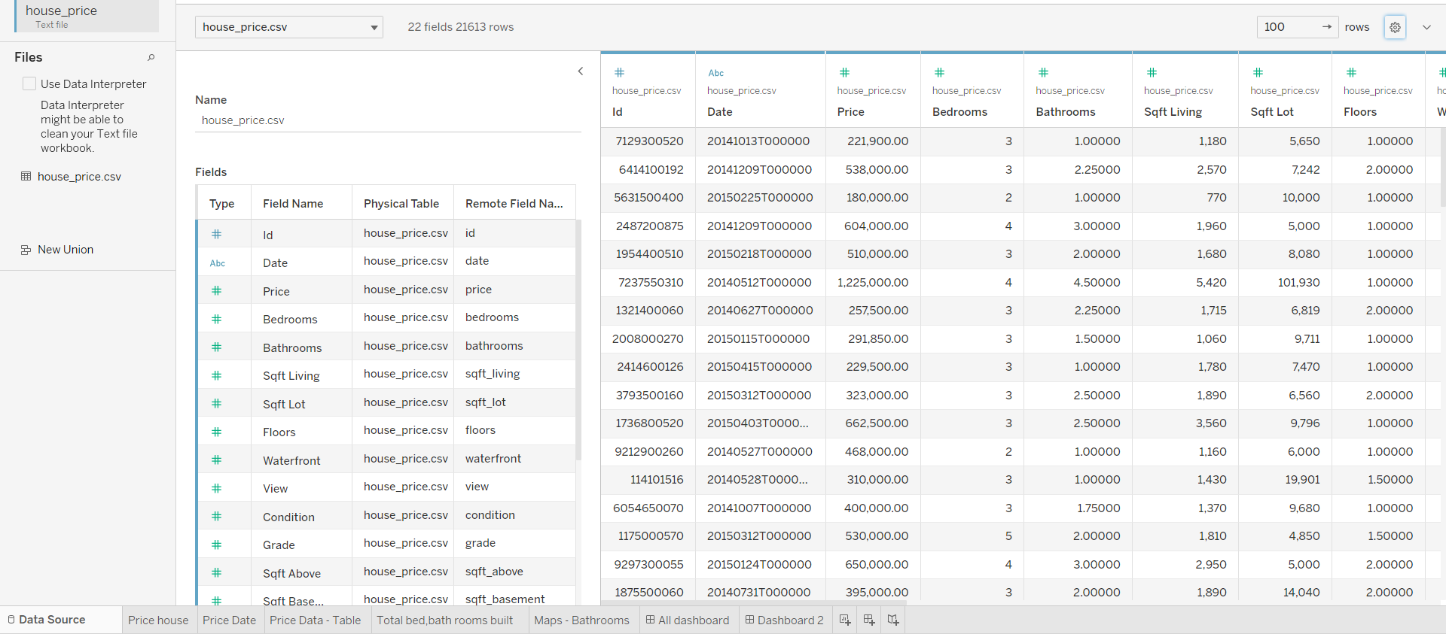

Step 3: Make the graph ( line, table, etc.) to analyse the dataset and give summary for this project

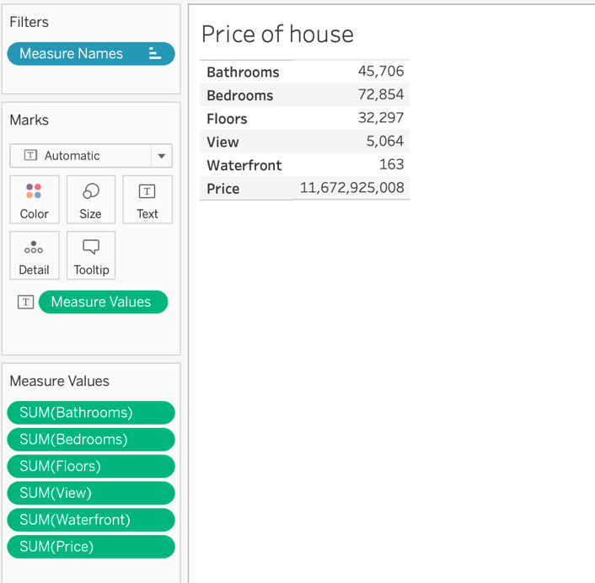

And useful line graph is to show how the price of a house changes over time, whether it increases or decreases.

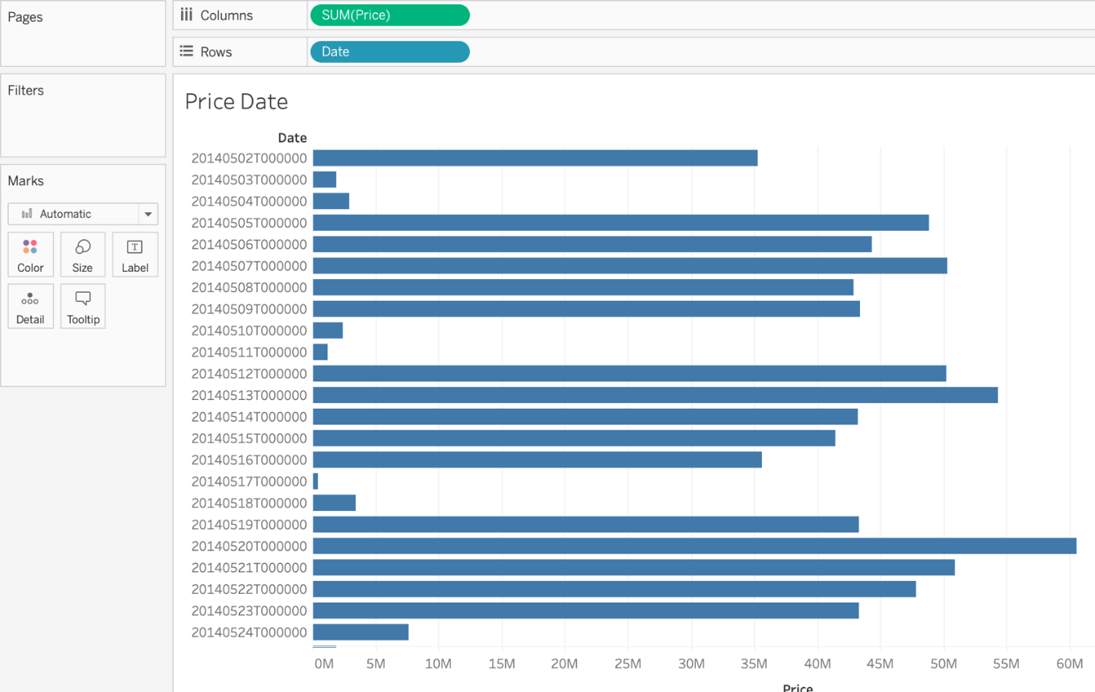

Organizations can utilize business intelligence dashboards to make complex data comprehensible and approachable for non-technical users. Business users can design and see their own dashboards, with content created by IT as a starting point. Non-technical individuals can engage with data via self-service BI. Chipotle utilizes dashboards to improve their analytical procedures and create a consistent view of its restaurant locations. Data visualizations based on dashboards can assist business users in identifying trends. Positive trends can be detected, bad trends can be isolated, and predicted insights can be provided. When Charles Schwab enabled thousands of bank branches to construct their own performance dashboards, they were able to track consumer satisfaction with their products without having to sift through pages of spreadsheets.

Next, I opted to use dual lines to investigate how many total bedrooms and baths were built throughout time, so you can see two lines of each above on the graph for simple study. This one tells us that the price of our project fluctuates based on the month. The maximum and lowest prices of our house can be seen in this line graph.

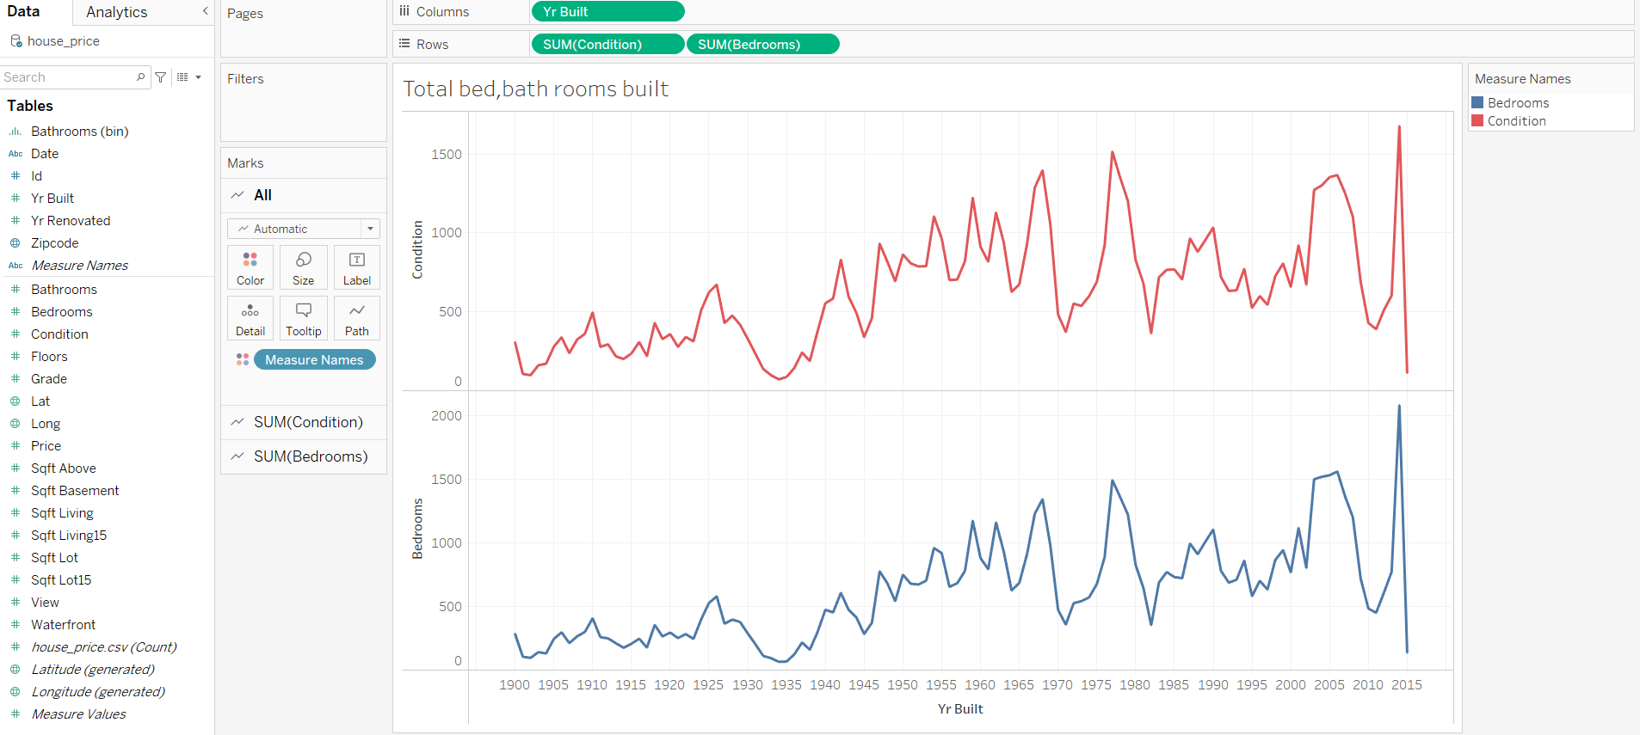

We might also use a map with two fields, Zip code and Bedrooms, to indicate which countries or places throughout the world have a robust housing market. A map of the area will appear based on the Zip code, with a circle representing the number of bedrooms that have been sold.

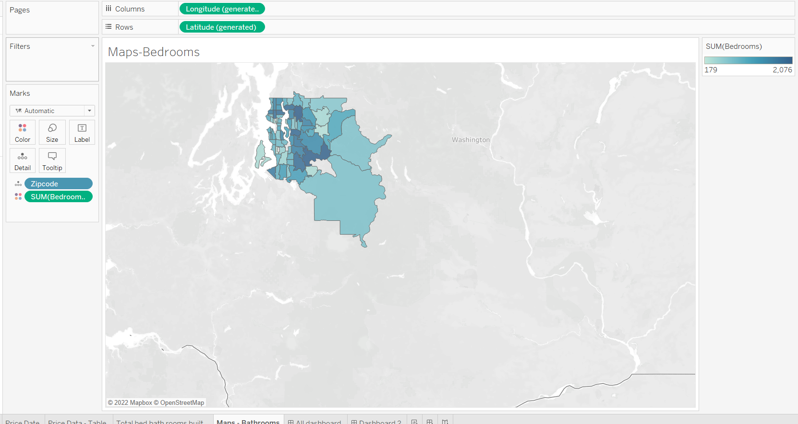

The graphic above depicts the design of the planned BI Tool that Courts would use to assess the Price and Date of their assets every year. This would be utilized to gain a better understanding of how houses are built in relation to the amount of money made when they sell them.

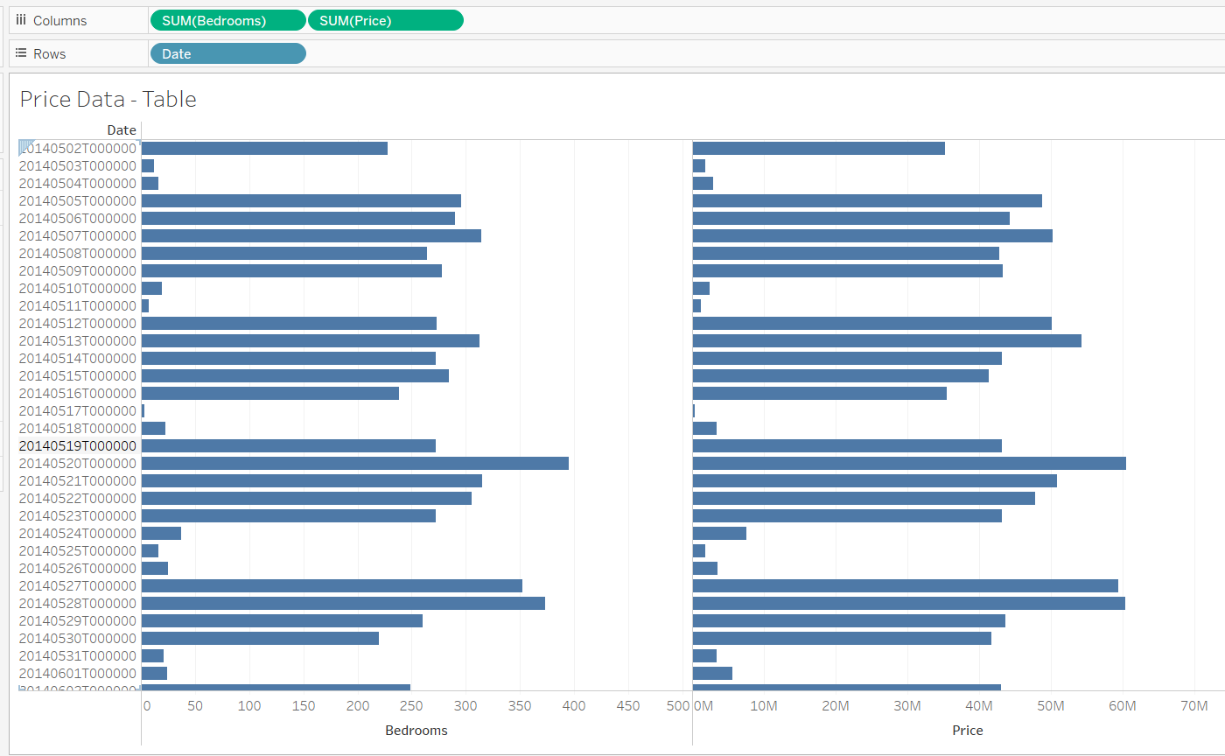

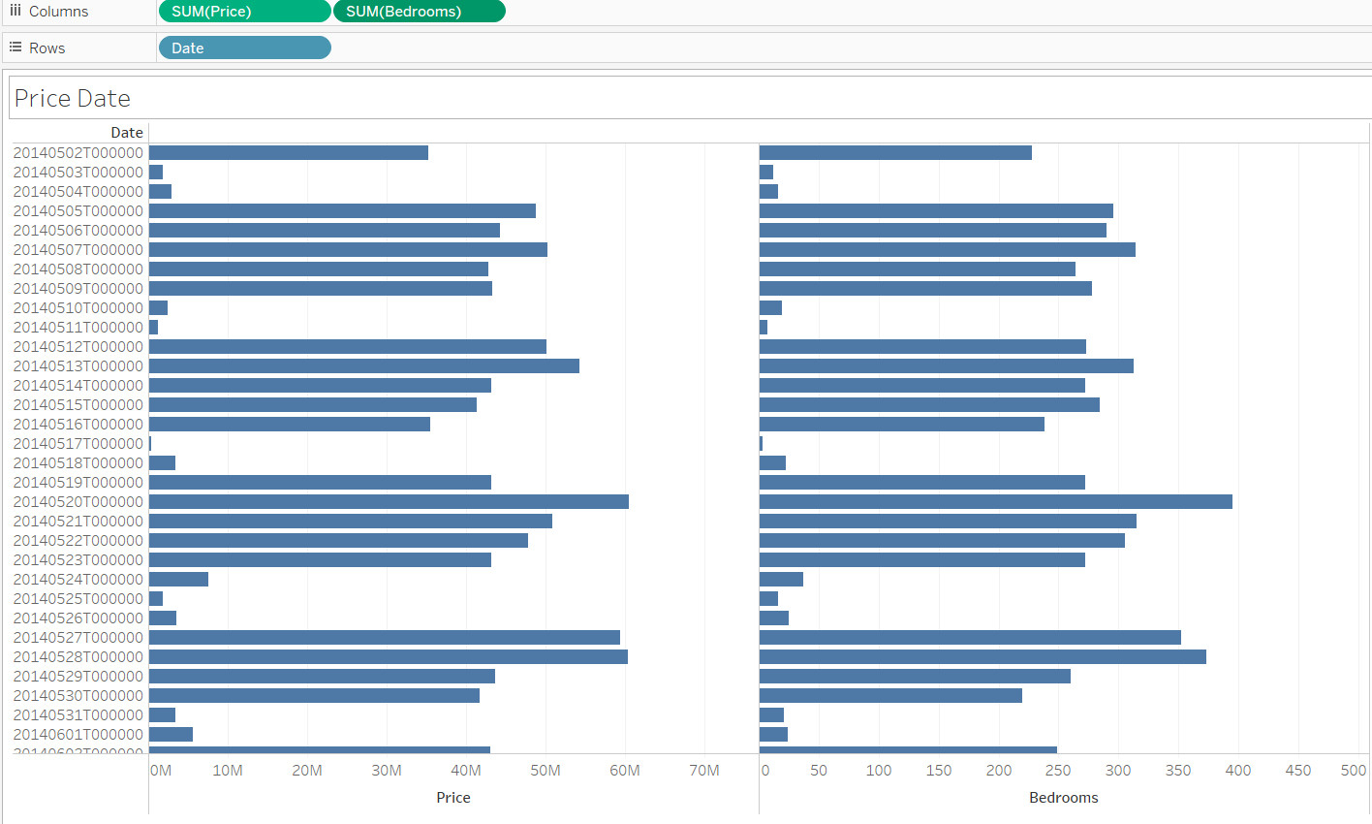

To see the total number of rooms/features as well as their total cost, go to House Price - Table.

Bedrooms / Maps - Maps: Determine which areas have a strong market for previously sold houses.

Total number of bed/bathroom rooms built — two lines: This one divides the room into two lines to make it easy to choose which is the most important to the people.

Price Data - Column Graph: See the annual price of a house and the profit from selling a house.

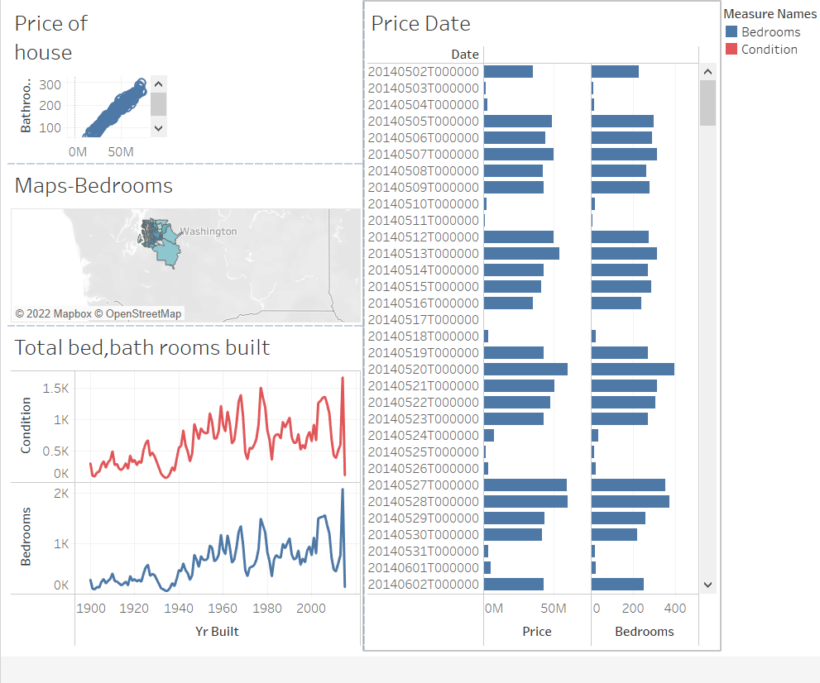

3.2. Dashboard interaction (Result / Conclusion / Suggestion)

The graphics above demonstrate how the slicer and period were combined with certain filters to provide data with a wide range of dates, times, and branches.

The Business Intelligence Tool's Dash Boards are seen in the images above. The four analyses indicated previously are included in this tool: Sales vs. Cost, Most Purchased House's rooms, Number of Rooms, and Yearly House Price. These evaluations will now be combined to form a single business intelligence tool that will aid courts by visually presenting a variety of parameters that are relevant to them.

In addition to a range of analysis, this tool would offer two filters for Transaction Date and Branch.

To see the total number of rooms/features as well as their total cost, go to House Price - Table.

Bathrooms / Maps - Maps: Determine which areas have a strong market for previously sold houses.

Total number of bed/bathroom rooms built — two lines: This one divides the room into two lines to make it easy to choose which is the most important to the people.

P5 Discuss how business intelligence tools can contribute to effective decision-making.

* 1. **The important of BI to the business**

1. Make decisions based on the information you have.

Data trends are shown in business intelligence. One of the biggest mistakes a firm can do is to make decisions based on its assumptions rather than the facts. Business intelligence gives companies the information they need to make critical decisions like which items to promote more and which to drop. All aspects of a company's operations, such as finances, manufacturing, and customer satisfaction, can be tracked with business data.

1. Obtain Data Access More Effortlessly

For modern firms, having quick access to up-to-date information is critical. It takes around two days on average to acquire an IT-generated report. Modern business intelligence technology, on the other hand, enables firms to obtain correct data at the touch of a button at any time. When time is of the essence and an important decision must be taken quickly, this can be useful. Faster data access can have an impact on other areas over time, such as the sales team's productivity. As a result, revenue may increase and employees may be able to gain new skills.

1. Transform data into action

Organizations can use business intelligence technologies to improve decision-making and identify the best tactics for predicting future market trends and patterns. Business intelligence solutions can be used to evaluate data acquired from websites and other sources and uncover trends that can be employed in your own business strategy. Business intelligence can also assist you in better understanding your company's specific operations. You can use this data to uncover new chances for a better future. While BI won't tell you exactly what to do, it can provide you with the data and insight you need to make these decisions.

1. Improve your sales and negotiating skills.

One of your most precious assets is your sales crew. Even the strongest sales team, however, can struggle to perform without the proper resources. Business intelligence technology may be a great tool for a sales team since it offers staff with up-to-date information on current sales patterns, consumer preferences, product upgrades, and other data that can make or break a transaction. This information is also useful when bargaining with your suppliers and future vendors. You might potentially save a lot of money if you have access to current trends and other important information.

1. Marketing Campaigns' Effectiveness is Measurable

Business intelligence is assisting the sales staff in bettering their negotiations. You invest time, money, and effort into your company's marketing activities. Of course, you'd like them to pay you back. However, it is not always evident whether a marketing campaign is doing as expected, particularly when utilizing traditional marketing tactics. By giving real-time insight into how customers are reacting, business intelligence technology provides firms with the resources they need to efficiently create and monitor the performance of marketing and promotional initiatives. Stop running efforts that aren't providing ROI right away and concentrate on the ones that are.

1. Customer Behavior: A Better Understanding

To continue to grow in a healthy manner, a company must address the needs of its customers. Unfortunately, figuring out exactly what your target customer wants isn't always simple. Organizations can use business intelligence technologies to get the information they need to better understand their consumers' behaviour, such as buying habits and trends. Your organization can use this information to create products and services that are tailored to their demands and needs. Customer happiness and brand awareness and loyalty may improve as a result of this. In your chosen industry, you can also obtain a competitive advantage.

P6 Explore the legal issues involved in the secure exploitation of business intelligence tools

1. **Data kind which is collected**