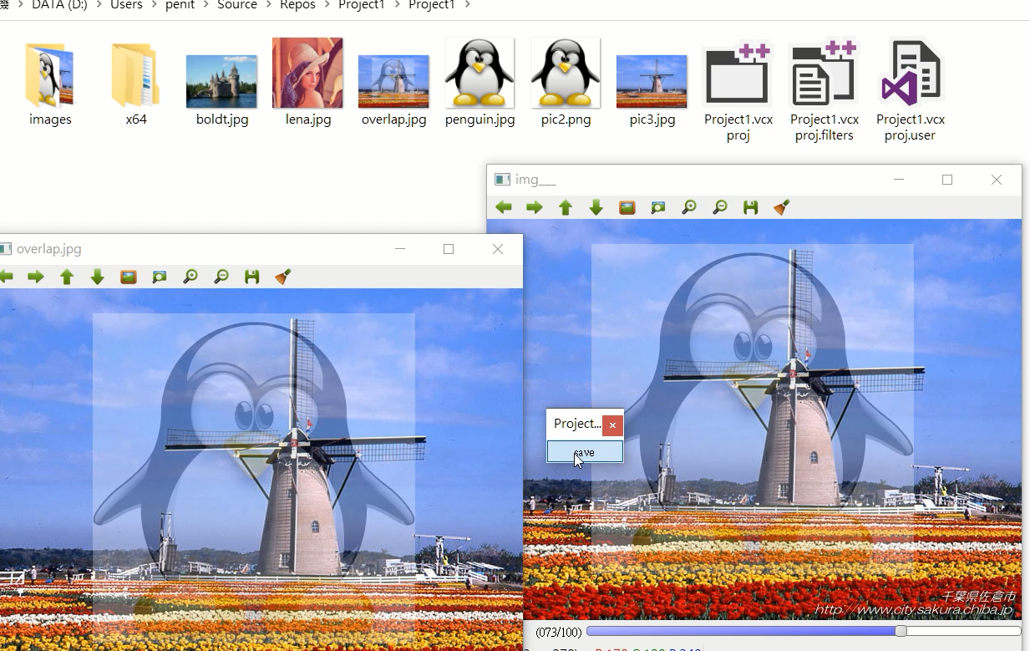

|  |
| --- |
| #include <cstdio>  #include <opencv2/opencv.hpp>  using namespace cv;  int sliderValue;  bool applysave = false;  Mat small, bigbackground, imgROI, imgROI2, temp, ans;  void applyFilters();  void saveCallback(int state, void* userData);  void on_trackbar(int, void*);  int main() {  sliderValue = 0;  int sliderMaxValue = 100;  bigbackground = imread("pic3.jpg", -1);  small = imread("penguin.jpg", -1);  imgROI = bigbackground(Rect(125, 30, small.cols, small.rows));  imshow("img___", bigbackground);  createTrackbar("Ratio", "img___", &sliderValue, sliderMaxValue, on_trackbar);  on_trackbar(sliderValue, 0);    createButton("save", saveCallback, NULL, QT_PUSH_BUTTON, 0);      waitKey(0);  return 0;  }  void applyFilters() {  if (applysave) {  imshow("overlap.jpg", ans);  imwrite("overlap.jpg", ans);  }  }  void saveCallback(int state, void* userData)  {  applysave = !applysave;  applyFilters();  }  void on_trackbar(int, void*) {  double alpha = (double)sliderValue / 100.0;  double beta = (1.0 - alpha);  addWeighted(small, beta, imgROI, alpha, 0, imgROI2);  cv::Mat temp = imgROI2.clone();//temp 是 ok 的感興趣圖  cv::Mat ans_center_roi = imgROI2.clone();//ans_center_roi 是 ok 的感興趣圖  ans = bigbackground.clone();  temp = ans(Rect(125, 30, small.cols, small.rows));  ans_center_roi.copyTo(temp);  imshow("img___", ans);  } |