**End-to-End Linear Regression Modelling**

**Simple Linear Regression**

One of the most interesting and common regression technique is simple linear regression. In this, we predict the outcome of a dependent variable based on the independent variables, the relationship between the variables is linear. Hence, the word linear regression.

**Objective** - Objective of the project is to build a prediction model for Salary Hike from the dataset.

**Use Case – Implementing Linear Regression**

The process takes place in the following steps:

1. Loading the Data
2. Exploring the Data
3. Assigning the Values to Variables
4. Generate The Model
5. Model Evaluation
6. Checking The accuracy Of the Model

Let us get into the details of each of the steps to implement linear regression.

1. **Loading the Data**

***import*** *pandas as* ***pd***

*data=pd.read_csv("E:/Top Mentor/3.Class 18.11.23/batch89assignmentsandsolutions/Project - 1&2_ Simple_Reg/* *Salary_Data.csv")*

Checking the data.

*data.head(5)*

Output:

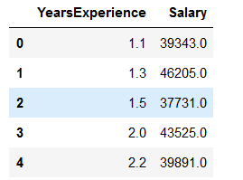

We can see that we have two variables in the data, both variable are numerical data. In this dataset, we get the variable ‘Years Experience’ as our dependent variable, and ‘Salary’ is independent variables.

1. **Exploring the Data**

*print("Shape of the data",data.shape)*

*data.describe()*

Output:

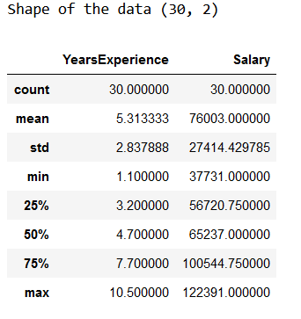

So we have 30 rows and 2 variables or features which is the shape of the data and you can also see the distribution of the numerical variables through the basic statistics measures.

1. **Assigning the Values to Variables**

*x=data['* *YearsExperience'].values.reshape(-1,1)*

*y=data['* *Salary'].values.reshape(-1,1)*

Output:

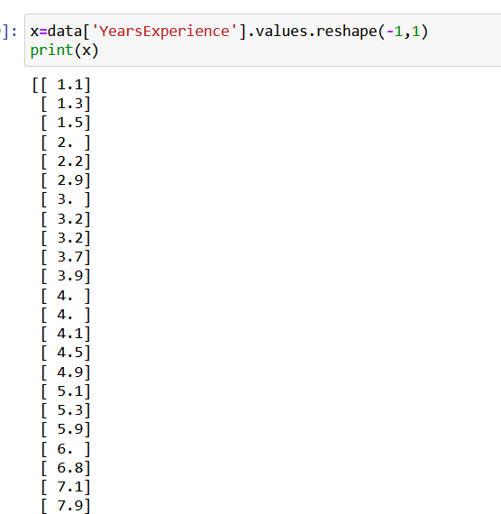

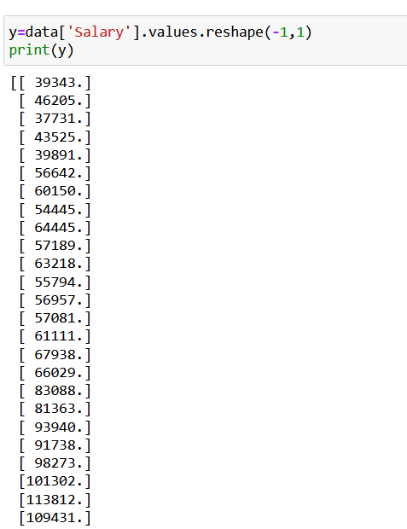

1. **Generate The Model**

***from*** *sklearn.linear_model* ***import*** *LinearRegression*

*model=LinearRegression()*

*model.fit(x,y)*

*print('Model is loaded')*

1. **Model Evaluation**

To evaluate our model, we must make some predictions on the data using our model to evaluate our model.

***import*** *matplotlib.pyplot* ***as*** *plt*

*plt.figure(figsize=(5,3))*

*plt.scatter(x,y,color='blue')*

*plt.plot(x,model.predict(x),color='red')*

Output:

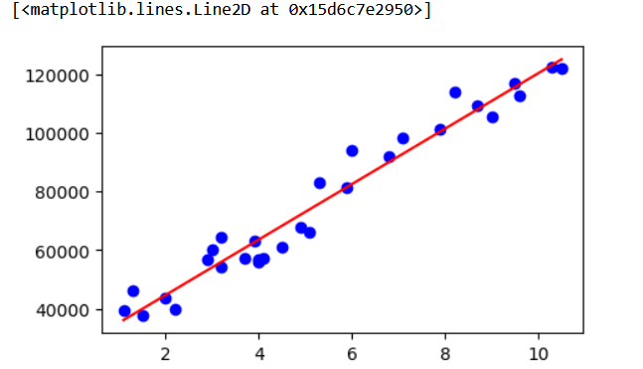

1. **Checking The accuracy Of the Model**

***from*** *sklearn.metrics* ***import*** *r2_score*

*r2_score(y,model.predict(x))*

Output :

*0.9569566641435086*

This brings us to the end of the Project where we have built a model using Linear Regression.