**Circuit Specification**

**Small Volume Ink System**

**Contents**

**1. Heaters**

**2. Temperature Sensors**

**3. Pumps**

**4. Pressure Sensor**

**5. Valves**

**6. Level Sensor**

**1. Heaters**

The circuit receives a digital input from the DAQ (DAQ_Dout_A). This signal is used to switch two transistors, which allows the inputs of the first XOR gate (U2A) to float to 5V. However since a capacitor is attached to input 2 of the XOR gate, the output of the XOR gate will change from low to high for a period of time equal to the charge time of the capacitor. This momentary high output from the XOR(U2A) gate is then inverted into a momentary low with the second XOR gate (U2B). This low signal causes the transistor Q3 to cut off grounding, leaving a simple voltage divider circuit (20k & 15k) to turn on the parallel heaters through BUZ71A mosfet (Q4).

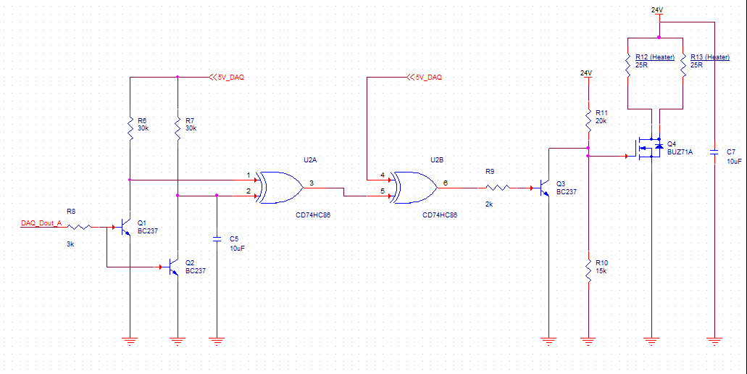

**2. Temperature Sensor**

The circuit uses 5V from the DAQ (5V_DAQ), put through a Wheatstone bridge circuit to convert a change in resistance to voltage. R1, R2, R3 are all fixed resistances and therefore the observed change in voltage difference is purely from the PT1000 temperature sensor (RT1). The voltage signal is then amplified with a LM358 operational amplifier (gain of -91k/10k7 = approx. 9).

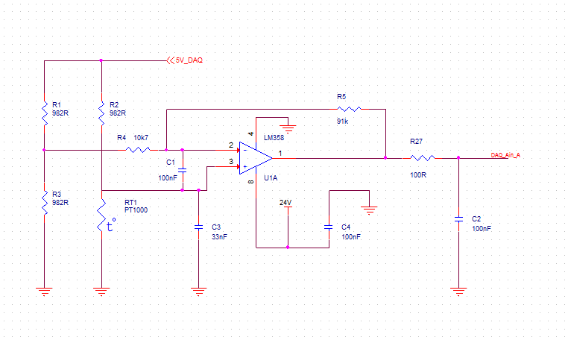

A small resistor of 100 ohms is needed at the output to stabilize the capacitive load.

**3. Pumps**

The circuit for the NF30 diaphragm pumps is incredibly simplistic, the pumps are powered from a 24V supply with an analogue voltage control signal to vary pump speed.

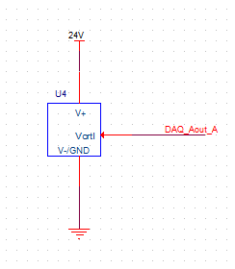

**4. Pressure Sensors**

The JUMO dTRANS p30 pressure transmitter is powered with 24V, with the output calibrated to acceptable voltage levels (390R + 240R) and read by an analog in DAQ pin (DAQ_Ain_B).

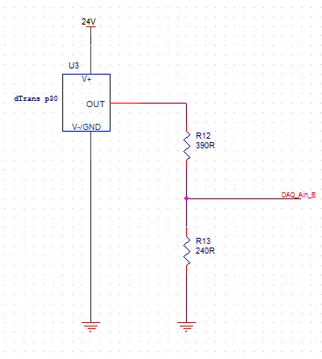

**5. Valves**

The circuit takes a digital input signal from the DAQ (DAQ_Dout_B), inverts the signal (active low) and inputs to a DRV101 solenoid driver. The pwm and delay of the solenoid driver can also be set with a predetermined value of resistor and capacitor at pins 2 and 3 respectively. The output of the solenoid driver is connected inline with the valve and 24V supply.

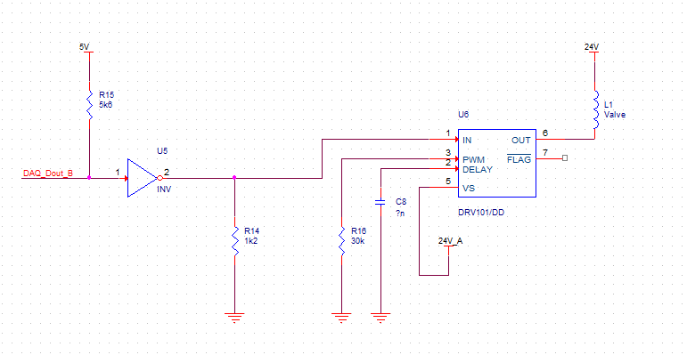

**6. Level Sensors**

The level sensor capacitance is measured in the circuit below with considerations to the capacitance present in length of wiring used. Comparators are used to subtract a ‘dummy wire’ signal of appropriate length from the level sensor signal. The comparators are referenced against a voltage divider value of approx. 2.4V. The comparator connected to the level sensor has the 2.4V reference signal at the positive pin, whereas the comparator connected to the dummy wire signal has the 2.4V reference signal at the negative pin. This means that the signal observed at the output node of both comparators, is driven high only for the period of time of: (level sensor charge time) – (dummy wire charge time). This pwm voltage signal (Vout) is then read by an analog in DAQ pin.

