
Document Reference No.:
Released
Preliminary
Draft
Copy of

R1
Level Sensor Circuit Optimisation

Distribution: | 1.  2.  3.

Issue | Date | Author | Approved | Pages
A | 13Jun05 | C.Hall | ---- | 11

File: Level_Optimisation.doc
Format: Word 2000
Copyright © 1995-2005, Domino UK Limited. The contents of this document are confidential and may not be disclosed to any third party without prior written permission.

Issue | Changes
A | Original.
Contents
1. Introduction 4
2. A-Series 4
2.1. Circuit Diagram 4
2.2. Circuit Description 5
2.3. Capacitance Model 5
2.4. Simulation Results 6
3. R1 8
3.1. Circuit Diagram 8
3.2. Circuit Description 8
3.3. Capacitance Model 9
3.4. Simulation Results 9
4. Optimisation Procedure 11
5. Conclusion 11

Introduction
R1 Hardware Integration Testing has revealed that the capacitive level sensing circuitry is not performing as expected.
Modifications have been made to the Backplane to aid manufacturing and it is believed that this has had detrimental effect on level sensor circuit performance. The modification in question moved the ink system ribbon cable connector to a more practical position but also had the negative side effect of increasing the capacitance seen by the level sensing circuit. The proposed solution to this is to reduce track capacitance by removing ground planes in the area of the level sensing tracks which unfortunately requires a re-spin of the backplane PCB with a potential delay of product launch.
There are two recent pieces of work that indicate that the Backplane capacitance is not the root cause of the problem. The first is a report by Matt Smith that indicates that increasing the value of the current limiting resistors improves performance, which in theory is the same as increasing the capacitance. The second is a piece of ongoing work being conducted by Anthony Davidson-Smith where he has commented that there appears to be a capacitance threshold below which the sensing circuit suddenly stops working.

A-Series
A-Series uses virtually identical capacitive level sensing circuitry to that used in R1 so it makes sense to have a look at how this works first.

Circuit Diagram
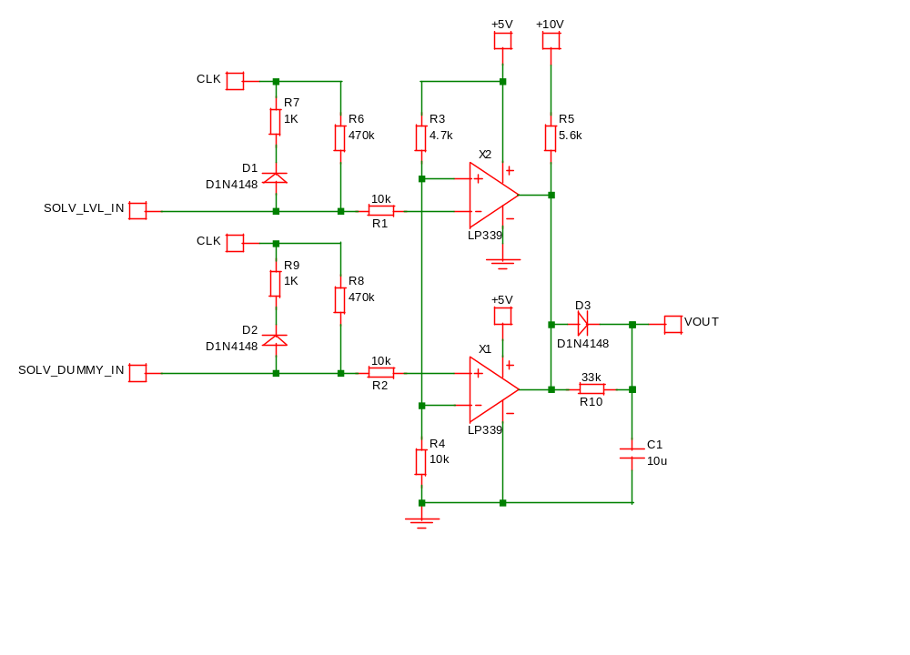

Circuit Description
The capacitor measurement circuit has two inputs these are, ‘SOLV_LVL_IN’ and ‘SOLV_DUMMY_IN’. The ‘SOLV_DUMMY_IN’ input simply connects to a piece of cable in the wiring loom and is used to measure the cabling capacitance between the level sensing circuit and the level sensor, it does not have a physical connection to the level sensor. The ‘SOLV_LVL_IN’ input connects through a similar cable but in this case also connects to the level sensor. The circuit then subtracts SOLV_DUMMY_IN from SOLV_LVL_IN to, in theory, leave a measure of level sensor capacitance.
The cable and sensor capacitance charging and discharging times are controlled by the ‘CLK’ signal, this is a 0 to 5V 8kHz pulse train with a mark to space ratio of 3:1. Charge current is limited by R6 for ‘SOLV_LVL_IN’ and R8 for ‘SOLV_DUMMY_IN’, while discharge current is limited by R7 and R9. The clock frequency and current limiting resistors are chosen to give the best sensitivity for the capacitance range to be measured.
R1 and R2 serve no other purpose than to provide input protection for the comparator (X1/X2). The comparator threshold voltage is set to approximately 0.68Vclk by R3 and R4 where Vclk is the peak voltage seen on the ‘CLK’ signal. This ensures that the capacitor charging voltage is still rapidly changing and well away from the plateau, therefore ensuring a reasonably wide comparator output pulse while still maintaining good noise immunity.
Comparators X1 and X2 have open collector outputs and are connected in such a way as to perform the subtraction of SOLV_DUMMY_IN from SOLV_LVL_IN. The resulting output pulse width is therefore proportional to the capacitance measured by the level sensor.
R5, R10, D3 and C1 simply average the pulses coming from the comparator outputs to give an output voltage that is proportional to the sensor capacitance. The value of R5 is chosen to give the desired output voltage for the maximum level sensor capacitance.

Capacitance Model
The capacitance seen by the capacitive level sensing circuit is rather more complex than simply the capacitance presented by the level sensor and can be represented by the following elements. Note: Cable resistance and inductance will be ignored, as it plays no significant role in circuit operation.
- Print Engine Controller to Ink System Interface ribbon cable = 20pF.
- Ink System Interface tracking and filtering = 60pF and 39K ohm in series.
- Capacitive Level Sensor cabling = 70pF.
- Capacitive Level Sensor fluid level dependent capacitance = 5pf to 20pF.
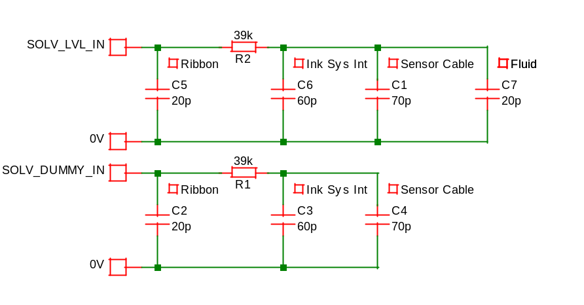

Simulation Results
Using the model presented in the previous section it is know possible to simulate circuit performance. This will be used later as a comparison for the performance of the R1 circuit. The comparator input signals can be seen below for a full reservoir of fluid, the blue trace is the comparator threshold, the green trace SOLV_DUMMY_IN and the red is SOLV_LVL_IN.
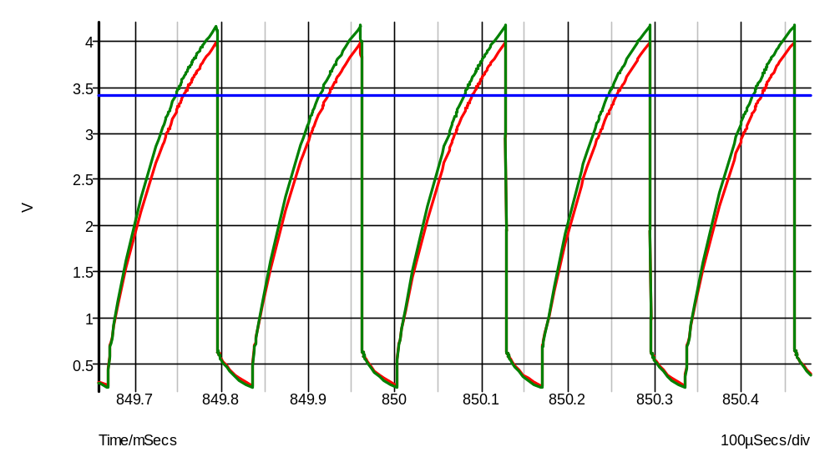
The following graph shows the same results but with the comparator output pulse (olive) together with the final dc output voltage. The comparator output pulses are well defined with a pulse width of around 11uS.
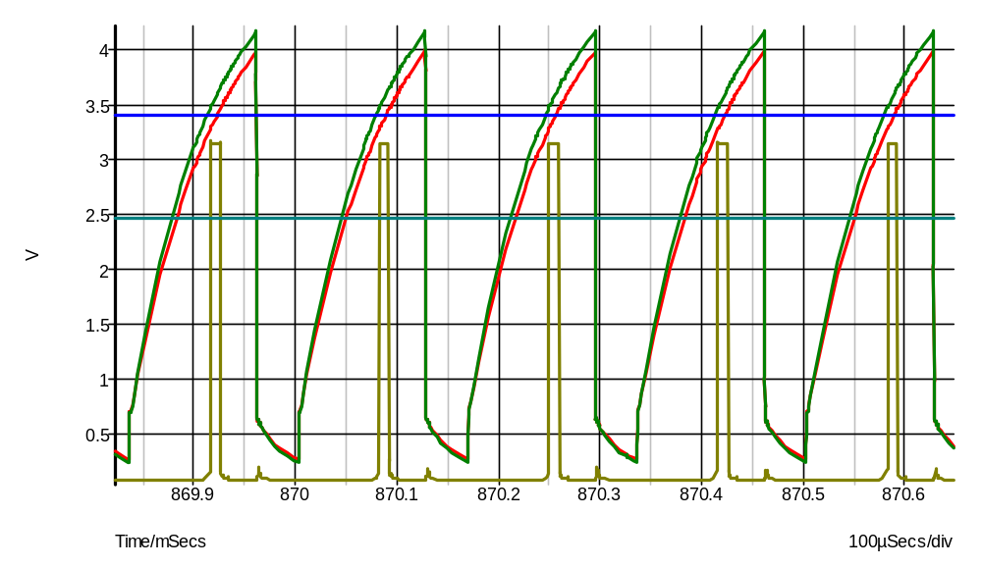

Here we have the comparator input signals for reservoir low. Although not shown here the comparator output pulse width is around 2.5uS.
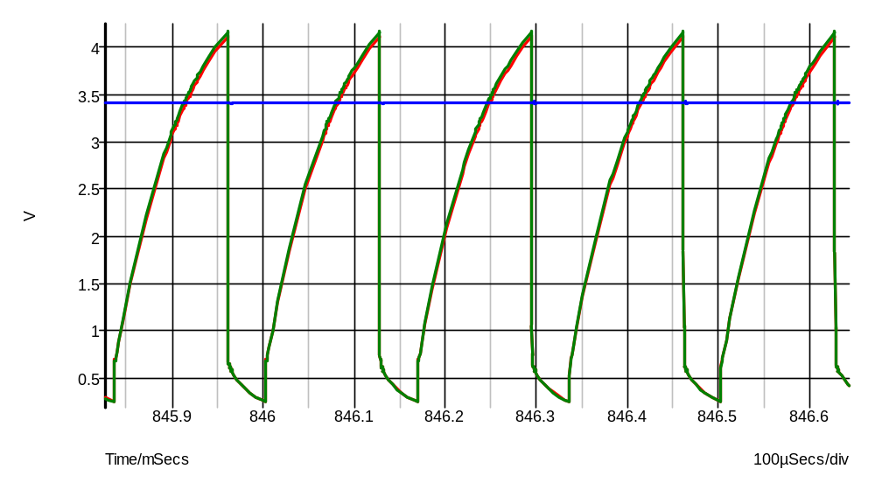
From these results it can be seen the A-Series circuit will perform to an acceptable level for all fluid level conditions.

R1

Circuit Diagram
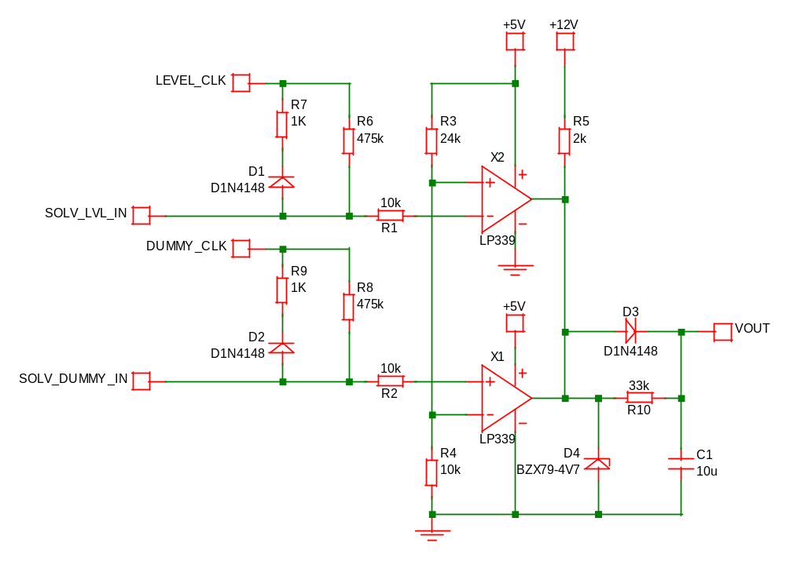

Circuit Description
Comparing the circuit above reveals that this circuit is almost identical to that used on A-Series as a result only the differences will be discussed here.
R6 and R8 are slightly different but this has virtually no impact on circuit operation so this can be ignored. R3 has been increased in value, this reduces the comparator threshold too less than 1.5V which according to the simulation results shown later appears to be to low. The timing clock is derived from a 3.3V FPGA instead of a 5V FPGA. R5 is reduced in value and partly compensates for the reduced pulse width caused by the threshold voltage reduction. The supply rail to R5 is increased to +12V but again the reduction in R5 compensates for this. D4 has been added but serves no purpose in normal operation so this can be ignored.

Capacitance Model
The only difference between the R1 model and the A-Series model is the addition of the 50pF of backplane tracking capacitance and is added to the model below.
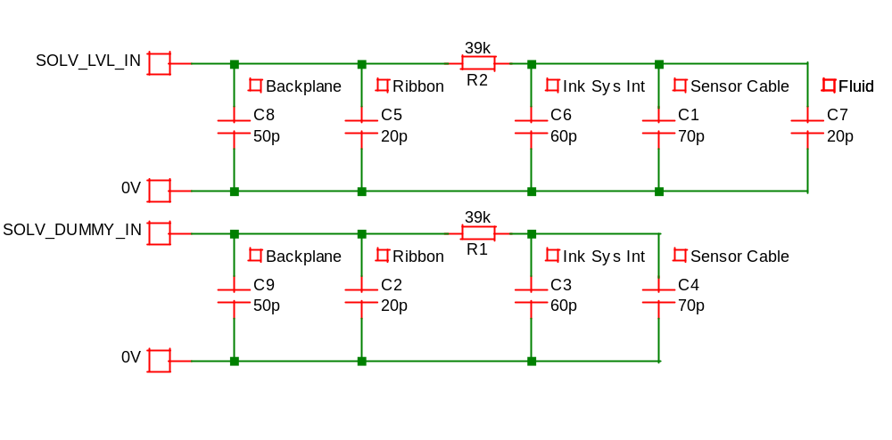

Simulation Results
The simulation results below are for a full reservoir of fluid and show the comparator input waveforms (red/green) versus the comparator threshold (blue). This clearly shows that the threshold is set rather low and does not make best use of the waveform available.

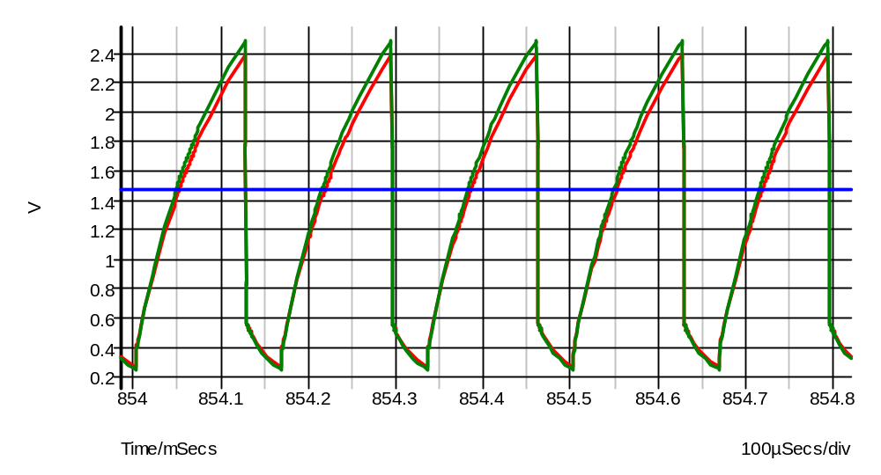

The following results show the comparator input waveforms together with the comparator output waveform (olive). It can be seen that the output pulse is rather small in fact it is only 3uS wide, which is starting to push the limits of the comparator.
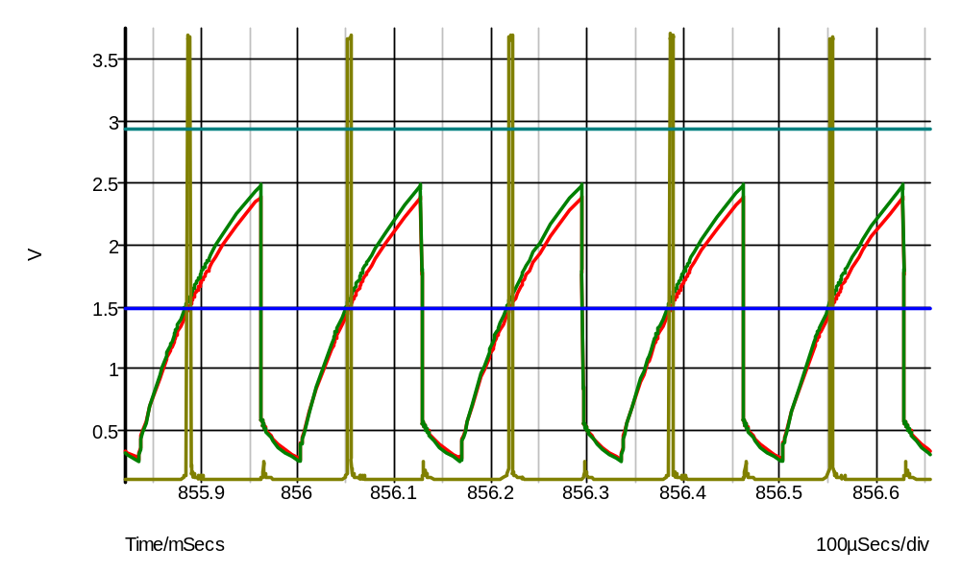

The results below show comparator input waveforms with the fluid level at minimum. The comparator is now expected to produce an output pulse of only 0.8uS. It is very unlikely that a comparator of this type will operate at this speed at best the results will be unpredictable. This appears to confirm the results that have been seen to date. Increasing the threshold to 0.68Vclk will yield a pulse width of around 2.5uS which seems to be much more suited to the comparator.
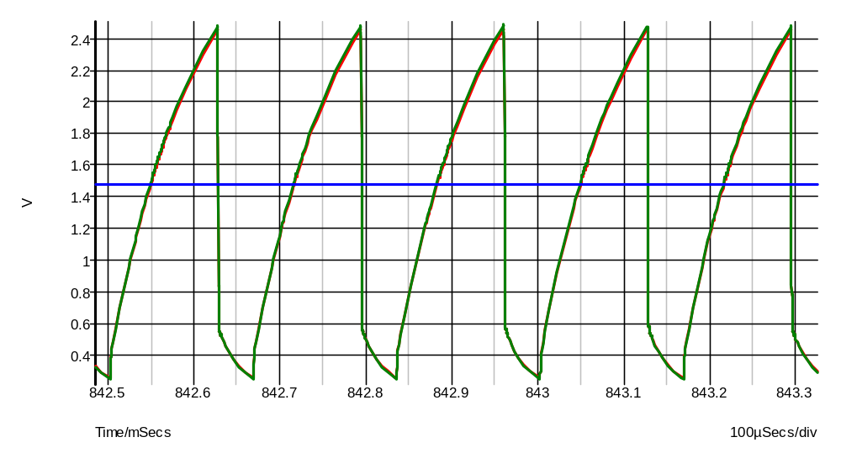

Optimisation Procedure
It is all too easy to take a quick look at the circuit and assume that the circuit sensitivity can be adjusted by changing say the comparator threshold which may not be the best course of action. It is therefore obvious that a well-defined optimisation procedure is required. This procedure assumes that the cabling and tracking capacitances are well balanced, if not, steps should be taken to address these issues first. Please note that the circuit references given here relate to the circuit diagram shown in section 3.1.
- The comparator threshold voltage should be set to 0.68Vclk (R3 value should = 12K ohm on R1).
- With all cables attached and the fluid level at the maximum level adjust the clock frequency so that the SOLV_LVL_IN just crosses the threshold voltage, remember to allow for component and cable tolerances. Adjusting the clock frequency on R1 requires firmware modification at present so as an alternative the value of the capacitor charging resistors R6 and R8 may be changed.
- Now adjust R5 to give the desired maximum output voltage. This will normally be between 3V and 4V for R1.

Conclusion
Comparing the R1 capacitive level sensing circuit with the A-Series level sensing circuit reveals the need for further optimisation. The results here indicate that the additional backplane capacitance is not the root cause of failure and as a result a re-lay of this board is not necessary for correct circuit operation.
For ideal operation of this circuit, extra capacitance introduced by system components such as pcbs and cables should be kept to a minimum.
If the circuit on R1 is optimized by selecting hardware values, then any change in system capacitance caused by re-laying boards, use of different cables etc, may cause the circuit to cease functioning again.
The recommendation is to use the procedure identified in section 4 for proper circuit optimization. This together with properly balanced cable/stray capacitance will help ensure satisfactory circuit operation.
Use of the clock signals to ‘calibrate’ the sensing circuits would offer a flexible solution less prone to disruption by changes to system components. To implement this solution requires modification to Print Engine firmware, and possibly PE software.
Investigation is on-going at this time to identify the following:
- An accurate system model to allow development and simulation.
- The cause of the ‘threshold’ detection problem.
- The optimal hardware configuration.

