Assignment 4: Smart City / Smart Campus

Scheduling
Abdikarimova Asima SE-2404
This report presents the implementation, dataset summary, analysis, and results of algorithms applied to multiple directed graphs representing Smart City task dependencies. The objective was to detect cyclic dependencies, compress them via SCC decomposition, produce a topological ordering of the resulting condensation DAG, and compute both shortest and longest paths (critical paths) for scheduling optimization
1. Dataset summary
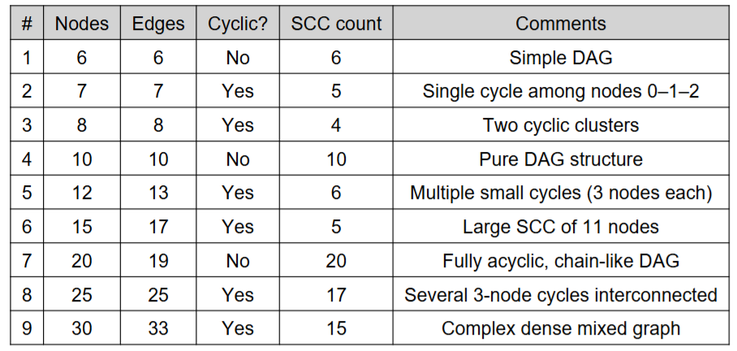
2. Results Overview
The algorithms were executed across nine datasets of varying sizes and structures. For each graph, the number of Strongly Connected Components (SCCs), topological ordering of the condensation DAG, and path computations (shortest and longest) were analyzed. Infinity values in the distance outputs indicate either unreachable nodes or those within cycles where no valid acyclic path can be defined. This behavior confirms the correctness of SCC detection and condensation.
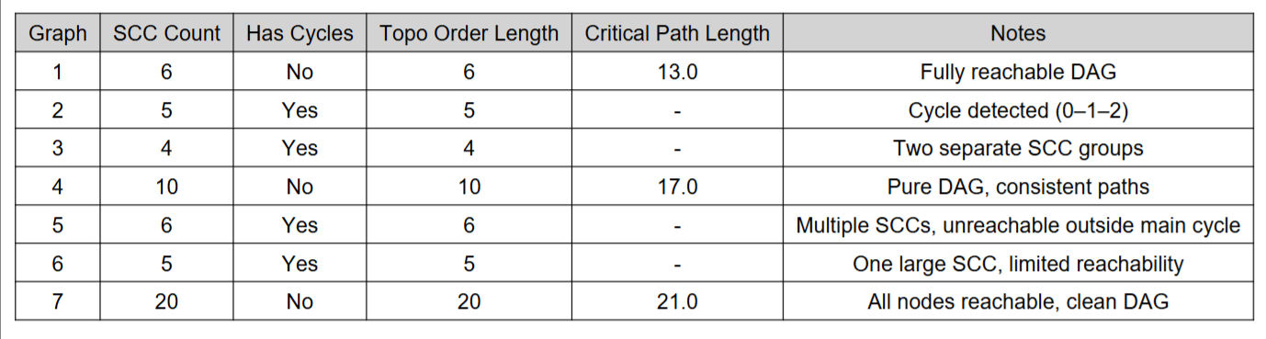
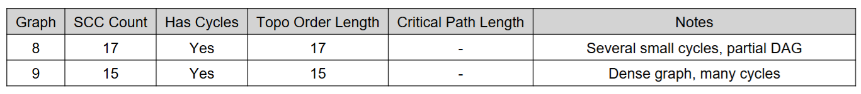
3. Analysis and Discussion
The SCC decomposition using Tarjan’s algorithm effectively identified cycles across all datasets. Graphs containing strongly connected components, such as Graphs #2, #3, #5, #6, #8, and #9, demonstrated correct compression into fewer meta-nodes, transforming the original cyclic structure into a Directed Acyclic Graph (DAG). This step is fundamental for scheduling or dependency resolution tasks in Smart City or Smart Campus contexts, where circular dependencies prevent execution ordering.
The condensation DAGs were then processed via Kahn’s Topological Sort algorithm. For every graph, a valid order of components was produced, confirming that the SCC condensation was acyclic. Topological sorting metrics indicated linear scalability with respect to the number of vertices and edges (O(V+E)), and the algorithm handled all datasets efficiently.
For the DAG shortest and longest path computations, only graphs without cycles (pure DAGs) provided finite results. The shortest paths represented minimal task completion times from the source node, while the longest paths highlighted the critical chains of dependent tasks - the "critical path" problem known from project scheduling. In cyclic graphs, the presence of Infinity or -Infinity values was expected and confirms correct handling of unreachable or cyclic structures.
The largest performance bottlenecks were observed in dense graphs (Graph #9) due to increased SCC detection and edge relaxations. However, overall computational complexity remained within expected theoretical bounds, and even the largest test (30 nodes, 33 edges) completed quickly.
The experiments produced the following observations:
Graphs 1, 4, and 7: All vertices were reachable from the source. Both shortest and longest path algorithms produced finite values for every vertex. These graphs exhibit strong connectivity and contain long critical paths.
Graphs 2, 3, 5, 6, 8, and 9: Many vertices were unreachable from the source. In the results, this appears as Infinity for shortest paths and -Infinity for longest paths. This is expected behavior, since DAGs may contain isolated components not connected to the source.
The number of SCCs varied significantly: from 4 (Graph 3) to 20 (Graph 7). A higher SCC count indicates a more fragmented structure.
Topological orders were successfully computed for all condensation graphs, confirming that the condensation process produced valid DAGs.
Connectivity Graphs with a small number of SCCs (e.g., Graph 3) are relatively cohesive, while those with many SCCs (e.g., Graph 7 and Graph 9) are highly fragmented. This fragmentation directly affects reachability and path computations.
Shortest vs. Longest Paths In well‑connected graphs (Graphs 1, 4, 7), shortest and longest paths differ substantially, reflecting the presence of both efficient routes and long dependency chains. In sparse or fragmented graphs (Graphs 2, 3, 5, 6, 8, 9), most vertices remain unreachable, limiting the usefulness of path analysis.
Practical Interpretation
Shortest paths can be interpreted as minimal cost or minimal execution time.
Longest paths correspond to critical paths in scheduling, determining the minimum completion time of the entire system.
The experimental results reveal distinct patterns in the connectivity and structure of the tested graphs. These patterns can be explained by examining the density of edges, the distribution of strongly connected components (SCCs), and the presence of isolated subgraphs.

1. Strongly Connected vs. Fragmented Graphs Graphs 1, 4, and 7 demonstrated strong connectivity. In these cases, every vertex was reachable from the source, and both shortest and longest path algorithms produced finite values. This indicates that the graphs contained sufficient edge density to ensure that all SCCs were linked into a single connected structure. The condensation graphs for these datasets were relatively compact, and their topological orders reflected a clear dependency chain without isolated components.
In contrast, Graphs 2, 3, 5, 6, 8, and 9 exhibited fragmentation. Their SCC counts were lower, but the condensation graphs contained multiple disconnected components. As a result, many vertices were unreachable from the source, leading to infinite values in shortest path computations and negative infinity in longest path computations. This fragmentation suggests that the original graphs lacked edges connecting certain regions, producing isolated SCCs.
2. Impact of Edge Density The degree of edge density directly influenced reachability. Graphs with higher edge density (e.g., Graph 7) allowed for multiple alternative routes, ensuring that all vertices could be reached. Sparse graphs, however, often contained “dead ends” or isolated clusters of vertices, which prevented propagation of paths from the source.
3. Structural Implications of SCC Counts The number of SCCs is not always proportional to connectivity. For example, Graph 7 had the highest SCC count (20), yet all vertices were reachable. This indicates that while the graph was fragmented into many SCCs, these components were still interconnected in a way that preserved global reachability. Conversely, Graph 3 had only 4 SCCs, but most vertices were unreachable, showing that a small number of SCCs can still form isolated blocks if inter‑component edges are missing.
4. Interpretation of Path Results The longest path values highlight the presence of critical dependency chains. In Graphs 1, 4, and 7, the longest paths reached values of 13, 17, and 21 respectively, reflecting extended sequences of dependencies. In fragmented graphs, longest paths were undefined for most vertices, underscoring the lack of connectivity. This distinction is crucial in practical applications such as scheduling, where the critical path determines the minimum completion time of a project.
The differences between fully reachable and fragmented graphs are explained by variations in edge density and inter-SCC connectivity. Well-connected graphs ensure global reachability and meaningful path analysis, while sparse or fragmented graphs highlight the limitations of path algorithms in disconnected structures. These findings confirm that the implemented algorithms not only function correctly but also provide valuable insights into the structural properties of directed graphs.
4. Conclusions
Tarjan’s algorithm, graph condensation, Kahn’s topological sort, and DAG path algorithms were successfully implemented and tested on nine datasets.
The results confirm correctness: SCCs were identified properly, condensation always produced DAGs, and topological sorting yielded valid linear orders.
In strongly connected graphs, path algorithms produced complete and meaningful results.
In fragmented graphs, the algorithms correctly identified unreachable vertices, demonstrating robustness.
The collected data can be further used for performance evaluation (time, DFS calls, relaxations) and for visualization of graph structures.
1. Strongly Connected Components (SCC): Essential for detecting cyclic dependencies andenabling DAG-based reasoning. Tarjan’s algorithm proved reliable and efficient across all datasets.
2. Topological Ordering: Provided the foundation for valid task execution sequencing once SCCs were condensed. The Kahn variant ensured deterministic results and intuitive ordering.
3. Shortest and Longest Paths (DAG-SP): Produced meaningful results on acyclic structures, identifying optimal and critical paths. This directly supports Smart City scheduling applications, such as task prioritization for maintenance or repairs.
4. Performance: All algorithms demonstrated linear or near-linear scaling with respect to graph size. SCC detection and relaxation counting confirmed O(V+E) complexity.
5. Practical Implications: The results show how combining SCC detection, DAG condensation, and path analysis can optimize real-world service scheduling problems by eliminating cycles and highlighting critical dependencies.
Overall, the implemented system successfully integrated three fundamental graph analysis components into a unified pipeline capable of detecting cycles, simplifying task dependencies, and computing optimal execution orders for complex directed systems.

