Task 1. Fundamental Matrix and Essential Matrix (Pen & paper) (1 point)

a) For what purpose are these matrices used and what are their differences?

The essential and fundamental matrices are 3x3 matrix that matches the epipolar geometry of two views.

Essential matrix, we use normalized points.

Fundamental matrix captures the relationship between the corresponding points in two views. Which means, with fundamental matrix, you can calculate the matching point of one plane in the other plane.

For fundamental matrix, we use real coordinate.

b) How can you derive essential matrix from fundamental matrix and what additional

information you need in order to do that?

Left Camera matrix(3\*3) = Kl

Left Camera matrix(3\*3) = Kr

K

Kr(transpose) E Kl = Fundamental matrix=0

c) How many degrees of freedom does fundamental matrix have and why?

7 degrees of freedom because we are using homogeneous coordinates

Determinant is zero.

d) How many degrees of freedom does essential matrix have and why?

L= 1x3 x=1x3( z =1 we are using homogenious coordinates.)

So it was 6 degrees of freedom in the beginning, due to homogenious coordinates, we lose one freedom.

E has five degrees of freedom

TASK2

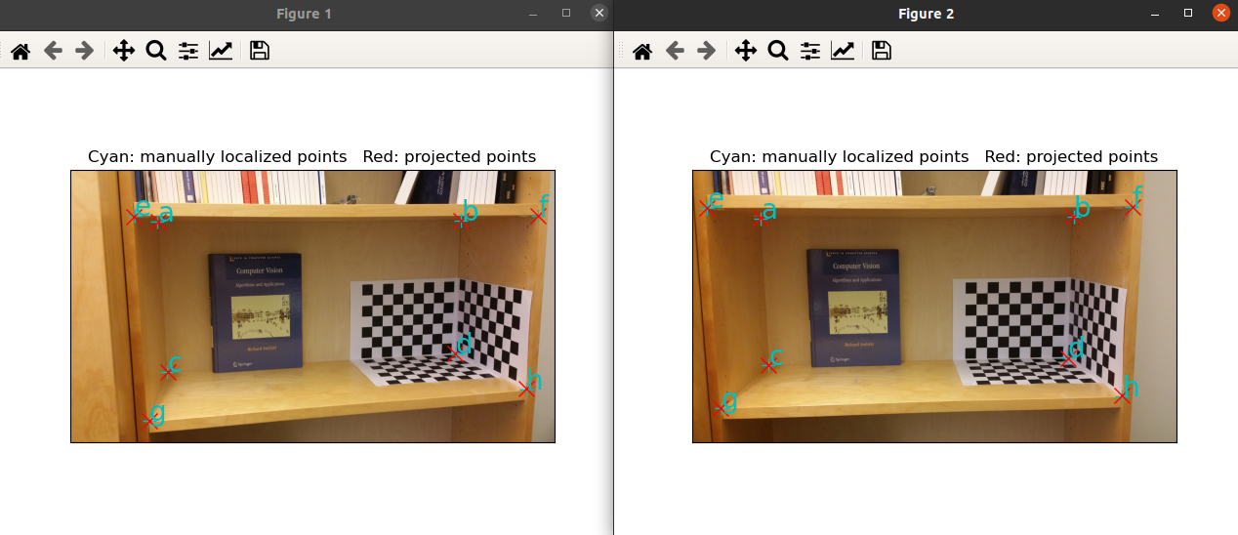

TASK3

Picture width: 139.74 mm

Picture height: 107.02 mm

