Task 1

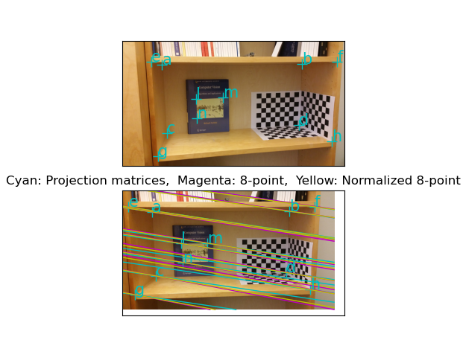

Task 2

To upgrade from the projective reconstruction to affine, similarity, or Euclidean transform, we can impose extra constraints using some additional information about the scene in question, such as parallel lines and right angles and the projection matrices of the cameras.

a) How are the cameras calibrated here?

The cameras are calibrated using DLT algorithm

b) Give an explanation why the model looks distorted but is anyway

correct.

The model looks distorted because it only use intersections and tangent ratio.

e)

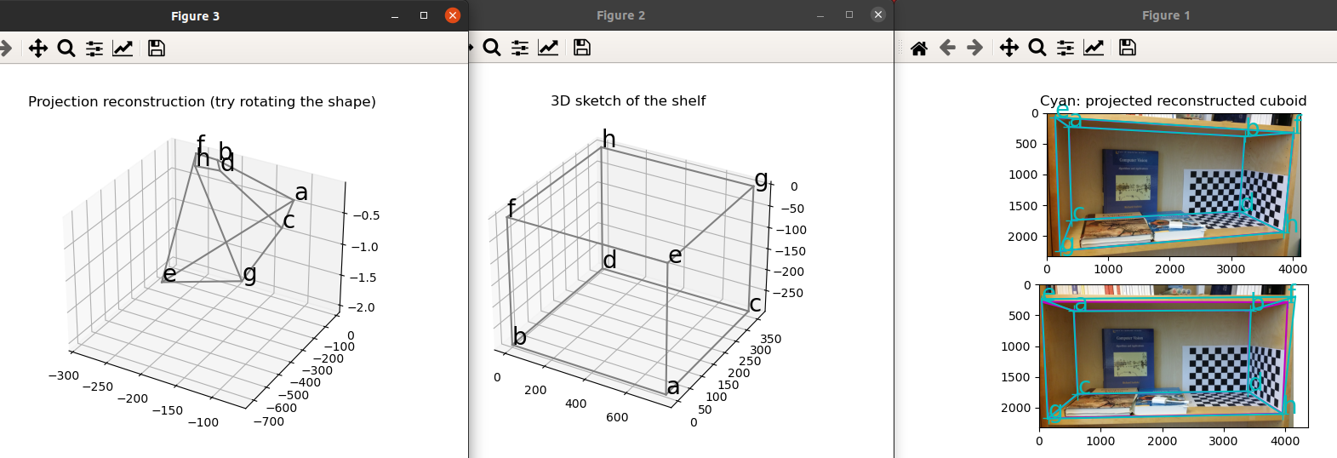

f ) Finally, describe what kind of information could be used to upgrade the projective

reconstruction to a similarity reconstruction, where angles and ratios of lengths are

the same as in the real one, without knowing the dimensions of the book shelf.

To upgrade from the projective reconstruction to similarity, we can use extra information. We can use extra points or extra lines. We can also use more sophisticated form of camera matrix.