1.Create server

const express = require("express");

const app = express();//created web serve

app.use("/", (req, res) => {
res.send("Hello from the server!");
});

app.use("/test", (req, res) => {
res.send("Hello from the test!");
});

app.use("/test1", (req, res) => {
res.send("Hello from the test1!");
});

for all the adresses we are getting Hello From ther server like localhost:3000, localhost:3000/test, localhost:3000/test1

To avoid it we will use get method

const express = require("express");

const app = express(); // Create web server

// Define specific routes with app.get()
app.get("/", (req, res) => {
res.send("Hello from the server!");
});

app.get("/test", (req, res) => {
res.send("Hello from the test!");
});

app.get("/test1", (req, res) => {
res.send("Hello from the test1!");
});

// Handle undefined routes
app.use((req, res) => {
res.status(404).send("Route not found!");
});

// Start server on port 3000
app.listen(3000, () => {
console.log("Server is successfully listening on port 3000...");
});

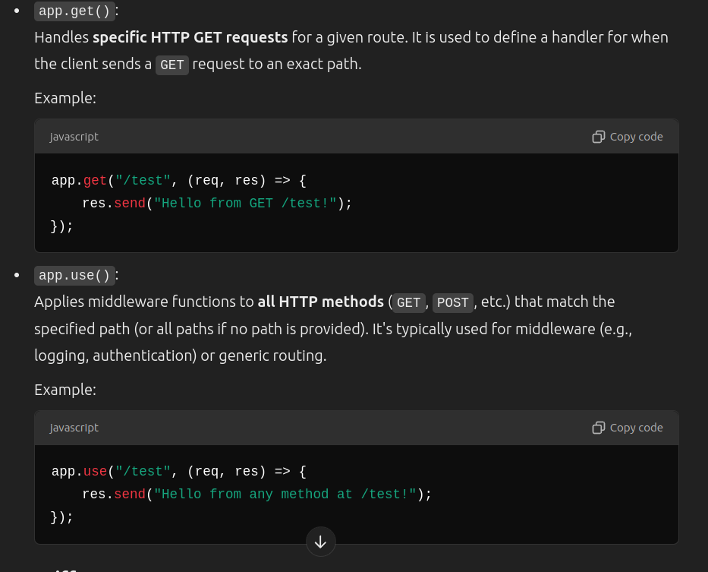
Day2

1.Yes, you can temporarily change the username or the terminal prompt to make it shorter →PS1='$

2. 'How to push repo on GITHub

1.git init
2.git add . (Add all the Files at the staging area)
3.git commit -m “created a express server” (committing on main branch-local git repo)
4.git remote add origin https://github.com/070Manish/3.DevTinder.git
git branch -M main
git push -u origin main
(Copy from Your repo of github)

3.HTTP Methods
GET, POST, PUT, PATCH, DELETE
-Browser is worst way to test API calls , its better to use POSTMAN.

// //This will only handle GET call to /user only
// app.get("/user", (req, res) =>
// {
// res.send({firstName: "Manish", lastName:"Nagpure"});
// })

// //This will only handle POST call to /user only
// app.post("/user", (req, res) =>
// {
// //DB logic here means sending data to db logic
// res.send("Data Successfully saved to the database !");
// })

// //This will only handle delete call to /user only
// app.delete("/user", (req, res) => {

// res.send("Data Successfully deleted");
// })

// //.use this will match all the HTTP methods API calls to /test
// app.use("/", (req, res) => {
// res.send("Hello from the server!");
// });

// // it will work for both /abc and /bc bcz of ? mark.
// app.get("/ab?c", (req, res) =>
// {
// res.send("Manish Nagpure");
// })

// // it will work for /abc and /bc , abbc , abbbbbc, bcz of + mark like regular expression.
// app.get("/ab+c", (req, res) =>
// {
// res.send("Manish Nagpure");
// })

// it will work for any cal which start a and end with b, like ajkhugjic, aryfthgc
// app.get("/a*c", (req, res) =>
// {
// res.send("Manish Nagpure");
// })

// //Reading Query Parameter
// app.get("/user", (req, res) =>
// {
// console.log(req.query);
// res.send("Manish Nagpure");
// })

//Reading Dynamic Route
// app.get("/user/:userId/:userName/:userPassword", (req, res) =>
// {
// console.log(req.params);
// res.send("Manish Nagpure");
// })// op->{ userId: '1', userName: 'Manish', userPassword: 'Testing'
.

DAY 3

1. Route Handler

app.use("/user", (req, res) =>
{
//Route Handler
res.send("Route Handler 1");
})

If we do not send res then it will go in infinite loop till time out

There can be multiple route handler

app.use("/user", (req, res) =>
{
//Route Handler
// res.send("Route Handler 1");
},
(req, res) => {
//route handler 2
console.log("Handling the route user 2 !!");
res.send("2nd resposense");
})

op→ nothing is going to give
If you want to go to send route handler then use next()

app.use("/user", (req, res, next) =>
{
//Route Handler
console.log(“Handling 1st Response !!”);
// res.send("Route Handler 1");
next();
},
(req, res) => {
//route handler 2
console.log("Handling the route user 2 !!");
res.send("2nd resposense");
})

we can define multiple independent route handler too

app.use("/user", (req, res, next) =>
{
//Route Handler
console.log("Handling the route user 1!");
//res.send("Route Handler 1");
next();
});

app.use("/user", (req, res, next) =>
{
//Route Handler
console.log("Handling the route user 2!");
res.send("Route Handler 2");
});

op→ Route Handler 2

2.Middleware

mtlb all the function which we are going till we get send.res() are miidlware .
->All the function which are in middle of route handler is called middleware.
→Route handler is where we return response.We can create multiple route handler .

//midlle ware
app.use("/user", (req, res, next) =>
{
console.log("Handling the route user 1!");
//res.send("Route Handler 1");
next();
});

//middleware
app.use("/user", (req, res, next) =>
{
console.log("Handling the route user 2!");
//res.send("Route Handler 2");
next();
});
//route handler
app.use("/user", (req, res, next) =>
{
//Route Handler
console.log("Handling the route user 3!");
res.send("Route Handler 3");
});

if we don not use middleware

app.get("/admin/getAllData", (req, res) =>
{
//logic of fetching all data
//check if the request is authorized
const token = "xyz1";
const isAdminAuthorized = token === "xyz"
if(isAdminAuthorized)
{
res.send("All Data Sent");
}
else{
res.status(401).send("Unauthorized user");
}
})

app.get("/admin/deleteUser", (req, res) =>
{
const token = "xyz1";
const isAdminAuthorized = token === "xyz"
if(isAdminAuthorized)
{
res.send("All Data Sent");
}
else{
res.status(401).send("Unauthorized user");
}
//Logic of deleting user
res.send("Delete a user");
})

→ again and again we have to authorized its admin or not instead of that we can use middle ware to authorize admin
