**Name:潘氏玄媖**

**Student ID: 0781532**

**Machine Learning on Material Informatics**

**Development Environment For Machine Learning**

**Homework 02**

**TASK**

1. Create an account and initial a project on one of online code management (github, gitlab or bitbucket). The commit history of your repository is considered to be part of evaluation. Please give me the URL.
2. Download Linear Regression Example from scikit-learn web site and open it in your python Environment (spyder or jupyter). And try to run this project. Please upload a snapshot of your desktop.

[**https://scikit-learn.org/stable/auto_examples/linear_model/plot_ols.html**](https://scikit-learn.org/stable/auto_examples/linear_model/plot_ols.html)

**SOLUTION**

1. **Create an account and initial a project on one of online code management use** **Github**

**Step 1**: Create an account

* Go to github.com and start the registration process for an account.

Usernam: 0781532

Password:

Email: tuyenbkdn@gmail.com

* Verify via email address if required.

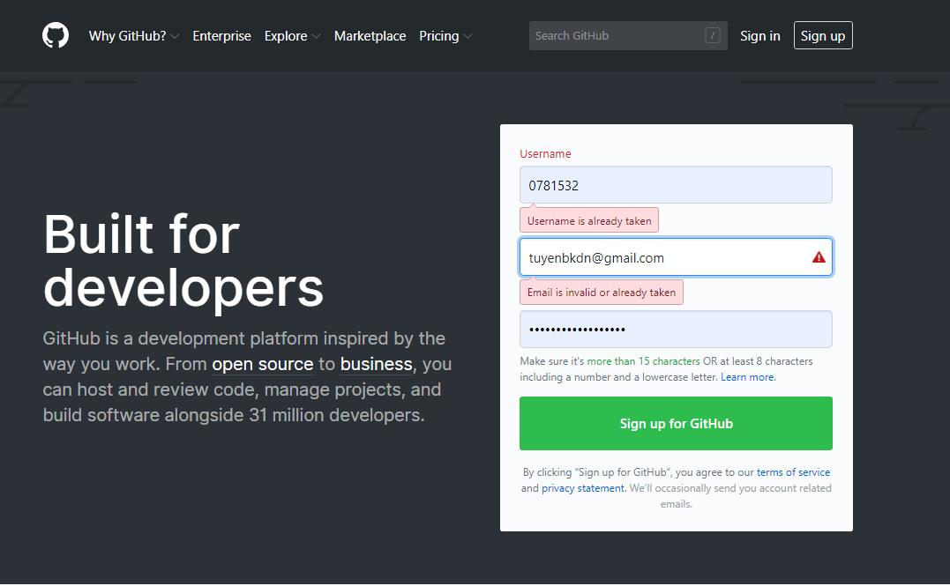

**Step 2**: Github interface after registration:

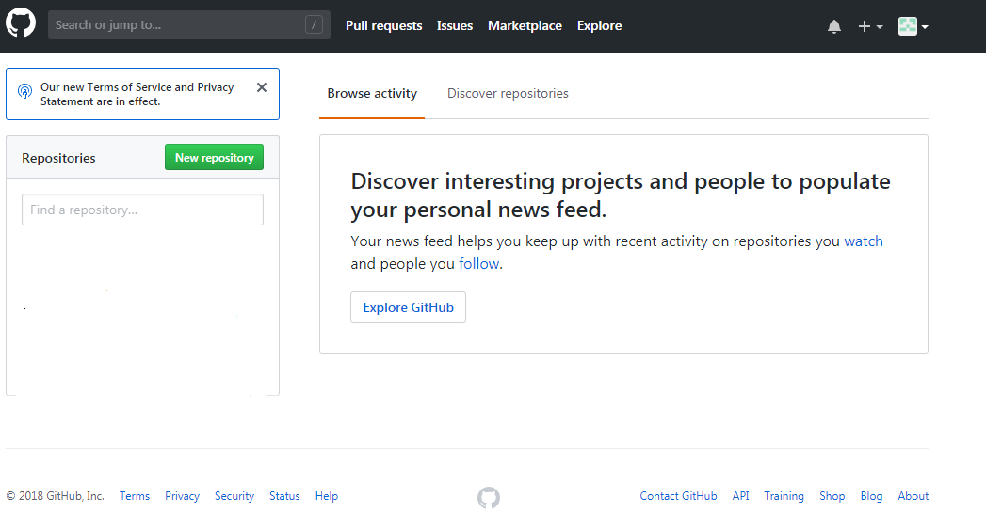

Create registration

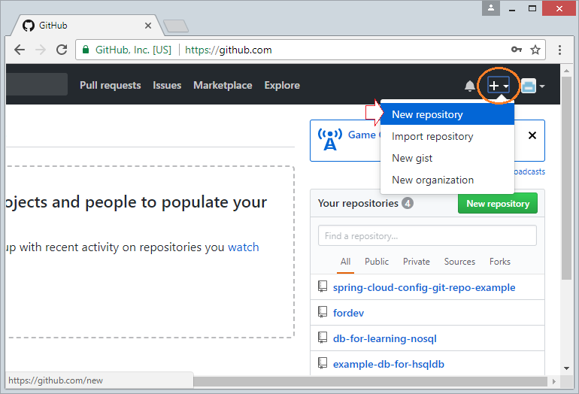

**Step 3:** log in to github: <https://github.com>

* Name account: 0781532
* Password:

**Step 4:** initial a project on one of online code management use **Github**

Initial a project >> choose **Star a project**

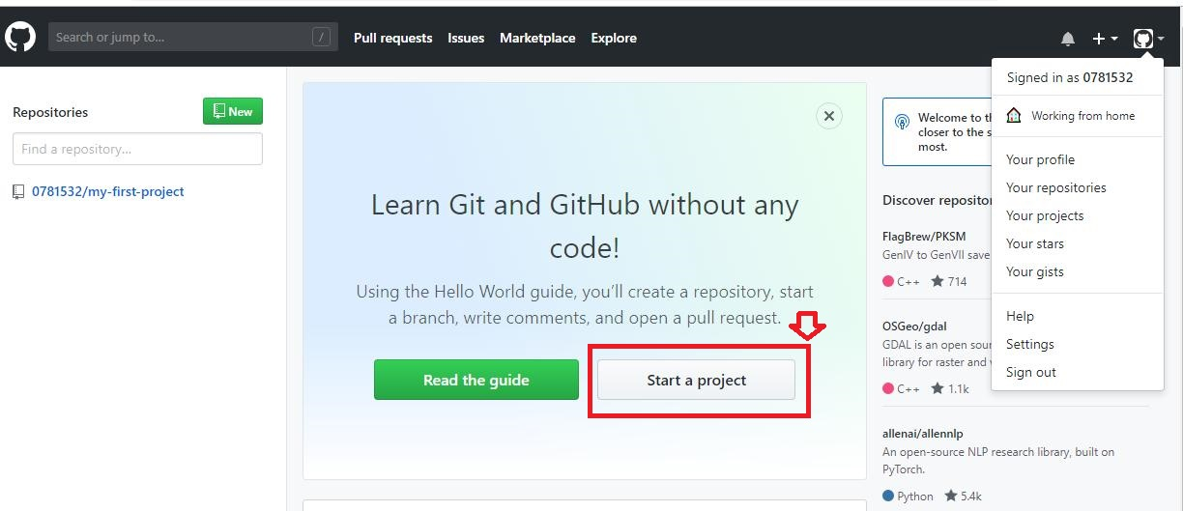

**Step 5: Name and describe the projest**

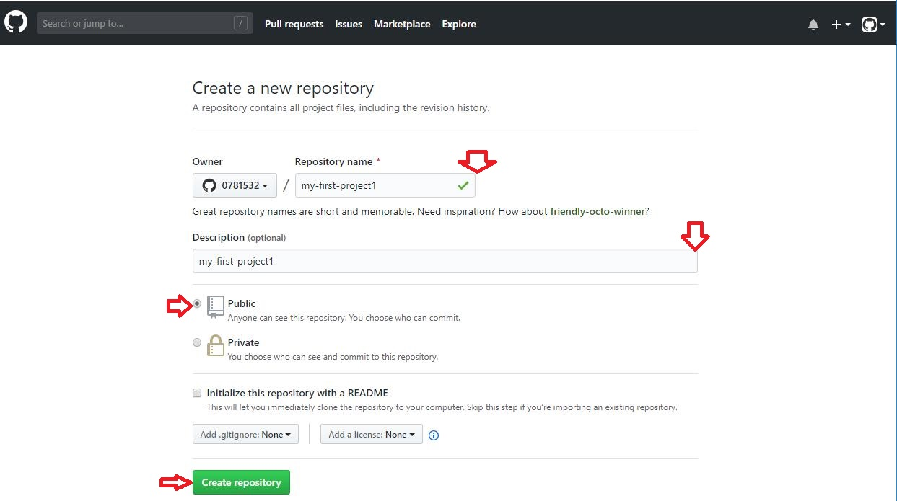

**Step 6: Select Create repository, will get a remote repo to store the project**

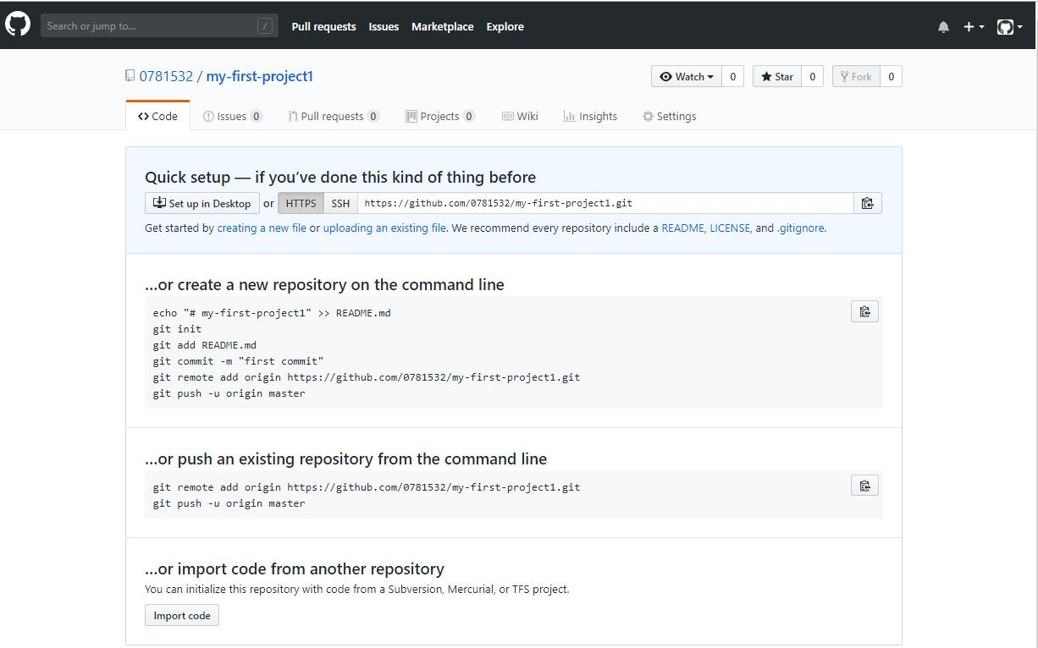

**GIT already has some basic commands available as shown.**

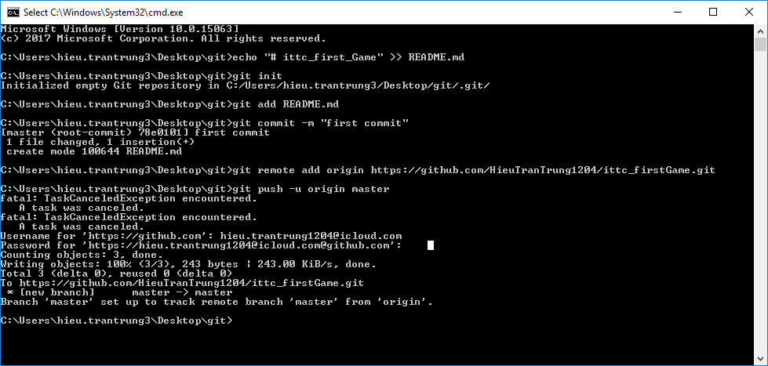

**Step 7:** Download&Install **Github Desktop**

* GitHub Desktop is essentially a visual tool that allows you to manage Local Repository on your computer.
* Download **Github Desktop:**

<https://desktop.github.com>

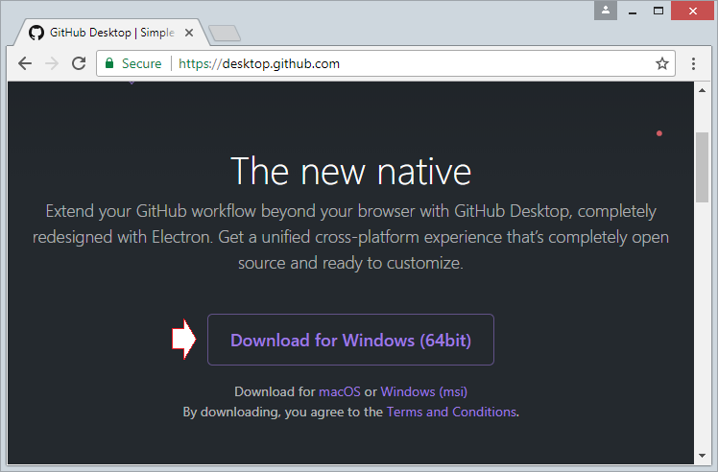

**Download results:**

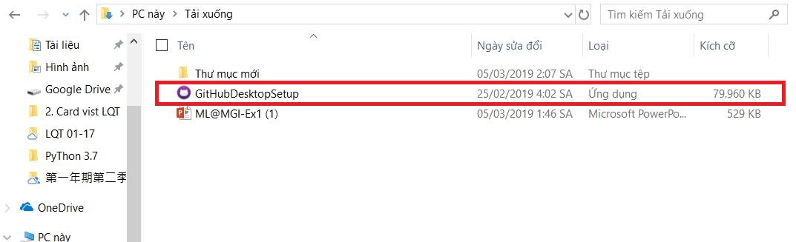

* Install **Github Desktop**
* Run **Github Desktop**
* Log in on **Github Desktop** to connect to your **Github** account

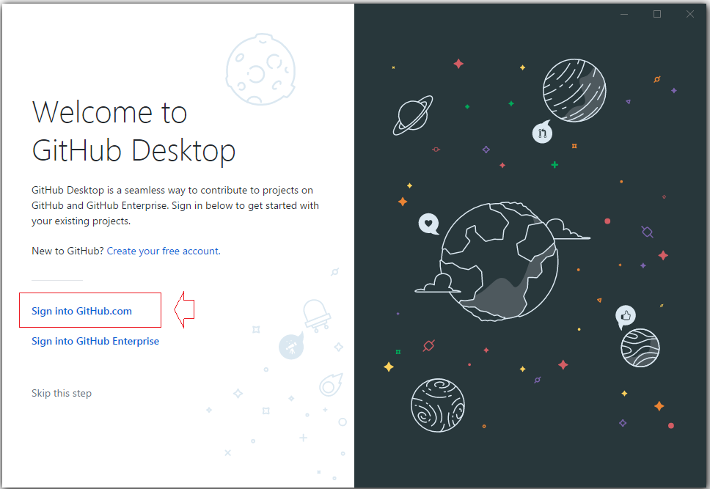

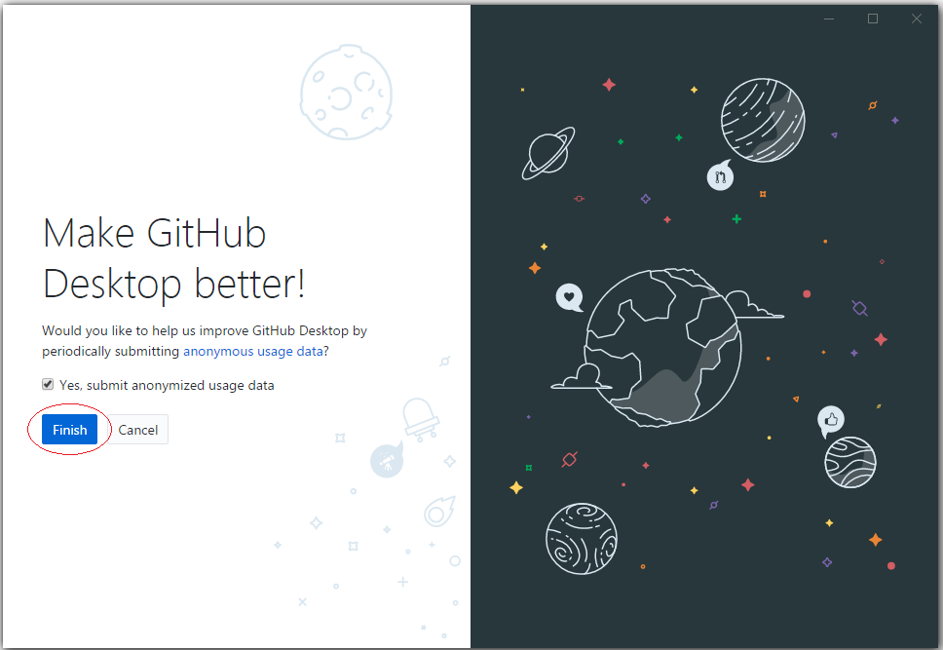

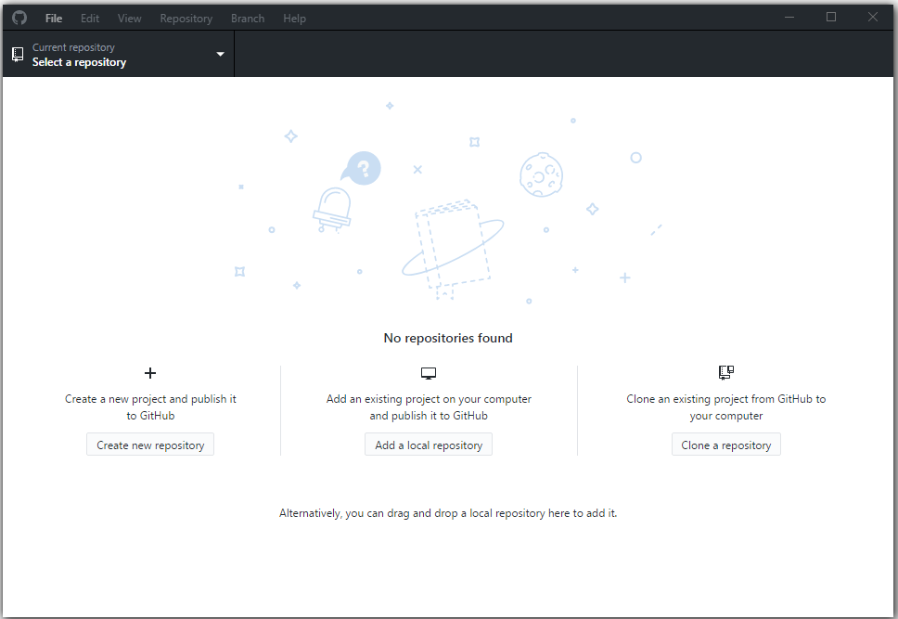

* Connect **GitHub** and **GitHub Desktop**

First, select an empty directory as the location fot the local data

* C:/GITHUB

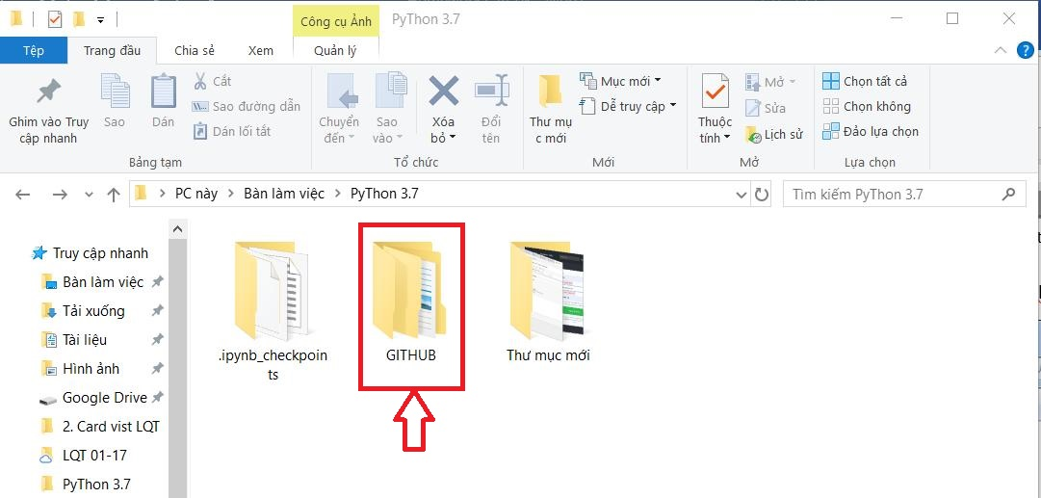

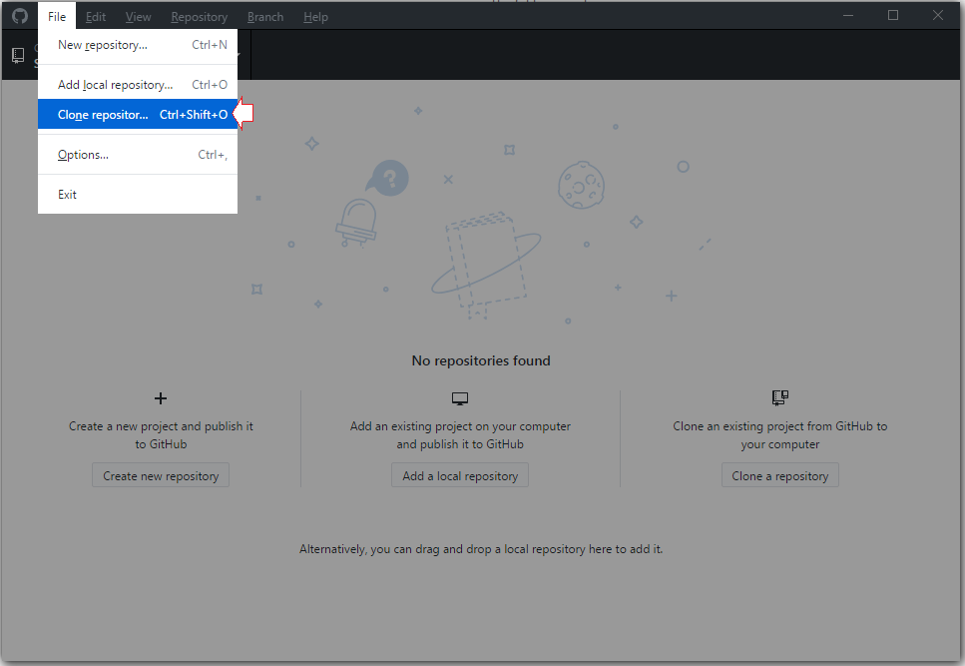

* On GitHub Desktop, select a Repository yiu created on GitHub to clone ( Create a copy) into a copy your local computer
* On GitHub Desktop you will see a local Repository hac been create.

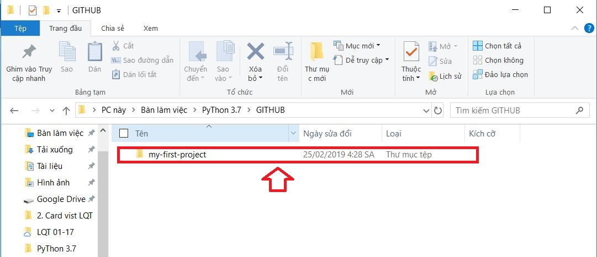

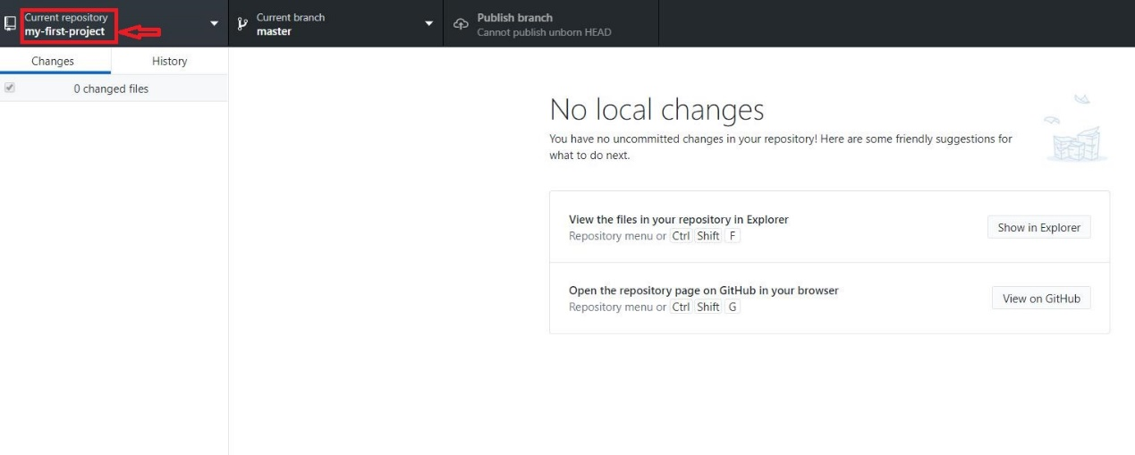

* Copy some data files into Local Repository

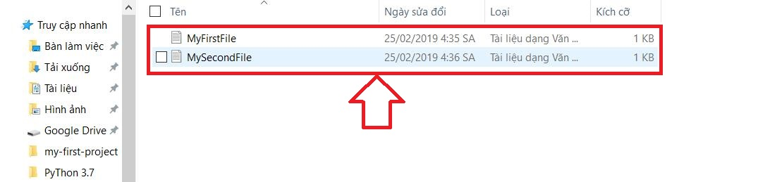

* GitHub Desktop immediately recognizes the changes at Local Repository

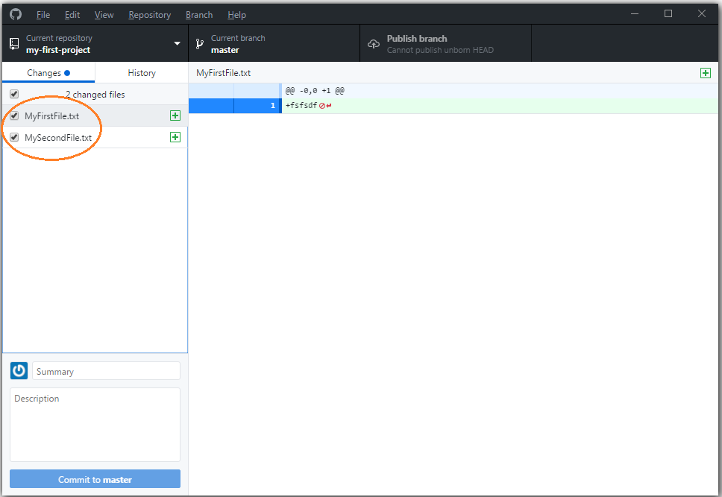

* Comment -> Commit

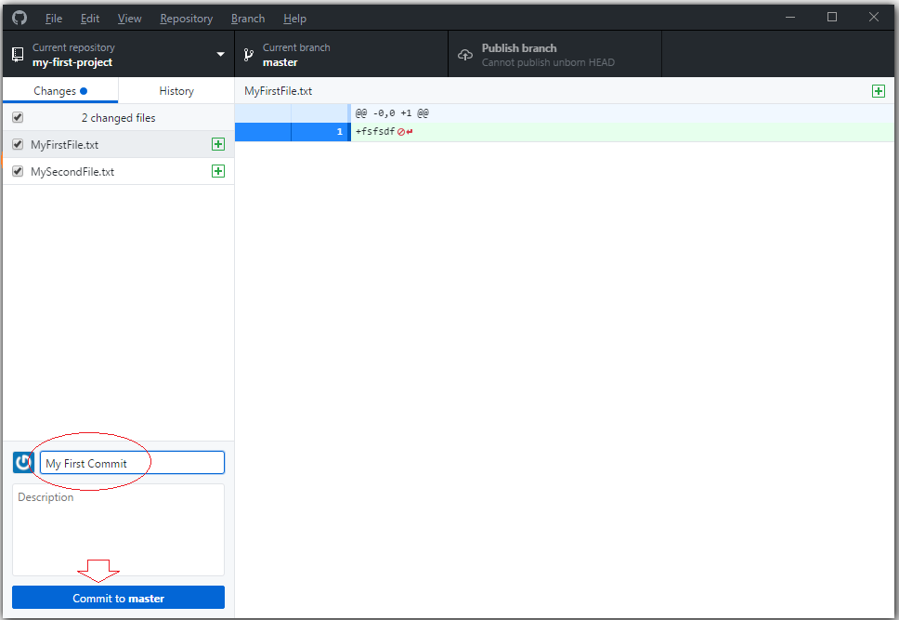

* **Publish branch** (Publish branch to GitHub)

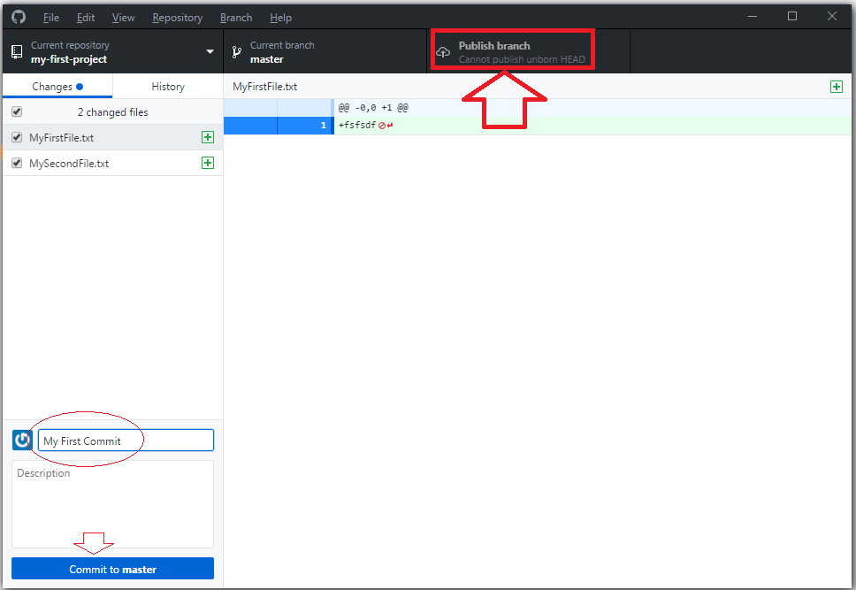

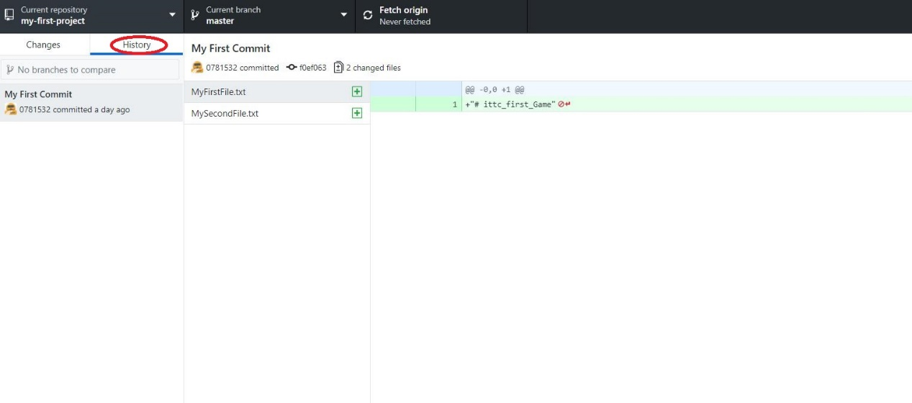

**Step 8:** Use GIT for new folders >> git add README.md >>git remote add origin

* Connecting local server to online server (remote)
* Require to enter the username and password of GITHUB account:
* [new branch] master -> master
* Branch ‘master’ set up to track remote branch ‘master’ from ‘origin’.

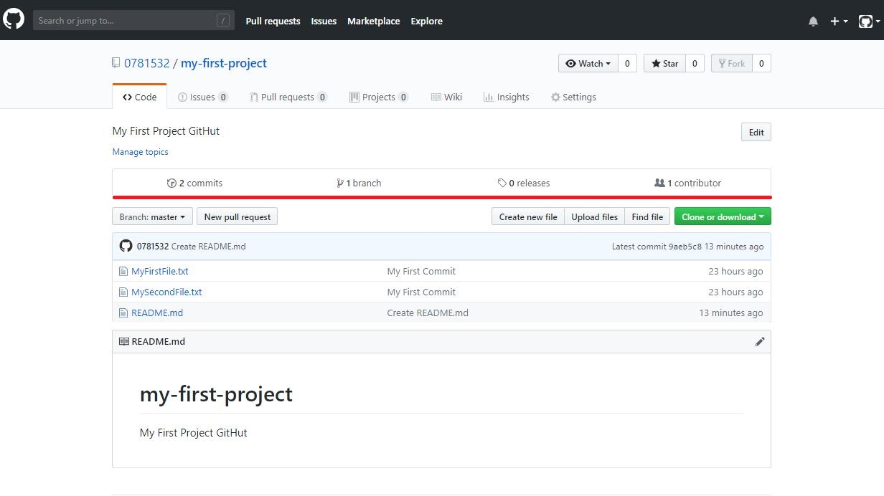

* **Check the log on the Github web site and the commit file**

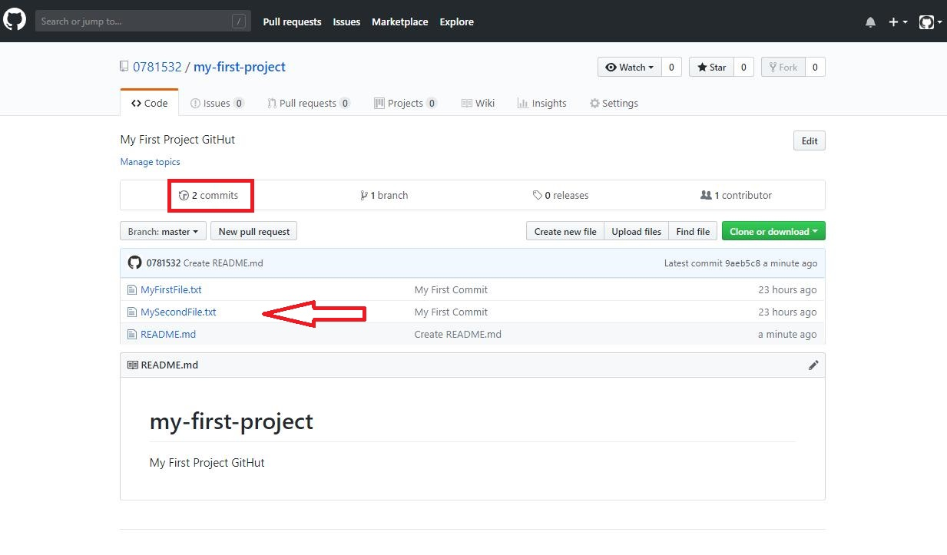

**Step 9:** Please check the URL

**https://github.com/0781532/my-first-project**

1. **Download Linear Regression Example from scikit-learn web site and open it in your python Environment (spyder or jupyter). And try to run this project. Please upload a snapshot of your desktop.**

[https://scikit-learn.org/stable/auto_examples/linear_model/plot_ols.html#](https://scikit-learn.org/stable/auto_examples/linear_model/plot_ols.html)

**Step 1:** click

[https://scikit-learn.org/stable/auto_examples/linear_model/plot_ols.html#](https://scikit-learn.org/stable/auto_examples/linear_model/plot_ols.html)

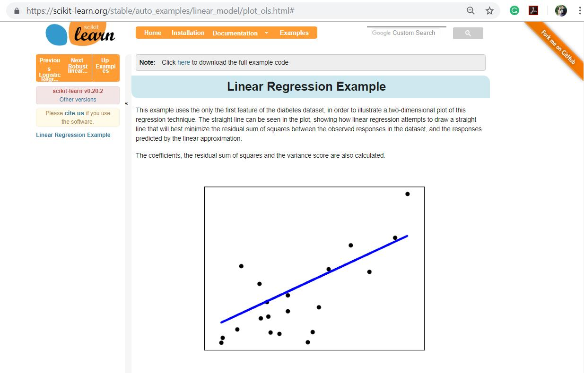

**Step 2:** Download

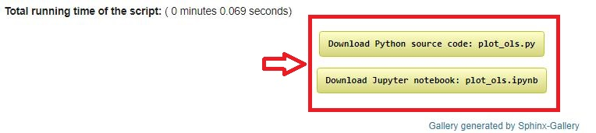

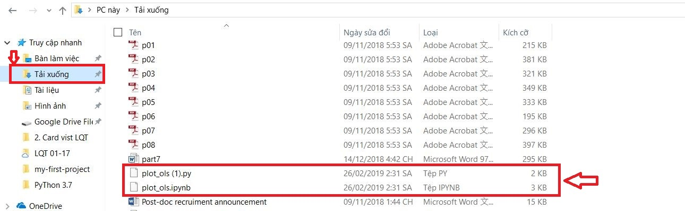

**Step 3:** Click **Home** >> Launch **jupyter Notebook** >> choose **File** >> choose **Open**

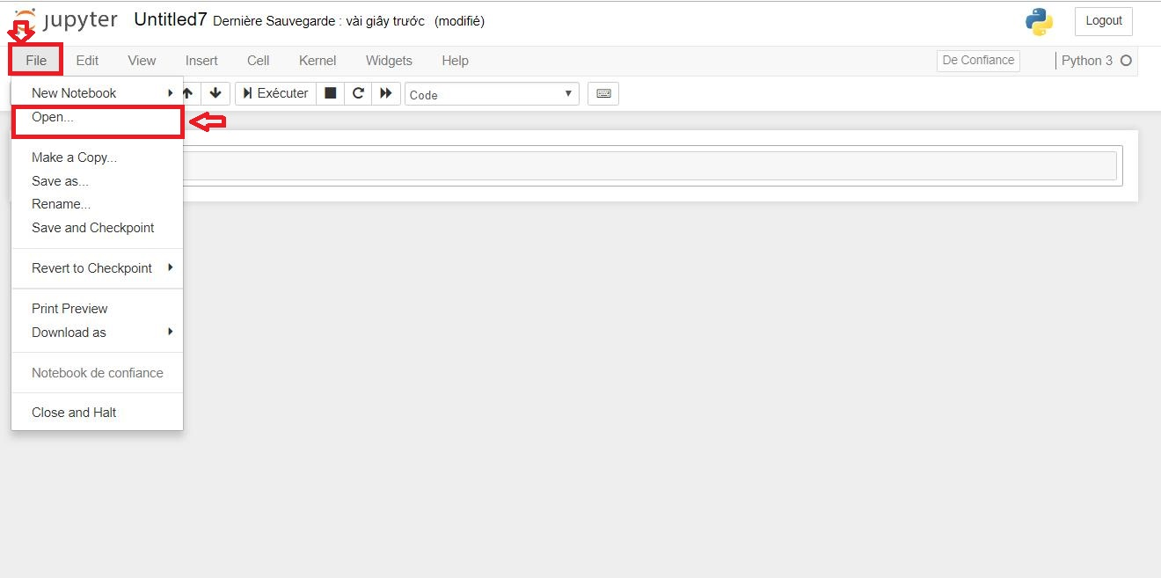

Choose **Download**

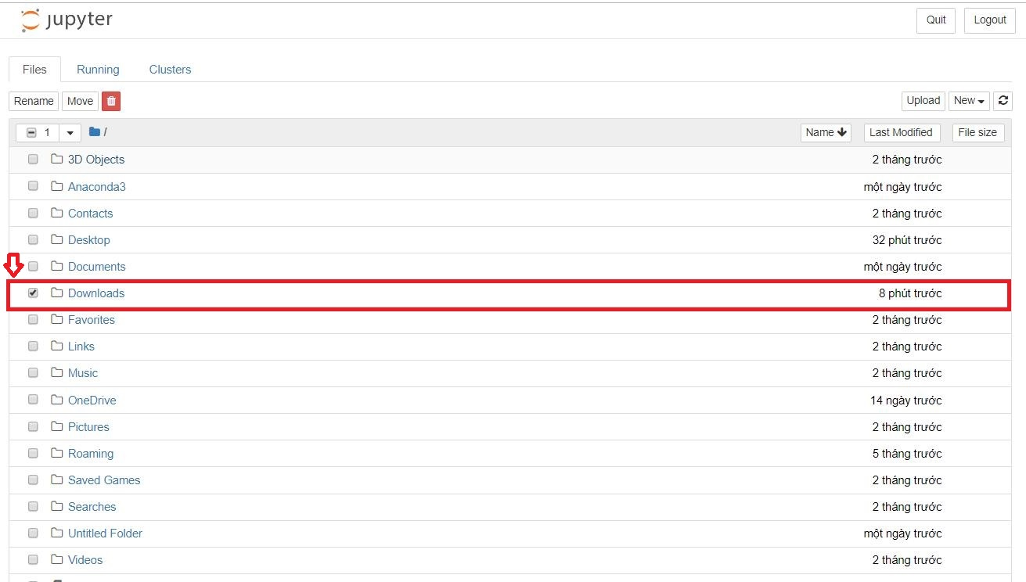

**Choose** file **plot_ols-checkpoint.ipynb**

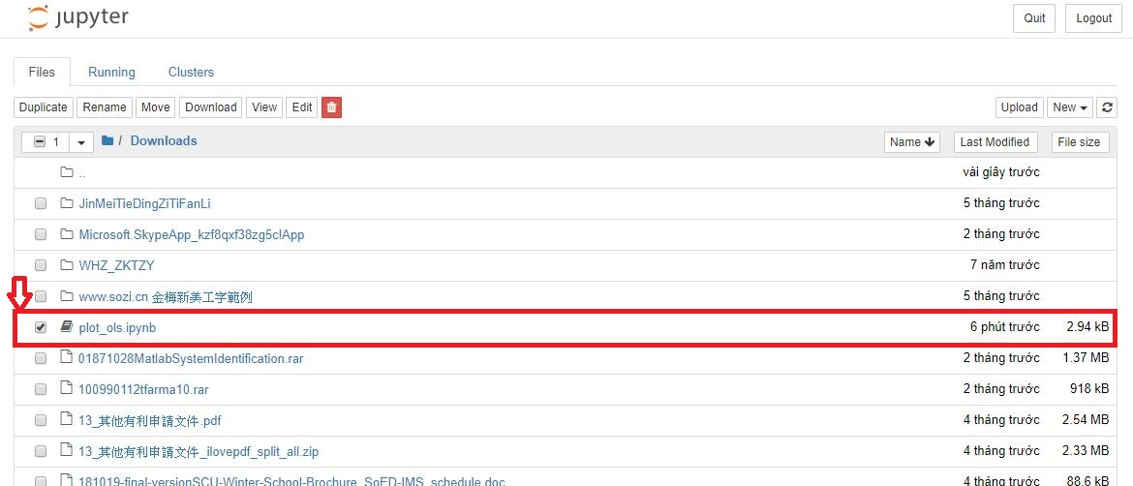

Double click file **plot_ols-checkpoint.ipynb**

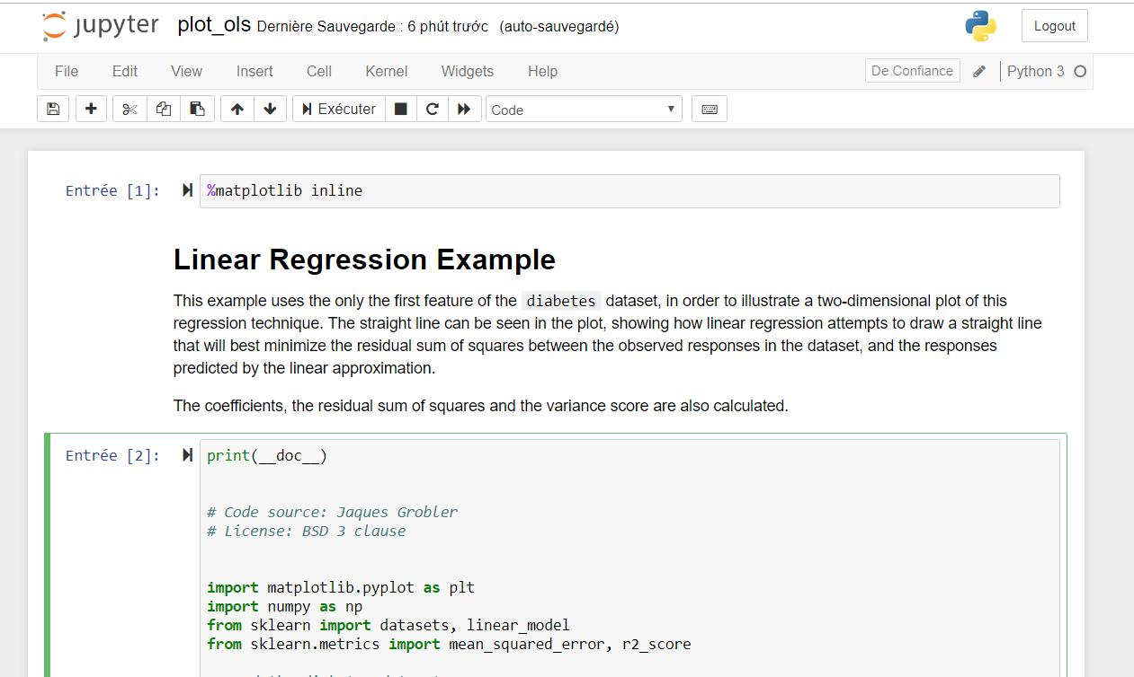

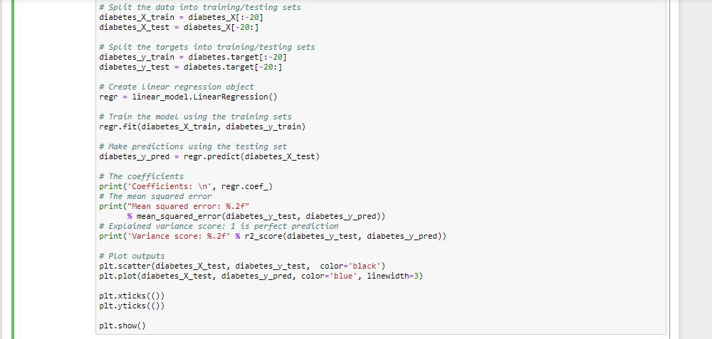

**Step 4: Run**

* **Result**

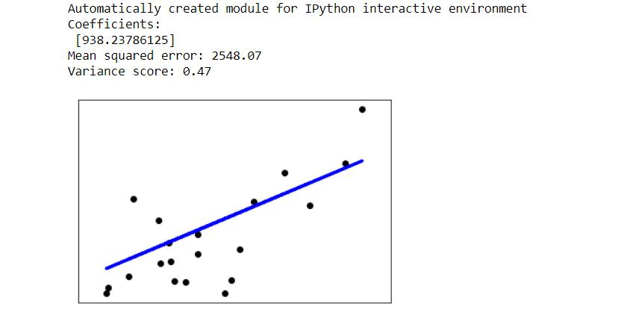

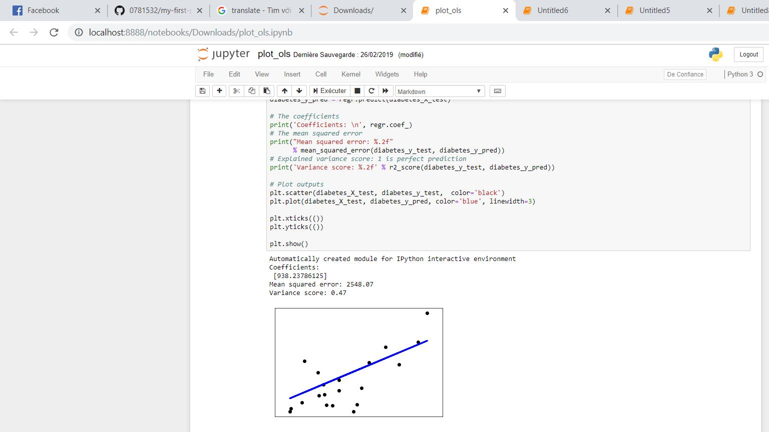

**Ex 1: call random function 10 times only to generate 10 random numbers between 0~9**

import random

N = 10

start = 0

stop = 10

for i in range (N) :

num = random.randint(start, stop)

print (num)

