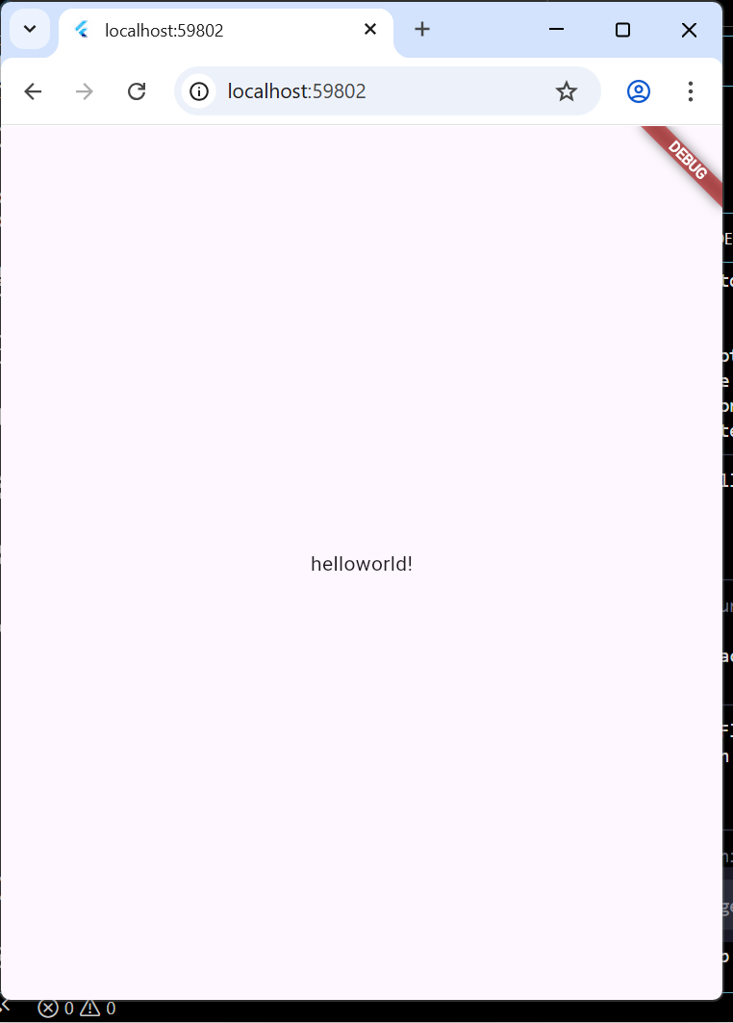
Main.dart code used
import 'package:flutter/material.dart';

void main() {
runApp(const MyApp());
}

class MyApp extends StatelessWidget {
const MyApp({super.key});

@override
Widget build(BuildContext context) {
return MaterialApp(
home: Scaffold(
body: Center(
child: const Text('helloworld!'),
),
),
);
}
}

