
CE80762
MOBILE COMMUNICATIONS
Unit 3: Cellular Network Architecture and Mobility Management

Year IV
Academic Year 2026-2027
Semester 1
Python 3 | NumPy | Matplotlib - all results reproducible with fixed random seeds
# | Group member name | Student ID
1 | Remy Boris RWIGAMBA | 223026974
2 | Marie Ange TUYIZERE IRADUKUNDA | 223026692
3 | Abel NIYIGENA | 223026691
Mini Projects 3.1 - 3.3
Frequency reuse, handover logic, capacity planning and the connection state machine
Mini Project 3.1 Simulating Frequency Reuse Planning and Handover Decision Logic
Mini Project 3.2 Cellular Capacity and Frequency-Reuse Planning
Mini Project 3.3 Modeling Device Connection and Handover as a Finite-State Machine
Lab Report | Prepared 3rd November 2026
Deliverable package: this report + Python source + generated figures and logs

Github Link: https://github.com/0788231715/MC_Unit3_Labs.git
Contents
Executive Summary
Mini Project 3.1 - Frequency Reuse Planning and Handover Decision Logic
- Objective, method, Q-versus-N results
- Handover behaviour: naive, hysteresis, hysteresis + TTT
- Interpretation paragraph and Lab Tasks 1-6
Mini Project 3.2 - Cellular Capacity and Frequency-Reuse Planning
- Configuration and formulas
- Capacity, cell splitting and sectoring results
- Written analysis
Mini Project 3.3 - Device Connection and Handover as a Finite-State Machine
- State design and transition table
- Scenario, logs, Monte-Carlo comparison
- Comparison report
Conclusions
Appendix A - Package contents
Appendices B-D - Source code

Executive Summary
This report documents the complete solution to the three Unit 3 mobile-communications mini projects. Every number, table and figure below was produced by the accompanying Python code (see the code folder of the package), and each script can be rerun to regenerate them.
Project | What was built | Headline result
3.1 Reuse & handover | Hexagonal reuse-pattern generator (N = 1, 3, 4, 7, 9, 12) and a handover simulator with naive, hysteresis and hysteresis+TTT triggers | Q = sqrt(3N) verified geometrically; handovers fell 13 -> 5 -> 1 as hysteresis and TTT were added
3.2 Capacity planning | Planning tool: channels/cell, cells in area, capacity, Q, SIR; cell-splitting and sectoring levers | N = 1 gives 1,925 ch but only 1.8 dB SIR; 3-sector N = 4 matches omni N = 7 SIR with 1.8x the capacity
3.3 FSM | Seven-state FSM with 4-step RACH, interchangeable policies, RLF path, 300-run Monte-Carlo | Naive: 7.4 ping-pongs/run; 3 dB+TTT 5: 0 ping-pongs, 0.27 RLF/run; 10 dB+TTT 12: 1.56 RLF/run

Key insight across all three projects
Mobility and capacity parameters are never free: every gain in interference protection (larger N, larger hysteresis, longer TTT) is paid for in capacity or in radio-link-failure risk. Good network planning is the search for the balanced operating point.

Mini Project 3.1 - Frequency Reuse Planning and Handover Decision Logic

1. Objective and background
Build two linked simulations: (a) a hexagonal frequency-reuse generator that labels each cell with a frequency group and computes the reuse ratio Q = D/R = sqrt(3N); (b) a handover simulator that applies hysteresis and time-to-trigger (TTT) to synthetic RSRP traces and exposes the ping-pong effect and the too-late-handover trade-off.
Key relations (Lecture Notes Sections 3.1 and 3.6)
Valid cluster sizes satisfy N = i^2 + i·j + j^2, giving N = 1, 3, 4, 7, 9, 12, ...
Co-channel reuse ratio Q = D/R = sqrt(3N); a larger Q means more separation, less co-channel interference and lower capacity.
Handover entering condition: neighbour RSRP > serving RSRP + hysteresis, held for TTT consecutive samples.

2. Environment (Procedure step 1)
NumPy 2.4.4 | Matplotlib 3.10.8 | Python 3.12.3

3. Method

3.1 Part (a): hexagon geometry and group assignment
- Step 2 - centres: axial coordinates (q, r) over the requested number of rings; for cell radius R the centre is x = R·sqrt(3)·(q + r/2), y = 1.5·R·r.
- Step 3 - group labels: find integers (i, j) with N = i^2 + ij + j^2. The cluster lattice is spanned by u = (i, j) and v = (-j, i+j) (determinant N). Each cell is reduced to its remainder inside the fundamental parallelogram using exact integer floor-division; cells with the same remainder share a frequency group, giving exactly N groups.
- Steps 4-6: layouts with 5 rings (91 cells) for N = 1, 3, 4, 7, coloured by group; Q computed analytically and measured as the smallest distance between same-group centres divided by R, as an independent check.
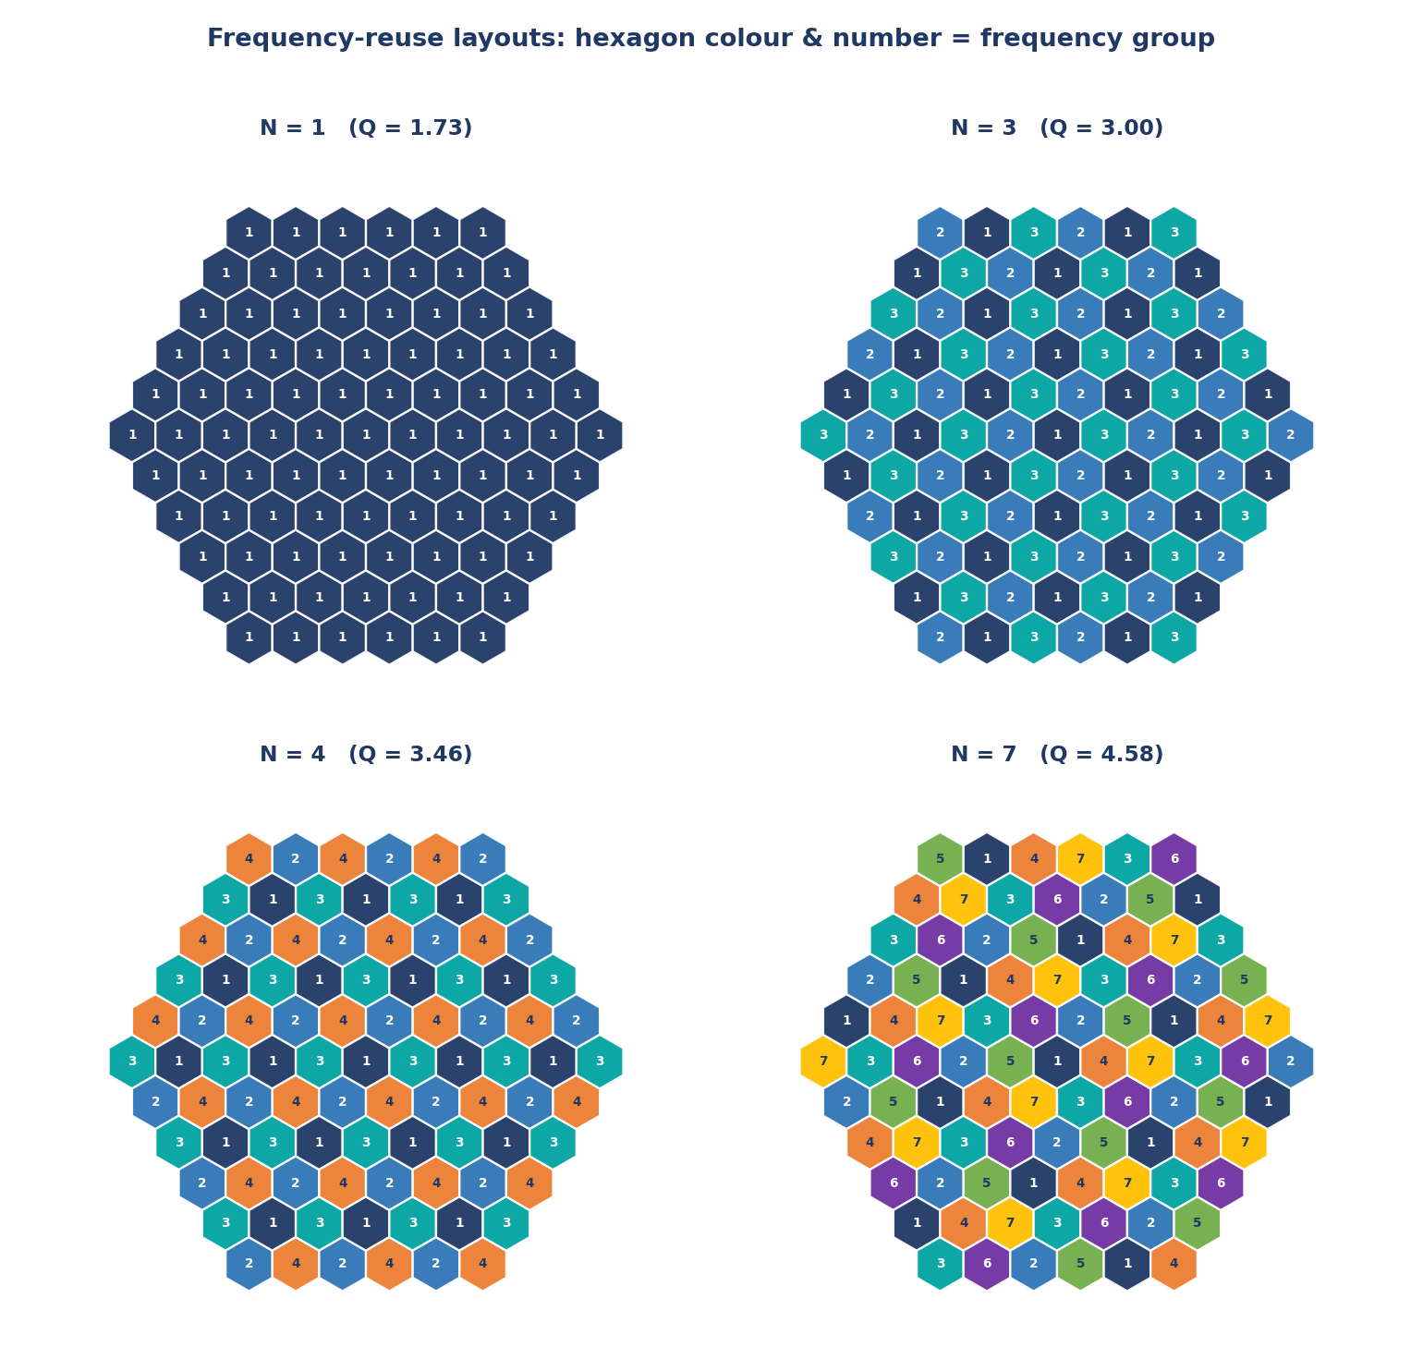
Figure 1. Frequency-reuse layouts for N = 1, 3, 4 and 7. Colour and number identify the frequency group.

3.2 Part (b): synthetic RSRP and triggers
- Steps 7-8: 300 samples per cell = linear trend + bridged random walk (sigma 0.35 dB per step) + white Gaussian noise (sigma 2.6 dB). Serving cell A falls from -76 to -108 dBm while neighbour B rises from -108 to -76 dBm, so they cross near sample 150 and stay close for a stretch.
- Step 9-12: one generic engine run_trigger(series, margin, ttt) implements all three triggers: naive (margin 0, TTT 1), hysteresis only (3 dB, TTT 1) and hysteresis+TTT (3 dB, TTT 5). A streak counter holds consecutive satisfied samples and is reset when the condition breaks; after a handover the old serving cell becomes the neighbour.
- Step 14: the serving-cell RSRP is checked against a -100 dBm minimum threshold to reveal too-late-handover risk.

4. Results

4.1 Q versus N (Step 6)
N | (i, j) | Q = sqrt(3N) | Groups in layout | Measured D/R
1 | (1, 0) | 1.732 | 1 | 1.732
3 | (1, 1) | 3.000 | 3 | 3.000
4 | (2, 0) | 3.464 | 4 | 3.464
7 | (2, 1) | 4.583 | 7 | 4.583

The measured reuse distance agrees with the closed-form Q for every N, which validates the lattice-based labelling. N = 7 has the largest Q (4.58) and therefore the best isolation of same-numbered hexagons.

4.2 Handover behaviour (Steps 10-14)
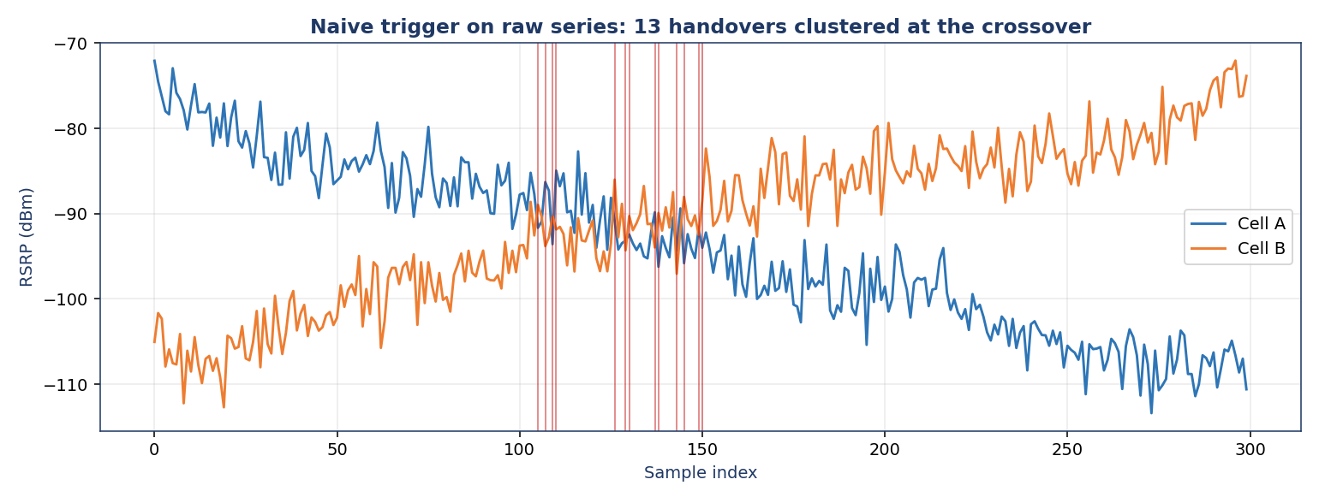
Figure 2. Naive trigger on the raw RSRP series. Red lines mark handovers, clustered where the curves overlap (ping-pong).
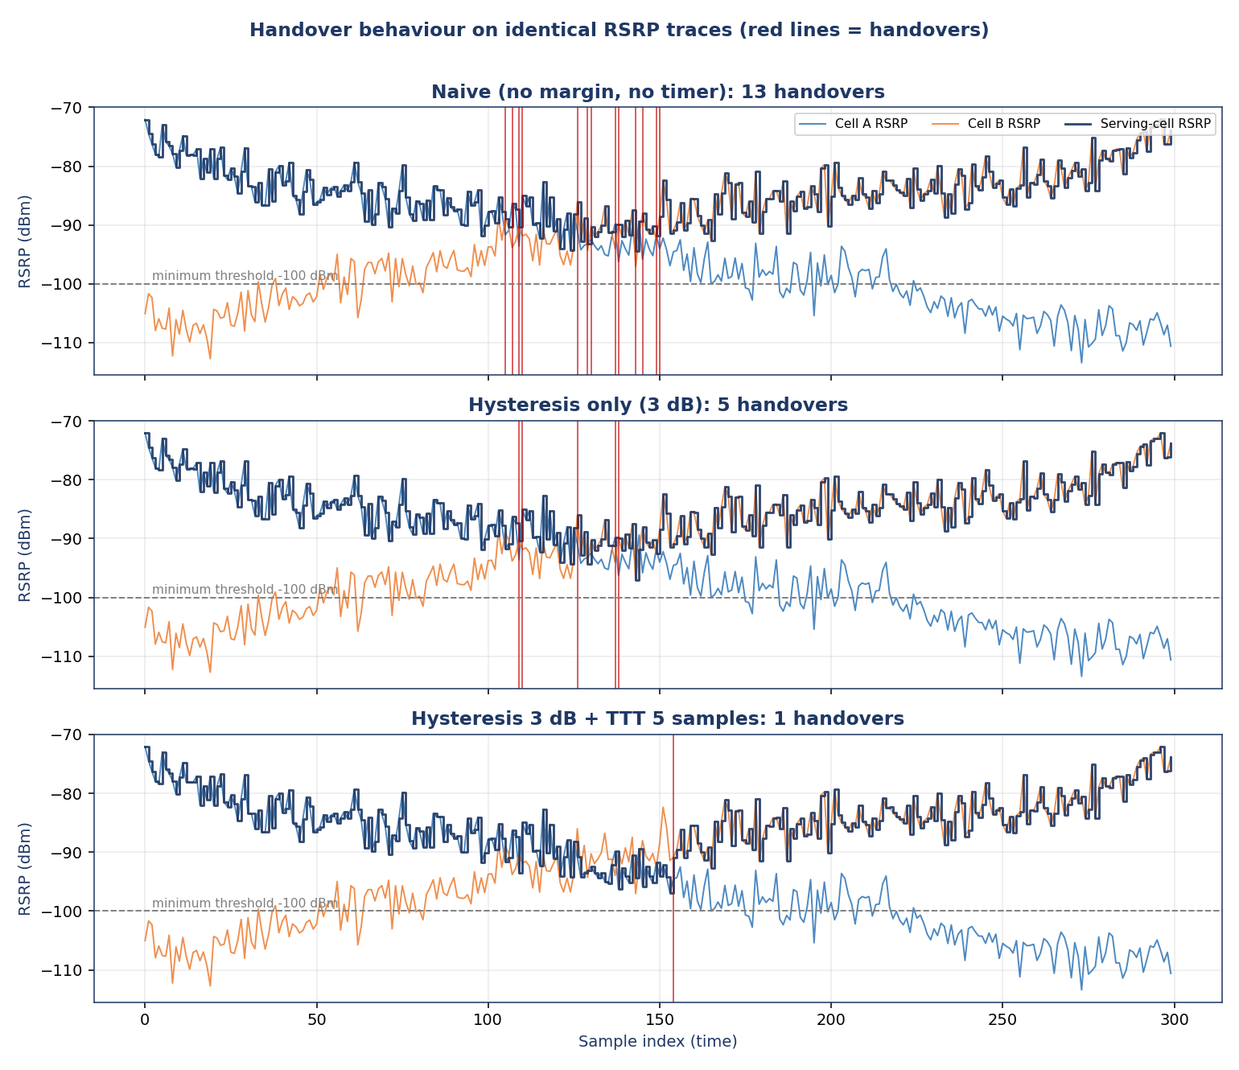
Figure 3. Three stacked subplots on identical data: naive, hysteresis-only, hysteresis+TTT. The dark line is the serving cell RSRP.
Configuration | Handovers | Ping-pongs | Samples < -100 dBm | Min serving RSRP (dBm)
Naive (no margin, no timer) | 13 | 11 | 0 | -94.4
Hysteresis only (3 dB) | 5 | 2 | 0 | -97.1
Hysteresis 3 dB + TTT 5 samples | 1 | 0 | 0 | -96.9

A ping-pong is a handover back to the cell just left within 10 samples. Hysteresis removes most of the noise-driven crossings; the 5-sample TTT removes the remainder, leaving the single legitimate A-to-B handover near sample 154. The minimum serving RSRP decreases slightly with tuning (-94.4 to -96.9 dBm) because the device stays on the weakening cell a little longer, an early warning of the too-late-handover risk; no sample dipped below -100 dBm at these settings.

5. Interpretation paragraph (deliverable, 150-250 words)
Interpretation (232 words)
Frequency reuse trades capacity against interference through the co-channel reuse ratio Q = D/R = sqrt(3N). Our generator confirmed this numerically: the measured nearest same-group distance matched Q exactly for every cluster size, rising from 1.73 at N = 1 through 3.00 (N = 3) and 3.46 (N = 4) to 4.58 at N = 7, and further to 5.20 (N = 9) and 6.00 (N = 12). Small N reuses each frequency often and so gives high capacity, but co-channel cells sit close together and interference is strong; N = 7 separates same-numbered cells widely at the price of using each frequency less often per unit area. The handover experiment used identical RSRP traces. The naive trigger, which hands over whenever the neighbour is merely stronger, produced 13 handovers, 11 of them ping-pong returns to the cell just left, all clustered where the two curves overlap. A 3 dB hysteresis margin cut this to 5 handovers (2 ping-pongs), and adding a time-to-trigger of 5 samples reduced it to the single necessary handover. The price of tuning is the too-late-handover risk: the minimum serving RSRP fell from -94.4 dBm (naive) to about -97 dBm (tuned), and in the fast-device test the tuned parameters let the serving cell stay below -100 dBm for 3.8 samples on average versus 0.5 at pedestrian speed. Over-tuning margin or TTT therefore trades ping-pong suppression for radio-link-failure risk.

6. Lab tasks

Task 1 - Extend to N = 9 and N = 12
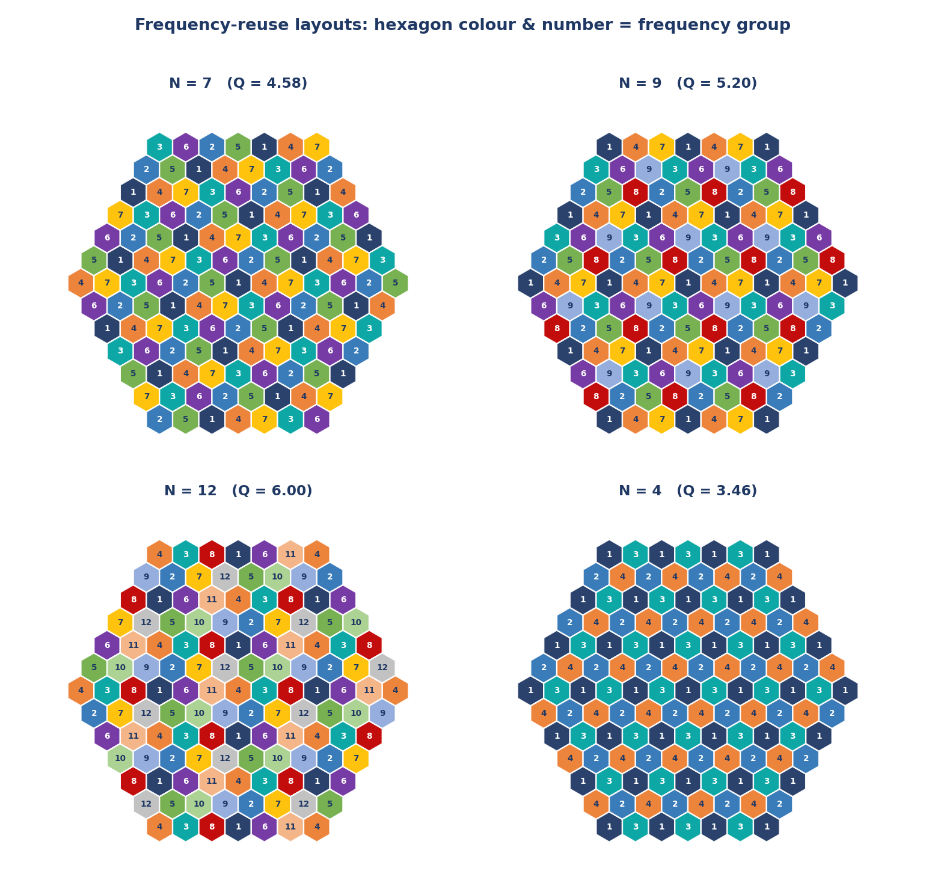
Figure 4. Layouts for N = 7, 9, 12 and 4 (6 rings).
N | (i, j) | Q | Groups | Capacity per cell (fraction of spectrum)
7 | (2, 1) | 4.583 | 7 | 1/7 = 14.3 %
9 | (3, 0) | 5.196 | 9 | 1/9 = 11.1 %
12 | (2, 2) | 6.000 | 12 | 1/12 = 8.3 %

Beyond N = 7 each increase in N buys little extra isolation: Q grows only as the square root of N (4.58 -> 5.20 -> 6.00), while the per-cell share of spectrum falls linearly (14.3 % -> 8.3 %). Moving from N = 7 to N = 12 gains 31 % in Q but costs 42 % of per-cell capacity, so the capacity-versus-interference trade-off turns increasingly unfavourable and operators prefer to improve SIR by sectoring or power control instead.

Task 2 - Strongest of three cells
The engine generalises to any number of cells: at each sample it selects the strongest non-serving cell, and hysteresis, TTT and streak tracking are applied to that candidate (the streak resets if the strongest candidate changes). A third cell C approaching later was added.
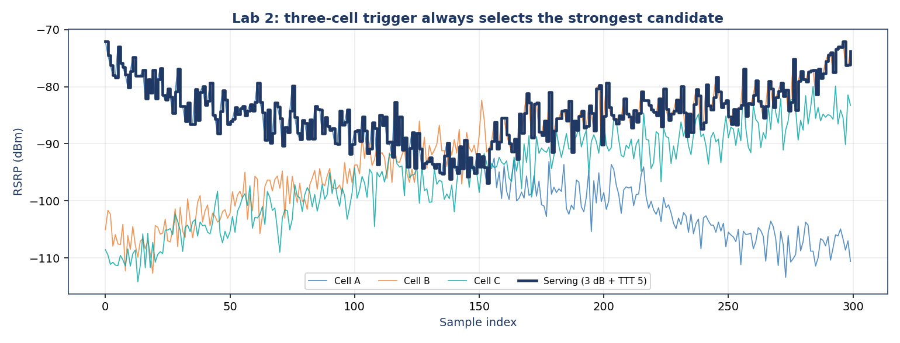
Figure 5. Three-cell scenario with the 3 dB + TTT 5 trigger always following the strongest cell.
Trigger | Handovers | Ping-pongs
Naive | 32 | 22
Hysteresis 3 dB | 9 | 4
Hysteresis 3 dB + TTT 5 | 1 | 0

With three overlapping candidates the naive trigger is even worse (32 handovers) because noise now reorders three curves, while hysteresis+TTT still keeps the count at one.

Task 3 - Joint sweep of margin and TTT (MRO-style)
Hysteresis 0-10 dB and TTT 1-20 samples were swept, averaging 12 independent noise realisations per cell of the grid. The goal is the combination with the fewest handovers whose mean minimum serving RSRP stays above -100 dBm; among near-minimal counts the one with the highest minimum RSRP wins (lowest RLF risk).
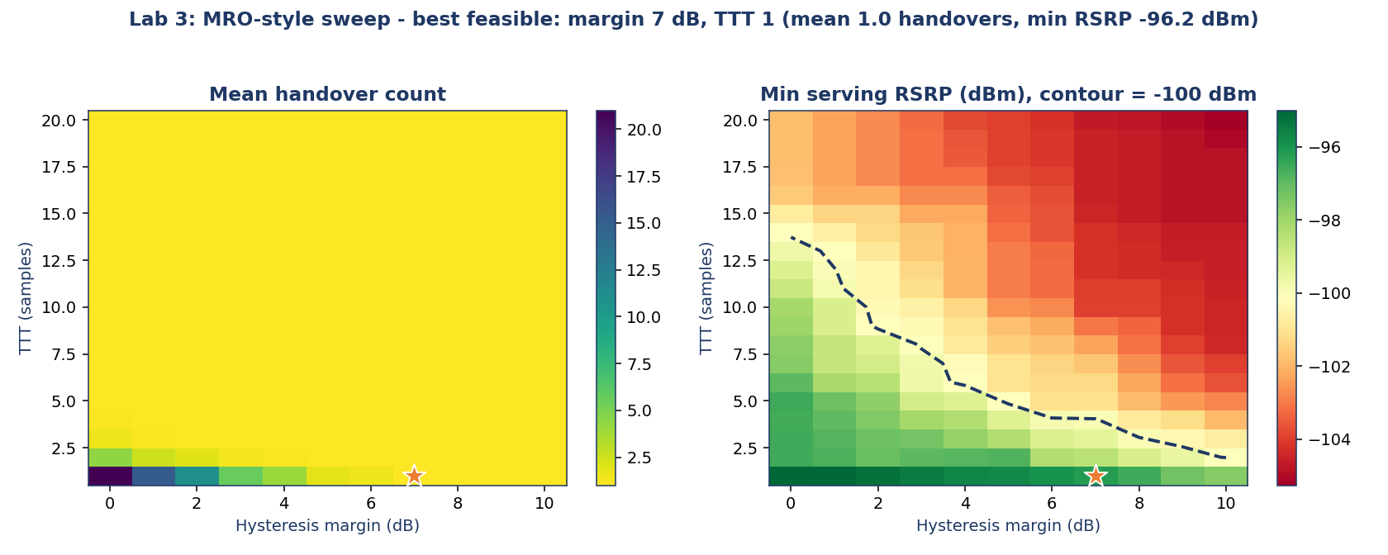
Figure 6. Left: mean handover count. Right: mean minimum serving RSRP with the -100 dBm contour. Star = selected optimum.
The optimum was hysteresis 7 dB, TTT 1: 1.0 handovers on average with a mean minimum serving RSRP of -96.2 dBm. For this slow, high-noise scenario a large margin alone suppresses ping-pong; TTT becomes more valuable when the margin is small. This is precisely the job of Mobility Robustness Optimization: choose the parameters that minimise handovers and failures jointly.

Task 4 - Faster device (highway or high-speed rail)
The trend slope was increased (-66 to -120 dBm) and the random-walk sigma raised to 0.9 dB. Using the tuned parameters from Task 3 and 30 repetitions of each scenario:
Scenario | Mean handovers | Mean min serving RSRP (dBm) | Mean samples < -100 dBm
Pedestrian-speed baseline | 1.07 | -97.0 | 0.47
Fast device | 1.33 | -98.1 | 3.8

The parameters tuned for slow mobility are no longer ideal at high speed: the serving link spends about eight times longer below -100 dBm, so a large margin that was safe at walking pace now risks too-late handover. Fast scenarios call for smaller margin or shorter TTT, which is why operators tune these parameters per mobility scenario.

Task 5 - Asymmetric offset for load balancing
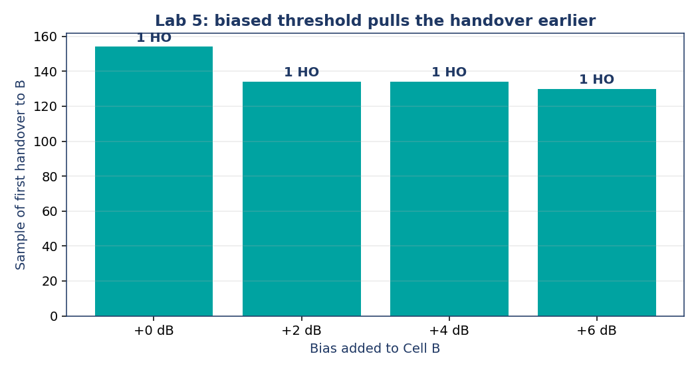
Figure 7. Effect of an additional bias favouring Cell B on the time of the first handover.
Adding a bias of 0, 2, 4 and 6 dB to cell B moved the first handover from sample 154 to 134, 134 and 130 while the count stayed at one. The biased threshold pulls the handover earlier and shifts the traffic boundary toward the serving cell, which is how a neighbour with spare capacity is made to take more users.

Task 6 - Three-sector sites
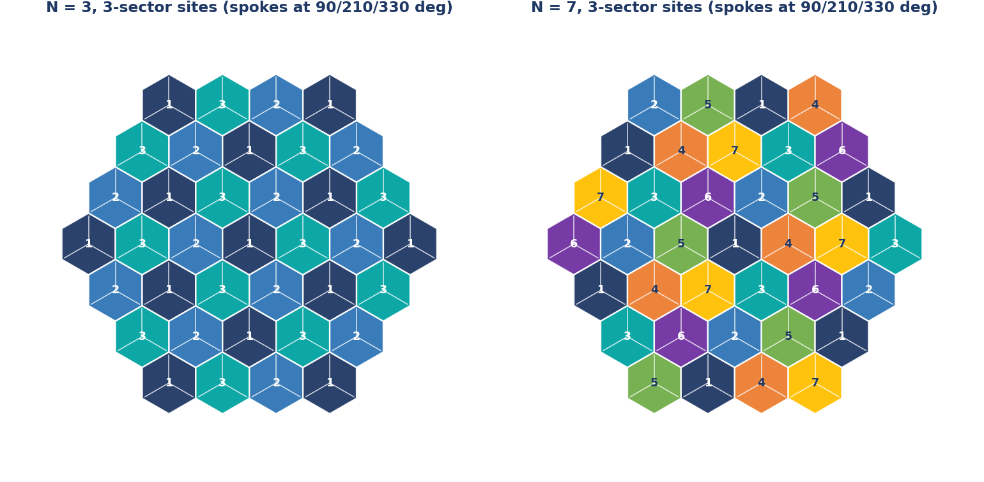
Figure 8. Sectored hexagon layouts (three 120-degree sectors per site) for N = 3 and N = 7.
With omnidirectional antennas a mobile sees six first-tier co-channel interferers. With 120-degree sectors only the cells whose beam points at the desired sector can interfere, about two of the six, so a tighter cluster size can be used for the same SIR. Quantification is in Mini Project 3.2.

Mini Project 3.2 - Cellular Capacity and Frequency-Reuse Planning

1. Problem and configuration
A planning tool computes system capacity for several reuse factors and relates it to Q and SIR; it then quantifies cell splitting and sectoring. All inputs live in one CONFIG block at the top of the script.
Parameter | Value | Parameter | Value
Total spectrum | 25 MHz | Coverage area | 1,000 km2
Channel bandwidth | 200 kHz | Cell radius R | 5 km
Total channels | 125 | Hexagon area 2.598 R2 | 64.95 km2 (15.4 cells fit)
TDMA slots / channel | 8 | Path-loss exponent n | 4
Candidate N | 1, 3, 4, 7, 9, 12 | Interferers (omni / 120 deg) | 6 / 2

2. Method (formulas)
- Total channels = spectrum / channel bandwidth = 25 MHz / 200 kHz = 125.
- Channels per cell = floor(125 / N). Cells in area = area / (3·sqrt(3)/2 * R^2).
- System capacity = channels per cell x number of cells (also expressed in simultaneous users with 8 slots per channel).
- Q = sqrt(3N); SIR = Q^n / i0 where i0 is the number of first-tier co-channel interferers (6 omni, 2 for 120-degree sectors, 1 for 60-degree sectors).
- Cell splitting: R -> R/2 or R/4 with the same N; cells multiply by 4 or 16 and transmit power must fall by 10·n·log10(factor) dB.

3. Results

3.1 Capacity versus reuse factor
N | Channels per cell | Cells | System capacity (channels) | Users (x8) | Q | SIR (dB)
1 | 125 | 15.4 | 1,925 | 15,396 | 1.73 | 1.8
3 | 41 | 15.4 | 631 | 5,050 | 3.00 | 11.3
4 | 31 | 15.4 | 477 | 3,818 | 3.46 | 13.8
7 | 17 | 15.4 | 262 | 2,094 | 4.58 | 18.7
9 | 13 | 15.4 | 200 | 1,601 | 5.20 | 20.8
12 | 10 | 15.4 | 154 | 1,232 | 6.00 | 23.3

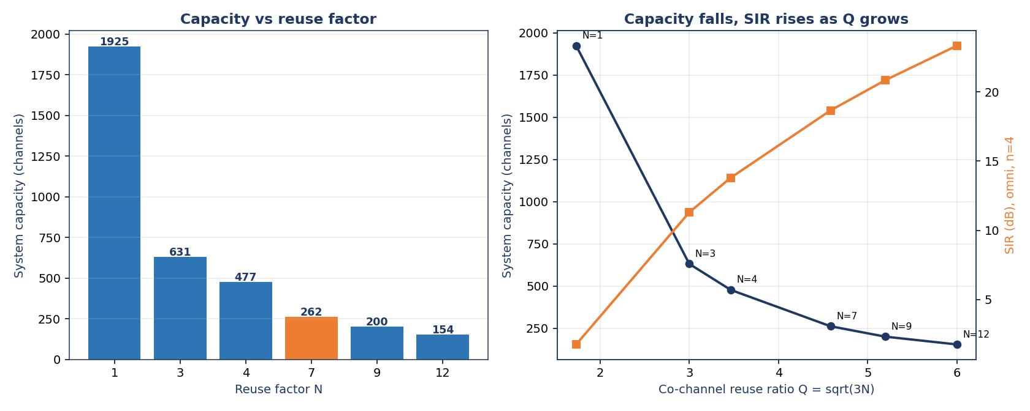
Figure 9. Left: capacity versus reuse factor. Right: capacity (navy) and SIR (orange) versus Q.

3.2 Cell splitting (N = 7)
Cell radius | Cells in area | Capacity (channels) | Gain | Tx power change
5.00 km (baseline) | 15 | 262 | x1 | 0 dB
2.50 km (R/2) | 62 | 1,047 | x4 | -12 dB
1.25 km (R/4) | 246 | 4,188 | x16 | -24 dB

Because the cluster size is unchanged, Q and the SIR stay the same while the number of cells grows with 1/R^2. The price is more base stations, lower transmit power and a handover every time the (now smaller) boundary is crossed.

3.3 Sectoring
Layout | Channels per cell | Q | SIR (dB) | Capacity (channels)
Omni, N = 7 | 17 | 4.58 | 18.7 | 262
Omni, N = 4 | 31 | 3.46 | 13.8 | 477
3-sector, N = 4 | 31 | 3.46 | 18.6 | 477
3-sector, N = 3 | 41 | 3.00 | 16.1 | 631
6-sector, N = 3 | 41 | 3.00 | 19.1 | 631

Why sectoring works (directional-beam argument, Section 3.1): a directional antenna only radiates and receives within its 120-degree beam, so a mobile in one sector is exposed only to co-channel cells whose beams happen to point at it. The first-tier interferers drop from six to about two, which raises the SIR by 10·log10(6/2) = 4.8 dB. That headroom lets the cluster shrink from N = 7 to N = 4 at the same SIR (18.6 dB versus 18.7 dB) while capacity rises from 262 to 477 channels. Caveats: each sector has only a third of the cell's channels (trunking efficiency drops) and handovers between sectors of the same site become frequent.

3.4 Capacity levers compared
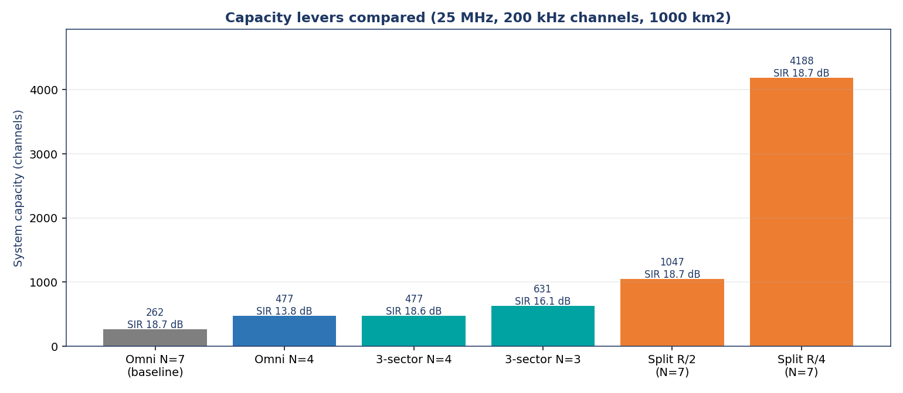
Figure 10. Capacity and SIR for each lever relative to the omni N = 7 baseline.

4. Written analysis (deliverable, 300-500 words)
Analysis (345 words)
The planning results show the central cellular trade-off. With 25 MHz and 200 kHz channels there are 125 channels. At N = 1 every cell may use all 125 and the 1,000 km2 area (about 15.4 cells of R = 5 km) offers 1,925 channels of capacity, but Q is only 1.73 and the SIR is about 1.8 dB, far too poor for any usable link. Moving to N = 3, 4, 7, 9 and 12 cuts capacity to 631, 477, 262, 200 and 154 channels, while Q rises to 3.00, 3.46, 4.58, 5.20 and 6.00 and the SIR improves from 11.3 dB to 23.3 dB. Capacity is inversely proportional to N and Q grows only as the square root of N, so every step towards cleaner signals costs a disproportionate share of capacity.
Choice of N depends on the deployment. In a dense urban area demand is the bottleneck, so operators accept a tighter reuse (N = 3 or 4) and rely on interference management and small cells; the high path-loss exponent and building shadowing already isolate co-channel cells. In rural deployments demand per km2 is low and coverage dominates, so a conservative reuse of N = 7 or more, with large cells, protects link quality at long range where signals are weak.
Once N is already small, shrinking it further is not an option because SIR collapses. Cell splitting and sectoring add capacity without touching the reuse pattern. Halving R quadruples the number of cells and therefore the capacity (262 to 1,047 channels at N = 7, and 4,188 at R/4), but it needs 12 dB less transmit power per halving at n = 4, more sites and far more handovers. Three-sectoring cuts the first-tier interferers from six to about two, so a 3-sector N = 4 layout reaches 18.6 dB SIR, equal to an omnidirectional N = 7 layout (18.7 dB), while giving 477 instead of 262 channels. Splitting and sectoring are therefore preferred because they raise capacity while keeping SIR acceptable, at the cost of additional sites, antennas and handover signalling.

5. Self-assessment against the evaluation criteria
Criterion | Weight | Where addressed
Correct channel and capacity calculations | 30 % | Section 3.1 table, plan() in the code
Correct computation and interpretation of Q | 15 % | Table and Figure 9; Q with SIR
Cell-splitting scenario | 15 % | Section 3.2 (R/2 and R/4, power change)
Sectoring discussion tied to interference | 10 % | Section 3.3, SIR numbers
Clarity of table and charts | 15 % | Figures 9-10, result tables
Depth and accuracy of written analysis | 15 % | Section 4

Mini Project 3.3 - Device Connection and Handover as a Finite-State Machine

1. Design of the state machine
The device lifecycle is an explicit FSM with seven states: IDLE; the four logical steps of RACH as sub-states (RA_PREAMBLE = Msg1, RA_RAR = Msg2, RA_MSG3 = Msg3, RA_CONTENTION = Msg4); CONNECTED; and HANDOVER (handover in progress). Each state occupies at least one 0.25 s sample so that every transition is time-stamped and logged with its trigger.
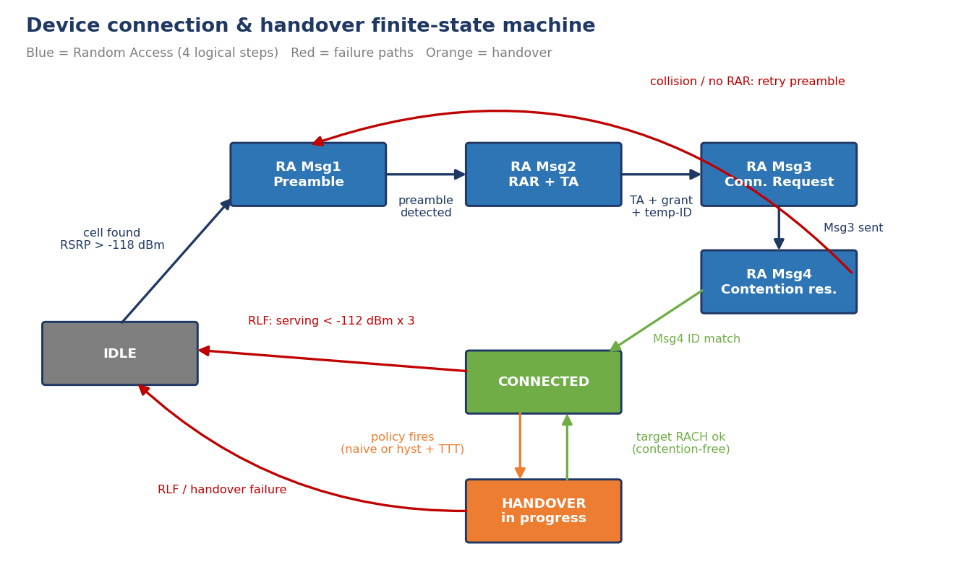
Figure 11. State-transition diagram with the four-step RACH, the handover loop and the RLF failure paths back to Idle.

State-transition table
From | To | Trigger / condition
IDLE | RA_PREAMBLE | A cell with RSRP > -118 dBm is found (cell selection); Msg1 preamble is sent
RA_PREAMBLE | RA_PREAMBLE | No Random Access Response (10 % probability): power ramp, retry up to 4 times, then IDLE
RA_PREAMBLE | RA_RAR | Preamble detected; Msg2 RAR delivers timing advance, UL grant and temporary ID
RA_RAR | RA_MSG3 | Msg3 (RRC Connection Request carrying the UE identity) is transmitted on the grant
RA_MSG3 | RA_CONTENTION | Waiting for Msg4
RA_CONTENTION | CONNECTED | Msg4 echoes the UE identity - contention resolved
RA_CONTENTION | RA_PREAMBLE | Collision (15 % probability): identity mismatch, new preamble
CONNECTED | HANDOVER | Active policy (naive or hysteresis+TTT) selects a target cell
HANDOVER | CONNECTED | After 2 samples the target is usable; contention-free RACH with a dedicated preamble completes
HANDOVER | IDLE | Handover failure: target RSRP below -112 dBm at completion
CONNECTED / HANDOVER | IDLE | RLF: serving RSRP < -112 dBm for 3 consecutive samples (too-late handover); 4-sample re-establishment search before re-access

2. Implementation
- Interchangeable policies: NaivePolicy and HystTTTPolicy(margin, ttt) expose the same interface, decide(t, serving, rsrp_dict) -> target or None, plus reset(). The device calls whichever is plugged in, so the identical scenario can be rerun under any policy.
- RACH: contention-based four-step sequence at initial access, with deterministic sub-states and random impairments (missing RAR, contention loss). At handover, the contention-free variant with a dedicated preamble is used, as described in Section 3.7 of the notes.
- Scripted scenario: cells A, B, C sit at 0, 800 and 1600 m on a road; the device drives from -100 m to 1700 m at 20 m/s (72 km/h), sampled every 0.25 s (360 samples). RSRP = -22 - 32·log10(d) plus AR(1) log-normal shadowing (sigma 3.5 dB, correlation 0.9) and 1.5 dB measurement noise, creating genuine overlaps between each consecutive pair.
- Post-processing: handovers completed, handover failures, RLFs, ping-pongs (handover back to the cell just left within 8 samples = 2 s) and percentage of time connected.
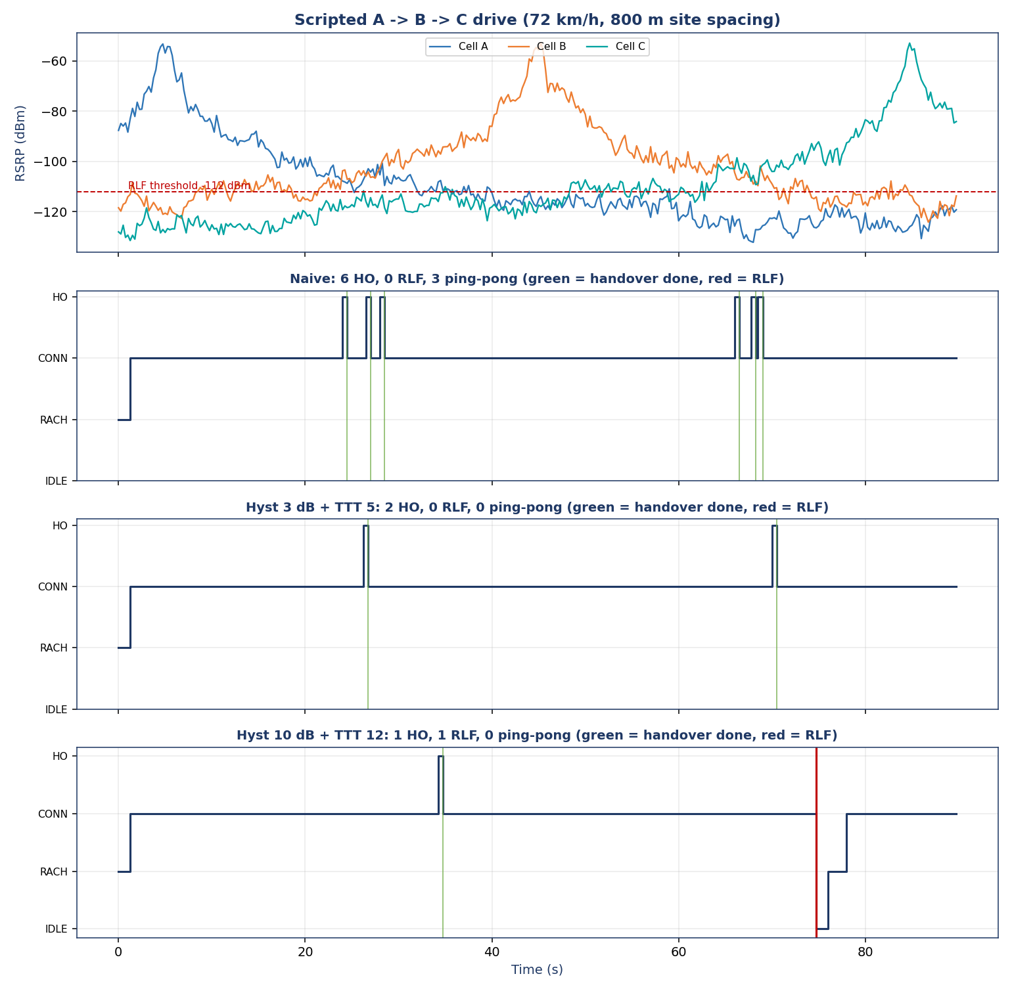
Figure 12. Top: scripted A -> B -> C signal series. Below: state timeline for each policy (green lines = handovers completed, red = RLF).

3. Results

3.1 Logged scenario (seed 2)
Policy | Handovers | HO failures | RLFs | Ping-pongs | Connected %
Naive | 6 | 0 | 0 | 3 | 98.6
Hysteresis 3 dB + TTT 5 | 2 | 0 | 0 | 0 | 98.6
Hysteresis 10 dB + TTT 12 | 1 | 0 | 1 | 0 | 95.0

3.2 Transition-log excerpts
Naive policy - the ping-pong A -> B -> A -> B at 24-28 s and B -> C -> B -> C at 66-69 s:
Transition log - policy: Naive
t(s) from to cell trigger
--------------------------------------------------------------------------------------------------------------
0.00 IDLE RA_PREAMBLE A cell A selected (-87.7 dBm); Msg1 preamble sent
0.25 RA_PREAMBLE RA_PREAMBLE A no RAR - power ramp, retry #2
0.50 RA_PREAMBLE RA_RAR A Msg2 RAR received: timing advance + UL grant + temp-ID
0.75 RA_RAR RA_MSG3 A Msg3 RRC Connection Request sent with UE identity
1.00 RA_MSG3 RA_CONTENTION A waiting for Msg4 contention resolution
1.25 RA_CONTENTION CONNECTED A Msg4 echoes UE identity - contention resolved
24.00 CONNECTED HANDOVER A Naive: B -103.8 vs A -107.8 dBm -> HO command
24.50 HANDOVER CONNECTED B contention-free RACH to B done (dedicated preamble, TA applied)
26.50 CONNECTED HANDOVER B Naive: A -105.2 vs B -105.9 dBm -> HO command
27.00 HANDOVER CONNECTED A contention-free RACH to A done (dedicated preamble, TA applied)
28.00 CONNECTED HANDOVER A Naive: B -102.6 vs A -105.4 dBm -> HO command
28.50 HANDOVER CONNECTED B contention-free RACH to B done (dedicated preamble, TA applied)
66.00 CONNECTED HANDOVER B Naive: C -103.0 vs B -104.4 dBm -> HO command
66.50 HANDOVER CONNECTED C contention-free RACH to C done (dedicated preamble, TA applied)
67.75 CONNECTED HANDOVER C Naive: B -106.5 vs C -107.9 dBm -> HO command
68.25 HANDOVER CONNECTED B contention-free RACH to B done (dedicated preamble, TA applied)
68.50 CONNECTED HANDOVER B Naive: C -108.9 vs B -109.7 dBm -> HO command
69.00 HANDOVER CONNECTED C contention-free RACH to C done (dedicated preamble, TA applied)

Hysteresis 3 dB + TTT 5 - two clean handovers, no ping-pong:
Transition log - policy: Hyst 3 dB + TTT 5
t(s) from to cell trigger
--------------------------------------------------------------------------------------------------------------
0.00 IDLE RA_PREAMBLE A cell A selected (-87.7 dBm); Msg1 preamble sent
0.25 RA_PREAMBLE RA_PREAMBLE A no RAR - power ramp, retry #2
0.50 RA_PREAMBLE RA_RAR A Msg2 RAR received: timing advance + UL grant + temp-ID
0.75 RA_RAR RA_MSG3 A Msg3 RRC Connection Request sent with UE identity
1.00 RA_MSG3 RA_CONTENTION A waiting for Msg4 contention resolution
1.25 RA_CONTENTION CONNECTED A Msg4 echoes UE identity - contention resolved
26.25 CONNECTED HANDOVER A Hyst 3 dB + TTT 5: B -103.8 vs A -107.1 dBm -> HO command
26.75 HANDOVER CONNECTED B contention-free RACH to B done (dedicated preamble, TA applied)
70.00 CONNECTED HANDOVER B Hyst 3 dB + TTT 5: C -104.1 vs B -108.9 dBm -> HO command
70.50 HANDOVER CONNECTED C contention-free RACH to C done (dedicated preamble, TA applied)

Hysteresis 10 dB + TTT 12 - the late handover and the RLF at 74.75 s that forces a return to IDLE and a fresh four-step RACH (with one contention loss):
Transition log - policy: Hyst 10 dB + TTT 12
t(s) from to cell trigger
--------------------------------------------------------------------------------------------------------------
0.00 IDLE RA_PREAMBLE A cell A selected (-87.7 dBm); Msg1 preamble sent
0.25 RA_PREAMBLE RA_PREAMBLE A no RAR - power ramp, retry #2
0.50 RA_PREAMBLE RA_RAR A Msg2 RAR received: timing advance + UL grant + temp-ID
0.75 RA_RAR RA_MSG3 A Msg3 RRC Connection Request sent with UE identity
1.00 RA_MSG3 RA_CONTENTION A waiting for Msg4 contention resolution
1.25 RA_CONTENTION CONNECTED A Msg4 echoes UE identity - contention resolved
34.25 CONNECTED HANDOVER A Hyst 10 dB + TTT 12: B -95.8 vs A -108.2 dBm -> HO command
34.75 HANDOVER CONNECTED B contention-free RACH to B done (dedicated preamble, TA applied)
74.75 CONNECTED IDLE None RLF: serving B -114.2 dBm < -112.0 for 3 samples
76.00 IDLE RA_PREAMBLE C cell C selected (-98.0 dBm); Msg1 preamble sent
76.25 RA_PREAMBLE RA_RAR C Msg2 RAR received: timing advance + UL grant + temp-ID
76.50 RA_RAR RA_MSG3 C Msg3 RRC Connection Request sent with UE identity
76.75 RA_MSG3 RA_CONTENTION C waiting for Msg4 contention resolution
77.00 RA_CONTENTION RA_PREAMBLE C contention lost (identity mismatch) - new preamble
77.25 RA_PREAMBLE RA_RAR C Msg2 RAR received: timing advance + UL grant + temp-ID
77.50 RA_RAR RA_MSG3 C Msg3 RRC Connection Request sent with UE identity
77.75 RA_MSG3 RA_CONTENTION C waiting for Msg4 contention resolution
78.00 RA_CONTENTION CONNECTED C Msg4 echoes UE identity - contention resolved

3.3 Monte-Carlo comparison (300 scenarios)
A single drive can be unrepresentative, so each policy was run over 300 independent shadowing realisations. Values are means per 90 s run.
Policy | Handovers | HO failures | RLFs | Ping-pongs | Connected %
Naive | 10.78 | 0.20 | 0.04 | 7.40 | 98.0
Hysteresis 3 dB + TTT 5 | 1.78 | 0.00 | 0.27 | 0.00 | 97.9
Hysteresis 10 dB + TTT 12 | 0.46 | 0.00 | 1.56 | 0.00 | 94.4

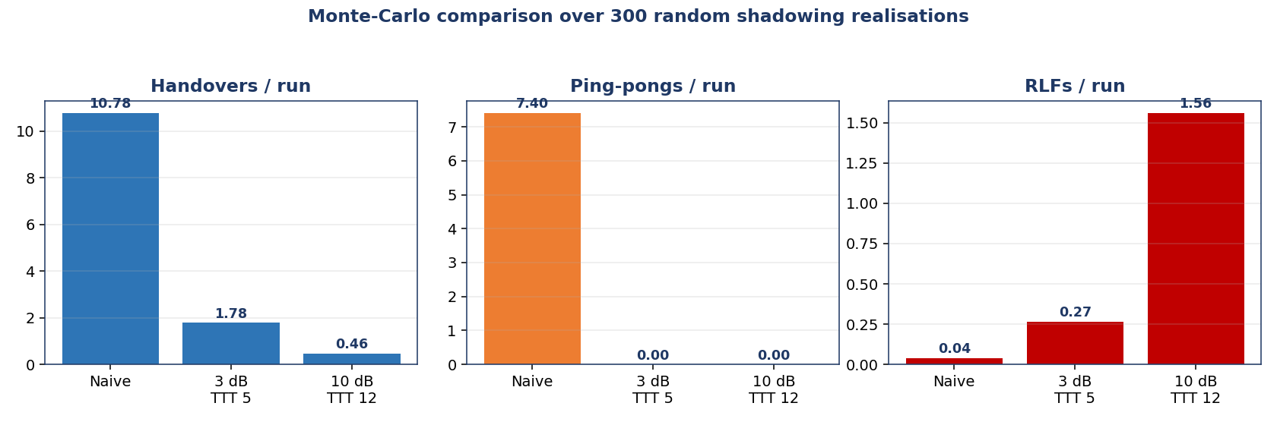
Figure 13. Mean handovers, ping-pongs and RLFs per run for the three policies over 300 scenarios.

4. Comparison report (deliverable, 250-400 words)
Comparison report (284 words)
We ran the same 90-second, 72 km/h A-to-B-to-C drive under three handover policies and then repeated it over 300 random shadowing realisations. The naive policy (hysteresis 0 dB, no time-to-trigger) fires whenever a neighbour is merely stronger. In the logged run it made 6 handovers, 3 of them ping-pongs back to a cell left within 2 s, and over 300 runs it averaged 10.8 handovers and 7.4 ping-pongs. It also recorded 0.2 handover failures per run because it sometimes handed the device to a target that had already faded. Its advantage is that it essentially never lets the serving link fall below the RLF threshold (0.04 RLFs per run), so connected time stays at 98.0 %.
The moderate policy (3 dB hysteresis, TTT of 5 samples = 1.25 s) delivered the two necessary handovers in the logged run with zero ping-pongs, and averaged 1.8 handovers and zero ping-pongs over 300 runs. Hysteresis filters out small differences, and TTT filters short fades, so only durable advantages trigger a handover. The cost is a small delay: RLFs rose to 0.27 per run.
The aggressive policy (10 dB, TTT of 12 samples = 3 s) shows the other end of the trade-off. It never ping-pongs, but it waits so long that the serving cell often collapses first: 1.56 RLFs per run, connected time dropped to 94.4 %, and in the logged run the device fell to Idle and had to repeat the full four-step RACH. This is the too-late handover. Larger hysteresis and longer TTT suppress ping-pong but raise RLF risk; smaller values do the opposite. The best operating point lies in between, which is exactly what Mobility Robustness Optimization tunes from observed RLF and ping-pong statistics.

5. Evaluation checklist
Criterion | Evidence
State machine complete, with RLF path (25 %) | Figure 11 and the state-transition table
RACH represented (15 %) | Four sub-states Msg1-Msg4, contention-free variant at handover, retry paths
Interchangeable policies (20 %) | NaivePolicy, HystTTTPolicy share one interface
Realistic scenario with decision points (15 %) | A-B-C drive, shadowing, overlaps visible in Figure 12
Logs and counts (15 %) | Excerpts above; complete logs in output/
Written report (10 %) | Section 4

Conclusions
- Frequency reuse and cluster size set the interference/capacity balance: Q = sqrt(3N) was verified geometrically and its effect on SIR and capacity quantified.
- Hysteresis and TTT eliminate ping-pong, but every increase moves the network closer to the too-late-handover / RLF boundary; the best settings depend on user speed.
- Cell splitting and sectoring are the practical capacity levers once N is small, each trading capacity for infrastructure and handover load.
- An explicit state machine with interchangeable policies makes the effect of mobility parameters measurable: policy comparison over 300 runs gave statistically stable counts.

Appendix A - Package contents
File | Purpose
code/mp31_reuse_handover.py | Mini Project 3.1 and Lab Tasks 1-6
code/mp32_capacity_planning.py | Mini Project 3.2 capacity planner and charts
code/mp33_fsm_handover.py | Mini Project 3.3 FSM, policies, scenario, Monte-Carlo
figures/ | All PNG figures used in this report
output/ | Tables (CSV/TXT), transition logs, signal series, console captures
To reproduce: pip install numpy matplotlib, then python3 code/mp31_reuse_handover.py, python3 code/mp32_capacity_planning.py, python3 code/mp33_fsm_handover.py.

Appendix B - Source code: Mini Project 3.1
#!/usr/bin/env python3
"""
Mobile Communications - Unit 3 - Mini Project 3.1
Simulating Frequency Reuse Planning and Handover Decision Logic

Part (a): hexagonal frequency-reuse pattern generator, Q = D/R = sqrt(3N)
Part (b): handover decision simulator (naive / hysteresis / hysteresis + TTT)
Lab Tasks 1-6 are implemented in the second half of this file.

Run: python3 mp31_reuse_handover.py (figures -> ../figures, tables -> ../output)
"""
import math
import os
import sys
import numpy as np
import matplotlib
matplotlib.use("Agg")
import matplotlib.pyplot as plt
from matplotlib.patches import RegularPolygon, Wedge
from matplotlib.lines import Line2D

HERE = os.path.dirname(os.path.abspath(__file__))
FIG = os.path.join(HERE, "..", "figures")
OUT = os.path.join(HERE, "..", "output")
os.makedirs(FIG, exist_ok=True)
os.makedirs(OUT, exist_ok=True)

NAVY, BLUE, TEAL, ORANGE, RED, GREY = "#1F3864", "#2E75B6", "#00A3A1", "#ED7D31", "#C00000", "#7F7F7F"
GROUP_COLORS = ["#1F3864", "#2E75B6", "#00A3A1", "#ED7D31", "#70AD47", "#7030A0",
"#FFC000", "#C00000", "#8FAADC", "#A9D18E", "#F4B183", "#BFBFBF"]
plt.rcParams.update({"font.family": "DejaVu Sans", "axes.edgecolor": NAVY, "axes.titleweight": "bold",
"axes.titlecolor": NAVY, "axes.labelcolor": NAVY, "figure.dpi": 120})

# --------------------------------------------------------------------------
# Step 1: environment check
# --------------------------------------------------------------------------
print("NumPy", np.__version__, "| Matplotlib", matplotlib.__version__, "| Python", sys.version.split()[0])

# --------------------------------------------------------------------------
# PART (a) - hexagonal geometry and frequency-group assignment
# --------------------------------------------------------------------------
def hex_centers(rings, R=1.0):
"""Step 2: centres of hexagons in `rings` rings around the origin (pointy-top, axial coords).
Returns list of (q, r, x, y)."""
cells = []
for q in range(-rings, rings + 1):
for r in range(max(-rings, -q - rings), min(rings, -q + rings) + 1):
x = R * math.sqrt(3) * (q + r / 2.0)
y = R * 1.5 * r
cells.append((q, r, x, y))
return cells

def find_ij(N):
"""Integers i>=j>=0 with N = i^2 + i*j + j^2 (None if N cannot tile a hex grid)."""
for i in range(0, 12):
for j in range(0, i + 1):
if i * i + i * j + j * j == N:
return i, j
return None

def group_labels(cells, N):
"""Step 3: frequency-group label 1..N for each cell using the cluster lattice
spanned by u=(i, j) and v=(-j, i+j) (axial coordinates, determinant = N).
Two cells share a label iff their difference is an integer combination of u and v."""
ij = find_ij(N)
if ij is None:
raise ValueError(f"N={N} does not satisfy N=i^2+ij+j^2")
i, j = ij
rem = []
for (q, r, _, _) in cells:
s = ((i + j) * q + j * r) // N # floor of lattice coordinate along u
t = (-j * q + i * r) // N # floor of lattice coordinate along v
rem.append((q - s * i + t * j, r - s * j - t * (i + j))) # remainder inside fundamental cell
order = {k: n + 1 for n, k in enumerate(sorted(set(rem)))} # stable label numbering
return [order[k] for k in rem]

def min_cochannel_distance(cells, labels, R=1.0):
"""Measured nearest same-group distance D (in units of R) - used to verify Q = sqrt(3N)."""
best = {}
xy = np.array([[c[2], c[3]] for c in cells])
lab = np.array(labels)
for g in set(labels):
pts = xy[lab == g]
if len(pts) < 2:
continue
d = np.sqrt(((pts[:, None, :] - pts[None, :, :]) ** 2).sum(-1))
d[d == 0] = 1e9
best[g] = d.min() / R
return min(best.values()) if best else float("nan")

def draw_layout(ax, N, rings, R=1.0, sectors=False, title=None):
cells = hex_centers(rings, R)
labels = group_labels(cells, N)
for (q, r, x, y), g in zip(cells, labels):
ax.add_patch(RegularPolygon((x, y), 6, radius=R, orientation=0,
facecolor=GROUP_COLORS[(g - 1) % len(GROUP_COLORS)],
edgecolor="white", linewidth=1.2, alpha=0.95))
txtc = "white" if g in (1, 2, 3, 6, 8) else NAVY
ax.text(x, y, str(g), ha="center", va="center", fontsize=7 if len(cells) > 60 else 9,
color=txtc, fontweight="bold")
if sectors: # Lab task 6: three 120-degree sectors drawn as spokes
for ang in (90, 210, 330):
ax.plot([x, x + 0.9 * R * math.cos(math.radians(ang))],
[y, y + 0.9 * R * math.sin(math.radians(ang))], color="white", lw=0.8, alpha=0.8)
lim = (rings + 1.2) * R * math.sqrt(3)
ax.set_xlim(-lim, lim); ax.set_ylim(-lim, lim)
ax.set_aspect("equal"); ax.axis("off")
ax.set_title(title or f"N = {N} (Q = {math.sqrt(3 * N):.2f})")
return cells, labels

def part_a(Ns=(1, 3, 4, 7), rings=5, fname="fig1_reuse_layouts.png", extra=False):
rows = []
cols = 2
nrows = math.ceil(len(Ns) / cols)
fig, axes = plt.subplots(nrows, cols, figsize=(11, 5.3 * nrows))
axes = np.atleast_1d(axes).ravel()
for ax, N in zip(axes, Ns):
cells, labels = draw_layout(ax, N, rings)
Q = math.sqrt(3 * N)
Dm = min_cochannel_distance(cells, labels)
ij = find_ij(N)
rows.append((N, ij, Q, len(set(labels)), Dm))
for ax in axes[len(Ns):]:
ax.axis("off")
fig.suptitle("Frequency-reuse layouts: hexagon colour & number = frequency group",
color=NAVY, fontweight="bold", fontsize=14)
fig.tight_layout(rect=[0, 0, 1, 0.96])
fig.savefig(os.path.join(FIG, fname), dpi=140)
plt.close(fig)
return rows

def print_q_table(rows, path):
lines = ["N (i,j) Q=sqrt(3N) groups_in_layout measured_D/R"]
for N, ij, Q, g, Dm in rows:
lines.append(f"{N:<4d} {str(ij):<7s} {Q:<12.3f} {g:<18d} {Dm:.3f}")
txt = "\n".join(lines)
print(txt)
with open(path, "w") as f:
f.write(txt + "\n")

# --------------------------------------------------------------------------
# PART (b) - synthetic RSRP series and handover triggers
# --------------------------------------------------------------------------
def make_series(n=300, start=-76.0, end=-108.0, walk_sigma=0.35, noise_sigma=2.6, rng=None):
"""Steps 7-8: linear trend + random walk + white Gaussian noise (dBm)."""
rng = rng or np.random.default_rng(7)
t = np.arange(n)
trend = start + (end - start) * t / (n - 1)
walk = np.cumsum(rng.normal(0, walk_sigma, n))
walk -= np.linspace(walk[0], walk[-1], n) # bridge the walk so the endpoints stay on-trend
return trend + walk + rng.normal(0, noise_sigma, n)

def run_trigger(series, serving0=0, margin=0.0, ttt=1, bias=None):
"""Generic handover engine for any number of cells.
margin : hysteresis margin in dB (0 = naive)
ttt : consecutive samples the entering condition must hold (1 = no timer)
bias : optional dict {cell: dB offset} added to a candidate (load balancing, Lab 5)
Returns serving-index array and list of (time, from, to)."""
n_cells, n = series.shape
serving = serving0
streak, cand = 0, None
serv_hist, events = np.zeros(n, dtype=int), []
for k in range(n):
vals = series[:, k].copy()
if bias:
for c, b in bias.items():
vals[c] += b
others = [c for c in range(n_cells) if c != serving]
best = max(others, key=lambda c: vals[c])
cond = vals[best] > series[serving, k] + margin
if cond:
streak = streak + 1 if best == cand else 1
cand = best
if streak >= ttt:
events.append((k, serving, best))
serving, streak, cand = best, 0, None
else:
streak, cand = 0, None
serv_hist[k] = serving
return serv_hist, events

def serving_rsrp(series, serv_hist):
return series[serv_hist, np.arange(series.shape[1])]

def ping_pongs(events, window=10):
"""Count handovers that return to the cell left within `window` samples."""
c = 0
for a, b in zip(events, events[1:]):
if b[2] == a[1] and (b[0] - a[0]) <= window:
c += 1
return c

def part_b():
rng = np.random.default_rng(7)
A = make_series(rng=rng, start=-76, end=-108) # serving: device moving away
B = make_series(rng=rng, start=-108, end=-76) # neighbour: device approaching
S = np.vstack([A, B])
t = np.arange(S.shape[1])
configs = [("Naive (no margin, no timer)", 0.0, 1),
("Hysteresis only (3 dB)", 3.0, 1),
("Hysteresis 3 dB + TTT 5 samples", 3.0, 5)]
THR = -100.0
results = []
fig, axes = plt.subplots(3, 1, figsize=(11, 9.5), sharex=True)
for ax, (name, m, ttt) in zip(axes, configs):
sh, ev = run_trigger(S, 0, m, ttt)
srv = serving_rsrp(S, sh)
ax.plot(t, S[0], color=BLUE, lw=1.0, alpha=0.85, label="Cell A RSRP")
ax.plot(t, S[1], color=ORANGE, lw=1.0, alpha=0.85, label="Cell B RSRP")
ax.plot(t, srv, color=NAVY, lw=1.5, alpha=0.9, drawstyle="steps-post", label="Serving-cell RSRP")
for (k, a, b) in ev:
ax.axvline(k, color=RED, lw=0.9, alpha=0.7)
ax.axhline(THR, color=GREY, ls="--", lw=1)
ax.text(2, THR + 0.6, "minimum threshold -100 dBm", fontsize=8, color=GREY)
ax.set_ylabel("RSRP (dBm)")
ax.set_title(f"{name}: {len(ev)} handovers")
ax.grid(alpha=0.25)
below = int(np.sum(srv < THR))
results.append((name, len(ev), ping_pongs(ev), below, float(srv.min())))
axes[0].legend(loc="upper right", ncol=3, fontsize=8)
axes[-1].set_xlabel("Sample index (time)")
fig.suptitle("Handover behaviour on identical RSRP traces (red lines = handovers)",
color=NAVY, fontweight="bold")
fig.tight_layout(rect=[0, 0, 1, 0.97])
fig.savefig(os.path.join(FIG, "fig2_handover_three_configs.png"), dpi=140)
plt.close(fig)

# raw curves figure (step 10 style) with naive markers
fig, ax = plt.subplots(figsize=(11, 4.2))
sh, ev = run_trigger(S, 0, 0, 1)
ax.plot(t, S[0], color=BLUE, label="Cell A"); ax.plot(t, S[1], color=ORANGE, label="Cell B")
for (k, a, b) in ev:
ax.axvline(k, color=RED, alpha=0.5, lw=0.9)
ax.set_title(f"Naive trigger on raw series: {len(ev)} handovers clustered at the crossover")
ax.set_xlabel("Sample index"); ax.set_ylabel("RSRP (dBm)"); ax.legend(); ax.grid(alpha=0.25)
fig.tight_layout(); fig.savefig(os.path.join(FIG, "fig3_naive_pingpong.png"), dpi=140); plt.close(fig)

lines = ["Configuration Handovers Ping-pongs Samples<-100dBm MinServingRSRP(dBm)"]
for (n_, h, pp, b_, mn) in results:
lines.append(f"{n_:<42s} {h:<10d} {pp:<11d} {b_:<16d} {mn:.1f}")
txt = "\n".join(lines)
print(txt)
open(os.path.join(OUT, "mp31_handover_counts.txt"), "w").write(txt + "\n")
return S, results

# --------------------------------------------------------------------------
# LAB TASKS
# --------------------------------------------------------------------------
def lab_task1():
"""Extend generator to N = 9 and 12."""
rows = part_a(Ns=(7, 9, 12, 4), rings=6, fname="fig4_lab1_N9_N12.png")
print("\n[Lab task 1] N=9 and N=12 added")
print_q_table(rows, os.path.join(OUT, "mp31_lab1_q_table.txt"))

def lab_task2(S2):
"""Third neighbour: strongest of three cells at each decision point."""
rng = np.random.default_rng(21)
C = make_series(rng=rng, start=-112, end=-84) # a third cell that approaches later than B
S3 = np.vstack([S2, C])
out = []
for name, m, ttt in [("Naive", 0, 1), ("Hyst 3 dB", 3, 1), ("Hyst 3 dB + TTT 5", 3, 5)]:
sh, ev = run_trigger(S3, 0, m, ttt)
out.append((name, len(ev), ping_pongs(ev)))
print("\n[Lab task 2] strongest-of-three:", out)
fig, ax = plt.subplots(figsize=(11, 4.2))
t = np.arange(S3.shape[1])
for c, col, lab in zip(range(3), (BLUE, ORANGE, TEAL), "ABC"):
ax.plot(t, S3[c], color=col, lw=0.9, alpha=0.8, label=f"Cell {lab}")
sh, ev = run_trigger(S3, 0, 3, 5)
ax.plot(t, serving_rsrp(S3, sh), color=NAVY, lw=2.4, drawstyle="steps-post", label="Serving (3 dB + TTT 5)")
ax.set_title("Lab 2: three-cell trigger always selects the strongest candidate")
ax.set_xlabel("Sample index"); ax.set_ylabel("RSRP (dBm)"); ax.legend(ncol=4, fontsize=8); ax.grid(alpha=0.25)
fig.tight_layout(); fig.savefig(os.path.join(FIG, "fig5_lab2_three_cells.png"), dpi=140); plt.close(fig)
return out

def lab_task3(S):
"""Sweep margin x TTT -> handover count and minimum serving RSRP (MRO-style optimisation)."""
margins = np.arange(0, 11, 1.0)
ttts = np.arange(1, 21, 1)
# average over several noise realisations for a stable optimum
reps = 12
cnt = np.zeros((len(ttts), len(margins)))
mn = np.zeros_like(cnt)
for rep in range(reps):
rg = np.random.default_rng(100 + rep)
SS = np.vstack([make_series(rng=rg, start=-76, end=-108), make_series(rng=rg, start=-108, end=-76)])
for a, ttt in enumerate(ttts):
for b, m in enumerate(margins):
sh, ev = run_trigger(SS, 0, m, int(ttt))
cnt[a, b] += len(ev) / reps
mn[a, b] += serving_rsrp(SS, sh).min() / reps
THR = -100.0
feasible = mn >= THR
masked = np.where(feasible, cnt, np.inf)
cmin = masked.min()
# among near-minimal counts, prefer the combination that keeps serving RSRP highest (lowest RLF risk)
cand = np.where(masked <= cmin + 0.25, mn, -np.inf)
a, b = np.unravel_index(np.argmax(cand), cand.shape)
best = (margins[b], ttts[a], cnt[a, b], mn[a, b])
fig, axes = plt.subplots(1, 2, figsize=(12, 4.8))
im0 = axes[0].imshow(cnt, origin="lower", aspect="auto", cmap="viridis_r",
extent=[margins[0] - .5, margins[-1] + .5, ttts[0] - .5, ttts[-1] + .5])
axes[0].set_title("Mean handover count"); plt.colorbar(im0, ax=axes[0])
im1 = axes[1].imshow(mn, origin="lower", aspect="auto", cmap="RdYlGn",
extent=[margins[0] - .5, margins[-1] + .5, ttts[0] - .5, ttts[-1] + .5])
axes[1].contour(margins, ttts, mn, levels=[THR], colors=[NAVY], linewidths=2)
axes[1].set_title("Min serving RSRP (dBm), contour = -100 dBm"); plt.colorbar(im1, ax=axes[1])
for ax in axes:
ax.scatter([best[0]], [best[1]], marker="*", s=220, color=ORANGE, edgecolor="white", zorder=5)
ax.set_xlabel("Hysteresis margin (dB)"); ax.set_ylabel("TTT (samples)")
fig.suptitle(f"Lab 3: MRO-style sweep - best feasible: margin {best[0]:.0f} dB, TTT {best[1]} "
f"(mean {best[2]:.1f} handovers, min RSRP {best[3]:.1f} dBm)", color=NAVY, fontweight="bold")
fig.tight_layout(rect=[0, 0, 1, 0.94])
fig.savefig(os.path.join(FIG, "fig6_lab3_sweep.png"), dpi=140); plt.close(fig)
print("\n[Lab task 3] best feasible (margin, TTT, mean handovers, mean min RSRP):", tuple(round(float(x),2) for x in best))
return best

def lab_task4(best):
"""Fast device: steeper trend + larger random walk; re-use tuned parameters."""
m, ttt = best[0], int(best[1])
res = {"slow": [], "fast": []}
for rep in range(30):
rg = np.random.default_rng(300 + rep)
slow = np.vstack([make_series(rng=rg, start=-76, end=-108), make_series(rng=rg, start=-108, end=-76)])
rg2 = np.random.default_rng(900 + rep)
fastS = np.vstack([make_series(n=300, start=-66, end=-120, walk_sigma=0.9, rng=rg2),
make_series(n=300, start=-120, end=-66, walk_sigma=0.9, rng=rg2)])
for key, SS in (("slow", slow), ("fast", fastS)):
sh, ev = run_trigger(SS, 0, m, ttt)
res[key].append((len(ev), serving_rsrp(SS, sh).min(), int(np.sum(serving_rsrp(SS, sh) < -100))))
summ = {k: tuple(np.mean(v, axis=0)) for k, v in res.items()}
print(f"\n[Lab task 4] tuned (m={m}, TTT={ttt}) slow vs fast (handovers, minRSRP, samples<-100):", summ)
return summ, (m, ttt)

def lab_task5(S):
"""Asymmetric offset favouring handover toward cell B (biased threshold, load balancing)."""
out = []
for bias in (0.0, 2.0, 4.0, 6.0):
sh, ev = run_trigger(S, 0, 3.0, 5, bias={1: bias})
first = ev[0][0] if ev else None
out.append((bias, len(ev), first))
print("\n[Lab task 5] bias toward B (dB, handovers, first handover time):", out)
fig, ax = plt.subplots(figsize=(7.5, 4))
ax.bar([f"+{b:.0f} dB" for b, _, _ in out], [f if f is not None else 0 for _, _, f in out], color=TEAL)
for i, (b, n_, f) in enumerate(out):
ax.text(i, (f or 0) + 3, f"{n_} HO", ha="center", color=NAVY, fontweight="bold")
ax.set_ylabel("Sample of first handover to B"); ax.set_xlabel("Bias added to Cell B")
ax.set_title("Lab 5: biased threshold pulls the handover earlier"); ax.grid(axis="y", alpha=0.25)
fig.tight_layout(); fig.savefig(os.path.join(FIG, "fig7_lab5_bias.png"), dpi=140); plt.close(fig)
return out

def lab_task6():
"""Sectored hex layout (3 x 120 degrees) for N = 3 and N = 7 and interferer count comparison."""
fig, axes = plt.subplots(1, 2, figsize=(11, 5.4))
for ax, N in zip(axes, (3, 7)):
draw_layout(ax, N, 3, sectors=True, title=f"N = {N}, 3-sector sites (spokes at 90/210/330 deg)")
fig.tight_layout(); fig.savefig(os.path.join(FIG, "fig8_lab6_sectored.png"), dpi=140); plt.close(fig)
# first-tier co-channel interferers seen by a desired mobile: omni = 6, 120-degree sector ~ 2
print("\n[Lab task 6] first-tier interferers: omni = 6, 120-deg sectors ~ 2 (see report)")
return {"omni": 6, "sector120": 2, "sector60": 1}

# --------------------------------------------------------------------------
def main():
rows = part_a()
print("\nFrequency reuse summary (Step 6)")
print_q_table(rows, os.path.join(OUT, "mp31_q_table.txt"))
S, results = part_b()
lab_task1()
lab_task2(S)
best = lab_task3(S)
lab_task4(best)
lab_task5(S)
lab_task6()

if __name__ == "__main__":
main()

Appendix C - Source code: Mini Project 3.2
#!/usr/bin/env python3
"""
Mobile Communications - Unit 3 - Mini Project 3.2
Cellular Capacity and Frequency-Reuse Planning Tool

Computes channels/cell, number of cells, system capacity, Q and SIR for several reuse
factors N, then quantifies cell splitting and sectoring as alternative capacity levers.

Run: python3 mp32_capacity_planning.py (tables -> ../output, charts -> ../figures)
"""
import csv
import math
import os
import numpy as np
import matplotlib
matplotlib.use("Agg")
import matplotlib.pyplot as plt

HERE = os.path.dirname(os.path.abspath(__file__))
FIG, OUT = os.path.join(HERE, "..", "figures"), os.path.join(HERE, "..", "output")
os.makedirs(FIG, exist_ok=True); os.makedirs(OUT, exist_ok=True)
NAVY, BLUE, TEAL, ORANGE, RED, GREY = "#1F3864", "#2E75B6", "#00A3A1", "#ED7D31", "#C00000", "#7F7F7F"
plt.rcParams.update({"font.family": "DejaVu Sans", "axes.edgecolor": NAVY, "axes.titleweight": "bold",
"axes.titlecolor": NAVY, "axes.labelcolor": NAVY, "figure.dpi": 120})

# ------------------------------------------------------------------ 1. CONFIGURATION
CONFIG = dict(
total_spectrum_hz=25e6, # 25 MHz allocation (one direction)
channel_bw_hz=200e3, # GSM-style 200 kHz carrier
slots_per_channel=8, # TDMA slots -> simultaneous users per channel (GSM)
coverage_area_km2=1000.0, # service area
cell_radius_km=5.0, # R
candidate_N=[1, 3, 4, 7, 9, 12],
path_loss_exp=4.0, # urban macro propagation exponent n
)
HEX_FACTOR = 3 * math.sqrt(3) / 2 # hexagon area = 2.598 R^2

def hex_area(R):
return HEX_FACTOR * R * R

def plan(cfg, R=None, N_list=None, sectors=1):
"""Return list of dict rows: N, channels per cell, cells, capacity, Q, SIR."""
R = R or cfg["cell_radius_km"]
total_ch = int(cfg["total_spectrum_hz"] // cfg["channel_bw_hz"])
cells = cfg["coverage_area_km2"] / hex_area(R)
i0 = {1: 6, 3: 2, 6: 1}[sectors] # first-tier co-channel interferers (omni / 120 / 60 deg)
rows = []
for N in (N_list or cfg["candidate_N"]):
ch_cell = total_ch // N
Q = math.sqrt(3 * N)
sir = Q ** cfg["path_loss_exp"] / i0
rows.append(dict(N=N, total_channels=total_ch, channels_per_cell=ch_cell, cells=cells,
capacity_channels=ch_cell * cells,
capacity_users=ch_cell * cells * cfg["slots_per_channel"],
Q=Q, SIR_dB=10 * math.log10(sir), R=R, sectors=sectors))
return rows

def write_csv(rows, path):
with open(path, "w", newline="") as f:
w = csv.DictWriter(f, fieldnames=list(rows[0].keys()))
w.writeheader()
for r in rows:
w.writerow({k: (round(v, 3) if isinstance(v, float) else v) for k, v in r.items()})

def main():
cfg = CONFIG
print("CONFIGURATION:", cfg)
base = plan(cfg)
total_ch = base[0]["total_channels"]
print(f"\nTotal channels = {cfg['total_spectrum_hz']/1e6:.0f} MHz / {cfg['channel_bw_hz']/1e3:.0f} kHz = {total_ch}")
print(f"Hex cell area (R={cfg['cell_radius_km']} km) = {hex_area(cfg['cell_radius_km']):.2f} km2 "
f"-> {base[0]['cells']:.1f} cells fit in {cfg['coverage_area_km2']:.0f} km2")
hdr = f"{'N':>3} {'ch/cell':>8} {'cells':>7} {'capacity(ch)':>13} {'users(x8)':>10} {'Q':>6} {'SIR dB':>7}"
print("\n" + hdr)
for r in base:
print(f"{r['N']:>3} {r['channels_per_cell']:>8} {r['cells']:>7.1f} {r['capacity_channels']:>13.0f} "
f"{r['capacity_users']:>10.0f} {r['Q']:>6.2f} {r['SIR_dB']:>7.1f}")
write_csv(base, os.path.join(OUT, "mp32_capacity_table.csv"))

# ---- cell splitting: halve and quarter R (frequency plan N unchanged) ----
N_split = 7
split_rows = []
for factor in (1, 2, 4):
R = cfg["cell_radius_km"] / factor
r = plan(cfg, R=R, N_list=[N_split])[0]
# transmit power must fall by 10*n*log10(factor) dB to keep the same SIR/cell edge level
r["power_reduction_dB"] = 10 * cfg["path_loss_exp"] * math.log10(factor)
r["gain_vs_base"] = r["capacity_channels"] / base[[b["N"] for b in base].index(N_split)]["capacity_channels"]
split_rows.append(r)
print(f"\nCell splitting (N={N_split}):")
for r in split_rows:
print(f" R={r['R']:.2f} km cells={r['cells']:.0f} capacity={r['capacity_channels']:.0f} ch "
f"gain x{r['gain_vs_base']:.1f} Tx power change -{r['power_reduction_dB']:.0f} dB")
write_csv(split_rows, os.path.join(OUT, "mp32_cell_splitting.csv"))

# ---- sectoring: omni vs 120-deg sectors with tighter reuse ----
sector_rows = []
for label, N, sec in [("Omni, N=7", 7, 1), ("Omni, N=4", 4, 1), ("3-sector, N=4", 4, 3),
("3-sector, N=3", 3, 3), ("6-sector, N=3", 3, 6)]:
r = plan(cfg, N_list=[N], sectors=sec)[0]
r["label"] = label
sector_rows.append(r)
print("\nSectoring (SIR = Q^n / i0, n=4):")
for r in sector_rows:
print(f" {r['label']:<14} ch/cell={r['channels_per_cell']:>3} Q={r['Q']:.2f} SIR={r['SIR_dB']:.1f} dB "
f"capacity={r['capacity_channels']:.0f}")
write_csv([{k: v for k, v in r.items() if k != 'label'} | {"label": r["label"]} for r in sector_rows],
os.path.join(OUT, "mp32_sectoring.csv"))

# ---------------------------------------------------------------- charts
Ns = [r["N"] for r in base]
cap = [r["capacity_channels"] for r in base]
Qs = [r["Q"] for r in base]
sirs = [r["SIR_dB"] for r in base]

fig, ax = plt.subplots(1, 2, figsize=(12, 4.8))
bars = ax[0].bar([str(n) for n in Ns], cap, color=[BLUE if n != 7 else ORANGE for n in Ns])
for b, c in zip(bars, cap):
ax[0].text(b.get_x() + b.get_width() / 2, c + 8, f"{c:.0f}", ha="center", color=NAVY, fontsize=9, fontweight="bold")
ax[0].set_xlabel("Reuse factor N"); ax[0].set_ylabel("System capacity (channels)")
ax[0].set_title("Capacity vs reuse factor"); ax[0].grid(axis="y", alpha=0.25)
ax[1].plot(Qs, cap, "-o", color=NAVY, lw=2, label="Capacity (channels)")
for q, c, n in zip(Qs, cap, Ns):
ax[1].annotate(f"N={n}", (q, c), textcoords="offset points", xytext=(5, 6), fontsize=8)
ax[1].set_xlabel("Co-channel reuse ratio Q = sqrt(3N)"); ax[1].set_ylabel("System capacity (channels)", color=NAVY)
ax2 = ax[1].twinx()
ax2.plot(Qs, sirs, "-s", color=ORANGE, lw=2, label="SIR (dB)")
ax2.set_ylabel("SIR (dB), omni, n=4", color=ORANGE)
ax[1].set_title("Capacity falls, SIR rises as Q grows"); ax[1].grid(alpha=0.25)
fig.tight_layout(); fig.savefig(os.path.join(FIG, "fig9_capacity_vs_N_Q.png"), dpi=140); plt.close(fig)

fig, ax = plt.subplots(figsize=(11, 4.8))
labels = ["Omni N=7\n(baseline)", "Omni N=4", "3-sector N=4", "3-sector N=3",
"Split R/2\n(N=7)", "Split R/4\n(N=7)"]
base7 = base[Ns.index(7)]["capacity_channels"]
vals = [sector_rows[0]["capacity_channels"], sector_rows[1]["capacity_channels"],
sector_rows[2]["capacity_channels"], sector_rows[3]["capacity_channels"],
split_rows[1]["capacity_channels"], split_rows[2]["capacity_channels"]]
sir_l = [sector_rows[0]["SIR_dB"], sector_rows[1]["SIR_dB"], sector_rows[2]["SIR_dB"],
sector_rows[3]["SIR_dB"], split_rows[1]["SIR_dB"], split_rows[2]["SIR_dB"]]
cols = [GREY, BLUE, TEAL, TEAL, ORANGE, ORANGE]
bs = ax.bar(labels, vals, color=cols)
for b, v, s_ in zip(bs, vals, sir_l):
ax.text(b.get_x() + b.get_width() / 2, v + 20, f"{v:.0f}\nSIR {s_:.1f} dB", ha="center", fontsize=8.5, color=NAVY)
ax.set_ylabel("System capacity (channels)"); ax.set_ylim(0, max(vals) * 1.18)
ax.set_title("Capacity levers compared (25 MHz, 200 kHz channels, 1000 km2)"); ax.grid(axis="y", alpha=0.25)
fig.tight_layout(); fig.savefig(os.path.join(FIG, "fig10_capacity_levers.png"), dpi=140); plt.close(fig)
print("\nCharts written to ../figures")

if __name__ == "__main__":
main()

Appendix D - Source code: Mini Project 3.3
#!/usr/bin/env python3
"""
Mobile Communications - Unit 3 - Mini Project 3.3
Device connection and handover modelled as a finite-state machine.

States : IDLE, RA_PREAMBLE, RA_RAR, RA_MSG3, RA_CONTENTION (Random-Access = 4 sub-states, Msg1..Msg4)
CONNECTED, HANDOVER
Failure: Radio Link Failure (RLF) -> IDLE (too-late handover), handover failure -> IDLE
Policies are interchangeable objects: decide(t, serving, rsrp_dict) -> target cell or None.

Run: python3 mp33_fsm_handover.py (logs -> ../output, figures -> ../figures)
"""
import os
import math
import numpy as np
import matplotlib
matplotlib.use("Agg")
import matplotlib.pyplot as plt
from matplotlib.patches import FancyBboxPatch, FancyArrowPatch

HERE = os.path.dirname(os.path.abspath(__file__))
FIG, OUT = os.path.join(HERE, "..", "figures"), os.path.join(HERE, "..", "output")
os.makedirs(FIG, exist_ok=True); os.makedirs(OUT, exist_ok=True)
NAVY, BLUE, TEAL, ORANGE, RED, GREY, GREEN = "#1F3864", "#2E75B6", "#00A3A1", "#ED7D31", "#C00000", "#7F7F7F", "#70AD47"
plt.rcParams.update({"font.family": "DejaVu Sans", "axes.edgecolor": NAVY, "axes.titleweight": "bold",
"axes.titlecolor": NAVY, "axes.labelcolor": NAVY, "figure.dpi": 120})

# ------------------------------------------------------------- scenario parameters
DT = 0.25 # s per sample
SPEED = 20.0 # m/s (72 km/h)
SITES = {"A": 0.0, "B": 800.0, "C": 1600.0} # cell positions along the road (m)
X0, X1 = -100.0, 1700.0
PL_EXP, PL_REF = 32.0, -22.0 # RSRP(d) = PL_REF - PL_EXP*log10(d)
SHADOW_SIGMA, SHADOW_CORR = 3.5, 0.9
RLF_THR, RLF_COUNT = -112.0, 3 # RLF if serving < thr for 3 consecutive samples
CAMP_THR = -118.0 # minimum RSRP to attempt random access
HO_DURATION = 2 # samples spent in HANDOVER (execution phase)
REESTABLISH = 4 # samples spent searching after RLF
P_NO_RAR, P_COLLISION = 0.10, 0.15 # RACH impairments (initial access only)
MAX_PREAMBLE_TRIES = 4
PING_PONG_WINDOW = 8 # samples (= 2 s)

def build_scenario(seed):
"""Scripted A -> B -> C drive with correlated log-normal shadowing: returns t, x, dict of RSRP series."""
rng = np.random.default_rng(seed)
n = int((X1 - X0) / SPEED / DT)
x = X0 + SPEED * DT * np.arange(n)
sig = {}
for c, pos in SITES.items():
d = np.maximum(np.abs(x - pos), 10.0)
shadow = np.zeros(n)
for k in range(1, n):
shadow[k] = SHADOW_CORR * shadow[k - 1] + math.sqrt(1 - SHADOW_CORR ** 2) * rng.normal(0, SHADOW_SIGMA)
fast = rng.normal(0, 1.5, n) # measurement noise / fast fading residue
sig[c] = PL_REF - PL_EXP * np.log10(d) + shadow + fast
return np.arange(n), x, sig

# ------------------------------------------------------------- interchangeable policies
class NaivePolicy:
name = "Naive"
def reset(self): pass
def decide(self, t, serving, rsrp):
best = max((c for c in rsrp if c != serving), key=lambda c: rsrp[c])
return best if rsrp[best] > rsrp[serving] else None

class HystTTTPolicy:
def __init__(self, margin=3.0, ttt=5):
self.margin, self.ttt = margin, ttt
self.name = f"Hyst {margin:g} dB + TTT {ttt}"
self.reset()
def reset(self):
self.cand, self.streak = None, 0
def decide(self, t, serving, rsrp):
best = max((c for c in rsrp if c != serving), key=lambda c: rsrp[c])
if rsrp[best] > rsrp[serving] + self.margin:
self.streak = self.streak + 1 if best == self.cand else 1
self.cand = best
if self.streak >= self.ttt:
self.reset()
return best
else:
self.reset()
return None

# ------------------------------------------------------------- the state machine
class Device:
RA_STEPS = ["RA_PREAMBLE", "RA_RAR", "RA_MSG3", "RA_CONTENTION"]

def __init__(self, policy, rng):
self.p, self.rng = policy, rng
self.state, self.cell, self.target = "IDLE", None, None
self.ra_idx, self.tries, self.ho_left, self.bad, self.wait = 0, 0, 0, 0, 0
self.log, self.state_hist, self.cell_hist = [], [], []
self.handovers, self.ho_fail, self.rlf = [], 0, 0

def go(self, t, new, cell, trigger):
self.log.append((t, self.state, new, cell, trigger))
self.state = new

def step(self, t, rsrp):
s = self.state
if s == "IDLE":
if self.wait > 0:
self.wait -= 1
else:
best = max(rsrp, key=rsrp.get)
if rsrp[best] > CAMP_THR:
self.cell, self.tries, self.ra_idx = best, 1, 0
self.go(t, "RA_PREAMBLE", best, f"cell {best} selected ({rsrp[best]:.1f} dBm); Msg1 preamble sent")
elif s == "RA_PREAMBLE": # Msg1 -> wait for Msg2
if self.rng.random() < P_NO_RAR:
if self.tries >= MAX_PREAMBLE_TRIES:
self.go(t, "IDLE", None, "max preamble attempts reached"); self.cell = None
else:
self.tries += 1
self.log.append((t, s, s, self.cell, f"no RAR - power ramp, retry #{self.tries}"))
else:
self.go(t, "RA_RAR", self.cell, "Msg2 RAR received: timing advance + UL grant + temp-ID")
elif s == "RA_RAR":
self.go(t, "RA_MSG3", self.cell, "Msg3 RRC Connection Request sent with UE identity")
elif s == "RA_MSG3":
self.go(t, "RA_CONTENTION", self.cell, "waiting for Msg4 contention resolution")
elif s == "RA_CONTENTION":
if self.rng.random() < P_COLLISION:
self.tries += 1
self.go(t, "RA_PREAMBLE", self.cell, "contention lost (identity mismatch) - new preamble")
else:
self.bad = 0
self.go(t, "CONNECTED", self.cell, "Msg4 echoes UE identity - contention resolved")
elif s in ("CONNECTED", "HANDOVER"):
self.bad = self.bad + 1 if rsrp[self.cell] < RLF_THR else 0
if self.bad >= RLF_COUNT: # ---- failure path (too-late handover)
self.rlf += 1
self.go(t, "IDLE", None, f"RLF: serving {self.cell} {rsrp[self.cell]:.1f} dBm < {RLF_THR} for {RLF_COUNT} samples")
self.cell, self.target, self.wait = None, None, REESTABLISH
self.p.reset()
return
if s == "CONNECTED":
tgt = self.p.decide(t, self.cell, rsrp)
if tgt:
self.target, self.ho_left = tgt, HO_DURATION
self.go(t, "HANDOVER", self.cell,
f"{self.p.name}: {tgt} {rsrp[tgt]:.1f} vs {self.cell} {rsrp[self.cell]:.1f} dBm -> HO command")
else:
self.ho_left -= 1
if self.ho_left <= 0:
if rsrp[self.target] < RLF_THR: # target unusable -> handover failure
self.ho_fail += 1
self.go(t, "IDLE", None, f"HO failure: target {self.target} {rsrp[self.target]:.1f} dBm too weak")
self.cell, self.target, self.wait = None, None, REESTABLISH
else:
old = self.cell
self.handovers.append((t, old, self.target))
self.cell, self.bad = self.target, 0
self.go(t, "CONNECTED", self.cell,
f"contention-free RACH to {self.cell} done (dedicated preamble, TA applied)")
self.target = None

def run(self, sig):
n = len(next(iter(sig.values())))
for t in range(n):
r = {c: float(sig[c][t]) for c in sig}
self.step(t, r)
self.state_hist.append(self.state)
self.cell_hist.append(self.cell)
return self

def count_ping_pongs(handovers, window=PING_PONG_WINDOW):
c = 0
for a, b in zip(handovers, handovers[1:]):
if b[2] == a[1] and b[0] - a[0] <= window:
c += 1
return c

def summarize(dev):
n = len(dev.state_hist)
conn = sum(1 for s in dev.state_hist if s in ("CONNECTED", "HANDOVER"))
return dict(handovers=len(dev.handovers), ho_fail=dev.ho_fail, rlf=dev.rlf,
ping_pong=count_ping_pongs(dev.handovers), connected_pct=100 * conn / n)

# ------------------------------------------------------------- figures
def draw_state_diagram(path):
fig, ax = plt.subplots(figsize=(12, 7))
ax.set_xlim(0, 12); ax.set_ylim(0, 7.6); ax.axis("off")
W, H = 1.9, 0.8
boxes = {"IDLE": (1.4, 2.8, GREY, "IDLE"), "M1": (3.8, 5.3, BLUE, "RA Msg1\nPreamble"),
"M2": (6.8, 5.3, BLUE, "RA Msg2\nRAR + TA"), "M3": (9.8, 5.3, BLUE, "RA Msg3\nConn. Request"),
"M4": (9.8, 3.8, BLUE, "RA Msg4\nContention res."), "CONN": (6.8, 2.4, GREEN, "CONNECTED"),
"HO": (6.8, 0.6, ORANGE, "HANDOVER\nin progress")}
for x, y, c, t in boxes.values():
ax.add_patch(FancyBboxPatch((x - W / 2, y - H / 2), W, H, boxstyle="round,pad=0.04", fc=c, ec=NAVY, lw=1.5))
ax.text(x, y, t, ha="center", va="center", color="white", fontsize=9.5, fontweight="bold")

def arrow(p1, p2, col=NAVY, rad=0.0):
ax.add_patch(FancyArrowPatch(p1, p2, arrowstyle="-|>", mutation_scale=15, color=col, lw=1.7,
connectionstyle=f"arc3,rad={rad}"))

def label(x, y, t, col=NAVY, ha="center"):
ax.text(x, y, t, fontsize=8.3, color=col, ha=ha, va="center", bbox=dict(fc="white", ec="none", alpha=0.9, pad=1.5))

arrow((1.4, 3.2), (2.85, 5.0)); label(1.3, 4.4, "cell found\nRSRP > -118 dBm")
arrow((4.75, 5.3), (5.85, 5.3)); label(5.3, 4.85, "preamble\ndetected")
arrow((7.75, 5.3), (8.85, 5.3)); label(8.3, 4.85, "TA + grant\n+ temp-ID")
arrow((9.8, 4.9), (9.8, 4.2)); label(10.75, 4.55, "Msg3 sent")
arrow((8.85, 3.7), (7.6, 2.8), GREEN); label(8.75, 3.0, "Msg4 ID match", GREEN)
arrow((10.75, 3.9), (3.8, 5.7), RED, rad=0.32); label(9.4, 6.6, "collision / no RAR: retry preamble", RED)
arrow((6.5, 2.0), (6.5, 1.0), ORANGE); label(5.0, 1.55, "policy fires\n(naive or hyst + TTT)", ORANGE)
arrow((7.1, 1.0), (7.1, 2.0), GREEN); label(8.55, 1.55, "target RACH ok\n(contention-free)", GREEN)
arrow((5.85, 2.55), (2.35, 2.85), RED); label(4.1, 3.25, "RLF: serving < -112 dBm x 3", RED)
arrow((5.85, 0.6), (1.6, 2.4), RED, rad=-0.2); label(2.7, 0.9, "RLF / handover failure", RED)
ax.text(0.2, 7.3, "Device connection & handover finite-state machine", fontsize=14, fontweight="bold", color=NAVY)
ax.text(0.2, 6.95, "Blue = Random Access (4 logical steps) Red = failure paths Orange = handover", fontsize=9, color=GREY)
fig.savefig(path, dpi=140, bbox_inches="tight"); plt.close(fig)

STATE_Y = {"IDLE": 0, "RA_PREAMBLE": 1, "RA_RAR": 1, "RA_MSG3": 1, "RA_CONTENTION": 1, "CONNECTED": 2, "HANDOVER": 3}

def draw_runs(t, x, sig, devs, path):
fig, axes = plt.subplots(len(devs) + 1, 1, figsize=(11, 3 + 2.6 * len(devs)), sharex=True,
gridspec_kw={"height_ratios": [1.5] + [1.3] * len(devs)})
cols = {"A": BLUE, "B": ORANGE, "C": TEAL}
for c in sig:
axes[0].plot(t * DT, sig[c], color=cols[c], lw=1.2, label=f"Cell {c}")
axes[0].axhline(RLF_THR, color=RED, ls="--", lw=1); axes[0].text(1, RLF_THR + 1, "RLF threshold -112 dBm", color=RED, fontsize=8)
axes[0].set_ylabel("RSRP (dBm)"); axes[0].legend(ncol=3, fontsize=8, loc="upper center")
axes[0].set_title("Scripted A -> B -> C drive (72 km/h, 800 m site spacing)"); axes[0].grid(alpha=0.25)
for ax, dev in zip(axes[1:], devs):
sy = [STATE_Y[s] for s in dev.state_hist]
ax.step(t * DT, sy, color=NAVY, lw=1.6, where="post")
for (k, a, b) in dev.handovers:
ax.axvline(k * DT, color=GREEN, lw=1, alpha=0.7)
for (tt, f, to, cell, trig) in dev.log:
if trig.startswith("RLF"):
ax.axvline(tt * DT, color=RED, lw=1.6)
ax.set_yticks([0, 1, 2, 3]); ax.set_yticklabels(["IDLE", "RACH", "CONN", "HO"], fontsize=8)
s = summarize(dev)
ax.set_title(f"{dev.p.name}: {s['handovers']} HO, {s['rlf']} RLF, {s['ping_pong']} ping-pong "
f"(green = handover done, red = RLF)", fontsize=10)
ax.grid(alpha=0.25)
axes[-1].set_xlabel("Time (s)")
fig.tight_layout(); fig.savefig(path, dpi=140); plt.close(fig)

def write_log(dev, path, limit=None):
with open(path, "w") as f:
f.write(f"Transition log - policy: {dev.p.name}\n")
f.write(f"{'t(s)':>6} {'from':<14}{'to':<14}{'cell':<5} trigger\n" + "-" * 110 + "\n")
for (t, a, b, c, trig) in (dev.log if not limit else dev.log[:limit]):
f.write(f"{t * DT:>6.2f} {a:<14}{b:<14}{str(c):<5} {trig}\n")

def main():
policies = lambda: [NaivePolicy(), HystTTTPolicy(3.0, 5), HystTTTPolicy(10.0, 12)]
draw_state_diagram(os.path.join(FIG, "fig11_fsm_diagram.png"))
SEED = 2
t, x, sig = build_scenario(SEED)
devs = []
for pol in policies():
d = Device(pol, np.random.default_rng(SEED + 1)).run(sig)
devs.append(d)
write_log(d, os.path.join(OUT, f"mp33_log_{pol.name.replace(' ', '_').replace('+', 'plus')}.txt"))
draw_runs(t, x, sig, devs, os.path.join(FIG, "fig12_scenario_runs.png"))
# save generated series
np.savetxt(os.path.join(OUT, "mp33_signal_series.csv"),
np.column_stack([t * DT, x, sig["A"], sig["B"], sig["C"]]), delimiter=",",
header="time_s,position_m,rsrp_A,rsrp_B,rsrp_C", comments="", fmt="%.3f")
print(f"Scenario seed {SEED}: {len(t)} samples, {len(t) * DT:.0f} s")
print(f"{'Policy':<24}{'HO':>4}{'HOfail':>8}{'RLF':>5}{'PingPong':>10}{'Conn%':>8}")
single = []
for d in devs:
s = summarize(d); single.append((d.p.name, s))
print(f"{d.p.name:<24}{s['handovers']:>4}{s['ho_fail']:>8}{s['rlf']:>5}{s['ping_pong']:>10}{s['connected_pct']:>8.1f}")

# Monte-Carlo over 300 random scenarios for statistically sound comparison
N = 300
agg = {p.name: [] for p in policies()}
for sd in range(1000, 1000 + N):
tt, xx, ss = build_scenario(sd)
for pol in policies():
s = summarize(Device(pol, np.random.default_rng(sd + 7)).run(ss))
agg[pol.name].append(s)
print(f"\nMonte-Carlo ({N} scenarios) mean per run:")
mc = []
for k, v in agg.items():
m = {key: float(np.mean([r[key] for r in v])) for key in v[0]}
mc.append((k, m))
print(f"{k:<24}{m['handovers']:>6.2f}{m['ho_fail']:>8.2f}{m['rlf']:>7.2f}{m['ping_pong']:>10.2f}{m['connected_pct']:>8.1f}")
with open(os.path.join(OUT, "mp33_summary.txt"), "w") as f:
f.write("Single run (seed 2)\n")
for n_, s in single:
f.write(f"{n_}: {s}\n")
f.write(f"\nMonte-Carlo {N} runs\n")
for n_, m in mc:
f.write(f"{n_}: {m}\n")
fig, ax = plt.subplots(1, 3, figsize=(12, 4))
names = [k for k, _ in mc]
for a, key, ttl, col in zip(ax, ["handovers", "ping_pong", "rlf"], ["Handovers / run", "Ping-pongs / run", "RLFs / run"],
[BLUE, ORANGE, RED]):
vals = [m[key] for _, m in mc]
a.bar(["Naive", "3 dB\nTTT 5", "10 dB\nTTT 12"], vals, color=col)
for i, v in enumerate(vals):
a.text(i, v + 0.02 * max(vals + [1]), f"{v:.2f}", ha="center", color=NAVY, fontsize=9, fontweight="bold")
a.set_title(ttl); a.grid(axis="y", alpha=0.25)
fig.suptitle(f"Monte-Carlo comparison over {N} random shadowing realisations", color=NAVY, fontweight="bold")
fig.tight_layout(rect=[0, 0, 1, 0.93]); fig.savefig(os.path.join(FIG, "fig13_policy_comparison.png"), dpi=140); plt.close(fig)

if __name__ == "__main__":
main()

