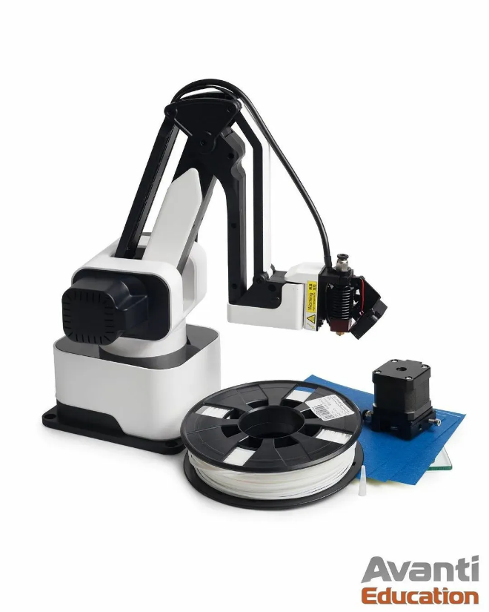

**Rotrisc dex arm**

*User Manual*

Annotation

Rotrisc Dex ARM is a multifunctional universal robot manipulator, with the possibility of wood engraving, drawing, 3D printing. With the help of the Python programming language, it is possible to automate industrial processes and use machine vision

Molganov A.A.

Jb723505@gmail.com

«Rotrics DexArm. User Manual», 2023. – 50 p.: il.

This book introduces the reader to the Rotrics DexArm robot, which helps to study in various disciplines and competencies – programming, robotics, mechatronics, 3D printing and electronics.

The publication is intended for schoolchildren, students, developers and teachers who want to learn programming, robotics, mechatronics and modeling, as well as to teach others with the help of this book.

Thanks to the modular design, the Rotrics robotic arm can easily switch between various functions such as writing and drawing, laser engraving, 3D printing and collecting, and placement.

With its easy-to-use software, Rotrics provides you with an intuitive and interactive way to manage and implement your ideas in just a few clicks.

Rotrics also provides developers with a free API in several languages, such as Python and G-Code (Marlin). You can easily control the robot using programming languages and SDK, as well as easily integrate it into your existing project.

**CONTENTS**

|  |  |
| --- | --- |
|  | стр |
| Introduction |  |
| Chapter 1. Interaction with the robot |  |
| 1.1. About the robot design |  |
| 1.2. Getting started with robot |  |
| 1.3. Spatial model of robot movement |  |
| Chapter 2. Programming the robot |  |
| 2.1. Programming in the Scratch language |  |
| 2.1.1. |  |
| 2.2. Programming in Python |  |
| 2.2.1. |  |
| 2.3. Programming in C++ |  |
| 2.3.1. |  |
| 2.4. Programming using the ROS package |  |
| 2.4.1. |  |
| Epilogue |  |
|  |  |
| Additional materials |  |
| List of materials used |  |
| List of graphic materials used |  |

**INTRODUCTION**

Robotics is a very complex science, located at the junction of mathematics, physics and computer science. To implement the simplest robot, you need to know several laws from electrical engineering, have experience programming microcontrollers and know the mathematical foundations of robot movement in space.

But with the help of Rotrics Dex ARM, robotics classes will become more exciting, easier and much more diverse in terms of creating a creative atmosphere for personal and educational spheres.

Rotrics Dex ARM reduces the threshold of entry into robotics by simplifying some minor, but one of the most time–consuming processes - programming a microcontroller.

The high-precision manipulator is programmed in the Scratch language, understandable even for school-age children with the help of simple and convenient visual designs. The Scratch language is fully programmable, that is, it is possible to implement almost all software theories and methods that are used in the development of full-featured software.

But the most important advantage of the robot is modularity. The robot was designed with an emphasis on modularity – when the user can change any module to a completely different one. It's really very simple and exciting!

This book expands the horizons of the robot's application, and uses in its arsenal such a powerful, flexible and easy–to-use programming language - Python. With the help of this programming language, you can automate the robot and come up with a variety of creative scenarios.

For example, production automation. Have you ever sorted boxes by color? It's simple, cool and, most importantly, accessible to everyone. And it's all in this book.

**Have a good trip!**

**PART 1. INTERACTION WITH THE ROBOT**

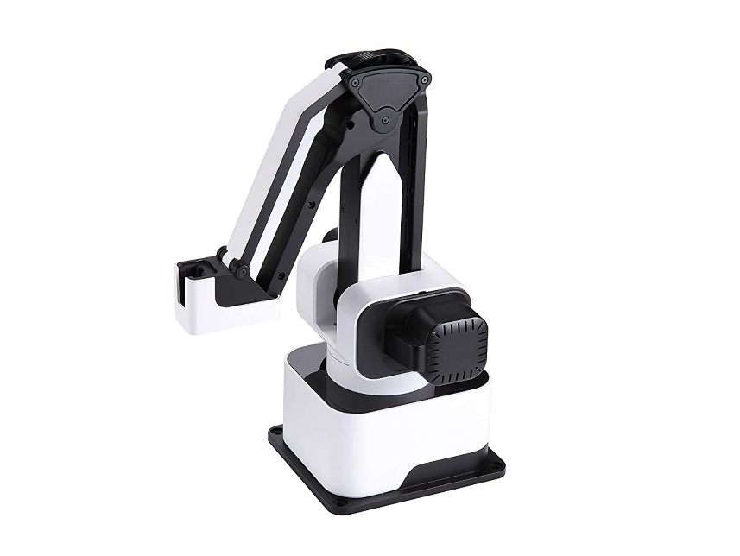 Rotrics Dex Arm is a universal desktop robot manipulator for teaching various competencies and areas – programming, robotics, mechatronics, electronics and industrial automation.

Thanks to the modular design, the robotic arm can easily switch between various functions such as painting, drawing, laser engraving, 3D printing, collecting, moving and sorting objects.

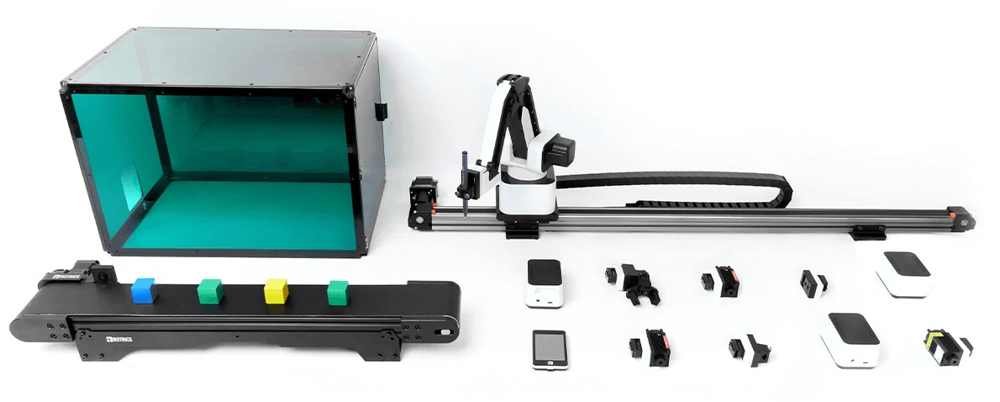Thanks to its easy-to-use software, Rotrics Des Arm provides you with an intuitive and interactive way to manage and implement your ideas in just a few mouse clicks.

* 1. **ABOUT THE ROBOT DESIGN**

The specifications of the robot include the following characteristics and weight and size properties:

* Accuracy of operation work: ~ 0.05 мм;
* Robot packing size: 220x155x160 мм;
* The size of a fully assembled robot: 175x128x315мм;
* Full weight: ~ 2.4* кг (The weight of the robot is specified without additional modules)

The robot includes the following components as standard:

1. Rotrics Dex Arm;
2. Mobile control panel with touchscreen-LCD display;
3. Cables and services instruction;
4. Module «Soft holed»;
5. Module «Solid holder»;
6. Module «2.5W-power laser»;
7. Module «3D-printer»;

The design of the robot is a 4DOF manipulator (a manipulator with support for 4 zones of spatial movement). Replaceable modules allow switching from one operation to another without additional hardware and software configuration of the robot or control computer.

Thanks to the open API, the robot can be controlled using the Python programming language, and not using a program to control the robot from Rotrics, called "Rotrics Studio". The API is a set of functions and variables already defined in the program that are necessary to control the robot.

* 1. **GETTING STARTED WITH ROBOT**

Алгоритм настройки робота состоит из следующих действий:

1. Извлеките коробку с роботом из транспортной упаковки;
2. После удаления транспортной упаковки, извлеките робота из коробки;
3. Поставьте робота на чистую, ровную, гладкую и не маркую поверхность;
4. Скачайте программное обеспечение «Rotrics Studio» - <https://rotrics.com/pages/downloads>;
5. 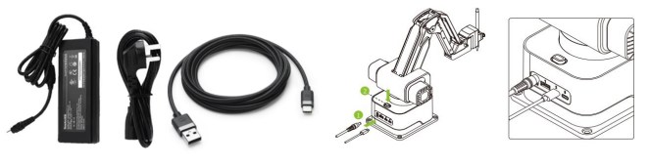После установки необходимого ПО, подключите к роботу питание с помощью кабеля «Power Adapter». Порт USB Type-C предназначен для подключения к роботу, а порт USB Type-A для подключения к компьютеру;
6. 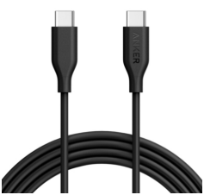ВНИМАНИЕ! Не используйте двойной кабель USB Type-C для подключения к персональному компьютеру. Данный кабель используется только для подключения дополнительных модулей к роботу;
7. 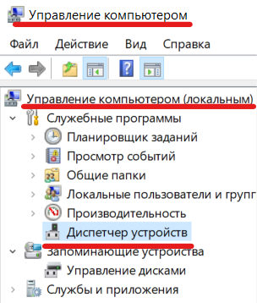После подключения робота к персональному компьютеру, убедитесь, что подключение прошло успешно. Перейдите в меню «Пуск», и найдите утилиту «Управление компьютером», как показано ниже:
8. В открывшемся окне, найдите подменю «Диспетчер устройств»;
9. 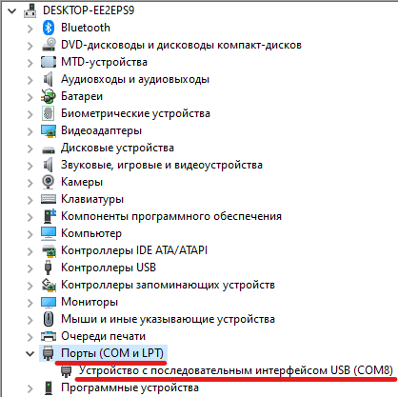В открывшемся подменю будет показан подключенный робот с номером порта к которому он подключен. (COMN, где N – номер порта);
10. После успешного подключения робота, откройте установленную программу «Rotrics Studio» и на верхней панели инструментов выберите кнопку, изображенную ниже:
11. 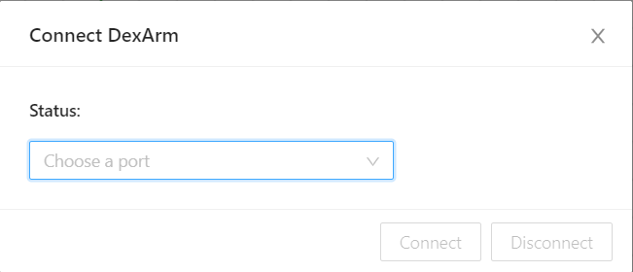В открывшемся диалоговом окне, в поле «Status», выберите доступный в данный момент COM-порт для соединения с роботом:
12. 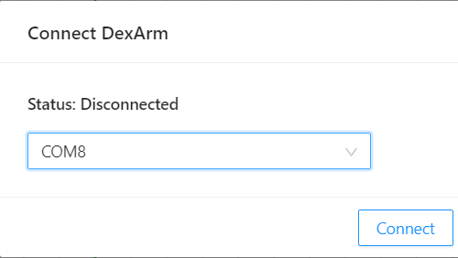После выбранного COM-порт для соединения, нажмите кнопку «Connect» для подключения:
13. После успешного подключения к роботу, поле «Status» изменится с «Disconnected» на «Connected»;
14. 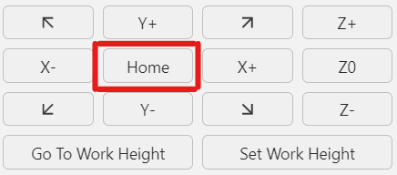В главном меню «Rotrics Studio», в правой части найдите панель управления, и нажмите кнопку «Home» для перемещения робота в начальную позицию.

После выполнения всех пунктов данного подглавы, попробуйте начать взаимодействовать с роботом через панель управления, а также с помощью «Мобильного пульта управления».

* 1. **ПРОСТРАНСТВЕННАЯ МОДЕЛЬ ПЕРЕМЕЩЕНИЙ РОБОТА**

Рассмотрим некоторые физические законы, по которому робот перемещается в пространстве и выполняет операции.

**ЧАСТЬ 2. ОСНОВЫ ПРОГРАММИРОВАНИЯ РОБОТА**

Программирование на языке Scratch

Программирование на языке Python

Программирование на языке C++

Программирование с помощью ROS

**ДОПОЛНИТЕЛЬНО**