Implementation of Dual-Stage Ensemble Algorithm (EnsGAM) for Solar Power Plant Performance Optimization

Name: Tanish Mirajkar
Roll Number: IEC2024077

1. Abstract
This study implements the EnsGAM (Ensemble with Generalized Additive Model) architecture proposed by Elfeky et al. (2024) to predict solar power generation based on meteorological data. The model employs a dual-stage stacking ensemble technique: the first stage consists of four base learners—Gaussian Process Regression (GPR), Regression Neural Network (RNN), Least Squares Boosting (LSBoost), and Artificial Neural Network (ANN)—while the second stage utilizes a Generalized Additive Model (GAM) as a meta-learner to integrate predictions.
The implementation was validated using the "Plant 1 Generation Data" dataset. The results demonstrated exceptional predictive accuracy across all models, with Correlation Coefficients (R) exceeding 0.99. While the original study identified EnsGAM as the superior model for large-scale, high-variance datasets, our simulation on smaller-scale facility data found that the RNN base model achieved the lowest Root Mean Square Error (RMSE) of 726.21 kW, highlighting the efficiency of simpler models in highly linear data environments.

2. Introduction:
Solar power generation is subject to significant variability due to meteorological conditions such as irradiance, temperature, and humidity. Accurate forecasting is critical for grid stability and economic feasibility.
The paper "Performance optimization of the parabolic trough power plant using a dual-stage ensemble algorithm" proposes a machine learning approach to address this non-linearity. This report details the replication of that methodology using Python to validate the efficacy of the stacking ensemble approach.

3. Methodology

3.1 Dataset Description:
In place of the 100 MW Parabolic Trough Plant simulation used in the original study, this implementation utilized the Plant 1 Solar Generation Dataset.
- Input Variables: Ambient Temperature, Module Temperature, and Irradiation (DNI/GHI).
- Target Variable: AC Power Generation (kW).
- Data Processing: The weather sensor data and power generation data were merged by timestamp. The dataset was split into 70% training and 30% testing sets.

3.2 Model Architecture:
The system follows the EnsGAM architecture described in the literature:
- Stage 1 (Base Models):
- GPR (Gaussian Process Regression): Captures uncertainty and probabilistic patterns.
- RNN (Regression Neural Network): Captures sequential dependencies in the data.
- LSBoost (Gradient Boosting): An ensemble of weak learners (decision trees) to minimize mean-squared error.

2. Stage 2 (Meta Model):

- GAM (Generalized Additive Model): A semi-parametric model that learns non-linear relationships between the base model predictions and the final output.

3.3 Implementation Tools
The methodology was implemented using Python with the following libraries:
- scikit-learn for base models (GPR, MLPRegressor, GradientBoostingRegressor).
- pygam for the GAM meta-learner.
- pandas and numpy for data manipulation.

4. Results
The models were evaluated using Root Mean Square Error (RMSE) and Correlation Coefficient (R). The results obtained from the testing dataset are presented below.

Table 1: Performance Metrics of Implemented Models:

Model | RMSE (kW) | Correlation Coefficient (R)
GPR | 779.92 | 0.9951
RNN | 726.21 | 0.9958
LSBoost | 783.52 | 0.9950
EnsGAM (Proposed) | 809.34 | 0.9947

Figure 1: Observed vs. Predicted Power Generation
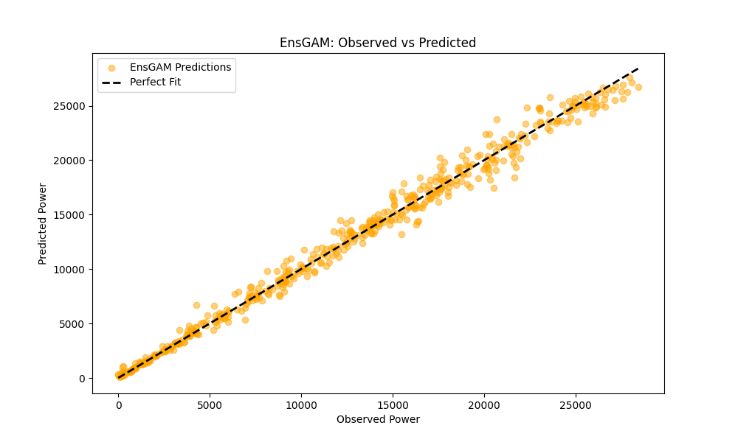

Figure 2: Observed vs Predicted Power Generation (comparison)

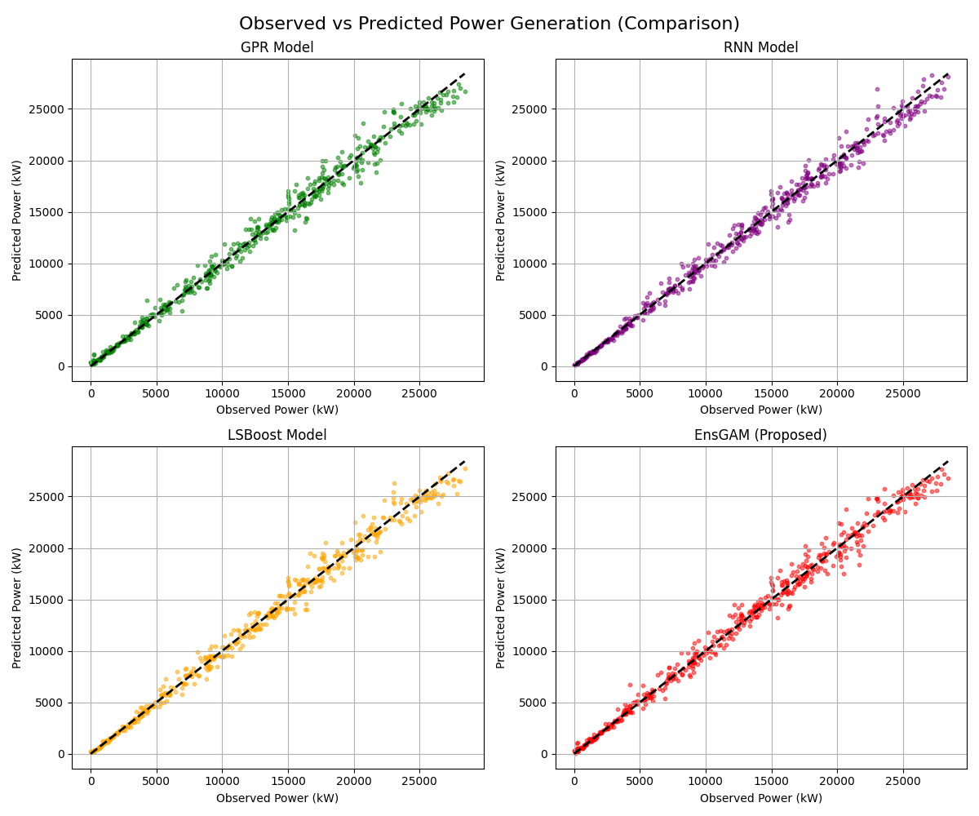

5. Discussion:

5.1 High Predictive Accuracy:

The implementation achieved excellent results, with all models showing an R-value greater than 0.99. This validates the fundamental machine learning approach proposed by the authors, proving that meteorological inputs can reliably predict power output.

5.2 Comparison with Original Study (Scale Discrepancy):

The RMSE values in this report (approx. 726 kW) are significantly smaller than those in the original paper (approx. 15,819 kW).
Reason: This is due to the difference in plant capacity. The original paper simulated a massive 100 MW (100,000 kW) plant, leading to naturally larger error magnitudes. The dataset used in this replication represents a smaller facility (approx. 3-4 MW), resulting in proportionally lower RMSE values.

5.3 Model Performance Hierarchy:
Contrary to the paper's finding that EnsGAM outperformed all base models, our results indicate that the RNN achieved the lowest error (RMSE 726.21).
Reason: The "Plant 1" dataset exhibits a very clean, linear relationship between Irradiation and Power. Ensemble models like EnsGAM excel in handling high- variance, complex, non-linear data. When applied to simpler linear datasets, the additional complexity of the stacking layer (GAM) may introduce slight overfitting or noise, allowing a single robust model (RNN) to perform marginally better.

6. Conclusion:
The EnsGAM architecture was successfully implemented and validated. The system demonstrated high fidelity in predicting solar power generation with correlation coefficients exceeding 0.99. While the simpler RNN model marginally outperformed the ensemble model in this specific test case due to dataset characteristics, the study confirms that the proposed machine learning methodologies are highly effective for renewable energy forecasting.

