- What is Index in DB2?
  - An index in DB2 is a database object that improves the speed of data retrieval from a table by allowing DB2 to find rows quickly without scanning the entire table.
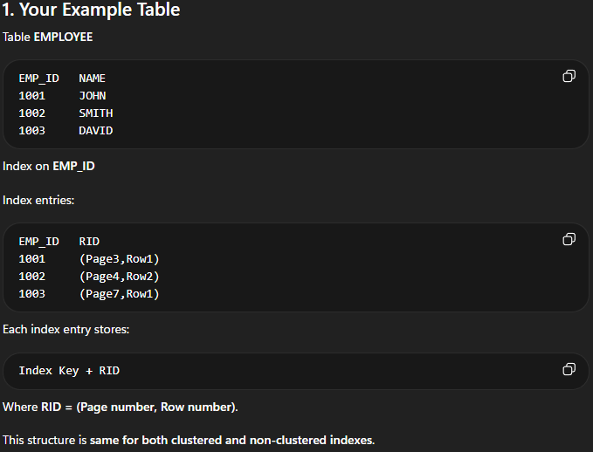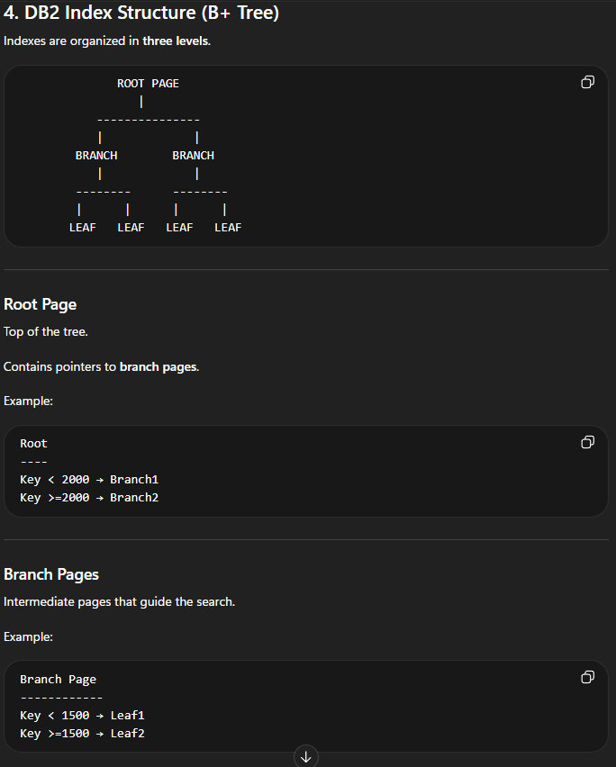
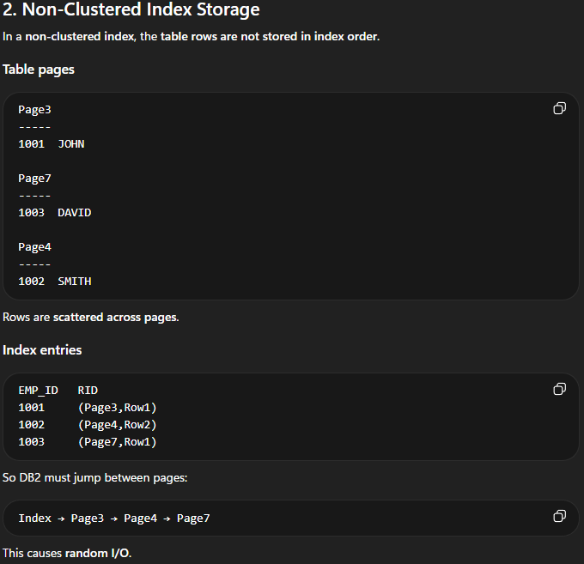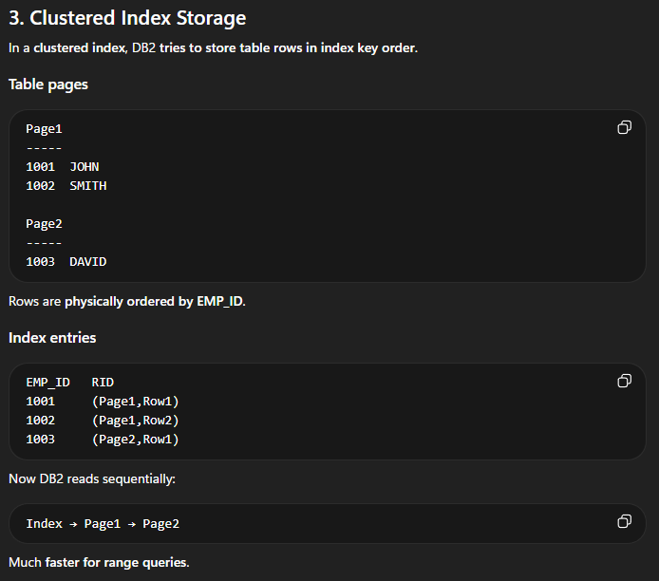

- Which is more speed Cluster index or Non-Clustered Index and why?
  - A clustered index is generally faster for range queries because rows are stored physically close together according to the clustering key, reducing page reads. A non-clustered index may require multiple random I/O operations because rows are scattered in the table.
  - Clustered Index
    - A Clustered Index in DB2 defines the preferred physical order in which rows are stored in a table based on the index key.
    - Physical order in DB2 means the actual order in which rows are stored on disk pages inside the table. It refers to how the data is physically placed in the table space pages, not how it appears when you query it.
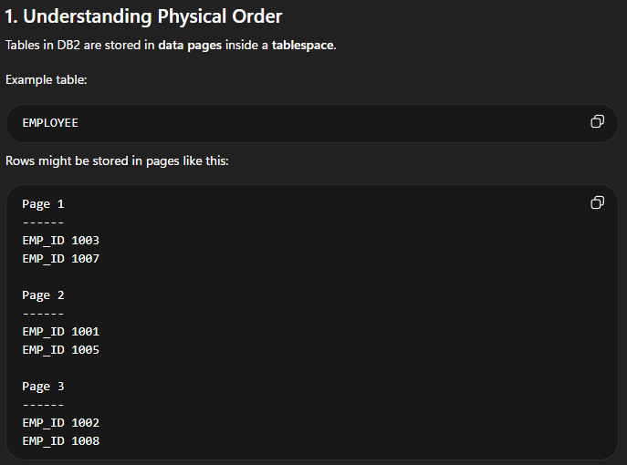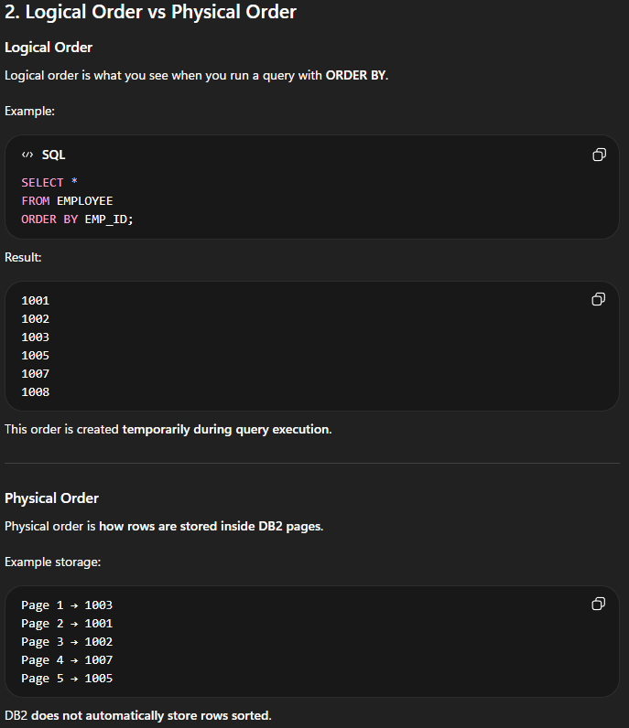
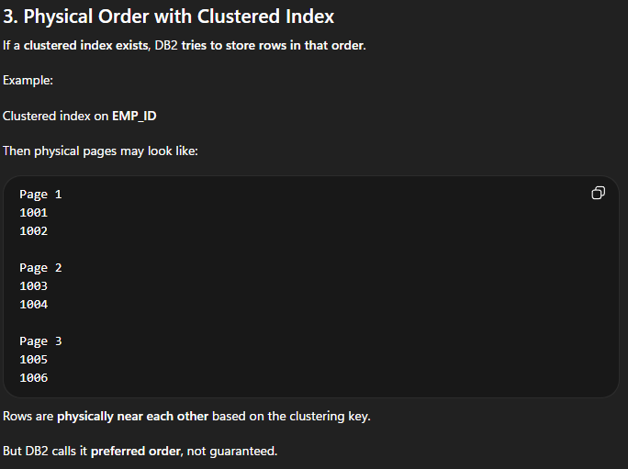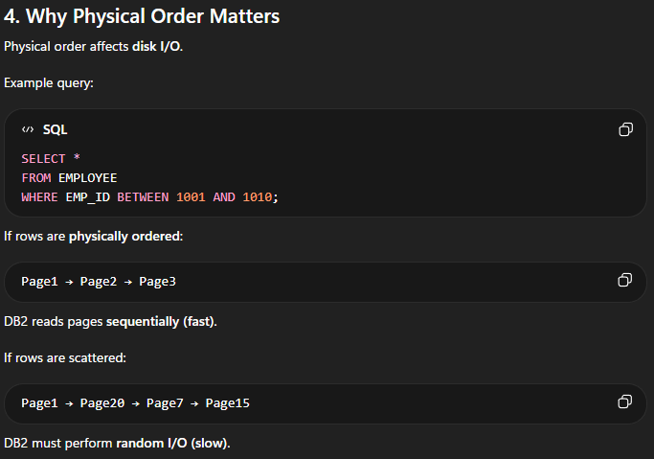

  - Non-cluster Index
    - Index is separate from table data.
    - Table rows may be scattered.
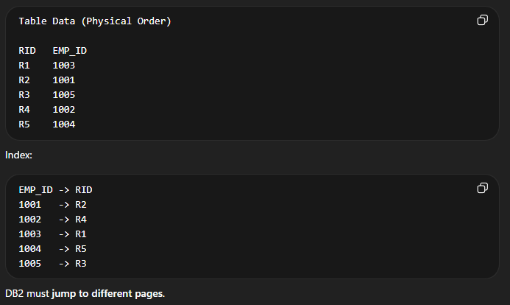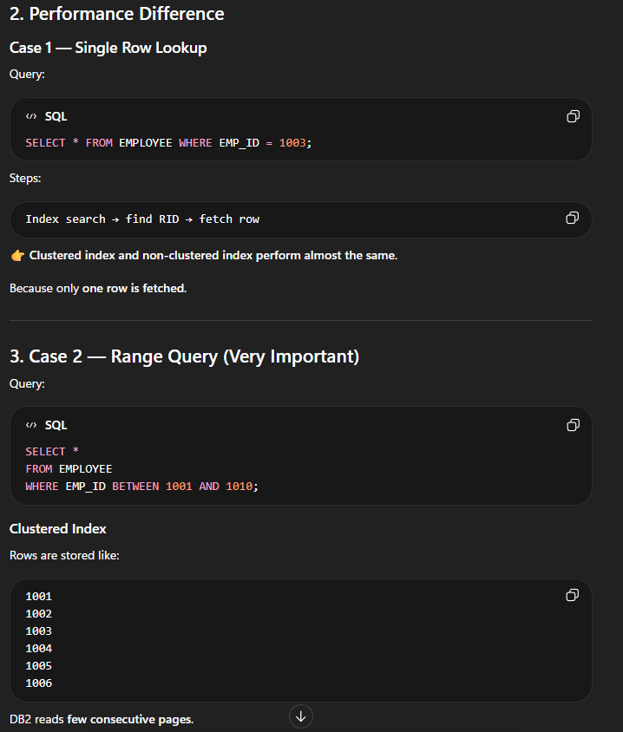
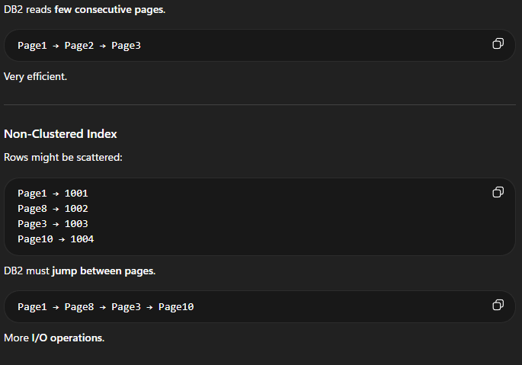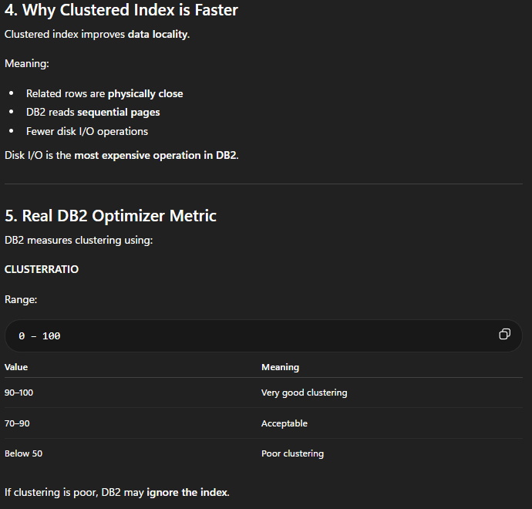

- How to increase the performance of the SQL query?
  - Never use SELECT * - Need to use all required column names
  - Use CTEs instead of temp table – We should prefer a CTE over a Temp table because temp tables are stored physically in TempDB which is deleted after the session end. While CTEs are created within memory. Execution of a CTE is very fast as compared to the temp tables and very light weight too
  - Use UNION ALL instead of UNION
  - Use COUNT(1) instead of COUNT(*) and COUNT(col_name)
  - Use stored procedure
  - Use BETWEEN instead of IN
  - Practice using Schema name
  - Always create index on table
  - Remove unused index
  - Use Alias name
  - Drop index before bulk insertion of data

- A
- A
- A

- A
- A
- A
- A
- A
- A
- A
- A
- A

What is DB2 for z/OS?
IBM's relational database running on mainframe z/OS used for high‑volume enterprise transaction systems. This concept is important in production DB2 systems because it directly affects query performance, resource utilization, and database scalability. In real enterprise environments such as banking or insurance systems running on IBM z/OS, understanding this helps developers design efficient SQL, reduce I/O, and support high‑volume transaction processing.
What is a DB2 subsystem?
A running DB2 environment in z/OS that manages databases, logs, buffer pools, and DB2 resources. This concept is important in production DB2 systems because it directly affects query performance, resource utilization, and database scalability. In real enterprise environments such as banking or insurance systems running on IBM z/OS, understanding this helps developers design efficient SQL, reduce I/O, and support high‑volume transaction processing.
What is a DB2 instance vs subsystem?
On z/OS the term subsystem is used; it represents the DB2 engine running under z/OS. This concept is important in production DB2 systems because it directly affects query performance, resource utilization, and database scalability. In real enterprise environments such as banking or insurance systems running on IBM z/OS, understanding this helps developers design efficient SQL, reduce I/O, and support high‑volume transaction processing.
What is a tablespace?
A physical storage structure where DB2 stores table rows in pages. This concept is important in production DB2 systems because it directly affects query performance, resource utilization, and database scalability. In real enterprise environments such as banking or insurance systems running on IBM z/OS, understanding this helps developers design efficient SQL, reduce I/O, and support high‑volume transaction processing.
Difference between database and tablespace?
Database is logical grouping of tablespaces; tablespace stores actual table data. This concept is important in production DB2 systems because it directly affects query performance, resource utilization, and database scalability. In real enterprise environments such as banking or insurance systems running on IBM z/OS, understanding this helps developers design efficient SQL, reduce I/O, and support high‑volume transaction processing.
What is an indexspace?
Physical storage structure that stores index data. This concept is important in production DB2 systems because it directly affects query performance, resource utilization, and database scalability. In real enterprise environments such as banking or insurance systems running on IBM z/OS, understanding this helps developers design efficient SQL, reduce I/O, and support high‑volume transaction processing.
What is a DB2 page?
Smallest I/O unit used by DB2 to store data; typically 4K, 8K, 16K, or 32K. This concept is important in production DB2 systems because it directly affects query performance, resource utilization, and database scalability. In real enterprise environments such as banking or insurance systems running on IBM z/OS, understanding this helps developers design efficient SQL, reduce I/O, and support high‑volume transaction processing.
What is row format?
Internal format DB2 uses to store a table row inside a page. This concept is important in production DB2 systems because it directly affects query performance, resource utilization, and database scalability. In real enterprise environments such as banking or insurance systems running on IBM z/OS, understanding this helps developers design efficient SQL, reduce I/O, and support high‑volume transaction processing.
What is a buffer pool?
Memory area used to cache DB2 pages to reduce disk I/O. This concept is important in production DB2 systems because it directly affects query performance, resource utilization, and database scalability. In real enterprise environments such as banking or insurance systems running on IBM z/OS, understanding this helps developers design efficient SQL, reduce I/O, and support high‑volume transaction processing.
What is a DB2 catalog?
System tables containing metadata about DB2 objects such as tables, indexes, and tablespaces. This concept is important in production DB2 systems because it directly affects query performance, resource utilization, and database scalability. In real enterprise environments such as banking or insurance systems running on IBM z/OS, understanding this helps developers design efficient SQL, reduce I/O, and support high‑volume transaction processing.
SQL Performance
What factors affect DB2 query performance?
Indexes, SQL design, RUNSTATS statistics, table size, buffer pool usage, and access path. This concept is important in production DB2 systems because it directly affects query performance, resource utilization, and database scalability. In real enterprise environments such as banking or insurance systems running on IBM z/OS, understanding this helps developers design efficient SQL, reduce I/O, and support high‑volume transaction processing.
What is access path?
Method DB2 uses to retrieve rows such as index scan or tablespace scan. This concept is important in production DB2 systems because it directly affects query performance, resource utilization, and database scalability. In real enterprise environments such as banking or insurance systems running on IBM z/OS, understanding this helps developers design efficient SQL, reduce I/O, and support high‑volume transaction processing.
What is DB2 optimizer?
Component that chooses the most efficient access path using statistics. This concept is important in production DB2 systems because it directly affects query performance, resource utilization, and database scalability. In real enterprise environments such as banking or insurance systems running on IBM z/OS, understanding this helps developers design efficient SQL, reduce I/O, and support high‑volume transaction processing.
What is predicate selectivity?
Measure of how many rows satisfy a condition; higher selectivity means fewer rows. This concept is important in production DB2 systems because it directly affects query performance, resource utilization, and database scalability. In real enterprise environments such as banking or insurance systems running on IBM z/OS, understanding this helps developers design efficient SQL, reduce I/O, and support high‑volume transaction processing.
What is stage 1 predicate?
Predicate evaluated by DB2 early during data retrieval, usually faster. This concept is important in production DB2 systems because it directly affects query performance, resource utilization, and database scalability. In real enterprise environments such as banking or insurance systems running on IBM z/OS, understanding this helps developers design efficient SQL, reduce I/O, and support high‑volume transaction processing.
What is stage 2 predicate?
Predicate evaluated later after data retrieval, usually slower. This concept is important in production DB2 systems because it directly affects query performance, resource utilization, and database scalability. In real enterprise environments such as banking or insurance systems running on IBM z/OS, understanding this helps developers design efficient SQL, reduce I/O, and support high‑volume transaction processing.
What is sargable predicate?
Predicate that allows DB2 to use an index efficiently. This concept is important in production DB2 systems because it directly affects query performance, resource utilization, and database scalability. In real enterprise environments such as banking or insurance systems running on IBM z/OS, understanding this helps developers design efficient SQL, reduce I/O, and support high‑volume transaction processing.
What is filter factor?
Estimate used by optimizer representing percentage of rows that match a predicate. This concept is important in production DB2 systems because it directly affects query performance, resource utilization, and database scalability. In real enterprise environments such as banking or insurance systems running on IBM z/OS, understanding this helps developers design efficient SQL, reduce I/O, and support high‑volume transaction processing.
What is index screening?
Using index to filter rows before accessing the table. This concept is important in production DB2 systems because it directly affects query performance, resource utilization, and database scalability. In real enterprise environments such as banking or insurance systems running on IBM z/OS, understanding this helps developers design efficient SQL, reduce I/O, and support high‑volume transaction processing.
What is index matching?
When predicate columns match the leading columns of an index. This concept is important in production DB2 systems because it directly affects query performance, resource utilization, and database scalability. In real enterprise environments such as banking or insurance systems running on IBM z/OS, understanding this helps developers design efficient SQL, reduce I/O, and support high‑volume transaction processing.
Indexing
What is an index?
Data structure that speeds up row retrieval. This concept is important in production DB2 systems because it directly affects query performance, resource utilization, and database scalability. In real enterprise environments such as banking or insurance systems running on IBM z/OS, understanding this helps developers design efficient SQL, reduce I/O, and support high‑volume transaction processing.
What is unique index?
Index that ensures column values remain unique. This concept is important in production DB2 systems because it directly affects query performance, resource utilization, and database scalability. In real enterprise environments such as banking or insurance systems running on IBM z/OS, understanding this helps developers design efficient SQL, reduce I/O, and support high‑volume transaction processing.
What is clustering index?
Index that determines physical ordering of rows. This concept is important in production DB2 systems because it directly affects query performance, resource utilization, and database scalability. In real enterprise environments such as banking or insurance systems running on IBM z/OS, understanding this helps developers design efficient SQL, reduce I/O, and support high‑volume transaction processing.
What is non‑clustering index?
Index that does not control physical row order. This concept is important in production DB2 systems because it directly affects query performance, resource utilization, and database scalability. In real enterprise environments such as banking or insurance systems running on IBM z/OS, understanding this helps developers design efficient SQL, reduce I/O, and support high‑volume transaction processing.
What is composite index?
Index defined on multiple columns. This concept is important in production DB2 systems because it directly affects query performance, resource utilization, and database scalability. In real enterprise environments such as banking or insurance systems running on IBM z/OS, understanding this helps developers design efficient SQL, reduce I/O, and support high‑volume transaction processing.
What is index‑only access?
DB2 retrieves data directly from index without accessing table. This concept is important in production DB2 systems because it directly affects query performance, resource utilization, and database scalability. In real enterprise environments such as banking or insurance systems running on IBM z/OS, understanding this helps developers design efficient SQL, reduce I/O, and support high‑volume transaction processing.
What is index scan?
DB2 scans index to find matching rows. This concept is important in production DB2 systems because it directly affects query performance, resource utilization, and database scalability. In real enterprise environments such as banking or insurance systems running on IBM z/OS, understanding this helps developers design efficient SQL, reduce I/O, and support high‑volume transaction processing.
What is index leaf page?
Lowest level page in index containing key values and pointers. This concept is important in production DB2 systems because it directly affects query performance, resource utilization, and database scalability. In real enterprise environments such as banking or insurance systems running on IBM z/OS, understanding this helps developers design efficient SQL, reduce I/O, and support high‑volume transaction processing.
What is RID?
Record Identifier pointing to the row location in tablespace. This concept is important in production DB2 systems because it directly affects query performance, resource utilization, and database scalability. In real enterprise environments such as banking or insurance systems running on IBM z/OS, understanding this helps developers design efficient SQL, reduce I/O, and support high‑volume transaction processing.
What is RID list processing?
DB2 collects RIDs from indexes then retrieves rows from table. This concept is important in production DB2 systems because it directly affects query performance, resource utilization, and database scalability. In real enterprise environments such as banking or insurance systems running on IBM z/OS, understanding this helps developers design efficient SQL, reduce I/O, and support high‑volume transaction processing.
Explain and Access Path
What is EXPLAIN?
Command used to view the access path chosen by DB2. This concept is important in production DB2 systems because it directly affects query performance, resource utilization, and database scalability. In real enterprise environments such as banking or insurance systems running on IBM z/OS, understanding this helps developers design efficient SQL, reduce I/O, and support high‑volume transaction processing.
What is PLAN_TABLE?
Table that stores EXPLAIN output. This concept is important in production DB2 systems because it directly affects query performance, resource utilization, and database scalability. In real enterprise environments such as banking or insurance systems running on IBM z/OS, understanding this helps developers design efficient SQL, reduce I/O, and support high‑volume transaction processing.
What does MATCHCOLS represent?
Number of index columns matched by query predicates. This concept is important in production DB2 systems because it directly affects query performance, resource utilization, and database scalability. In real enterprise environments such as banking or insurance systems running on IBM z/OS, understanding this helps developers design efficient SQL, reduce I/O, and support high‑volume transaction processing.
What is ACCESSTYPE?
Column in PLAN_TABLE indicating access method such as I or T. This concept is important in production DB2 systems because it directly affects query performance, resource utilization, and database scalability. In real enterprise environments such as banking or insurance systems running on IBM z/OS, understanding this helps developers design efficient SQL, reduce I/O, and support high‑volume transaction processing.
What is PREFETCH?
Indicates sequential or list prefetch operations. This concept is important in production DB2 systems because it directly affects query performance, resource utilization, and database scalability. In real enterprise environments such as banking or insurance systems running on IBM z/OS, understanding this helps developers design efficient SQL, reduce I/O, and support high‑volume transaction processing.
What is tablespace scan?
Reading entire table when no useful index exists. This concept is important in production DB2 systems because it directly affects query performance, resource utilization, and database scalability. In real enterprise environments such as banking or insurance systems running on IBM z/OS, understanding this helps developers design efficient SQL, reduce I/O, and support high‑volume transaction processing.
What is index access?
Retrieving rows using an index. This concept is important in production DB2 systems because it directly affects query performance, resource utilization, and database scalability. In real enterprise environments such as banking or insurance systems running on IBM z/OS, understanding this helps developers design efficient SQL, reduce I/O, and support high‑volume transaction processing.
What is join sequence?
Order in which DB2 joins tables. This concept is important in production DB2 systems because it directly affects query performance, resource utilization, and database scalability. In real enterprise environments such as banking or insurance systems running on IBM z/OS, understanding this helps developers design efficient SQL, reduce I/O, and support high‑volume transaction processing.
What is query block?
Section of SQL statement optimized separately. This concept is important in production DB2 systems because it directly affects query performance, resource utilization, and database scalability. In real enterprise environments such as banking or insurance systems running on IBM z/OS, understanding this helps developers design efficient SQL, reduce I/O, and support high‑volume transaction processing.
How do you detect inefficient SQL?
Run EXPLAIN and check for tablespace scans or poor index usage. This concept is important in production DB2 systems because it directly affects query performance, resource utilization, and database scalability. In real enterprise environments such as banking or insurance systems running on IBM z/OS, understanding this helps developers design efficient SQL, reduce I/O, and support high‑volume transaction processing.
DB2 Utilities
What is RUNSTATS?
Utility that gathers table and index statistics for optimizer. This concept is important in production DB2 systems because it directly affects query performance, resource utilization, and database scalability. In real enterprise environments such as banking or insurance systems running on IBM z/OS, understanding this helps developers design efficient SQL, reduce I/O, and support high‑volume transaction processing.
Why is RUNSTATS important?
Without statistics optimizer may choose inefficient access paths. This concept is important in production DB2 systems because it directly affects query performance, resource utilization, and database scalability. In real enterprise environments such as banking or insurance systems running on IBM z/OS, understanding this helps developers design efficient SQL, reduce I/O, and support high‑volume transaction processing.
What is REORG?
Utility that reorganizes table data to remove fragmentation. This concept is important in production DB2 systems because it directly affects query performance, resource utilization, and database scalability. In real enterprise environments such as banking or insurance systems running on IBM z/OS, understanding this helps developers design efficient SQL, reduce I/O, and support high‑volume transaction processing.
When should REORG be used?
When clustering is degraded or performance drops. This concept is important in production DB2 systems because it directly affects query performance, resource utilization, and database scalability. In real enterprise environments such as banking or insurance systems running on IBM z/OS, understanding this helps developers design efficient SQL, reduce I/O, and support high‑volume transaction processing.
What is LOAD utility?
Used to load large volumes of data efficiently. This concept is important in production DB2 systems because it directly affects query performance, resource utilization, and database scalability. In real enterprise environments such as banking or insurance systems running on IBM z/OS, understanding this helps developers design efficient SQL, reduce I/O, and support high‑volume transaction processing.
What is COPY utility?
Creates backup of tablespaces or indexes. This concept is important in production DB2 systems because it directly affects query performance, resource utilization, and database scalability. In real enterprise environments such as banking or insurance systems running on IBM z/OS, understanding this helps developers design efficient SQL, reduce I/O, and support high‑volume transaction processing.
What is RECOVER utility?
Restores tablespaces using image copies and logs. This concept is important in production DB2 systems because it directly affects query performance, resource utilization, and database scalability. In real enterprise environments such as banking or insurance systems running on IBM z/OS, understanding this helps developers design efficient SQL, reduce I/O, and support high‑volume transaction processing.
What is REBUILD INDEX?
Recreates index structure. This concept is important in production DB2 systems because it directly affects query performance, resource utilization, and database scalability. In real enterprise environments such as banking or insurance systems running on IBM z/OS, understanding this helps developers design efficient SQL, reduce I/O, and support high‑volume transaction processing.
What is CHECK DATA?
Validates referential integrity. This concept is important in production DB2 systems because it directly affects query performance, resource utilization, and database scalability. In real enterprise environments such as banking or insurance systems running on IBM z/OS, understanding this helps developers design efficient SQL, reduce I/O, and support high‑volume transaction processing.
What is MODIFY utility?
Removes old image copies or recovery information. This concept is important in production DB2 systems because it directly affects query performance, resource utilization, and database scalability. In real enterprise environments such as banking or insurance systems running on IBM z/OS, understanding this helps developers design efficient SQL, reduce I/O, and support high‑volume transaction processing.
Join Performance
What is nested loop join?
DB2 reads rows from one table and probes another using index. This concept is important in production DB2 systems because it directly affects query performance, resource utilization, and database scalability. In real enterprise environments such as banking or insurance systems running on IBM z/OS, understanding this helps developers design efficient SQL, reduce I/O, and support high‑volume transaction processing.
What is merge scan join?
Tables are scanned in sorted order and merged. This concept is important in production DB2 systems because it directly affects query performance, resource utilization, and database scalability. In real enterprise environments such as banking or insurance systems running on IBM z/OS, understanding this helps developers design efficient SQL, reduce I/O, and support high‑volume transaction processing.
What is hybrid join?
Combination of nested loop and merge join techniques. This concept is important in production DB2 systems because it directly affects query performance, resource utilization, and database scalability. In real enterprise environments such as banking or insurance systems running on IBM z/OS, understanding this helps developers design efficient SQL, reduce I/O, and support high‑volume transaction processing.
What affects join performance?
Indexes, table size, join predicates, and join order. This concept is important in production DB2 systems because it directly affects query performance, resource utilization, and database scalability. In real enterprise environments such as banking or insurance systems running on IBM z/OS, understanding this helps developers design efficient SQL, reduce I/O, and support high‑volume transaction processing.
How do indexes help joins?
They reduce rows scanned during join operations. This concept is important in production DB2 systems because it directly affects query performance, resource utilization, and database scalability. In real enterprise environments such as banking or insurance systems running on IBM z/OS, understanding this helps developers design efficient SQL, reduce I/O, and support high‑volume transaction processing.
What happens when joins lack indexes?
DB2 may perform expensive tablespace scans. This concept is important in production DB2 systems because it directly affects query performance, resource utilization, and database scalability. In real enterprise environments such as banking or insurance systems running on IBM z/OS, understanding this helps developers design efficient SQL, reduce I/O, and support high‑volume transaction processing.
What is join predicate?
Condition used to join two tables. This concept is important in production DB2 systems because it directly affects query performance, resource utilization, and database scalability. In real enterprise environments such as banking or insurance systems running on IBM z/OS, understanding this helps developers design efficient SQL, reduce I/O, and support high‑volume transaction processing.
What is outer join?
Join returning unmatched rows from one table. This concept is important in production DB2 systems because it directly affects query performance, resource utilization, and database scalability. In real enterprise environments such as banking or insurance systems running on IBM z/OS, understanding this helps developers design efficient SQL, reduce I/O, and support high‑volume transaction processing.
What is inner join?
Join returning rows matching in both tables. This concept is important in production DB2 systems because it directly affects query performance, resource utilization, and database scalability. In real enterprise environments such as banking or insurance systems running on IBM z/OS, understanding this helps developers design efficient SQL, reduce I/O, and support high‑volume transaction processing.
What is star join optimization?
Optimization used for data warehouse star schema queries. This concept is important in production DB2 systems because it directly affects query performance, resource utilization, and database scalability. In real enterprise environments such as banking or insurance systems running on IBM z/OS, understanding this helps developers design efficient SQL, reduce I/O, and support high‑volume transaction processing.
Locking and Concurrency
What is locking in DB2?
Mechanism used to maintain data consistency during concurrent access. This concept is important in production DB2 systems because it directly affects query performance, resource utilization, and database scalability. In real enterprise environments such as banking or insurance systems running on IBM z/OS, understanding this helps developers design efficient SQL, reduce I/O, and support high‑volume transaction processing.
What is lock escalation?
DB2 converts many row/page locks into a tablespace lock. This concept is important in production DB2 systems because it directly affects query performance, resource utilization, and database scalability. In real enterprise environments such as banking or insurance systems running on IBM z/OS, understanding this helps developers design efficient SQL, reduce I/O, and support high‑volume transaction processing.
What is deadlock?
Two transactions waiting for each other's locks. This concept is important in production DB2 systems because it directly affects query performance, resource utilization, and database scalability. In real enterprise environments such as banking or insurance systems running on IBM z/OS, understanding this helps developers design efficient SQL, reduce I/O, and support high‑volume transaction processing.
What is timeout?
Transaction waits too long for a lock and DB2 cancels it. This concept is important in production DB2 systems because it directly affects query performance, resource utilization, and database scalability. In real enterprise environments such as banking or insurance systems running on IBM z/OS, understanding this helps developers design efficient SQL, reduce I/O, and support high‑volume transaction processing.
What is isolation level?
Defines degree of data visibility between transactions. This concept is important in production DB2 systems because it directly affects query performance, resource utilization, and database scalability. In real enterprise environments such as banking or insurance systems running on IBM z/OS, understanding this helps developers design efficient SQL, reduce I/O, and support high‑volume transaction processing.
What is UR isolation?
Uncommitted read allowing dirty reads. This concept is important in production DB2 systems because it directly affects query performance, resource utilization, and database scalability. In real enterprise environments such as banking or insurance systems running on IBM z/OS, understanding this helps developers design efficient SQL, reduce I/O, and support high‑volume transaction processing.
What is CS isolation?
Cursor stability locking current row. This concept is important in production DB2 systems because it directly affects query performance, resource utilization, and database scalability. In real enterprise environments such as banking or insurance systems running on IBM z/OS, understanding this helps developers design efficient SQL, reduce I/O, and support high‑volume transaction processing.
What is RS isolation?
Repeatable read for selected rows. This concept is important in production DB2 systems because it directly affects query performance, resource utilization, and database scalability. In real enterprise environments such as banking or insurance systems running on IBM z/OS, understanding this helps developers design efficient SQL, reduce I/O, and support high‑volume transaction processing.
What is RR isolation?
Repeatable read locking all qualifying rows. This concept is important in production DB2 systems because it directly affects query performance, resource utilization, and database scalability. In real enterprise environments such as banking or insurance systems running on IBM z/OS, understanding this helps developers design efficient SQL, reduce I/O, and support high‑volume transaction processing.
What is lock avoidance?
DB2 skipping locks when safe to improve performance. This concept is important in production DB2 systems because it directly affects query performance, resource utilization, and database scalability. In real enterprise environments such as banking or insurance systems running on IBM z/OS, understanding this helps developers design efficient SQL, reduce I/O, and support high‑volume transaction processing.
Performance Troubleshooting
How do you analyze slow SQL?
Run EXPLAIN, review indexes, check RUNSTATS, and rewrite SQL. This concept is important in production DB2 systems because it directly affects query performance, resource utilization, and database scalability. In real enterprise environments such as banking or insurance systems running on IBM z/OS, understanding this helps developers design efficient SQL, reduce I/O, and support high‑volume transaction processing.
What if query suddenly becomes slow?
Check statistics, new indexes, data volume changes, or access path change. This concept is important in production DB2 systems because it directly affects query performance, resource utilization, and database scalability. In real enterprise environments such as banking or insurance systems running on IBM z/OS, understanding this helps developers design efficient SQL, reduce I/O, and support high‑volume transaction processing.
How to detect tablespace scan?
Review PLAN_TABLE ACCESSTYPE value. This concept is important in production DB2 systems because it directly affects query performance, resource utilization, and database scalability. In real enterprise environments such as banking or insurance systems running on IBM z/OS, understanding this helps developers design efficient SQL, reduce I/O, and support high‑volume transaction processing.
How to reduce I/O cost?
Create selective indexes and avoid unnecessary columns. This concept is important in production DB2 systems because it directly affects query performance, resource utilization, and database scalability. In real enterprise environments such as banking or insurance systems running on IBM z/OS, understanding this helps developers design efficient SQL, reduce I/O, and support high‑volume transaction processing.
What if CPU usage is high in DB2?
Check inefficient SQL, missing indexes, and large scans. This concept is important in production DB2 systems because it directly affects query performance, resource utilization, and database scalability. In real enterprise environments such as banking or insurance systems running on IBM z/OS, understanding this helps developers design efficient SQL, reduce I/O, and support high‑volume transaction processing.
How to tune join queries?
Ensure join columns are indexed. This concept is important in production DB2 systems because it directly affects query performance, resource utilization, and database scalability. In real enterprise environments such as banking or insurance systems running on IBM z/OS, understanding this helps developers design efficient SQL, reduce I/O, and support high‑volume transaction processing.
How to improve range query performance?
Use clustering index. This concept is important in production DB2 systems because it directly affects query performance, resource utilization, and database scalability. In real enterprise environments such as banking or insurance systems running on IBM z/OS, understanding this helps developers design efficient SQL, reduce I/O, and support high‑volume transaction processing.
Why avoid SELECT *?
Retrieves unnecessary columns increasing I/O. This concept is important in production DB2 systems because it directly affects query performance, resource utilization, and database scalability. In real enterprise environments such as banking or insurance systems running on IBM z/OS, understanding this helps developers design efficient SQL, reduce I/O, and support high‑volume transaction processing.
How do functions in WHERE clause affect performance?
They prevent index usage. This concept is important in production DB2 systems because it directly affects query performance, resource utilization, and database scalability. In real enterprise environments such as banking or insurance systems running on IBM z/OS, understanding this helps developers design efficient SQL, reduce I/O, and support high‑volume transaction processing.
What are correlated subqueries?
Subqueries executed for each row of outer query. This concept is important in production DB2 systems because it directly affects query performance, resource utilization, and database scalability. In real enterprise environments such as banking or insurance systems running on IBM z/OS, understanding this helps developers design efficient SQL, reduce I/O, and support high‑volume transaction processing.
Advanced Topics
What is partitioned tablespace?
Tablespace divided into partitions improving manageability and performance. This concept is important in production DB2 systems because it directly affects query performance, resource utilization, and database scalability. In real enterprise environments such as banking or insurance systems running on IBM z/OS, understanding this helps developers design efficient SQL, reduce I/O, and support high‑volume transaction processing.
What is data partitioning?
Splitting large table into smaller partitions. This concept is important in production DB2 systems because it directly affects query performance, resource utilization, and database scalability. In real enterprise environments such as banking or insurance systems running on IBM z/OS, understanding this helps developers design efficient SQL, reduce I/O, and support high‑volume transaction processing.
What is parallelism in DB2?
DB2 executing parts of query simultaneously. This concept is important in production DB2 systems because it directly affects query performance, resource utilization, and database scalability. In real enterprise environments such as banking or insurance systems running on IBM z/OS, understanding this helps developers design efficient SQL, reduce I/O, and support high‑volume transaction processing.
What is query acceleration?
Offloading queries to specialized engines. This concept is important in production DB2 systems because it directly affects query performance, resource utilization, and database scalability. In real enterprise environments such as banking or insurance systems running on IBM z/OS, understanding this helps developers design efficient SQL, reduce I/O, and support high‑volume transaction processing.
What is buffer pool tuning?
Adjusting memory pools to optimize page caching. This concept is important in production DB2 systems because it directly affects query performance, resource utilization, and database scalability. In real enterprise environments such as banking or insurance systems running on IBM z/OS, understanding this helps developers design efficient SQL, reduce I/O, and support high‑volume transaction processing.
What is dynamic SQL cache?
Caching dynamic SQL statements for reuse. This concept is important in production DB2 systems because it directly affects query performance, resource utilization, and database scalability. In real enterprise environments such as banking or insurance systems running on IBM z/OS, understanding this helps developers design efficient SQL, reduce I/O, and support high‑volume transaction processing.
What is package in DB2?
Collection of compiled SQL statements. This concept is important in production DB2 systems because it directly affects query performance, resource utilization, and database scalability. In real enterprise environments such as banking or insurance systems running on IBM z/OS, understanding this helps developers design efficient SQL, reduce I/O, and support high‑volume transaction processing.
What is plan in DB2?
Execution structure referencing DB2 packages. This concept is important in production DB2 systems because it directly affects query performance, resource utilization, and database scalability. In real enterprise environments such as banking or insurance systems running on IBM z/OS, understanding this helps developers design efficient SQL, reduce I/O, and support high‑volume transaction processing.
What is bind process?
Process of compiling SQL into executable form. This concept is important in production DB2 systems because it directly affects query performance, resource utilization, and database scalability. In real enterprise environments such as banking or insurance systems running on IBM z/OS, understanding this helps developers design efficient SQL, reduce I/O, and support high‑volume transaction processing.
What is rebind?
Re-optimizing SQL after statistics change. This concept is important in production DB2 systems because it directly affects query performance, resource utilization, and database scalability. In real enterprise environments such as banking or insurance systems running on IBM z/OS, understanding this helps developers design efficient SQL, reduce I/O, and support high‑volume transaction processing.
Total Questions Covered: 90

