HOW TO CONFIGURE OBJECT DETECTION CODE IN

**Steps:**

**Step 1** − Download PyCharm IDE and Python Software and Install it.. ...

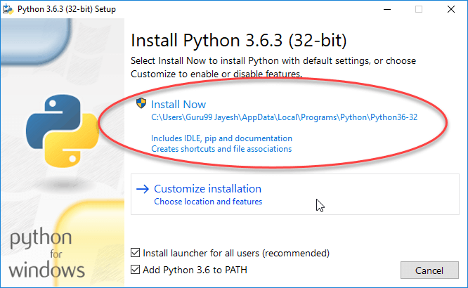

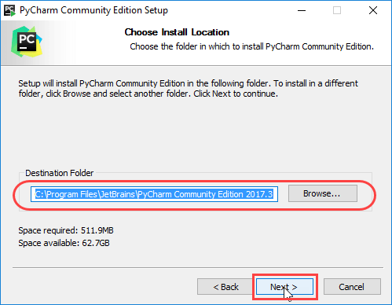

**Step 2** – Open PyCharm go terminal and install Required package/ Library

By Following Command.

pip install opencv-python

pip install matplotlib

**Step 3** – Download following Extra required file that provide python GitHub page.

coco.names.txt

frozen_inference_graph.pb

lena.png

ssd_mobilenet_v3_large_coco_2020_01_14.pbtxt

test video.mp4

**Step 4** – Write the given code in PyCharm working Area code given Below.

**Step 5** – Give Permission for Camera and code will Executed There.

********All File Also provide my GitHub page Link Give Below********

**Object Detections Python Code :**

import cv2

#-----------------------------------------------------------------------------------------------------------------------

thres = 0.49

#-----------------------------------------------------------------------------------------------------------------------

#img = cv2.imread('lena.png')

cap = cv2.VideoCapture('test video.mp4')

#cap = cv2.VideoCapture(0)

cap.set(3,640)

cap.set(4,480)

classNames = []

classFile = 'coco.names.txt'

with open(classFile,'rt') as f:

classNames = f.read().rstrip('\n').split('\n')

print(classNames)

configPath = 'ssd_mobilenet_v3_large_coco_2020_01_14.pbtxt'

weightsPath = 'frozen_inference_graph.pb'

net = cv2.dnn_DetectionModel(weightsPath,configPath)

net.setInputSize(360,360)

net.setInputScale(1.0/ 127.5)

net.setInputMean((127.5, 127.5, 127.5))

net.setInputSwapRB(True)

while True:

success, img = cap.read()

classIds, confs, bbox = net.detect(img, thres)

print(classIds,bbox)

if len(classIds) != 0:

for classId, confidence,box in zip(classIds.flatten(),confs.flatten(),bbox):

cv2.rectangle(img,box,color=(0,255,0),thickness=2)

cv2.putText(img,str(round(confidence*100)),(box[0] + 200, box[1] + 30), cv2.FONT_HERSHEY_COMPLEX_SMALL, 1,(0, 200, 0), 2)

cv2.putText(img,classNames[classId-1].upper(),(box[0] + 10, box[1] + 30), cv2.FONT_HERSHEY_COMPLEX_SMALL, 1,(0, 255, 0), 2)

cv2.imshow("camera",img)

cv2.waitKey(1)