BornoChinho
A N N O T A T E . P R E S E R V E . U N D E R S T A N D .
User Manual
Marking up scanned pages for OCR training data

September 2026
© 2025–2026 Md. Mehedi Hasan

What is in this manual
1. What this tool is for
2. The words used in this manual
3. Before you begin
4. A tour of the screen
5. What a page description contains
6. A whole page, from start to finish
7. Checking a page somebody else has done
8. Working in the annotation panel
9. Working through a whole folder
10. Saving your work
11. When the tool will not save
12. Things that surprise people
13. If something goes wrong

1. What this tool is for
BornoChinho is used to prepare the dataset that will be used to train AI models for performing Optical Character Recognition tasks.
A computer that reads scanned books learns the same way a child does: by being shown thousands of examples. Each example is one page, and it comes in two parts; the image of the page, and the content of the page in editable text format. We address this content as annotations. The annotation content says, for every block on that page: what kind of block it is, what it contains, and exactly where it sits.
Somebody has usually already typed out what each block says and given it a category name. What is missing is the position, where on the image that block actually is. Filling in those positions, and checking that everything lines up, is the work you do here.

The screen is split in two
- On the left is the image of the page
- On the right is the annotation of the page
You work between the two. You find a block on the image, draw a rectangle around it, and the tool tells you the four numbers that describe where your rectangle is. You put those numbers into that block’s entry in the list. When every block has its numbers, you can have the tool draw all of them back onto the image, so you can see at a glance whether anything is out of place.
In one sentence: the tool is a ruler and a checking table; you measure where each block is, write the measurements down, and then look at your work drawn back onto the page.
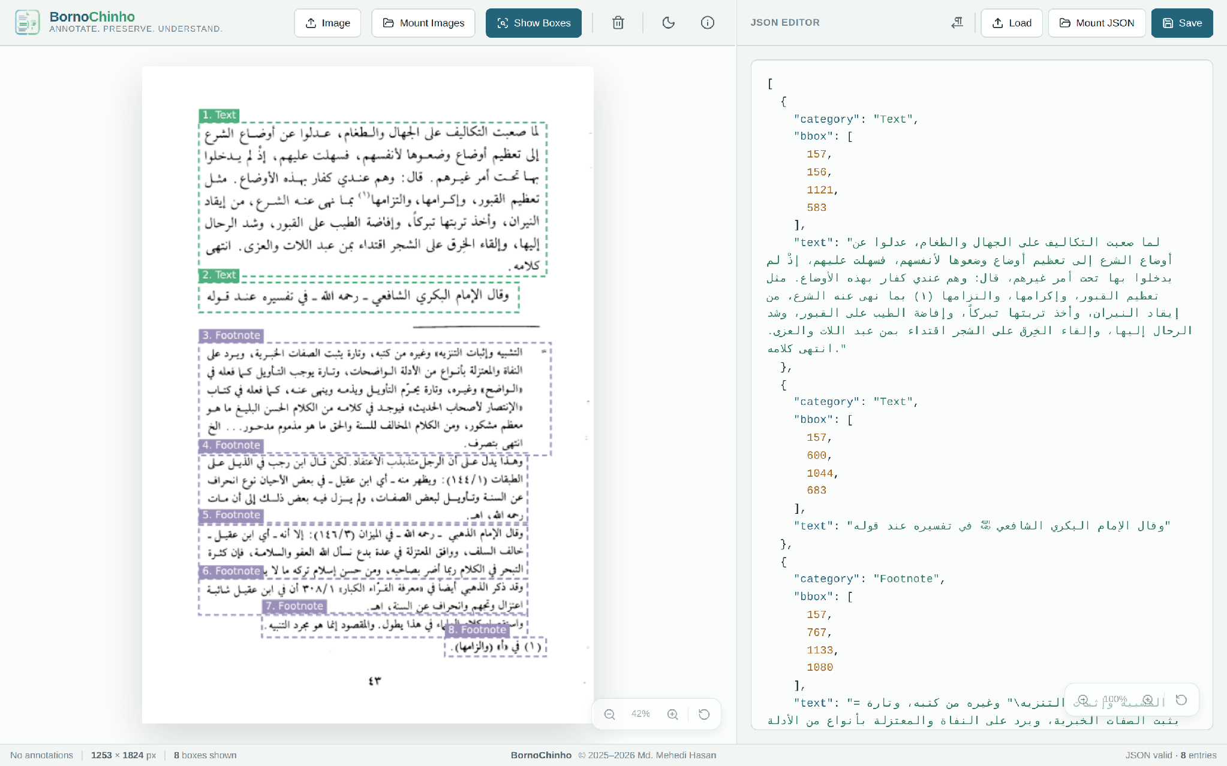
Figure 1. A finished page. Every block in the list on the right is outlined and numbered on the image on the left.

2. Before you begin

What you need
- A web browser. Google Chrome or Microsoft Edge are strongly recommended. Two useful things, opening a whole folder at once, and saving straight back onto the original file, only work in these two web browsers.
- The app runs on your computer. The address of the application is http://10.10.40.252:2828/. Type the address into your computer and press Enter.
- A reasonably wide window. The app needs a wide screen. On a narrow window a scroll bar appears along the bottom instead of the buttons squashing together.

The names have to match
The image of the page and its annotation belong together because they share a name, ignoring the ending. So 1_NoVolume_page_0043.png goes with 1_NoVolume_page_0043.json. Keep that habit and the tool can walk you through a whole book without you opening files one at a time.

3. A tour of the screen
Everything is on one screen. There are no menus to hunt through.
Figure 2. The bar along the top. The left half belongs to the image; the right half belongs to the list.
Button | What it does
Image | Open a page image from your computer.
Mount Images | Open a whole folder of page images so you can turn the pages.
Server Images | Open a whole folder of page images from the server.
Show Boxes | Show the boxes from the annotation on top of the image. Press it again to hide them.
Bin icon | Clears every rectangle you have drawn by hand. It asks you first.
Moon / sun icon | Switches between the light and dark colour schemes.
i icon | Open the About box: the shortcuts, and who made the tool.
Paragraph-arrow icon | Switch the text between left-to-right and right-to-left reading.
Load | Open one annotation file.
Mount JSON | Open a whole folder of annotation files from your computer.
Server Json | Open a whole folder of annotation files from the server.
Save | Check your work and save it.

The four areas
- The picture (left). You drag rectangles on it to measure. A small floating pill at the bottom-right makes the picture bigger or smaller.
- Selected Rectangle (top right). Appears the moment you draw a rectangle, and shows its four numbers.
- JSON Editor (right). The annotation itself. You can type in it directly.
- The bar along the bottom. A quiet strip that keeps score: the size of the picture, how many boxes are on screen, and whether the list can still be read.

4. What a page annotation contains
The list has one entry per block, and the entries are in reading order, the first entry is the first block on the page. Every entry contains three things:
Part | What it is
category | The category of block, chosen from the ten names. Spelling and capital letters must match exactly.
text | The text in that block, exactly as they appear on the page.
bbox | The four numbers that say where the block sits, how far from the left edge, how far from the top, then the same again for the opposite corner. These are the numbers the rectangle tool gives you.
Nothing else is allowed in an entry. Adding anything extra will stop the file from saving.

The ten categories of block
Only these names are accepted, and capital letters matter: "Text" works, "text" and "TEXT" do not. Each kind is drawn in its own colour when the boxes are shown.
Name | Use it for | Has text? | Colour
Title | The main title of the page | Yes | Red
Section-header | A heading inside the page | Yes | Dark teal
Text | An ordinary paragraph | Yes | Green
List-item | One item of a numbered or bulleted list | Yes | Light green
Table | A table | Yes | Orange
Picture | A photograph, drawing or diagram | No | Purple
Caption | The line that describes a table or a picture | Yes | Yellow
Footnote | A note at the foot of the page | Yes | Purple-grey
Page-header | The running line along the top of the page | Yes | Blue
Page-footer | The running line along the bottom, page numbers | Yes | Blue

5. A whole page, from start to finish
This section follows one real page all the way through: page 43 of a scanned Arabic volume. It has eight blocks, two paragraphs of main text, and six footnotes below the rule.

Step 1 — Open the page picture
- Click Image at the top and choose the page.
The picture appears on the left, shrunk so the whole page fits the height of the window. The number in the corner will therefore read something like 42% rather than 100%, that is normal and nothing is lost; the picture itself is untouched.
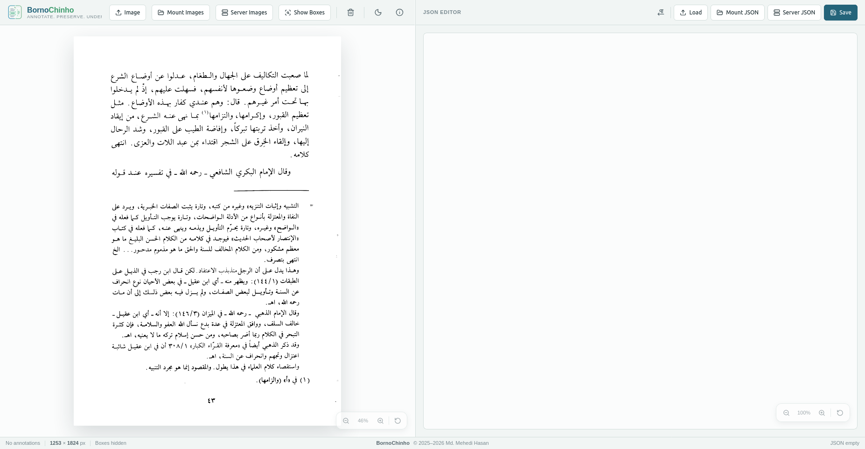
Figure 3. The page picture, open and fitted to the window.

Step 2 — Open the list that goes with it
- Click Load above the right-hand panel and choose the matching file.
This is what a page looks like before anybody has measured it. Each entry already says what category of block it is and what text it contains; but there are no numbers anywhere, because nobody has recorded where the blocks are yet.
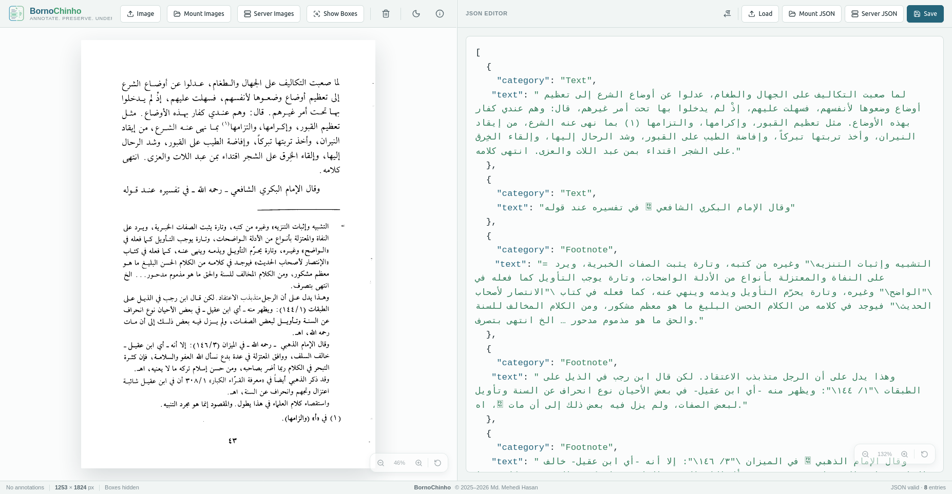
Figure 4. The starting point: eight entries, each with a kind and its words, and no positions.
Written out, the first two entries look like this:
[
{
"category": "Text",
"text": "… the words of the first paragraph …"
},
{
"category": "Text",
"text": "… the words of the second paragraph …"
},
… six more entries, all Footnote …
]
If you press Show Boxes now, nothing is drawn, and the bottom bar says so plainly. That is exactly what you would expect, there are no positions to draw yet.
Figure 5. The bottom bar reports that the annotation contains no positions yet.

Step 3 — Measure the first block
Look at the picture and find the block the first entry is describing. Here, it is the big paragraph at the top of the page.
- Point at the top-left corner of the paragraph.
- Hold the left mouse button down and drag to the bottom-right corner.
- Let go. A green rectangle stays behind, and the Selected Rectangle panel appears above the list.
Take in a little of the white space around the words rather than cutting into them. Tiny drags are ignored on purpose, so a stray click will not leave a mark.
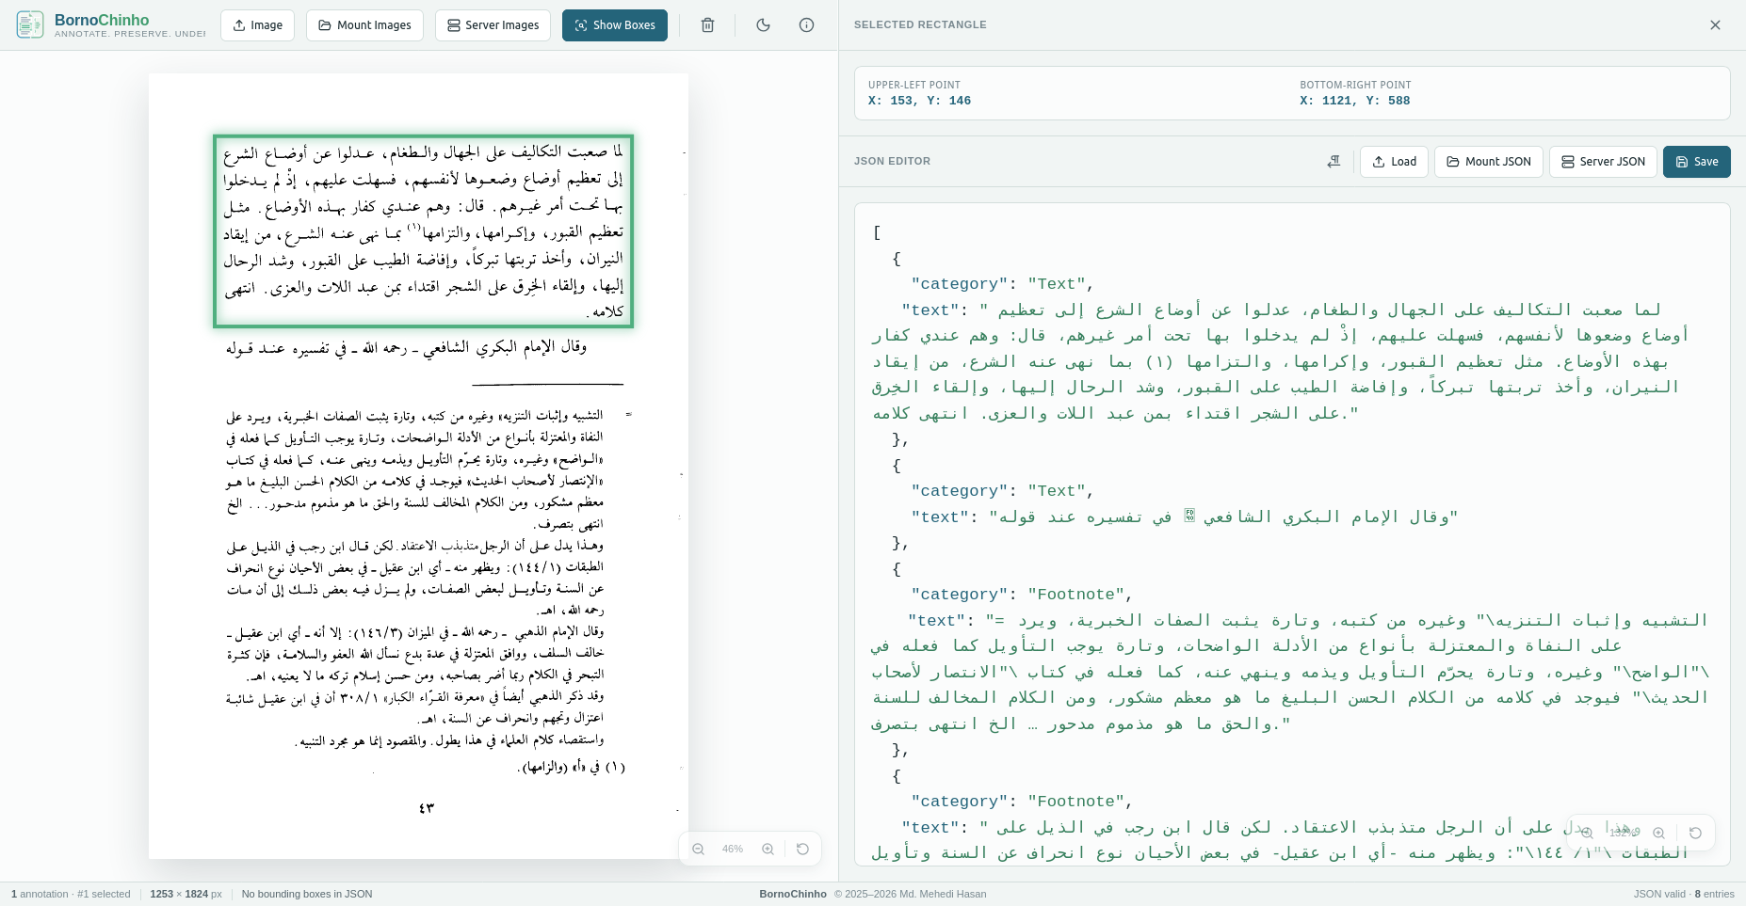
Figure 6. A rectangle drawn around the first paragraph.
The panel now reports the two corners of what you drew:
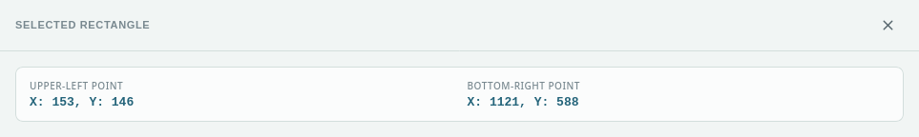
Figure 7. The four numbers for that rectangle.

Step 4 — Write the numbers into the entry
Read the panel across into the entry, in this order:
- Upper-left X → the 1st number
- Upper-left Y → the 2nd number
- Bottom-right X → the 3rd number
- Bottom-right Y → the 4th number
The panel above reads 153 and 146 for the upper-left corner, and 1121 and 588 for the bottom-right. So click into the first entry and add a line for the position:
{
"category": "Text",
"bbox": [153, 146, 1121, 588],
"text": "… the words of the first paragraph …"
},
Mind the small punctuation: the four numbers sit inside square brackets, separated by commas, and the line ends with a comma before the next line begins. If you get it wrong the bottom right of the screen will say so straight away, and you can put it right before moving on.

Step 5 — Do the same for every other block
Work down the page in order. Draw around the second paragraph, copy its numbers into the second entry, and so on through all eight. Press Delete after each one if you would rather keep the picture clean; the numbers you have already copied are safe in the list.
Some tips that save time:
- Make the picture bigger before measuring small blocks, the boxes stay attached to the words, so nothing shifts.
- Blocks are allowed to touch or overlap slightly. A footnote that begins where the one above ends is perfectly normal.
- Work in the order the entries are listed. It is much easier than hunting for which entry matches which block.
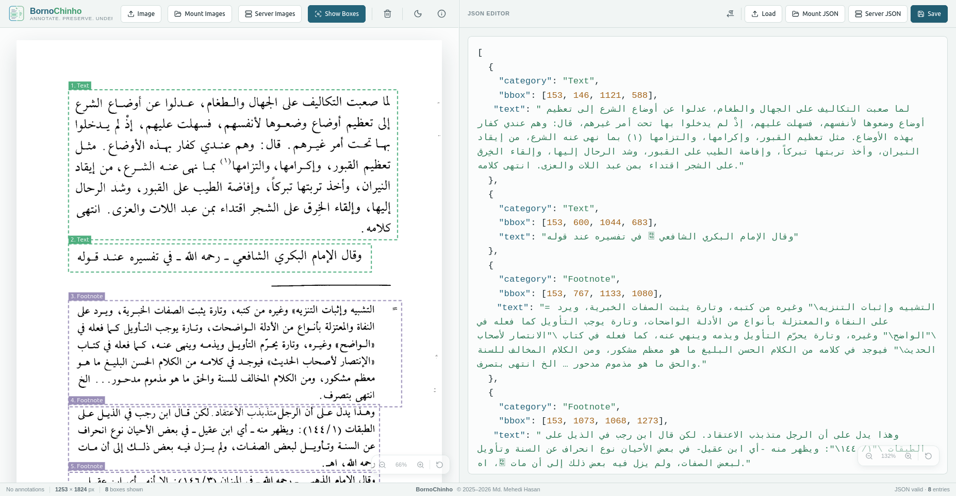
Figure 8. The picture enlarged for close work. Scroll bars appear and the zoom controls stay put.

Step 6 — Look at your work
When every entry has its numbers, press Show Boxes. Each entry is outlined on the picture in its own colour and tagged with its number and category, such as "1. Text", "3. Footnote", and so on. The number is the entry’s place in the annotation.
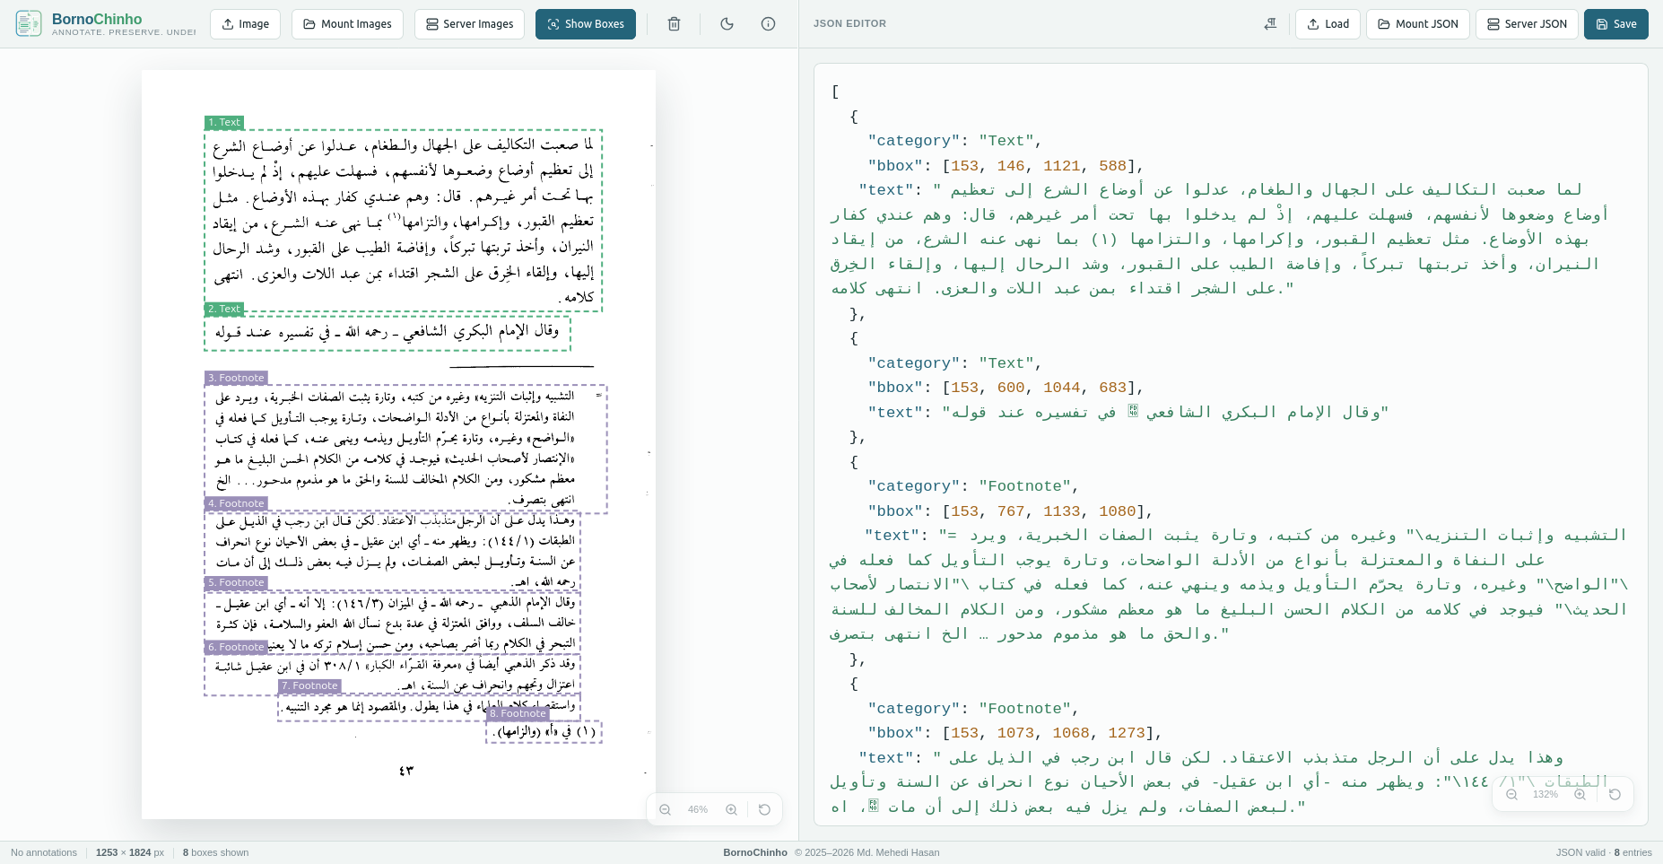
Figure 9. All eight blocks measured, outlined and numbered.
This is the moment to check your work. Look for a box that has slipped off its words, a box that swallows part of the block next door, a block on the page with no box at all, or a label sitting on the wrong sort of block. The bottom bar tells you how many boxes were drawn; if that number is lower than the number of entries, one of them has a position the tool could not use.

Step 7 — Save
Press Save. Your work is checked first, and only saved if everything passes. Sections 10 and 11 cover where it goes and what happens if a check fails.

What the finished file looks like
The finished annotation is the annotation you started with, with one position added to every entry.
[
{
"category": "Text",
"bbox": [153, 146, 1121, 588],
"text": "… first paragraph …"
},
{
"category": "Text",
"bbox": [153, 600, 1044, 683],
"text": "… second paragraph …"
},
{
"category": "Footnote",
"bbox": [153, 767, 1133, 1080],
"text": "… first footnote …"
},
… and so on for every block on the page …
]
For this page, all eight entries end up with these positions:
Entry | Kind | Left | Top | Right | Bottom
1 | Text | 153 | 156 | 1121 | 583
2 | Text | 153 | 600 | 1044 | 683
3 | Footnote | 153 | 767 | 1133 | 1080
4 | Footnote | 153 | 1073 | 1068 | 1273
5 | Footnote | 153 | 1267 | 1068 | 1422
6 | Footnote | 153 | 1423 | 1068 | 1523
7 | Footnote | 332 | 1518 | 1068 | 1585
8 | Footnote | 839 | 1585 | 1120 | 1638

A few things worth noticing in that table, because they are normal and often worry people the first time:
- Most blocks start at the same left edge, 153, because the text column is straight. The last two start further in — those footnotes are shorter lines that do not fill the width.
- Entry 3 ends at 1080 and entry 4 starts at 1073, so they overlap very slightly. That is fine.
- No number is ever zero or below. The very top-left of the picture counts as 1, not 0.

6. Checking a page somebody else has done
Sometimes the positions are already there, filled in by a colleague, or guessed automatically by another program, and your job is to check rather than to measure. The routine is shorter:
- Open the page picture and its annotation.
- Press Show Boxes.
- Compare what is drawn against what is on the page.
- Correct anything that is wrong, and save.
What to look for:
- A block with no box around it, an entry that was missed altogether.
- A box that has slipped, or is too tight, or is swallowing the block next to it.
- A label that does not match what it is sitting on, a footnote marked as ordinary text.
- Two boxes stacked on the same block, or a box over blank paper.
- Words in the entry that do not match the words in the picture.
To correct a position, measure the block again with the rectangle tool and replace the four numbers. To correct a label or the words, simply type over them. The outlines redraw as you type, so you can watch a box move into place.

7. Working in the annotation panel

The colours
The panel colours the list as you type: the part names in teal, the words in green, the numbers in amber. That is a quick check in itself, a piece of text that is not green usually means a quotation mark is missing.

Bigger or smaller text
The floating pill at the bottom-right of the panel changes only the size of the writing in the panel, up to three times or down to half. The circular arrow puts it back to normal. Useful when you need to look closely at the words.

Pages that read right to left
The paragraph-arrow button next to Load flips the panel round for pages in Arabic, Urdu, Persian and other right-to-left scripts, so the words sit the way they are read while the shape of the list stays put. Your choice is remembered next time.
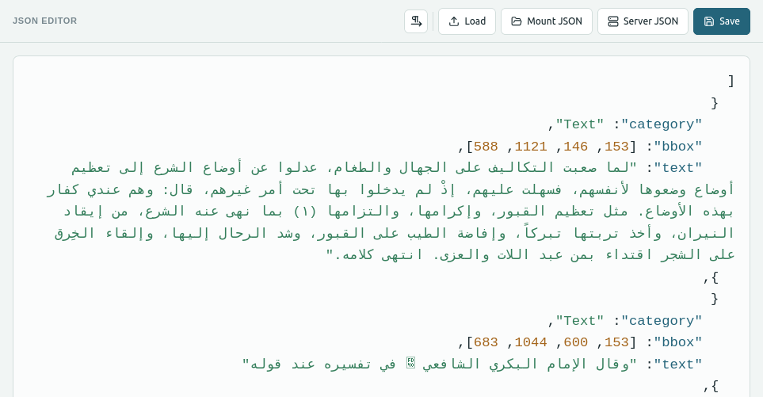
Figure 10. The same list, flipped for right-to-left reading.

8. Working through a whole folder
Opening files one at a time is fine for a few pages. For a whole book, let the tool open the folders instead.
- Click Server Images and choose the folder of page images.
- Click Server JSON and choose the folder of annotations.
- Two sets of arrows appear; one under the picture, one under the list, and the first page opens by itself.
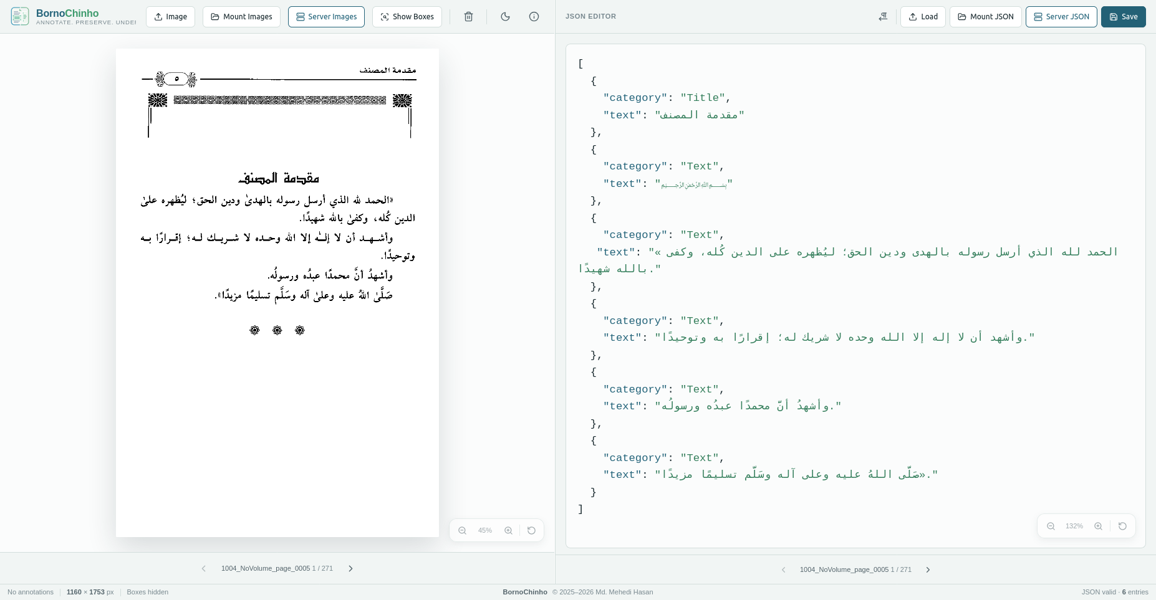
Figure 12. Both folders open. The label shows the file name and the position in the folder — here page 43 of 120.

The two sets of arrows, and Sync
The picture and the annotation can be moved separately, which is handy for comparing one page with the next. When they drift apart, both labels turn amber and a Sync button appears; press it to bring the annotation back to the same page as the picture.

Opening only one folder
You can open just the pictures, or just the annotations, turn the pages on that side alone, and add the other folder later.
If nothing happens: a message about no matching pairs means the two folders hold files with different names. A message about needing Chrome or Edge means your browser cannot open folders, use the Image and Load buttons instead.

9. Saving your work
Press the Save button. Two things happen, in this order:
- The tool checks every entry in the list.
- If nothing is wrong, it saves. If anything is wrong, nothing at all is written and you get a report.
When the save works, the button turns green for a moment and reads "Saved!". That flash is the confirmation, there is no other message.
Figure 13. The Save button confirms that the file has been written.

10. When the tool will not save
If any entry has a problem, nothing is saved and a report appears telling you exactly what is wrong. It is headed with a count, "3 entries need fixing", and gives one card for each entry.
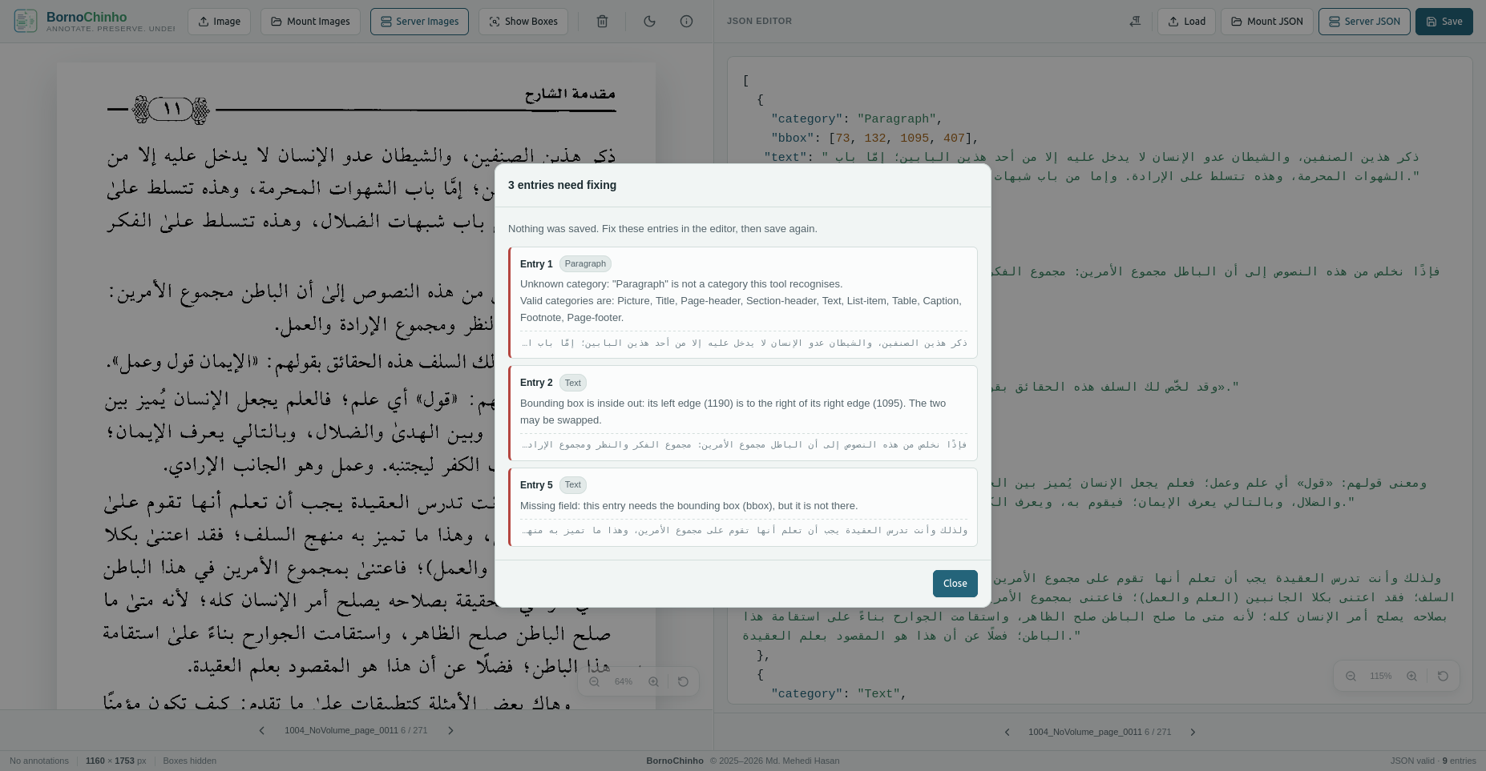
Figure 14. The report. Each card names the entry, its kind, what is wrong, and the first few words of its text.
Each card carries four things:
- The entry number, counted from the top of the annotation. It is the same number the boxes are tagged with, so switch Show Boxes on and "Entry 2" is the block labelled 2 on the picture.
- The category, in a small oval, so you know what the entry claims to be.
- What is wrong, in plain words. One entry can have more than one problem.
- The first few words of the text, as a landmark for finding the entry in the annotation.

Fix the entries, then press Save again. These are the messages you are likely to meet:
The message begins | What it means | How to put it right
Unknown category… | The kind is not one of the ten names, or the capital letters are wrong. The message lists all ten for you. | Correct the spelling to match the table in section 5.
Missing field… | The entry is short of one of its three parts. | Add the missing part. Only a Picture entry is allowed to have no words.
Unexpected field… | There is something in the entry that does not belong — an extra part, or words on a Picture entry. | Delete the part that does not belong.
The bounding box should be four numbers… | The position has too few or too many numbers. | Leave exactly four: left, top, right, bottom.
Bounding box is inside out… | The left number is bigger than the right one — the two are probably the wrong way round. | Put the smaller number first.
Bounding box is upside down… | The top number is bigger than the bottom one. | Put the smaller number second.
Bounding box off the page… | One of the numbers is zero or less. Every number must be at least 1. | Measure the block again with the rectangle tool.

Before the checks even run: if the bottom right of the screen says "JSON invalid", the annotation itself cannot be read, usually a missing comma, quotation mark or bracket. Save will complain about that first.

11. Things that surprise people
None of these are faults. They are just how the tool works, and knowing them saves a lot of puzzling.
- Rectangles you draw do not go into the annotation by themselves. Drawing measures; typing records. Copying the numbers across is always your step.
- Only the newest rectangle is selected. You cannot click an older rectangle to bring it back. If you need its numbers again, draw it again.
- Backspace can delete a rectangle. Just after drawing, the first press of Backspace in the annotation removes the rectangle instead of a letter. Press it once to clear the rectangle, then carry on typing normally.
- Turning the page clears your rectangles. The annotation is left alone.
- Show Boxes is about the annotation, not your drawings. Solid green rectangles are the ones you drew; dashed coloured ones with number tags come from the annotation.
- Boxes disappear while you are typing. For a moment the annotation cannot be read, so nothing is drawn. They come back as soon as the entry is complete.
- The size rarely reads 100%. The opening view shrinks the page to fit the window. It changes nothing about the picture or your numbers.
- Save is all or nothing. One bad entry stops the whole page from being saved.

12. If something goes wrong
Problem | What to do
The page is blank, or the app will not open. | Reload the address http://10.10.40.252:2828/
Nothing happens when I drag on the picture. | A picture has to be open first. Check you are dragging on the page itself and not the empty area around it. Very small drags are ignored.
Server Images or Server JSON does nothing. | Use Chrome or Edge, and make sure the address is correct.
It says the folder has no images (or no annotations). | Wrong folder, or the files sit in a folder inside it. Only files directly inside the chosen folder are used.
It says no matching pairs were found. | The picture and the annotation must share a name; 1_NoVolume_page_0043.png with 1_NoVolume_page_0043.json.
Fewer boxes are drawn than there are entries. | One or more positions cannot be used, missing, not four numbers, or a box with no size. Press Save and the report will name them.
Save says permission was declined. | The browser asked to change files in your folder and was refused. Press Save again and allow it.
The buttons are cut off at the edge. | The window is too narrow. Make it wider, or scroll sideways.

