ALANYA ALAADDİN KEYKUBAT UNIVERSITY

RAFET KAYIŞ FACULTY OF ENGINEERING
COMPUTER ENGINEERING DEPARTMENT

COM 305
SOFTWARE ENGINEERING

“eRestaurant”
Requirements Analysis Report

30.12.2021

Kağan Coşkun
Furkan Lüleci

CONTENT
1. INTRODUCTION…………………………………………………...………2
1.1 Project Title…………………………………………………………..2
1.2 Problem Definition…………………………………………………..2
1.3 Project Goal………………………………………………………….2
1.4 Project Scope…………………………………………………………3
1.5 Application Areas……………………………………………………3
2. TEAM ORGANIZATION…………………………………………………..4
3. PROJECT SCHEDULE…………………………………………………….5
4. PROCESS MODEL………………………………………………………….6
5. SYSTEM REQUIREMENTS……………………………………………….7
5.1 Functional Requirements……………………………………………7
5.2 Non-functional Requirements………………………………………8
6. USE CASE ANALYSIS……………………………………………………..9
6.1 Usage Scenarios……………………………………………………...9
6.2 Use Case Glossary………………………………………………….10
6.3 Use Case Diagrams…………………………………………………11
6.4 Use Case Narratives………………………………………………..12
7. REFERENCES……………………………………………………………..16

1. INTRODUCTION
eRestaurant is a software that consumers can order without leaving their homes due to viruses and lockdowns.
1.1 Project Title
The subject of our project is “Order Without Leaving Homes” and the title for this project is “eRestaurant”.
1.2 Problem Definition
Loss of income due to the pandemic in the food sector puts the operators in a difficult situation. On the other hand, consumers have difficulty in reaching the tastes they miss due to the pandemic and are afraid. Therefore, they want to reach the products online without leaving the house.
1.3 Project Goal
From the project deadline, we plan to provide consumers with the opportunity to easily place their orders by communicating with the business through this system without leaving their homes.

1.4 Project Scope
This project aims to achieve success in the following features:
- Graph API Client: The Graph API allows reading and writing data to Facebook easily. However, we need to process the raw data that we gather by using the Graph API.
- Core Recommendation Engine: It is going to be the implementation of a set of algorithms that predicts an active user’s future interests using her known interests, and people who have similar interests with her.
- Recommendation Service: It will be a web service on top of Core Recommendation Engine in order to serve personalized recommendations to the clients.
- Web Client: This will be a web page that will allow users to login with their Facebook account, and see personalized recommendations.
- Mobile Client: It will be a native iPhone application that will allow users to login with their Facebook account, and see personalized recommendations.

1.5 Application Areas
This project has been launched in order to provide a personalized experience for the members of Facebook by using the Graph API. Our system will provide recommendations on information items such as people, events, photos, pages, etc. Currently, we are planning to support web client and mobile client.
Our system can be applicable to some other social network services that provide access to human data via an application-programming interface. Furthermore, our mobile client is a native iPhone application, but the system can also work with Android if necessary modifications are provided.

2. TEAM ORGANIZATION
Our team consists of two members who are Kağan Coşkun and Furkan Lüleci. We are attempting to structure the team as productively as possible with respect to the unique specifications and interests of each team member because there are many different duties to be completed during the project's development phase.
The table below depicts the team organization in terms of certain tasks and the members' roles in relation to those tasks:
Job/Team Member | Kağan Coşkun | Furkan Lüleci
Project Management |  | √
System Design | √ | √
Recommendation Service | √ | √
Web Services | √
Web Client Development | √
Documentation | √ | √

3. PROJECT SCHEDULE
Previously, we had created a project plan, which includes task allocation between team members, milestones of the project, and time schedules for project tasks. In this section, we provide the overview of that schedule below:

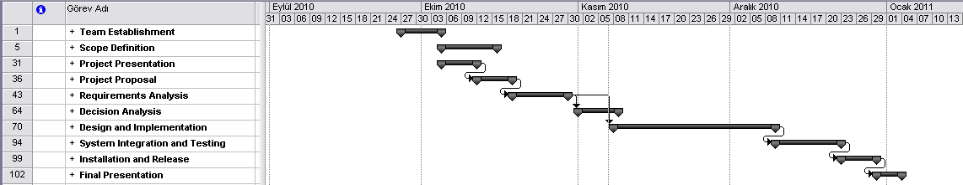

In the figure above, the main tasks of the project are shown with their start and end dates, and the dependencies among each other. These main tasks are team establishment, scope definition, project presentation, project proposal, requirements analysis, decision analysis, design and implementation, system integration and testing, installation and release, and final presentation. As it can be understood by the figure, the start date of the project is defined as 24th of September, 2010 and the end date of the project is defined as 4th of January, 2011.
Detailed information about the project schedule can be found at the project website, under project documents.

4. PROCESS MODEL
Agile software development is a group of software development methodologies based on iterative and incremental development. In this type of software development methodologies, the requirements and solutions can evolve through collaboration between self-organizing, cross-functional teams [2].
Extreme Programming is a type of agile software development, which aims to improve software quality and responsiveness to changing customer needs. In this methodology, frequent releases in short development cycles are provided. The programming, code review, and unit testing are done in pairs. Extreme Programming attempts to reduce the cost of change by having multiple short development cycles, rather than one long one [3].
In our project, we have chosen Extreme Programming as the software development methodology. As it is described above, XP is a type of agile software development, which is based on iterative and incremental development. The characteristics of this methodology are considerably suitable for our project and the team members. As we do not depend on strict requirements and our project is suitable for immediate changes, we agreed on applying the principles of agile software development and decided Extreme Programming.

5. SYSTEM REQUIREMENTS
In this section of the report, system requirements are described as functional requirements and non-functional requirements.
5.1 Functional Requirements
The system should;
- Provide log in mechanism with Facebook account
- Get extended user permissions
- Provide option for filtering by type of recommendation functionality (Show only recommended events, movies, etc.)
- Provide “Don’t recommend that anymore” functionality (User should be able to remove a recommended content from future recommendations)
- Decide recommender type (Just using friends, or whole user data)
- List most popular content in user’s network
- Provide option for filtering most popular content by type functionality (Show only popular movies, events, etc.)

5.2 Non-functional Requirements
The system should be;
- Available on iOS and modern web browsers.
      - As well as a native iPhone application, the system should live on the web with all functionalities. Ease of use and simplicity are the main goals while designing user interfaces.
- Scaled out when needed.
      - Since this system is open for all people with a Facebook account, a horizontal scalability (i.e. scaling by adding new computers) strategy will be defined.
- Highly extendible based on future release requirements.
      - The architecture of the software system should be module based, so that any modification may easily be done without changing whole system. Such modifications may be adding new features, or removing an existing one.
- Designed by taking usability principles into consideration.
      - The users, who interact with the system, should find the system easy to learn, efficient and satisfying to use. System functionalities and user interfaces must be well designed so that it should be easy for users to accomplish basic tasks when they first encounter the design, and they should be able to perform tasks quickly.

6. USE CASE ANALYSIS
In this section, we are going to provide the use case analysis in terms of usage scenarios, use case glossary, use case diagrams and use case narratives. The sections are listed below:
6.1 Usage Scenarios
Although the system will have mobile client and web client, both of the users will be provided with the same features. Thus, our system will have one actor that can be named as “Application User”.
In order to use our product, the user should first log in to her Facebook account by using the authentication mechanism provided within our software. After a successful validation, the user will be asked allow extended permission to her social network connections.
Having successfully completed Facebook authentication and extended permission steps, the user can request to see the recommended content for her. She can filter this content by specifying the type of items, such as displaying people, events, movies, pages, and so on. Furthermore, the user can specify the scope of connections by selecting to analyze only user connections or the whole connections available at the system. The user is also provided with the ability to ignore a recommended item for further executions of the application. Another thing that can be done by the user is filtering the content by looking at the most popular items. When the user requests to see the most popular category, she will be provided with the items that are currently popular among the social network connections.
The usage scenarios that are described above are given as a list of items in the following section:
- Log in to Facebook and allow extended permission
- Request to see the recommended items
- Filter recommendations by item type
- Filter recommendations by selecting connection scope
- Request to not recommend an item anymore
- Request to see most popular items
6.2 Use Case Glossary

Use Case Name | Use Case Description | Participating Actors
Log in to Facebook Account | The user logs in to her profile on Facebook via the authentication mechanism of the system. | Application User
Allow Extended Permission | The user allows extended permission to access her data (including her connections). | Application User
Ask for Recommendations | The user wants to see the recommendations provided by the system to her. | Application User
Filter Recommendations by Item Type | The user wants to filter the recommendations by item type such as event, page, and movie. | Application User
Filter Recommendations by Connection Scope | The user may want to retrieve recommendations from only her connections or the whole connections. | Application User
Request to Ignore a Recommendation | The user may not be interested in a recommendation and wants to ignore it. | Application User
Request to See Most Popular Items | The user may be interested in the most popular items and wants recommendations about them. | Application User

6.3 Use Case Diagrams
The use case diagram that represents our system is provided at the following figure below:
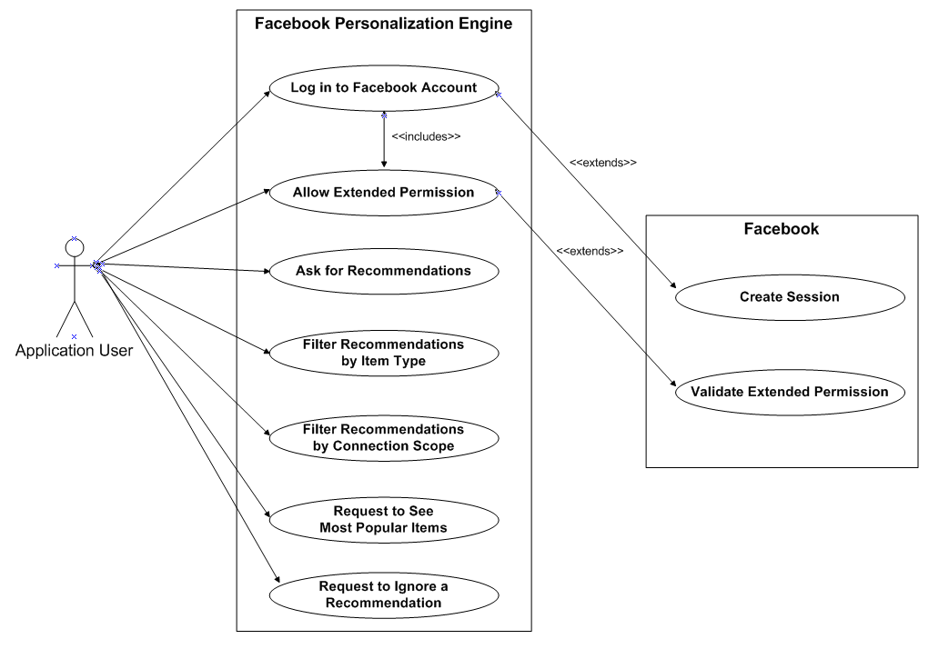

6.4 Use Case Narratives
6.4.1 Log in to eRestaurant account
Use-Case Name: | Log in to eRestaurant Account | Use-Case Type
Use Case ID: | 001 | Business Requirements:
Priority: | High
Primary Business Actor: | Application User
Description: | The user logs in to her profile on eRestaurant via the authentication mechanism of the system.
Precondition: | The user must have a eRestaurant account.
Trigger: | The user must run an executable of the system, via a browser or an iPhone
Typical Course of Events: | Actor Action | System Response
 | User submits eRestaurant account data. | The system responds with authentication mechanism.
 |  | The system requests extended permission from the user.
Alternate Courses: | If the authentication fails, the user should be directed to the login page.
Conclusion: | Conclude if authentication is successful.
Business Rules: | The system is not usable by the people who have no eRestaurant account
Assumptions: | None

6.4.2 Allow Extended Permission
Use-Case Name: | Allow Extended Permission | Use-Case Type
Use Case ID: | Personalized-UC-002 | Business Requirements:
Priority: | High
Primary Business Actor: | Application User
Description: | The user allows extended permission to access her data (including her connections).
Precondition: | The user must be signed in to the system.
Trigger: | The user submits correct Facebook email and password.
Typical Course of Events: | Actor Action | System Response
 | User allows extended permission to access her account data. | The system retrieves data from user profile and her connections.
 |  | The system posts data to subsystems to process raw data.
Alternate Courses: | If the user denies extended permission, the system shows an informative page about the necessity of extended permission and requires again.
Conclusion: | Conclude if the user allows extended permission.
Business Rules: | Allowing extended permission must not discomfort any of the users.
Implementation Constraints: | The feature supplied by Facebook must be used while requesting extended permission.
Assumptions: | None

6.4.3 Ask for Recommendations
Use-Case Name: | Ask for Recommendations | Use-Case Type
Use Case ID: | Personalized-UC-003 | Business Requirements:
Priority: | High
Primary Business Actor: | Application User
Description: | The user wants to see the recommendations provided by the system to her.
Precondition: | The user must allow extended permission to access her account data.
Trigger: | The user requests to see recommendations for her.
Typical Course of Events: | Actor Action | System Response
 | User clicks button/touches screen related with recommendation request. | On the fly, system analyzes user connections.
 |  | Recommendation engine creates possible recommendations.
 |  | System shows the results to the user, providing filtering options.
Alternate Courses: | In case of no relevant matches, the system shows popular items.
Conclusion: | Concludes until a new request arrives from the user.
Business Rules: | The most relevant results must be shown to the user.
Implementation Constraints: | The results must be displayed in a reasonable time.
Assumptions: | None.

6.4.4 Filter Recommendations by Item Type
Use-Case Name: | Filter Recommendations by Item Type | Use-Case Type
Use Case ID: | Personalized-UC-004 | Business Requirements:
Priority: | Medium
Primary Business Actor: | Application User
Description: | The user wants to filter the recommendations by item type such as event, page, and movie.
Precondition: | The user has already requested to see recommendations.
Trigger: | The user wants to filter relevant matches.
Typical Course of Events: | Actor Action | System Response
 | User selects an item type to be used in filtering the results. | The system posts the item type to recommendation engine.
 |  | Recommendation engine filters results with respect to user choice.
 |  | System shows the results to the user, providing filtering options.
Alternate Courses: | In case of no relevant matches, the system provides popular items of the selected category.
Conclusion: | Concludes until a new request arrives from the user.
Business Rules: | Users should be able to select any kind of supported information items.
Implementation Constraints: | The results must be displayed in a reasonable time.
Assumptions: | None.
6.4.5 Filter Recommendations by Connection Scope
Use-Case Name: | Filter Recommendations by Connection Scope | Use-Case Type
Use Case ID: | Personalized-UC-005 | Business Requirements:
Priority: | Medium
Primary Business Actor: | Application User
Description: | The user wants to filter the recommendations by connection scope, only using user friends or using all available connections.
Precondition: | The user has already requested to see recommendations.
Trigger: | The user wants to filter relevant matches.
Typical Course of Events: | Actor Action | System Response
 | User selects the connection scope as only user friends. | The system posts the selection to recommendation engine.
 |  | Recommendation engine creates results by user friends’ data.
 |  | System shows the results to the user, providing filtering options.
Alternate Courses: | In case of no relevant matches, system applies default connection scope.
Conclusion: | Concludes until a new request arrives from the user.
Business Rules: | Users should be able to prefer see results obtained from friends data.
Implementation Constraints: | The results must be displayed in a reasonable time.
Assumptions: | By default, all available connections are used.

6.4.6 Request to Ignore a Recommendation
Use-Case Name: | Request to Ignore a Recommendation | Use-Case Type
Use Case ID: | Personalized-UC-006 | Business Requirements:
Priority: | Low
Primary Business Actor: | Application User
Description: | The user may not be interested in a recommendation and wants to ignore it.
Precondition: | The user has already requested to see recommendations.
Trigger: | The user wants to discard a recommendation.
Typical Course of Events: | Actor Action | System Response
 | User clicks button/touches screen to ignore a recommendation. | The system passes user id and recommendation id to subsystems.
 |  | The request is stored in permanent storage.
Alternate Courses: | None.
Conclusion: | Concludes until a new request arrives from the user.
Business Rules: | Users should not be provided with recommendations ignored by them.
Implementation Constraints: | Ignored recommendations should be recalled and recoverable.
Assumptions: | None.

6.4.7 Request to See Most Popular Items
Use-Case Name: | Request to See Most Popular Items | Use-Case Type
Use Case ID: | Personalized-UC-007 | Business Requirements:
Priority: | Medium
Primary Business Actor: | Application User
Description: | The user may be interested in the most popular items and wants recommendations about them.
Precondition: | The user has already requested to see recommendations.
Trigger: | The user wants to see most popular items.
Typical Course of Events: | Actor Action | System Response
 | User clicks button/touches screen to see most popular items. | The system posts the request to recommendation engine.
 |  | The recommendation engine retrieves most popular items.
 |  | System shows the results to the user, providing filtering options.
Alternate Courses: | None.
Conclusion: | Concludes until a new request arrives from the user.
Business Rules: | The popular items should be obtained from all connections.
Implementation Constraints: | None.
Assumptions: | Connection scope is default.

7. REFERENCES

- ‘Social Network Service’, in Wikipedia,
http://en.wikipedia.org/wiki/Social_network_service [accessed 07 November 2010].
- ‘Agile Software Development’, in Wikipedia,
http://en.wikipedia.org/wiki/Agile_software_development [accessed 07 November 2010].
- ‘Social Network Service’, in Wikipedia,
http://en.wikipedia.org/wiki/Extreme_Programming [accessed 07 November 2010].

