Our project is about configure DHCP and a web server (HTTP), IPv4 addressing and address translation. We used cisco packet tracker and implemented in windows computer. Our DHCP configuration automatically assign IPv4 address to the host .

First we will take hosts from where admissions, results, eTender, advising and different types of activities are done. To interface the hosts we will take switch. At that point we will take a router for making a network. After that we will take DHCP server, DNS server and HTTP server .The DNS server is for HTTP server. So the web server can be workable. Everything ought to be associated with wire at that point. Then we will assign gateway IP in the router .The router will recognize server and switch with those gateway IP.

We will assign the IP’s of switch or server which will be recognizable to router. Our Those will be their default gateway ip.

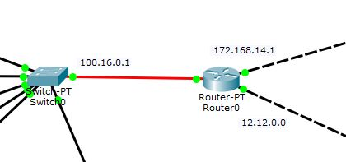

Figure: Name IP of gateway

We will also assign the server IP.

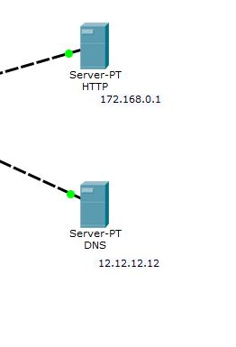Figure: Name IP of server

Now we will make recognizable the switch side network to router. For this we have to go to the port Fa4/0 and then give the default gateway.

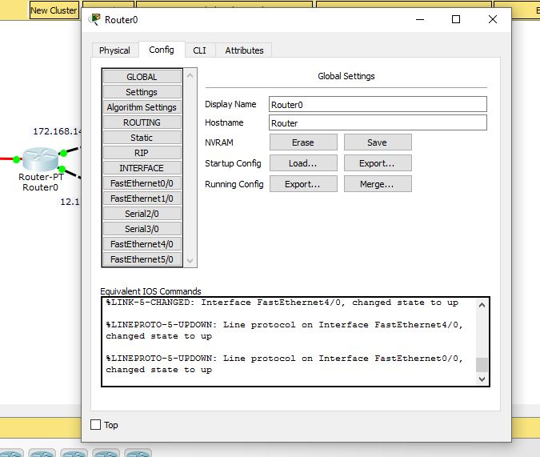

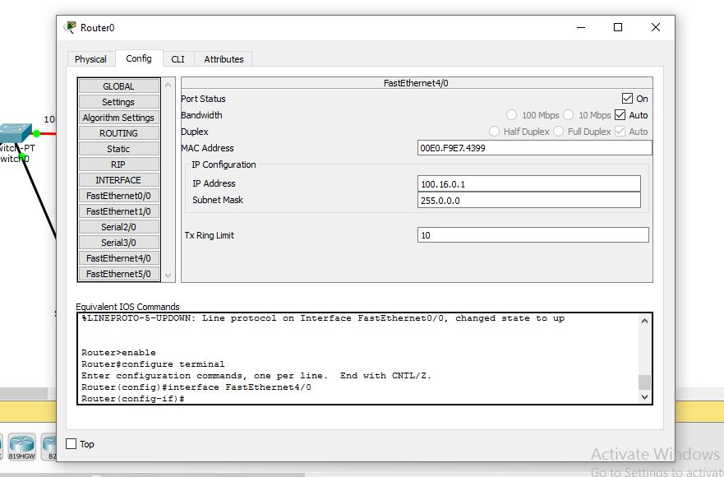

Figure: Assign default gateway

Similarly we can assign the default gateway to the server.

Then we will go to the HTTP server and give it IP address and tell it the default gateway, DNS server.

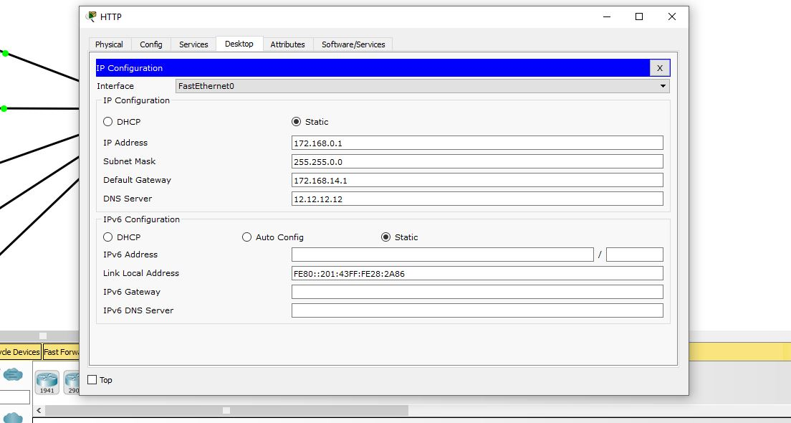

Figure: Assign IP to HTTP server.

We will assign IP similarly to DNS and DHCP server.

Now we will go to the ‘Services’ to name the website. We named our website ‘www.cse405cn.com’.And also include the IP of the web server in the interface.

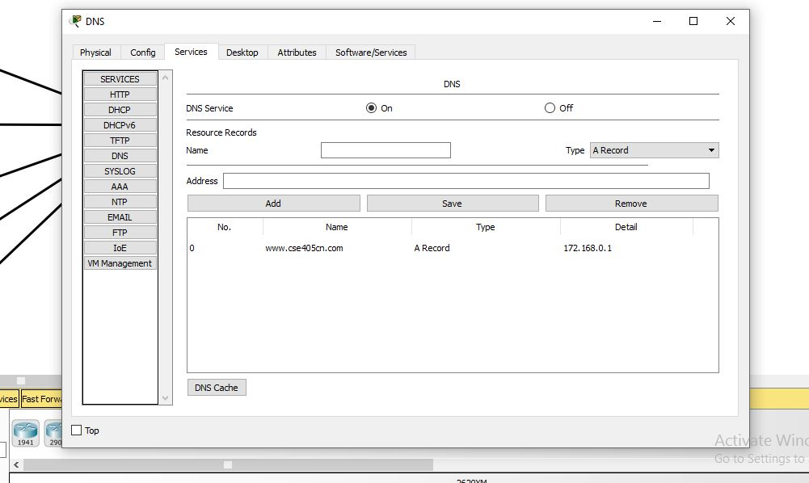

Figure:Assingning name to Web server

We can also edit the page of the website.

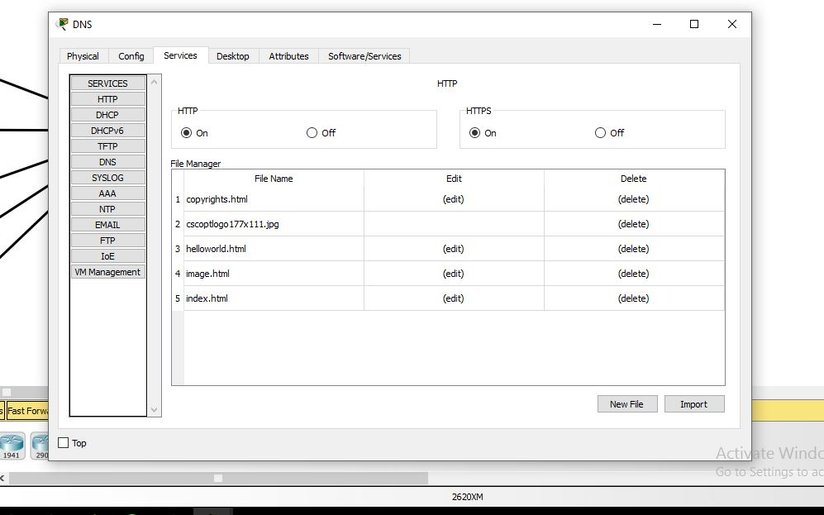

Figure: Edit HTTP page

Now we will work with Hosts . Host should configured as DHCP instead of Static .That will generate automatically an IP number to the host.

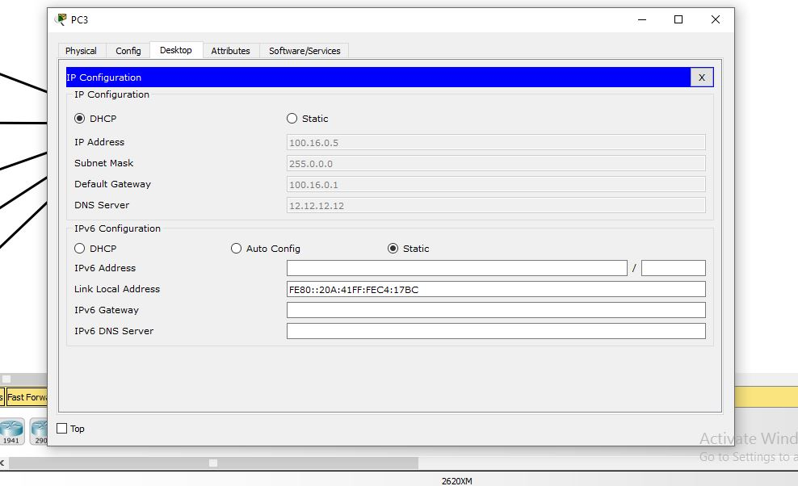

Figure: Assign HOST the IP number

Then we will ping 172.168.0.1 from every host and check whether it is sending packets and replying or not . If We get reply then we will go to the web page and type ‘www.cse405cn.com’ and then a web page will appear .

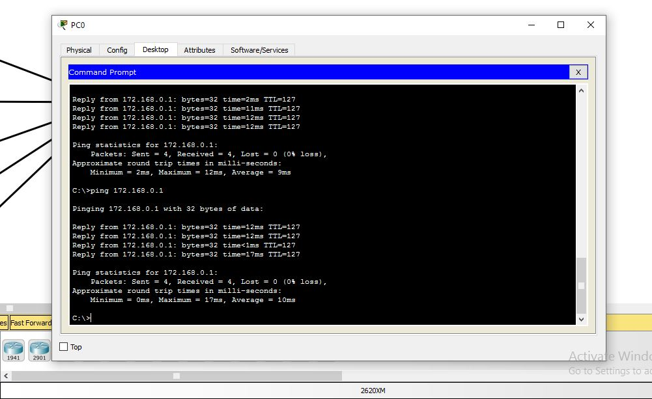

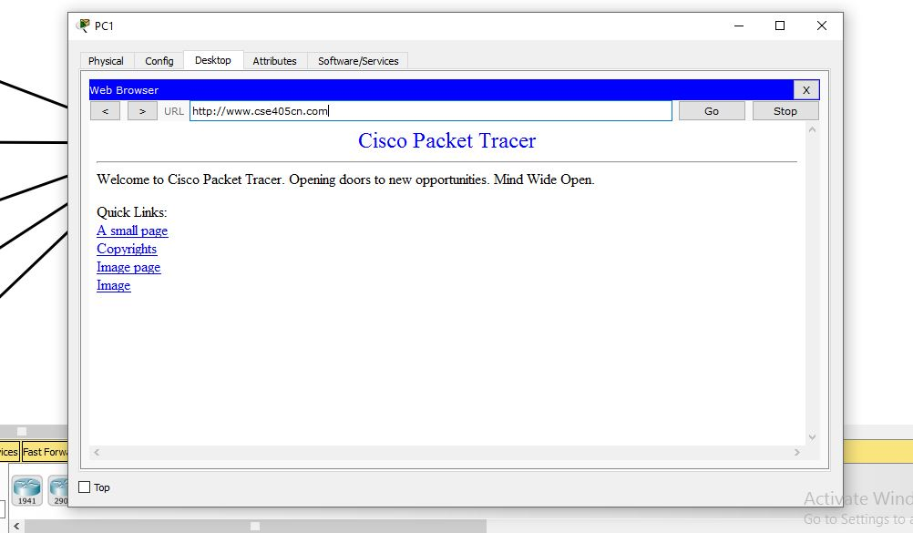

Figure: Pinging and web page

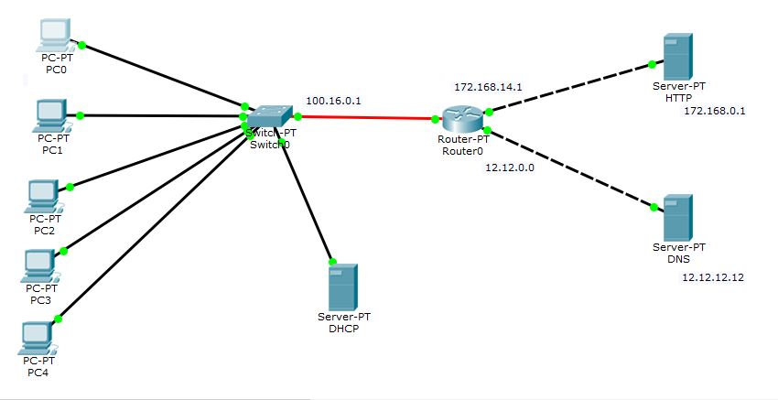

Figure: Final Design