COMP11109 - Database Design & Implementation

University of West of Scotland (London Campus)


Instructor: Martins Olaleye
Coursework

Group Members:
Name | Student ID
Prajwalaradhya Shivakumaraswamy Kesaramadu | B01759301
Adil Khan | B01767321
Sayyar Hayat | B01772768
Sapana Lamichhane
Imran Sagar

Submission Date:

Declaration of Originality
We the undersigned certify that this assignment is a piece of coursework which we have independently developed. This work is original for this assignment only and has not copy, reproduced, or adopted from any source not authorized in writing by the administrator of the assignment
We state that all relative criteria of ethical academic writing have been satisfied and all references consulted, treated and cited properly.

Table of Contents
Task 1 ……………………………………………………………………………………………………………………….1
Entities and Attributes…………………………………………………………………………………1
Relationship and Constraint…………………………………………………………………………...2
- 1:1 Relationship……………………………………………………………………………...2
- 1:M Relationship……………………………………………………………………………..2
- M:1 Relationship……………………………………………………………………………..2
- M:N Relationship…………………………………………………………………………….3
Summary of Relationship…………………………………………………………………….3
- Integrity Constraints………………………………………………………………………….3
Entity Relationship Diagram…………………………………………………………………………………………….4
Partial Diagram with Primary and Foreign keys……………………………………………………………4
Full Diagram with all Attributes………………………………………………………………………………..4
Task 2
Implementation in Microsoft Access…………………………………………………………………………………..5
1. Clients Table 5
2. Employees Table 5
3. ServiceCatalogue Table 6
4. Invoices Table 6
5. ClientAppointments Table 7
6. ServicesProvided Table 7
7. InvoiceRows Table 8
Task 3
Populating Tables with Data 9
1. Clients 9
2. Employees 9
3. ServiceCatalogue 10
4. Invoices 10
5. ClientAppointments 11
6. ServicesProvided 11
7. InvoiceRows 12
Task 4
SQL Queries

Task 5
Database Application
Task 6
Rebuttal of Privacy and Security Issues
Task 7

Task 1: Conceptual Design in ER

Entities and Attributes
Entities:
- Client.
- Employees.
- ServiceCatalogue.
- Invoices.
- ClientAppointments.
- ServicesProvided.
- InvoiceRows.
Attributes of Each Entity and their Primary key and foreign key.
- Client {ClientID, ClientName, ClientAddress, ClientEmail, ClientMobile}
  - Primary Key: ClientID.
- Employee {EmployeeID, EmployeePayrollNumber, EmployeeName, EmployeeMobile}
  - Primary Key: EmployeeID
- ServiceCatalogue {ServiceID, ServiceName, ServiceDescription, ServiceHourlyRate}
  - Primary Key: ServiceID
- Invoice {InvoiceID, InvoiceNumber, InvoiceCost, InvoiceDiscount, InvoiceTotal}
  - Primary Key: InvoiceID
- ClientAppointments:{AppointmentID, ClientID, ServiceID, EmployeeID, Appoinmentdate}
  - Primary Key: AppointmentID
  - Foreign Keys: ClientID, ServiceID, EmployeeID
- ServicesProvided {EmployeeID, ServiceID, ClientAppoinmentID, Expenses}
  - Primary Key: (EmployeeID, ServiceID) [Composite Key]
  - Foreign Key: EmployeeID, ServiceID
- InvoiceRows {InvoiceRowID, InvoiceID , AppointmentID,}
  - Primary Key: InvoiceRowID
  - Foreign Keys: InvoiceID, AppointmentID
Relationship and Constraint.
- 1:1 relationships
As there is no one-to-one (1:1) relation between the entities, all have either 1:M or M:N relation in the diagram.

- One to Many Relationship (1:M)
This happens when one record in one entity is related to multiple records in another.
Explanation:
- Client → ClientAppoinment: One client can have many appointments(One ClientAppointments)
- Employee → ClientAppoinment: A single Employee can have multiple appointments on (ClientAppointments).
- ServiceCatalogue → ClientAppoinment: One or more appointments can be booked for a Service from the Service Catalogue.
- Invoice → InnvoiceRow: This means that an invoice can have zero or many invoice rows (InvoiceRow).
- ClientAppoinment → InvoiceRow: One invoice row can be attached to multiple client appointments

- M:1 relationships
In a way these are kind of the opposite of one-to-many (1:M) relationships.
Explanation:
- Multiple appointments are associated with one client
- Single employee has many appointments.
- One service can have many appointments.
- One invoice has many invoice rows.
- Multiple invoice rows point to one client appointments.

- Many-to-Many Relationships (M:N)
These relationships are constructed using junction tables.
Explanation:
- Employee ⇄ ServicesProvided ⇄ Service Catalogue: A single employee is able to provide multiple services, and a single service is being provided by multiple employees. (ServicesProvided table)
- Employee ⇄ ServicesProvided ⇄ ClientAppointments: One employee can conduct many clients appointments, and one appointment can be for many employees. (ServicesProvided table)
- Service Catalogue ⇄ ServicesProvided ⇄ ClientAppointments: And a service maybe for multiple appointments and an appointment maybe for multiple services. (ServicesProvided table)
- Invoice ⇄ InvoiceRows ⇄ ClientAppointments: One or more invoices can be associated with one or more appointments; and one or more appointments can be billed in multiple invoices. (InvoiceRows table)

Summary of relationships
Type of Relationships | Example
1:1 (One-to-One) | No, 1:1 Relationships
1:M (One-to-Many) | Client → ClientAppoinment, Employee → ClientAppoinment, ServiceCatalogue → ClientAppoinment, Invoice → InnvoiceRow, ClientAppoinment → InvoiceRow
M:1 (Many-to-One) | Opposite of One-to-Many
M:N (Many-to-Many) | Employee ⇄ ServicesProvided ⇄ Service Catalogue, Employee ⇄ ServicesProvided ⇄ ClientAppointments, Service Catalogue ⇄ ServicesProvided ⇄ ClientAppointments, Invoice ⇄ InvoiceRows ⇄ ClientAppointments
Table 1.1
Integrity Constraints
- Add Foreign Key Constraints: Enforce referential integrity between related tables.
- In invoice row and servicesProvided, Composite Keys are used to establish M:N Relationships.

Entity Relationship Diagram

Partial Diagram with Primary and Foreign keys
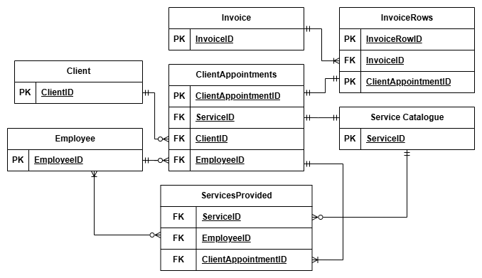

Full Diagram with all Attributes

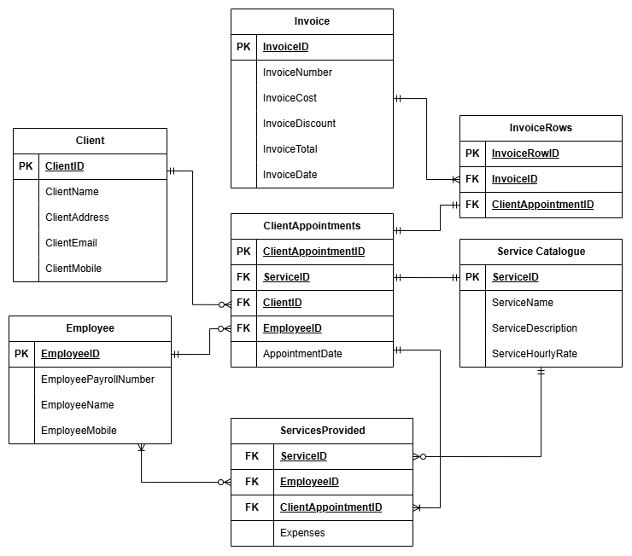
Task 2: Implementation in Microsoft Access.
We are using Microsoft Access to create tables for this application.
1. Client Table
The Clients table stores information about the company’s clients.
Clients table has 5 attributes including ClientID, ClientName, ClientAddress, ClientEmail, ClientMobile and ClientID, The Primary key is client ID. The below screenshot 2.1 shows the table structure with data type.
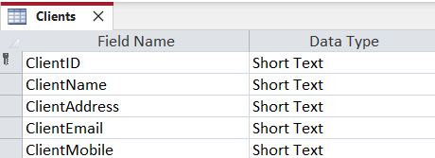
2.1
Every attribute has a validation rule, and some valid data must be provided. Input mask has been set for ClientID as "CL-"099999 and ClientMobile as "0"000\ 000\ 0000 is set, so user can easily enter data without confusion.

2. Employees
The Employees table stores all the data related to employee who works for the company. Employees table has 4 attributes including EmployeeID, EmployeePayrollNumber, EmployeeName, EmployeeMobile and EmployeeID which is the primary key. The below screenshot 2.2 shows the table structure with data type.
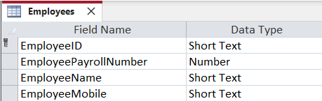
2.2
Every attribute has a validation rule and some valid data must be provided. Input mask has been set for EmployeeID as "EM-"099999 and EmployeeMobile as "0"000\ 000\ 0000 is set, so users can easily enter data without confusion.

3. SerciceCatalogue Table:
The Service Catalogue table stores all the services provided by the company.
Service Catalogue table has 4 attributes including ServiceID, ServiceName, ServiceDescription, ServiceHourlyRate and ServiceID which is the primary key. The below screenshot 2.3 shows the table structure with data type.
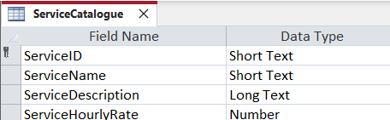
2.3
Every attribute has a validation rule, and some valid data must be provided. Input mask has been set for ServiceID as "SC-"099999.
4. Invoices Table
The Invoices table stores all the billing related information for every client appointment.
The Invoices table has 6 attributes including InvoiceID, InvoiceNumber, InvoiceCost, InvoiceDiscount, InvoiceTotal, InvoiceDate and InvoiceID which is the primary key. The below screenshot 2.4 shows the table structure with data type.
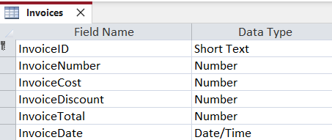
2.4

Every attribute has a validation rule and some valid data must be provided. Input mask has been set for InvoiceID as "IN-"099999.

- ClientAppoinment Table
The Client Appointments table stores all the information about appointments with client and employee for a particular service.
Client Appointments table has 5 attributes including ClientAppointmentID, ServiceID, ClientID, EmployeeID, AppointmentDate and ClientAppointmentID which is the primary key. And Foreign keys are, ServiceID which is linked to ServiceCatalogue table, EmployeeID is linked to Employees table, and finally ClientID linked to Clients table. The below screenshot 2.5 shows the table structure with data type.

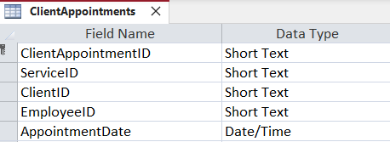
2.5

Every attribute has a validation rule and some valid data must be provided. Input mask has been set for ClientAppointmentID as "CA-"099999.

- ServicesProvided Table
The Services Provided table stores information about which employee provided what service to which client.
Services Provided table has 4 attributes including ServiceID, EmployeeID, ClientAppointmentID, Expenses. The below screenshot 2.6 shows the table structure with data type.
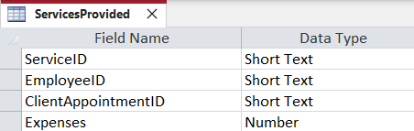
2.6

- InvoiceRows Table
The Invoice Rows links the Invoice table to the ClientAppointments table.
The Invoice Rows table has 3 attributes including InvoiceRowID, InvoiceID, ClientAppointmentID, and InvoiceID which is the primary key. The below screenshot shows the table structure with data type. The Foreign keys are InvoiceID which is linked to Invoices table and ClientAppointmentID is linked to ClientAppointments table. The below screenshot 2.7 shows the table structure with data type.

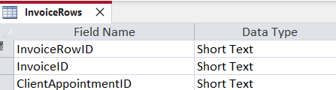
2.7

Every attribute has a validation rule, and some valid data must be provided. Input mask has been set for InvoiceRowID as "IR-"099999.

Task 3: Populate the Tables with Data TODO: ADD THESE
1. Clients
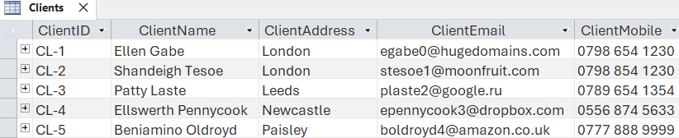
3.1
Screenshot 3.1 contain clients information.
- ClientID: This is the unique ID for each client (CL-1, CL-2, etc.).
- ClientName: The name of the client (Ellen Gabe, Shandeigh Tesoe etc.).
- ClientAddress: The city where the client is (London, Leeds, Newcastle, etc.)
- ClientEmail: The client's email address (ex. egabe0@hugedomains.com)
- ClientCellphone: The cellphone number of the client (e.g., 0798 654 1230).

2. Employees
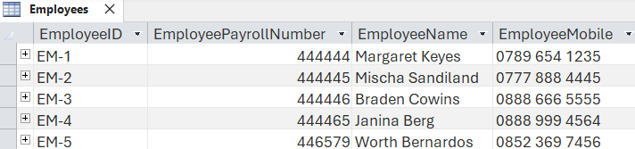
3.2

Screenshot 3.2 contains Employees Information
- EmployeeID: A unique number assigned to each employee (say, EM-1, EM-2, etc.)
- EmployeePayrollNumber: Numeric payroll value for each employee
- EmployeeName: Employee name (e.g., Margaret Keyes, Mischa Sandiland)
- EmployeeMobile: Employee mobile number.

3. SerciceCatalogue
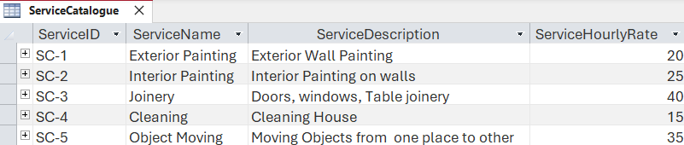
3.3
Screenshot 3.3 Contain information of Service Catalogue.
- ServiceID: An identifier for each service (e.g., SC-1, SC-2, etc)
- ServiceName: This must be the name that you provide for the services that you provide (e.g. ExteriorPainting, Cleaning, Joinery).
- ServiceDescription: Short description of service (Exterior wall Painting, Moving objects from one place to another).
- ServiceHourlyRate: The hourly service rate (e.g., 20,25, 40).

4. Invoices
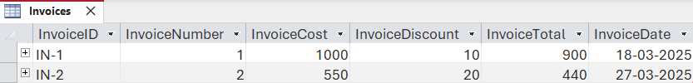
3.4
Screenshot 3.4 contain information of Invoices
- InvoiceID: A unique ID for each invoice (eg: IN-1, IN-2).
- InvoiceNumber: A number that increments with every invoice.
- InvoiceCost: This is the raw cost without a discount.
- InvoiceDiscount: The amount of discount that is applied to the invoice.
- InvoiceTotal : The total amount at the end (InvoiceCost - InvoiceDiscount).
- InvoiceDate: Date when the invoice was created (Example: 18-03-2025, 27-03-2025)

5. ClientAppoinments
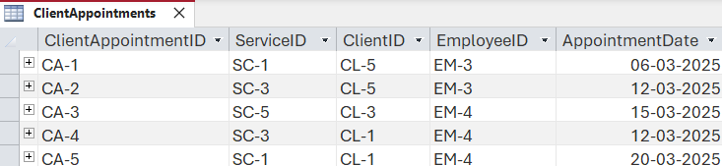
3.5
Screenshot 3.5 contains information of client appointment
- ClientAppointmentID: This is mainly the ID for each of the client appointments (CA-1, CA-2 ….)
- ServiceID: Identifier of the service being performed (e.g., SC-1, SC-3, etc.).
- ClientID: Which client are we providing our service (CL-5, CL-3, etc.).
- EmployeeID: The ID of the employee who is assigned to the appointment (like EM-3, EM-4, etc.
- AppointmentDate: The date on which appointment is scheduled (e.g. 06-03-2025, 12-03-2025)?

6. ServiceProvided
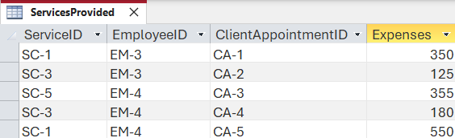
3.6

Screenshot 3.6 Contain information of Service Provided.
- ServiceID: Identifier of the service being performed (e.g., SC-1, SC-3, etc.).
- EmployeeID: The ID of the employee who is assigned to the appointment (like EM-3, EM-4, etc.
- ClientAppointmentID: This is mainly the ID for each of the client appointments (CA-1, CA-2 etc.)
- Expenses: Cost of using the service (in money-terminal e.g 350,350,125)

7. InvoiceRow
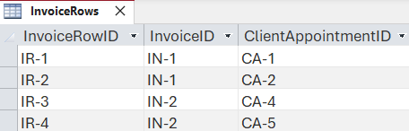
3.7

Screenshot 3.7 Contain information of Invoice Row.
- InvoiceID: A unique ID for each invoice (eg: IN-1, IN-2).
- InvoiceRowID: A unique ID for each invoice row (IR-1. IR2 etc.)
- ClientAppointmentID: This is mainly the ID for each of the client appointments (CA-1, CA-2 etc.)

Task 6: Rebuttal of Privacy and Security Issues:
Currently, in the Appointment Scheduling Database for the service-based SME, the design does not contain the suggested methods for high privacy and security. This poses new dangers of data breaches, unauthorized access, and violation of data protection laws like the General Data Protection Regulation (GDPR). Here, we assess the primary privacy and security challenges and suggest some solutions to help.
- Identification of Sensitive Data
In

- Client Data: Name, address, email address, and cell phone number.
- Employee Detail: Name, Mobile number of employees, Payroll numbers.
- Appointment information: Services, employees, date and time of appointment.
- Financial information: Invoice information for costs, discounts, and payment history.

- Data Protection Measures
These measures need to be implemented to the confidentiality, integrity and availability of the data.

- Access Control:
- Restrict access to sensitive data based on user roles (e.g., administrators, employees, and clients) with role-based access control (RBAC).
- Implement strong authentication methods, like passwords or biometrics.
- Data Encryption:
- In case of data breaches, encrypting client stored and employee information to keep them safe from unauthorized access.
- Encrypt data in motion with secure sockets layer (SSL).
- Audit Logs & Monitoring:
- To track any suspicious activity, maintain the logs that are regularly accessing the database and updating records.
- Review access logs regularly to identify unauthorized access attempts.

- Data Backups & Recovery:
- Company can take Automated and secure backup to avoid Cyber Attacks or system failures to data loss.
- Backing them up to a remote location, safely.

- Data Retention Policies:
- Set a policy for how long you are storing data and when to delete it.

- GDPR Compliance Considerations
The design of the database must ensure that the following principles are incorporated into it for complying with GDPR

- Data Minimization:
- Ask people to share only the bare minimum of personal data you need to schedule and prepare an invoice.
- Do not store unnecessary or unimportant data.
- Purpose Limitation:
- Have a clear data collection purpose and limit its usage for service scheduling, employee management, and billing only.
- Do not use data for marketing purposes without clear customer consent.
- Storage Limitation:
- Set up automatic data retention that automatically deletes outdated client and financial records after a certain time frame.
- Data Subject Rights:
- Allow clients and employees to secure access to their personal data
- Facilitate mechanisms to enable an individual to update or correct, or delete information about them, on his/her own information, when appropriate.
- Ensure compliance in responding to data subject requests in a legal timeframe.

Providing Recommendations for Industry Compliance and Security
- Establish a Privacy Policy: Have a privacy policy describing your data collection, processing, and protection measures.
- Add User Authentication: Combine this with a multi-factor authentication (MFA) to ensure better security.
- Protect Data Transfers: Use HTTPS for web access to prevent interception
- Regular Security Audits: Perform vulnerability assessments and penetration testing at regular intervals.
- Training up Employees: Train your employees on data protection best practices & the GDPR Regulations.
With these additions to privacy and security, the database system will both secure sensitive data and be in line with legal requirements, establishing clients and employees trust and confidence in your tender.

