**Enrolment in moodle using Authorize.net payment gateway for paid courses**

This enrolment plugin helps moodle users **(students)** in automatic enrolment for any paid course. Payment will be done by credit card, as soon as they complete their transaction, they will be informed about the transaction and enrolment. This plugin has all the settings for development as well as for production usage. Its easy to install, set up and effective.

**Installation Guidence :**

Login to your moodle site as an admin user and follow the steps to configure the plugin

**1)** Upload the zip package from ***Site administration >*** ***Plugins > Install plugins****.* Choose Plugin type 'Enrolment method (enrol)'. Upload the ZIP package, check the acknowledgement and install.

**2)** Go to Enrolments > Manage enrol plugins > Enable 'Authorize.net' from list

**3)** Click 'Settings' which will lead to the settings page of the plugin

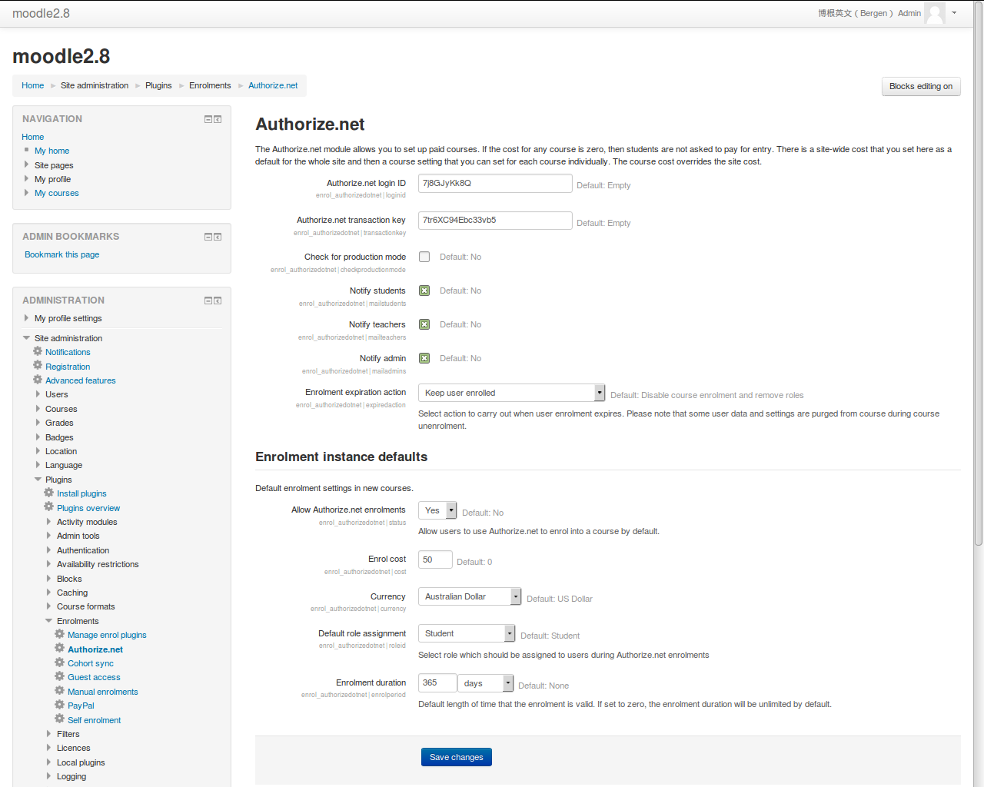

**4)** Provide the marchant credentials for Authorize.net, select the checkbox as per requirement. Save the settings.

**5)** Select any course from course listing page.

**6)** Go to Course administration > Users > Enrolment methods > Add method 'Authorize.net' from the dropdown. Set 'Custom instance name', 'Enrol cost' etc and add the method.

And its all done from administrator end. Now registered users can login to the moodle site and view the course only after a successfull payment.

Check the screenshots for the student --

a) when try to view a paid course details,

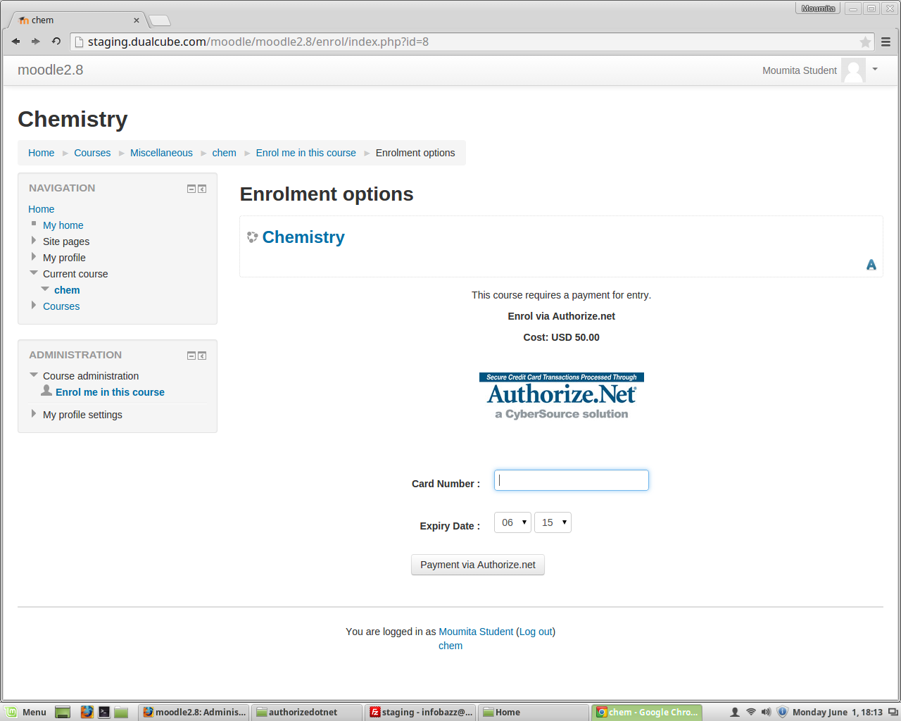

b) after successfull payment transaction,

