**CHATBOT DEPLOYMENT WITH IBM CLOUD WATSON ASSISTANT**

**INTRODUCTION:**

A potent tool for creating chatbots and virtual assistants is IBM Cloud Watson Assistant. It makes use of machine learning and natural language processing to comprehend user input and deliver insightful responses. By building and training your chatbot within the Watson Assistant platform, and then connecting it into your application or website using the offered APIs, you may deploy a chatbot with IBM Cloud Watson Assistant. You can improve user interactions and streamline communication procedures as a result.

**DESCRIPTION:**

To start, set up your project on IBM Cloud Foundry, and configure Watson Assistant for your chatbot. Implement various functions based on your project needs, ensuring seamless integration and functionality. Once the tasks are completed, document the entire process comprehensively. This document will serve as a valuable resource for assessment, detailing the steps taken, configurations made, and functions implemented during the chatbot deployment with IBM Watson Assistant on IBM Cloud Foundry.

**IBM WATSON ASSISTANT:**

IBM Watson Assistant empowers developers to build conversational interfaces. With its natural language processing capabilities, it understands user inputs and responds intelligently. After creating and training your chatbot on the Watson Assistant platform, integrate it seamlessly using provided APIs. Elevate user interactions and communication in just a few lines of code.

**DATASET:**

The dataset was extracted from the following link for the project, <https://www.kaggle.com/datasets/nelgiriyewithana/top-spotify-songs-2023>

Here’s a snippet of the dataset:

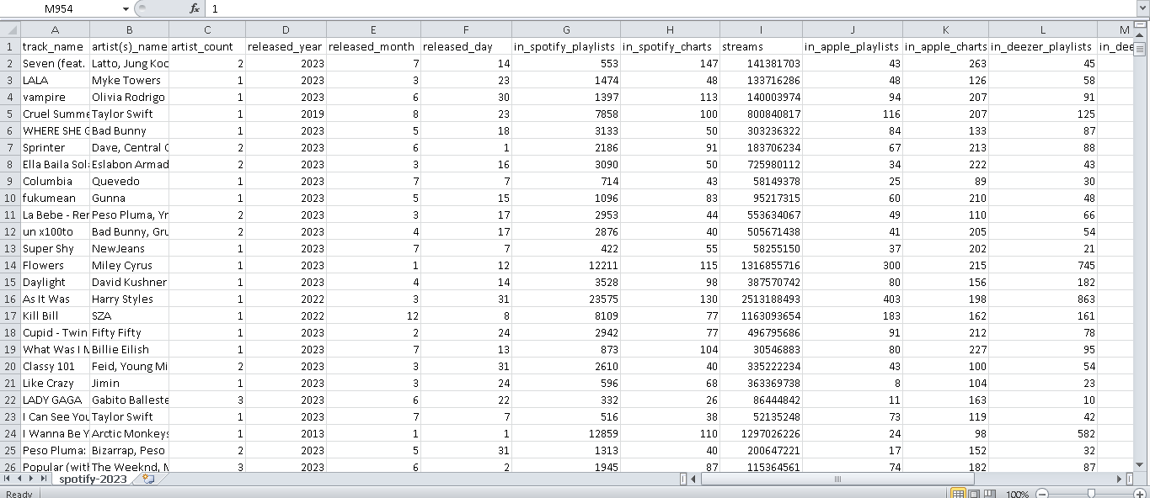

Since the data we’ve selected for our project is preprocessed and prepared already. They’ve asked for some relevant activities and functions to be performed with the dataset. We have chosen and done some visualisation using the IBM Cognos Tool.

1. **BARCHART**

* Based on the current forecasting, streams may reach 12.96 by released_day 38.
* 1 is the most frequently occurring category of released_day with a count of 95 items with streams values (10 % of the total).
* in_spotify_charts shows a strong seasonal trend every 6 months. The largest values typically occur at period 6, whereas the smallest values at period 4.
* 2022 is the most frequently occurring category of released_year with a count of 402 items with streams values (42.2 % of the total).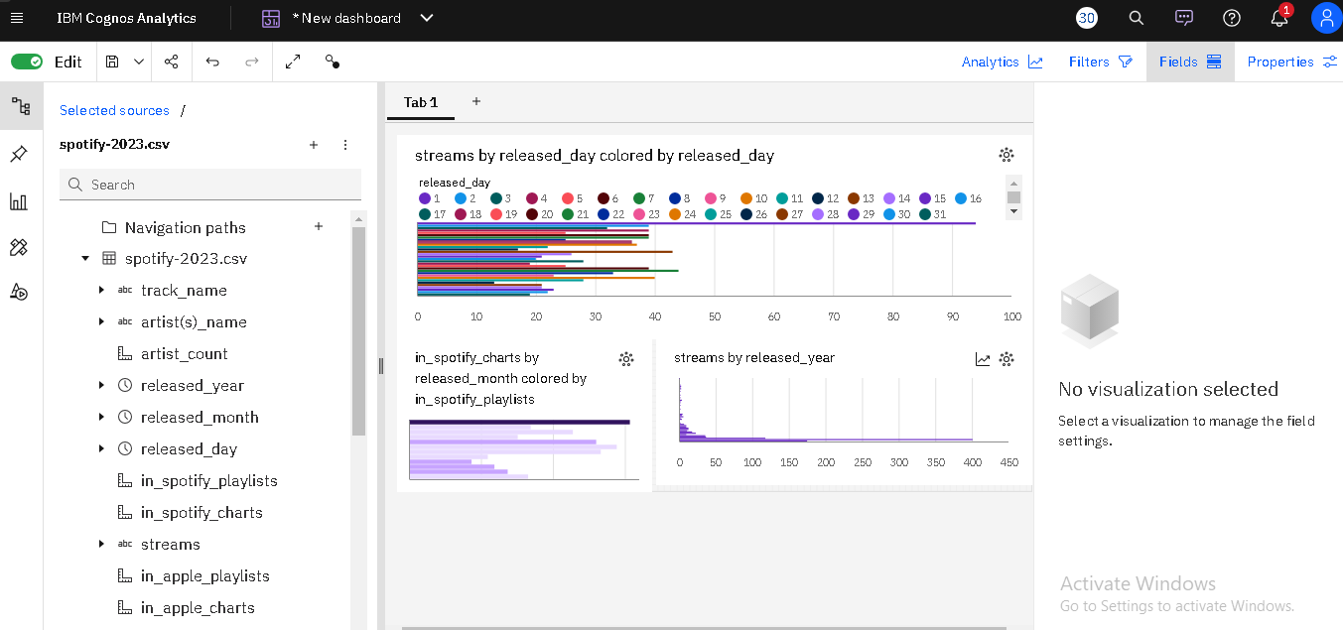

1. **LINE CHART:**

* 2022 is the most frequently occurring category of released_year with a count of 402 items with streams values (42.2 % of the total).
* From 2021 to 2022, streams increased by 240%.
* Based on the current forecasting, in_spotify_charts may reach 535.7 by released_day 38.
* n_spotify_charts ranges from 110, when released_day is 27, to almost 1500, when released_day is 1.

