PRACTICAL – 1
Problem Definition: Initiate the semester-long StudentHub portal by identifying the problem scope, user roles, key modules, navigation flow, and minimum 10 pages. Create a sitemap, low-fidelity wireframe, project folder structure, README file, and GitHub repository.

Code/Script/Task:

Sitemap:
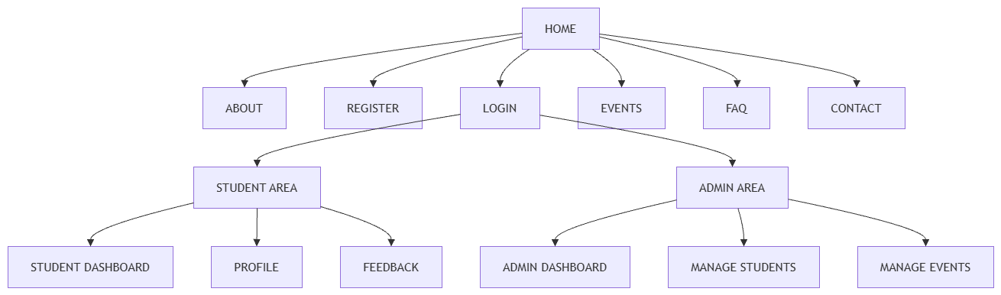
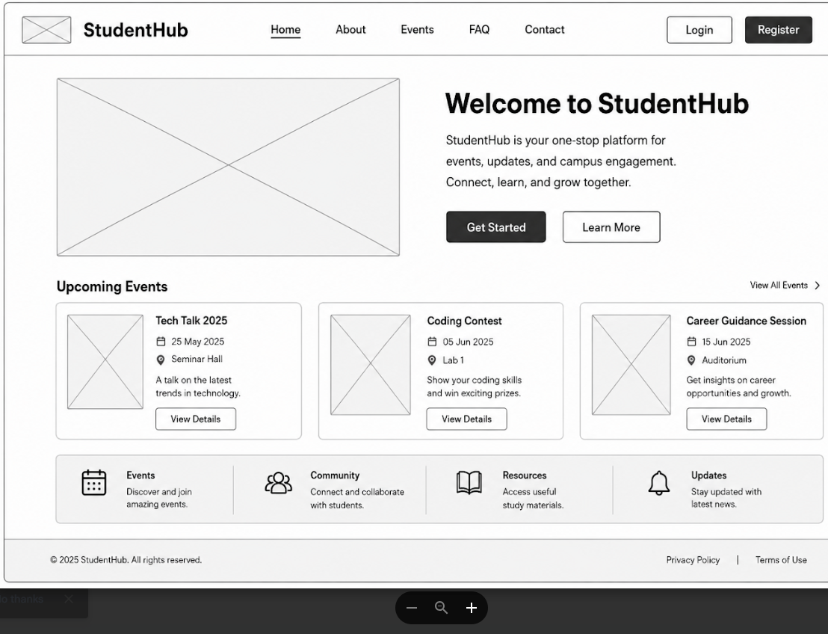
Home-wireframe:

Login-wireframe:
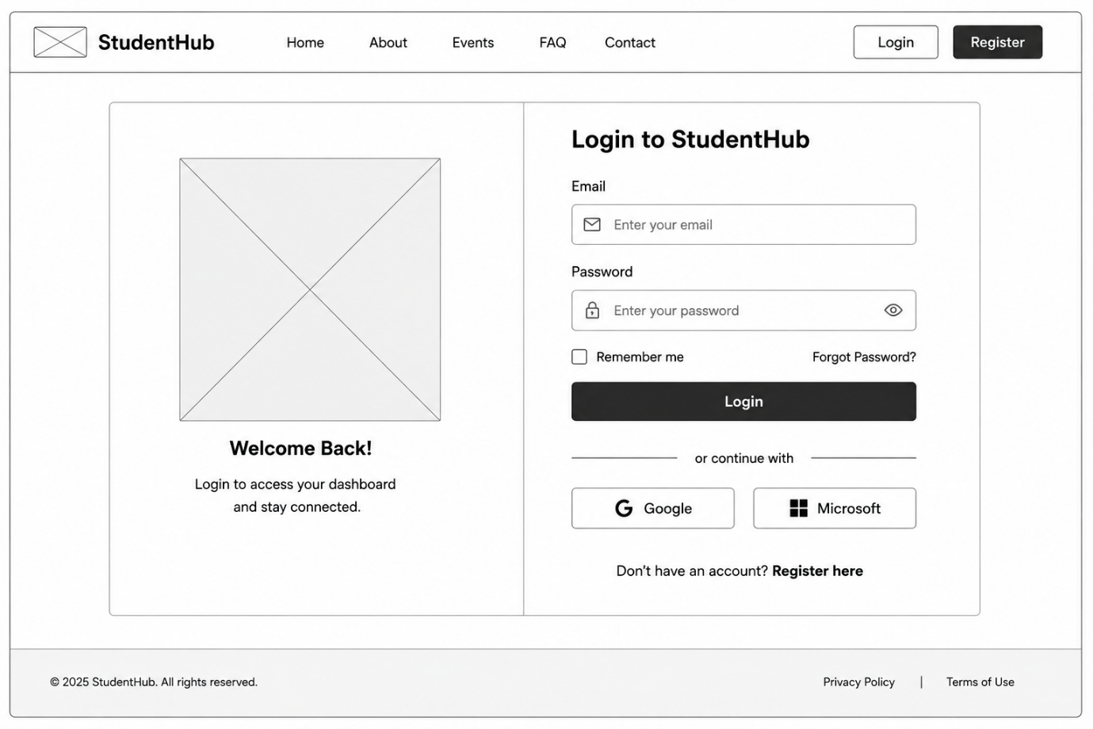
Dashboard-wireframe:
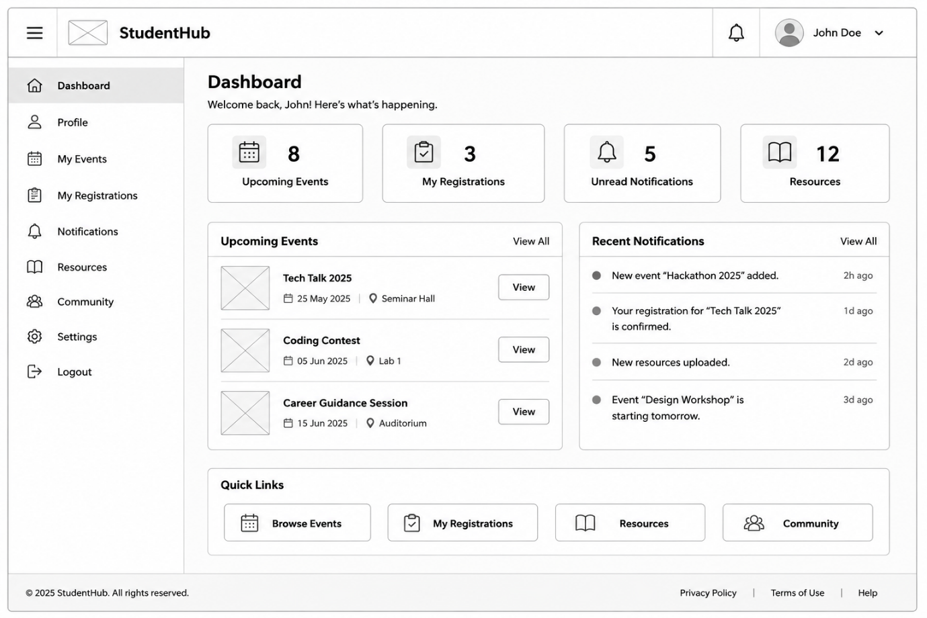

Events-wireframe:
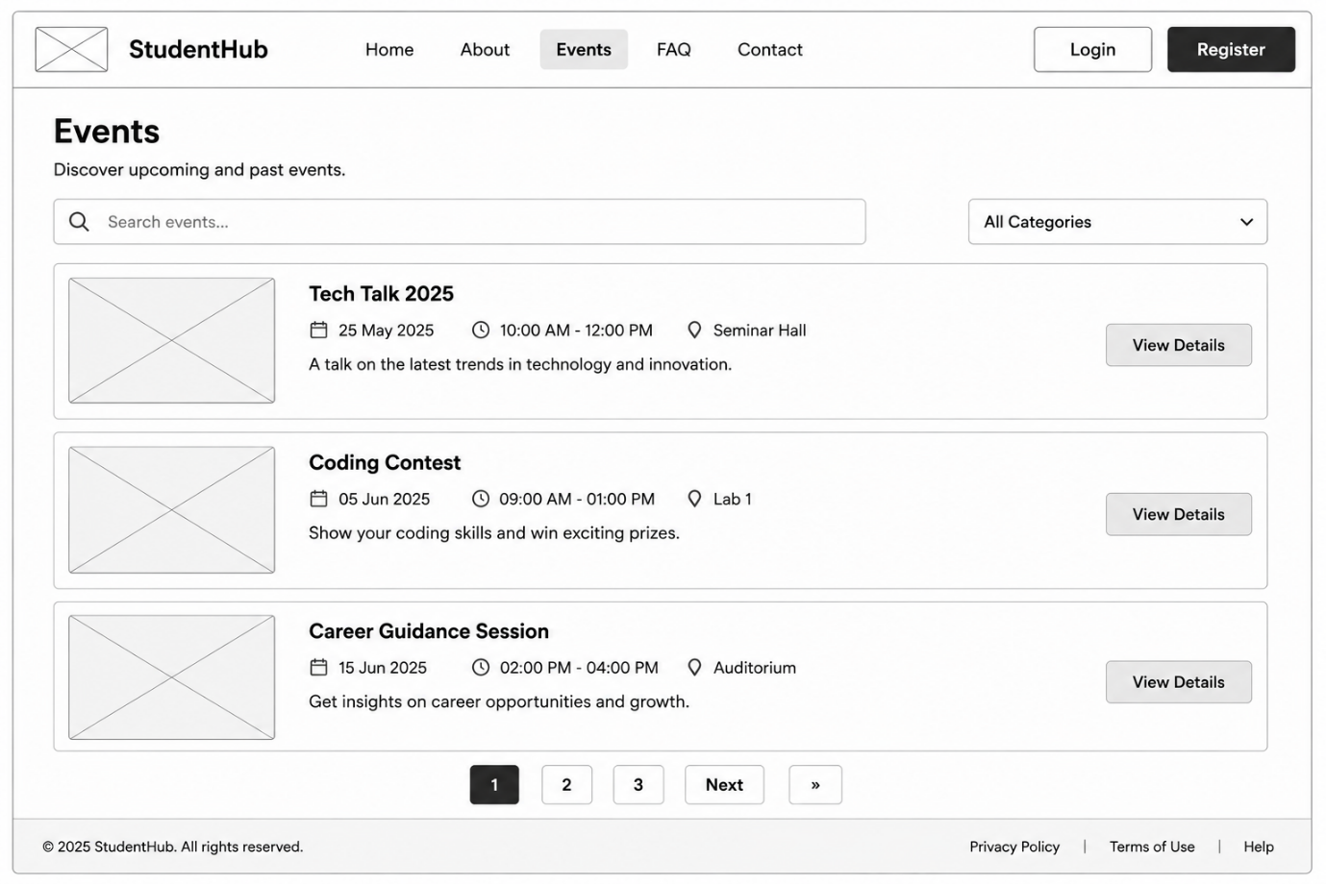
README.md:
1. Problem Definition
Students need a single web portal to access academic and campus-related information.
Currently, information about events, registrations, notices, student profiles, and feedback may be available through different systems.
StudentHub will provide one centralized web portal for students and administrators.
2. Project Objectives
1. Provide a single portal for students.
2. Allow students to register and log in.
3. Display college events and notices.
4. Allow students to register for events.
5. Allow students to manage their profiles.
6. Provide an administrative management system.
3. User Roles
3.1 Student
The student can:
• Register
• Login and logout
• View the student dashboard
• View and search events
• Register for events
• View and update profile
• View FAQ
• Submit feedback
3.2 Admin
The administrator can:
• Login
• View the admin dashboard
• Manage student records
• Add, update, and delete events
• View event registrations
• View system activities
4. Functional Requirements
1. The system shall allow a new student to register.
2. The system shall allow registered users to log in and log out.
3. The student shall be able to view a personal dashboard.
4. The student shall be able to view and search events.
5. The student shall be able to register for an event.
6. The student shall be able to view and update profile details.
7. The system shall provide About, Contact, FAQ, and Feedback pages.
8. The administrator shall be able to manage student records.
9. The administrator shall be able to add, update, and delete events.
10. The system shall restrict admin pages to administrator users only.
5. Non-Functional Requirements
1. The website should be easy to use and navigate.
2. The website should work properly on mobile, tablet, and desktop devices.
3. The website should follow basic accessibility guidelines.
4. User passwords should be stored securely.
5. The project should use an organized and maintainable folder structure.
6. The source code should be maintained using Git and GitHub.
6. Proposed Pages
1. Home
2. About
3. Register
4. Login
5. Student Dashboard
6. Events
7. Profile
8. Contact
9. FAQ
10. Feedback
11. Admin Dashboard
12. Manage Students
13. Manage Events
GITHUB REPOSITORY:
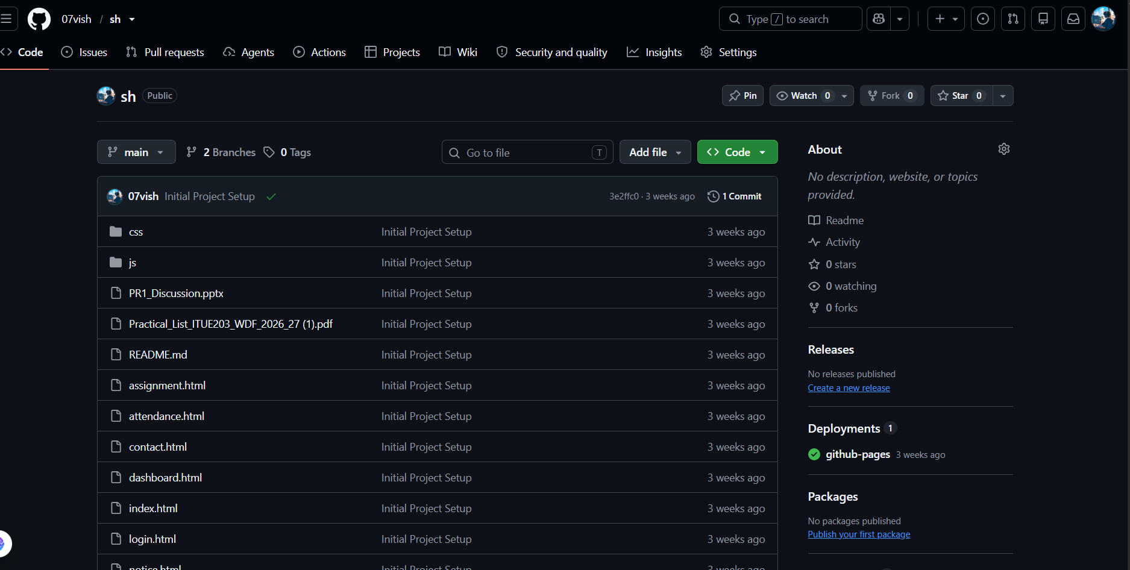
https://github.com/D26IT106/SH
Question & Answer:
1. What is URL and parts of URL?
Ans. A URL is the web address of a resource. Its parts are protocol, domain name, path, query, and fragment.
2. How does HTML file processed in web browser?
Ans. The browser loads the HTML file, parses it, downloads CSS/JS, builds the page, and displays it.
3. How will page navigation flow managed among all HTML pages?
Ans. Navigation is managed using anchor (<a>) tags with links between pages.
4. How will GitHub commits be maintained after each practical?
Ans. Commit changes with a meaningful message after each practical and push them to GitHub to maintain version history.

Conclusion / Learning Outcome:
In this practical, the StudentHub project was successfully initiated by defining the project requirements, user roles, modules, sitemap, wireframe, and folder structure. Basic concepts such as URLs, HTML page processing, page navigation, and GitHub version control were understood. This practical established a strong foundation for the project's development and ensured proper planning before implementation.

