PRACTICAL – 2

Problem Definition: Develop static HTML5 skeletons for at least 10 StudentHub pages such as Home, About, Register, Login, Dashboard, Events, Profile, Contact, Admin, FAQ, and Feedback. Use semantic tags and accessibility-friendly structure.

CODE/SCRIPT/TASK:
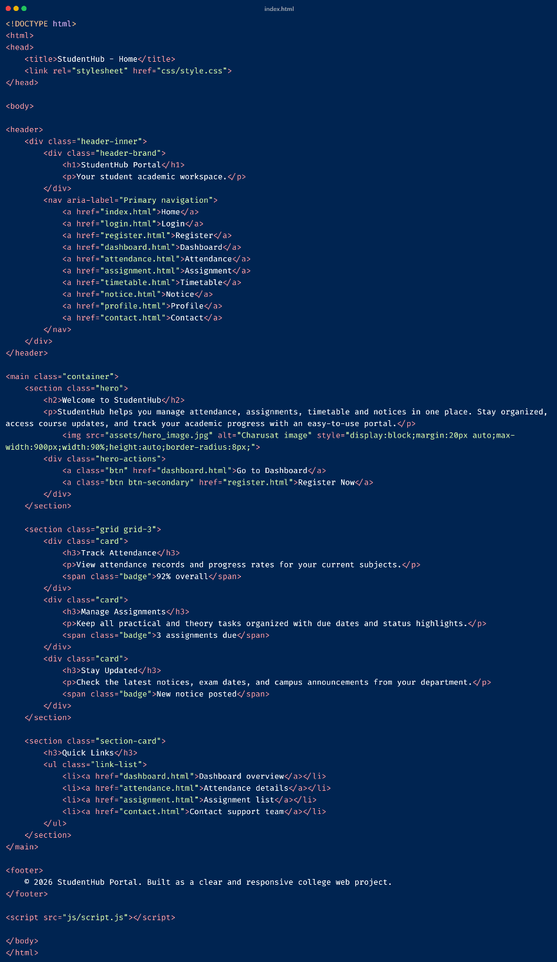
HTML(index.html):

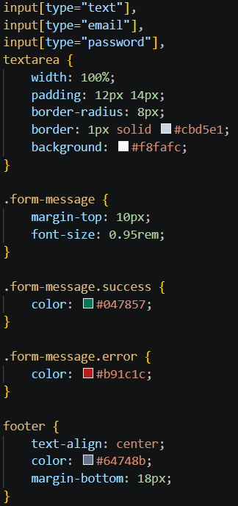
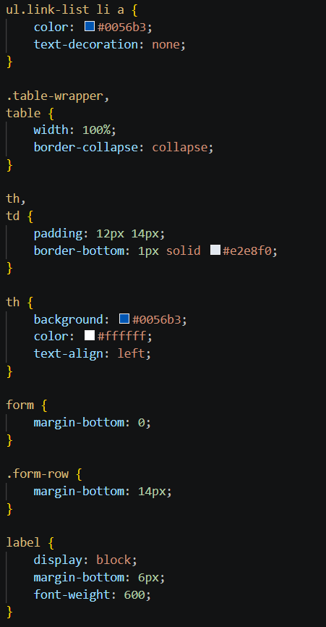
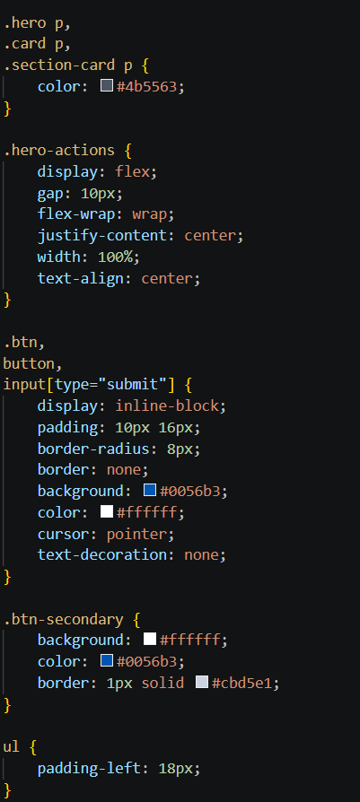
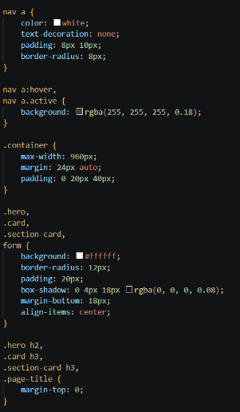
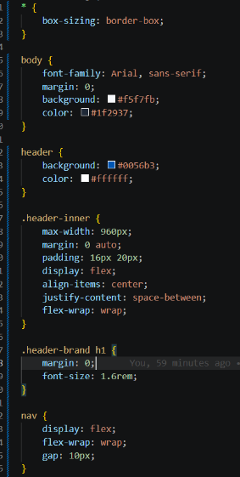
CSS(style.css):

OUTPUT:

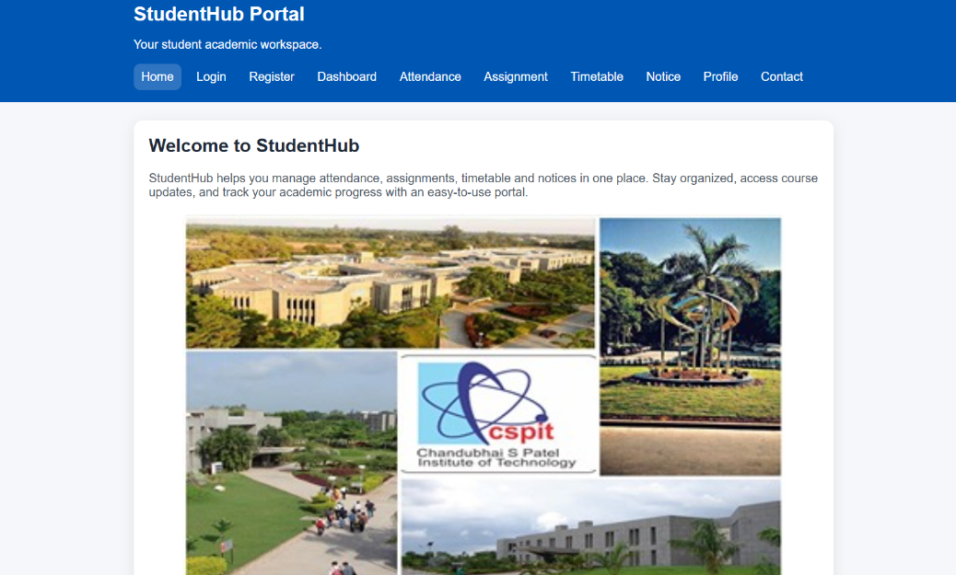
Home:
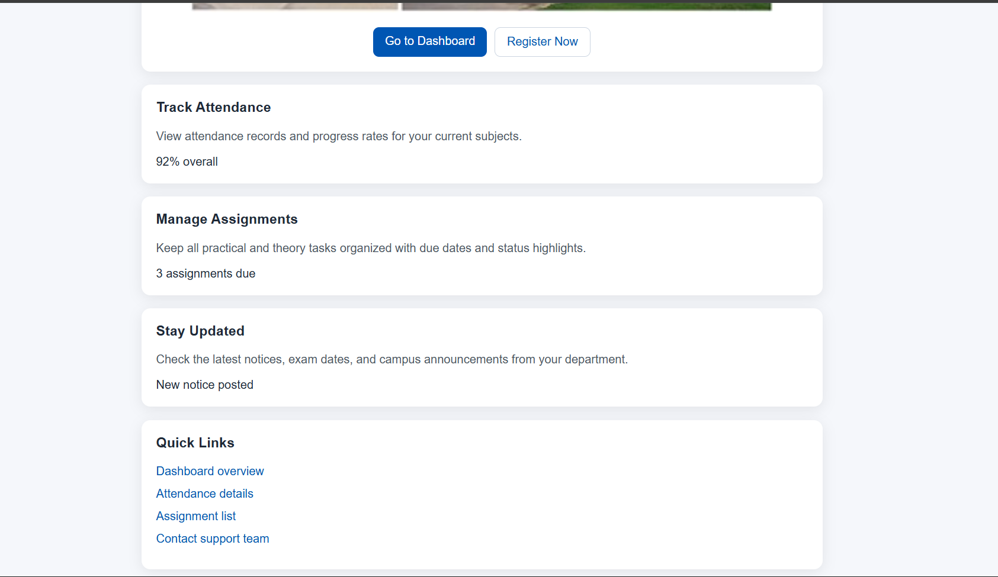

Login:
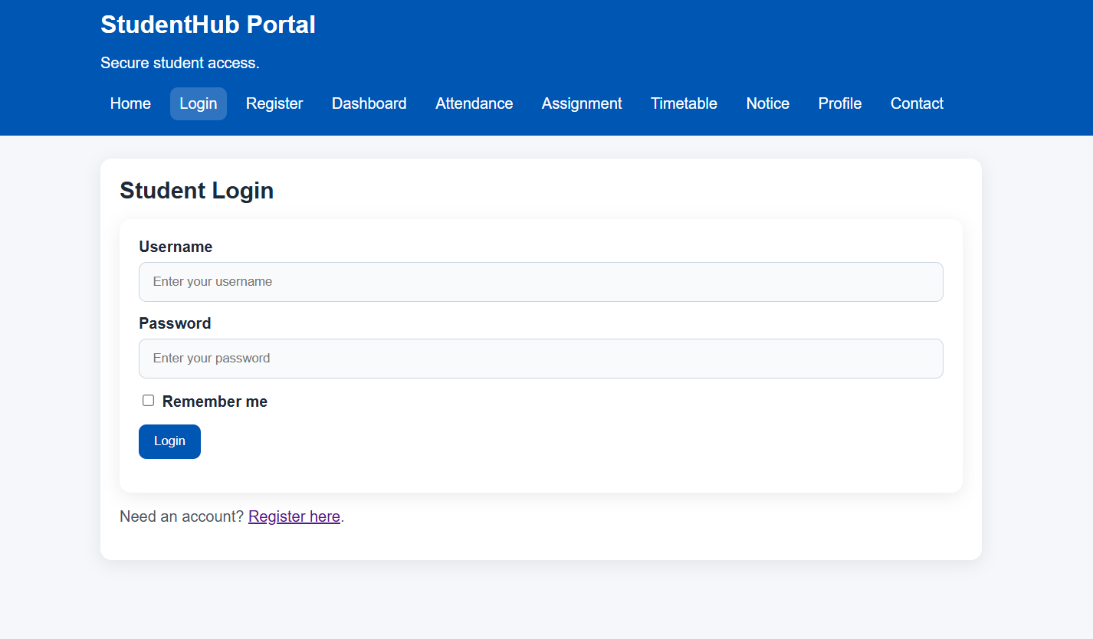

Register:
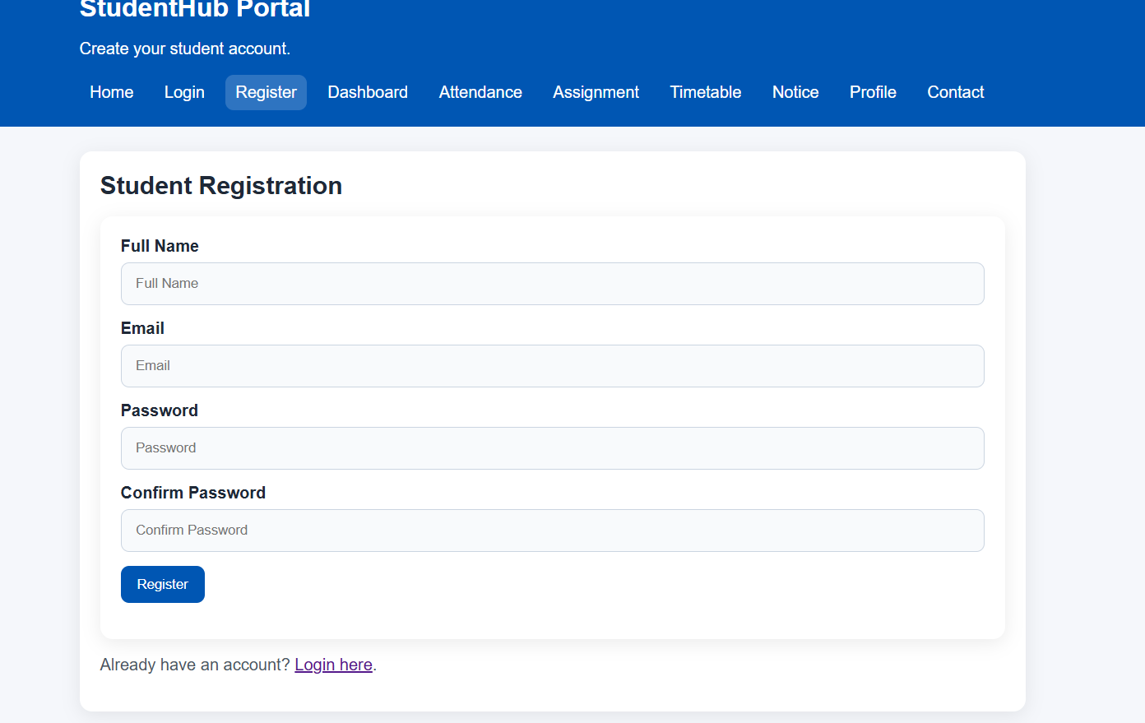
Dashboard:
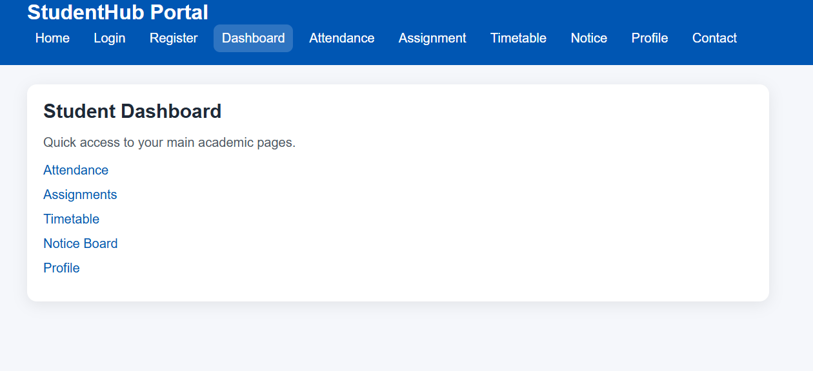

Profile:
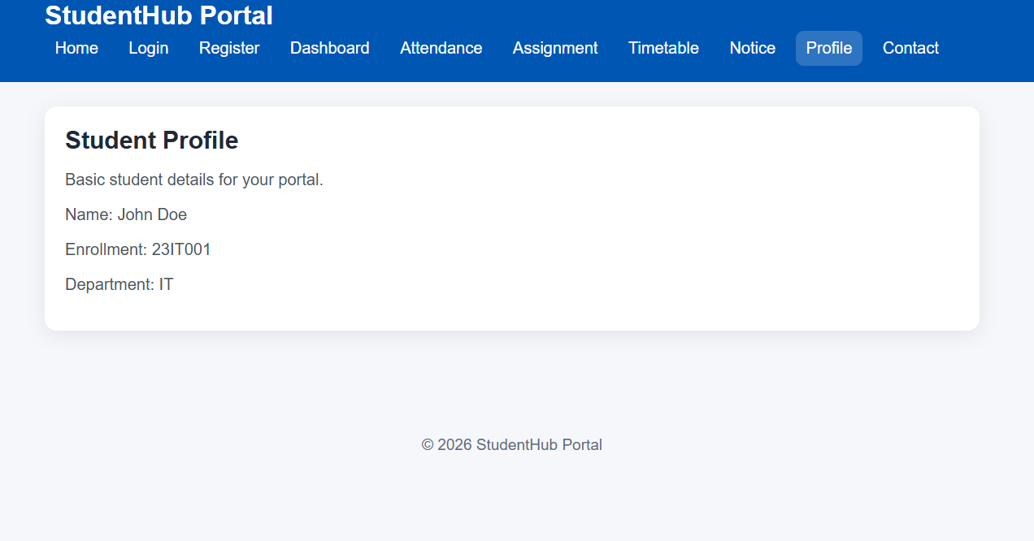
Attendance:
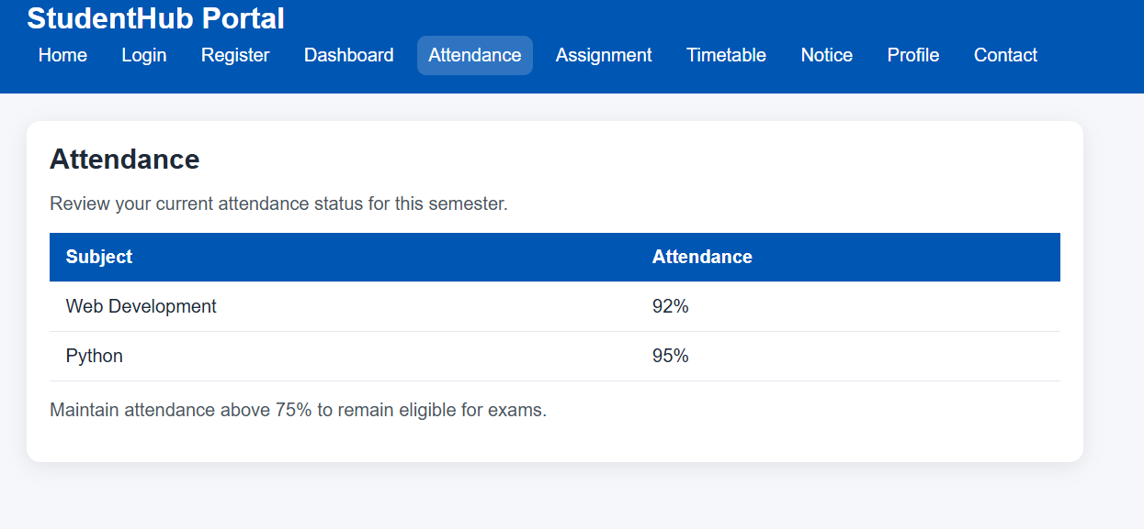

Timetable:
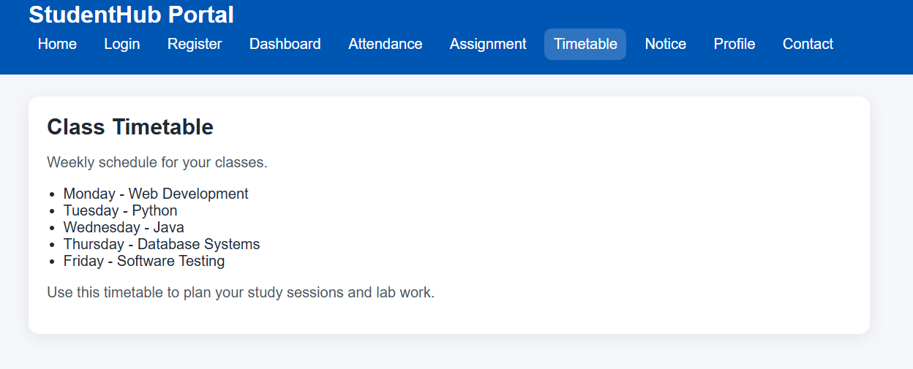
Assignments:
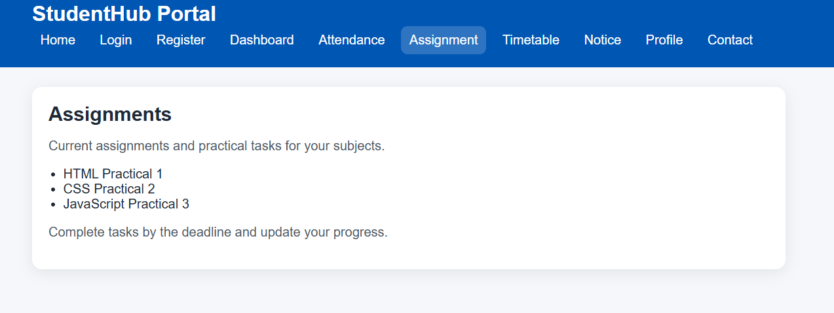
Notice:
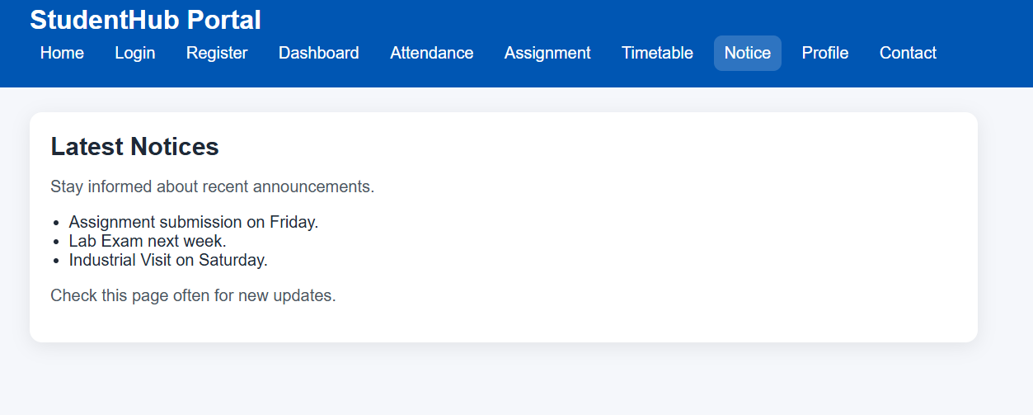
Contact:
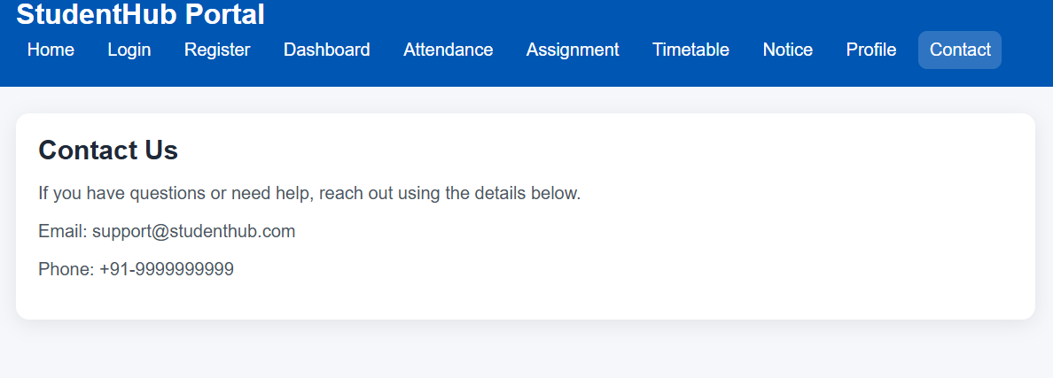
KEY QUESTIONS/ANSWERS:
- Are semantic tags such as header, nav, main, section, article, aside, and footer used properly?
Ans. Yes. Semantic HTML tags are used correctly to organize the webpage into meaningful sections, improving readability, maintainability, accessibility, and SEO.

- Are form labels, headings, image alt text, and navigation links accessible?
Ans. Yes. Form fields have proper labels, headings follow a logical hierarchy (h1 to h6), images include descriptive alt text, and navigation links are clear and accessible for all users, including those using screen readers.

- Is the page structure consistent across all pages?
Ans. Yes. All pages follow a consistent layout with the same header, navigation bar, main content area, and footer, providing a uniform and user-friendly experience throughout the website.

Github:
https://github.com/07vish/sh.git
Conclusion / Learning Outcome:

Successfully developed accessible HTML5 StudentHub pages using semantic tags. The pages are properly linked, follow accessibility guidelines, and maintain a consistent structure.

