PRACTICAL – 3
Problem Definition: Design responsive layouts for Home, About, Registration, Dashboard, and Events pages using CSS Grid and Flexbox. Optional to use CSS framework such as Bootstrap or Tailwind. Ensure mobile-first responsiveness.

Output:
Home Page:
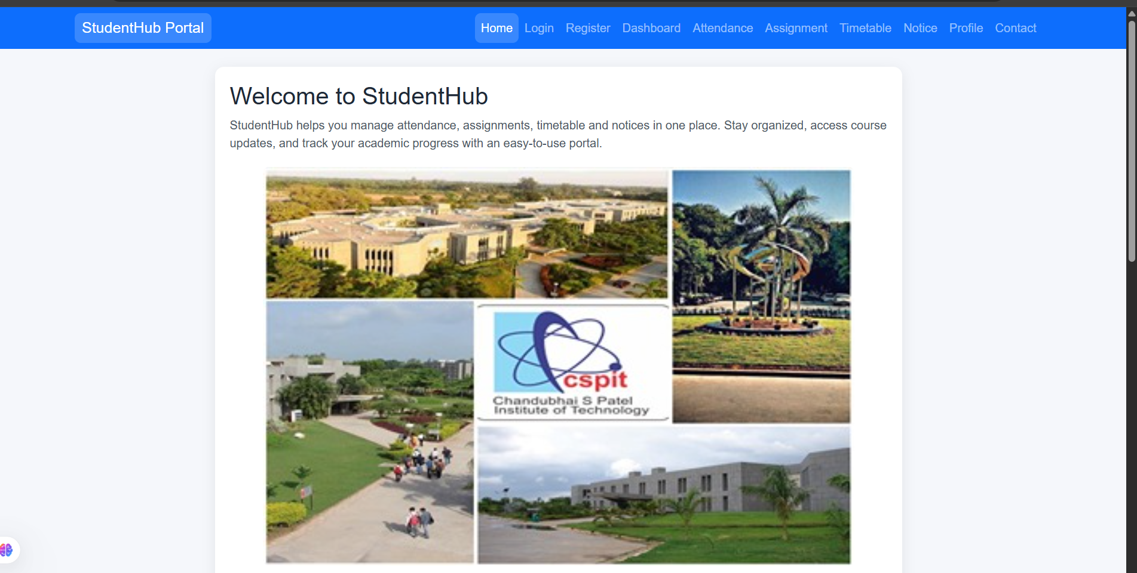

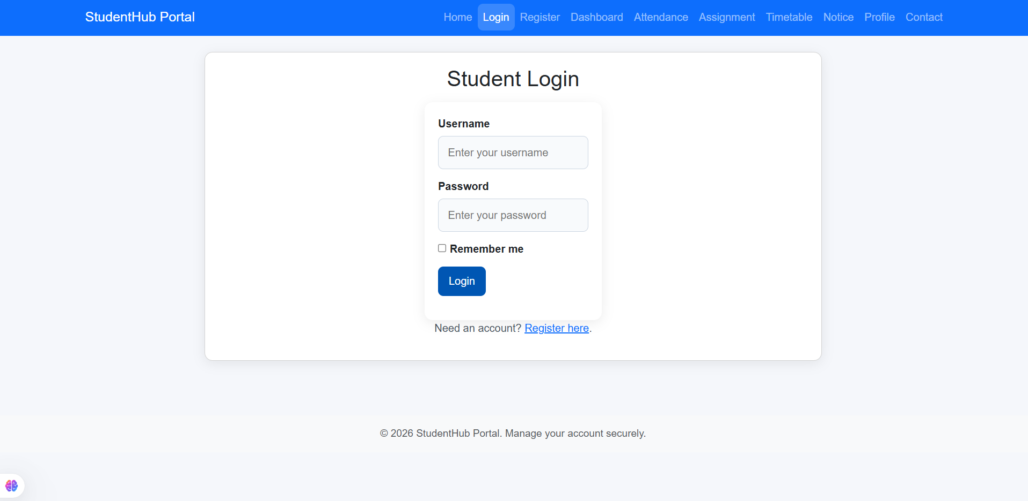

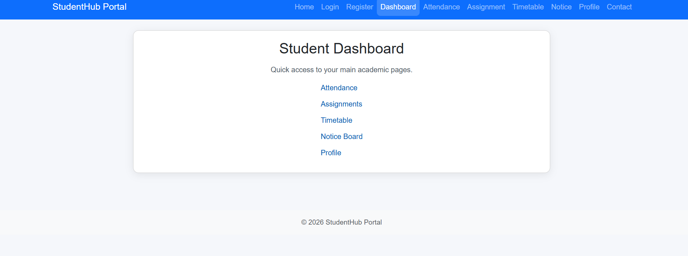

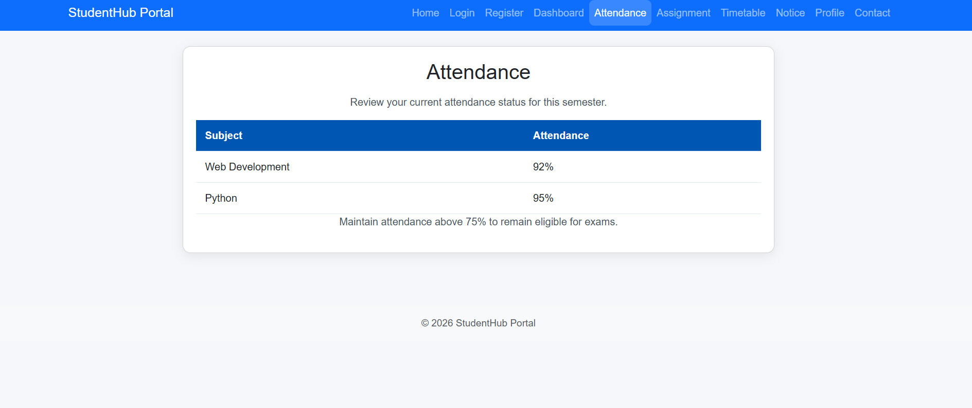

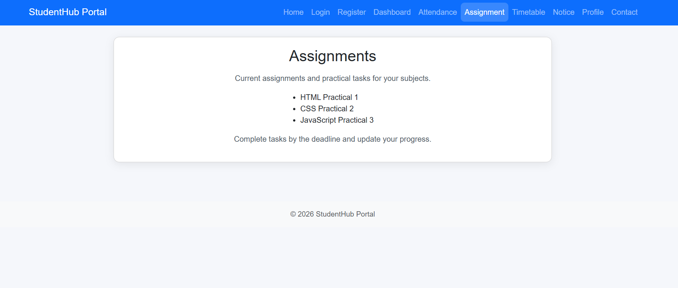

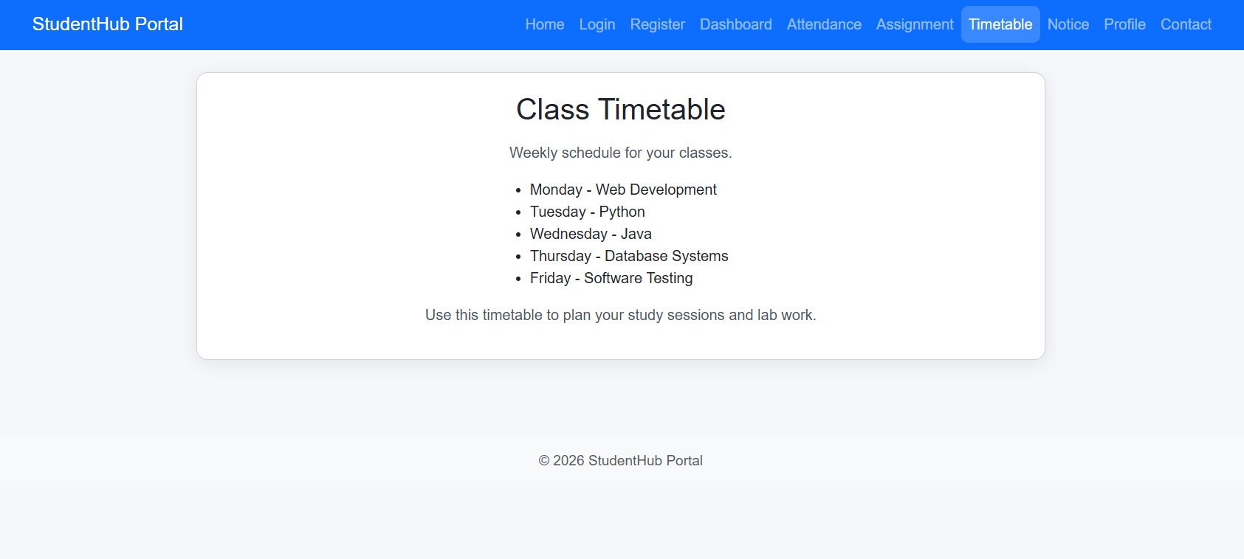
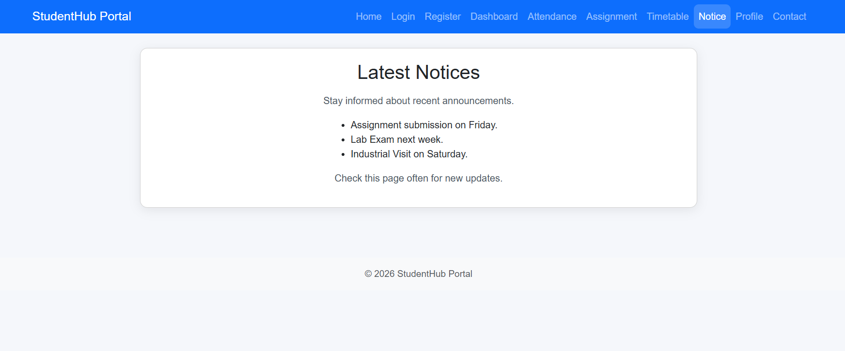

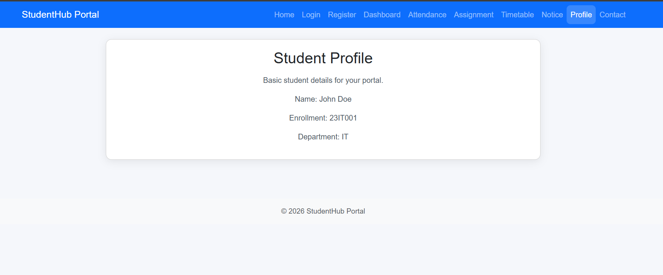

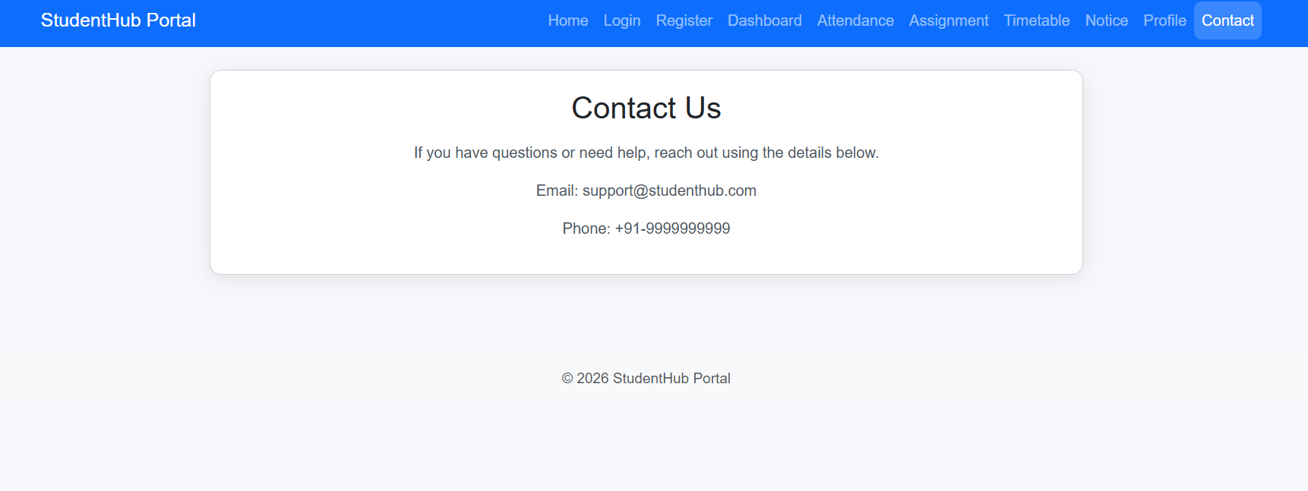

Question & Answer:
- How does the layout adapt for mobile, tablet, and desktop screens?
The layout uses responsive design to adjust according to different screen sizes. On mobile, content is arranged in a single-column layout for easy scrolling. On tablets, columns and spacing are adjusted to use the available screen space. On desktops, multiple columns and wider layouts are used for better presentation.

- Which layout technique is used and why?
CSS Flexbox and Grid are used to create the responsive layout. Flexbox is mainly used for navigation, alignment, and arranging smaller components. CSS Grid is used for structured sections such as cards and page content. These techniques make the layout flexible, organized, and responsive.

- Are typography, spacing, colors, and contrast readable?
Yes, the typography is clear and easy to read on different screen sizes. Proper spacing is maintained between headings, sections, buttons, and content. Colors are selected to provide good visual appearance and sufficient contrast. Responsive font sizes and spacing improve readability on mobile, tablet, and desktop.

- Is the framework used consistently without unnecessary inline CSS?
Yes, Bootstrap is used consistently for responsive layouts and common UI components.
Bootstrap classes are used for grids, buttons, spacing, navigation, and responsiveness. Custom CSS is used only where additional styling is required. Avoiding unnecessary inline CSS keeps the code clean, reusable, and easy to maintain.

Conclusion / Learning Outcome:

This practical helped in designing responsive and user-friendly web pages using CSS Grid, Flexbox, Media Queries, and Bootstrap. The layouts for Home, About, Registration, Dashboard, and Events pages were made adaptable for mobile, tablet, and desktop screens. Bootstrap components and custom CSS were used to maintain consistent styling, spacing, typography, and responsiveness. Overall, the practical improved understanding of responsive UI design and reusable web layouts for multi-device applications.

Github link :- https://github.com/07vish/sh.git

