PRACTICAL – 7
Problem Definition: Process submitted registration/contact form data using PHP. Validate and sanitize inputs on the server side and store records in CSV or JSON file format. Display success/error messages.
Output:
Contact Form with Server-Side PHP Processing:
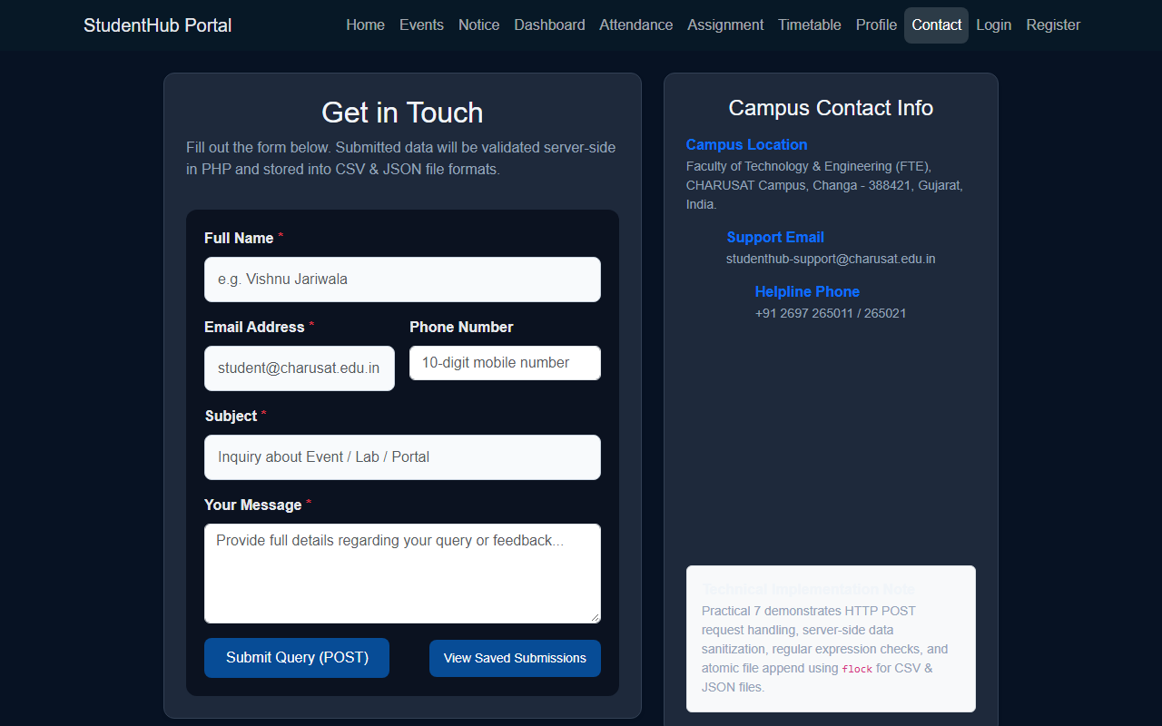
Stored CSV and JSON Submissions Viewer:
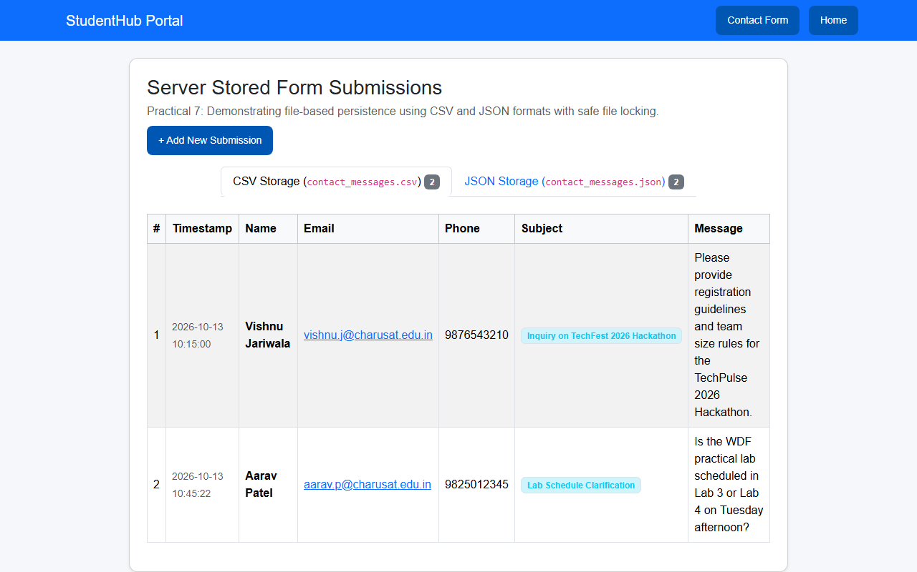
Question & Answer:
1. Is the form submitted using POST?
Ans. Yes. The form is submitted using the HTTP POST method. This ensures that submitted form values (name, email, phone, subject, message) are sent securely inside the HTTP request body rather than being visible in the browser address bar query string.
2. Are inputs validated and sanitized server side?
Ans. Yes. All received values are sanitized using trim(), htmlspecialchars() to prevent Cross-Site Scripting (XSS), and filter_var() for email validation. Regex checks ensure names contain only alphabets and phone numbers match 10 digits before saving.
3. Is file writing handled safely?
Ans. Yes. File operations use fopen() with exclusive file locking (flock($fp, LOCK_EX)) to prevent race conditions during concurrent write operations. Form data is appended safely to CSV using fputcsv() and to JSON using json_encode(), with locks released immediately after writing.
4. Are success and error responses displayed clearly?
Ans. Yes. The processing script displays clean, responsive Bootstrap alert messages indicating whether the submission was accepted and stored, or listing specific validation errors that must be corrected.
Conclusion / Learning Outcome:
Practical 7 delivered robust backend form processing using PHP 8. Server-side data validation, input sanitization against injection attacks, and persistent storage in both CSV and JSON formats were completed. Safe atomic file operations using exclusive file locking (flock) were demonstrated and verified via an administrative review interface (view_submissions.php).
Github link :- https://github.com/07vish/sh.git

