PRACTICAL – 8
Problem Definition: Design the database for StudentHub with students, events and registrations. Create PHP database connection using MySQL statements.
Output:
Database Connectivity Test & Table Statistics Verification:
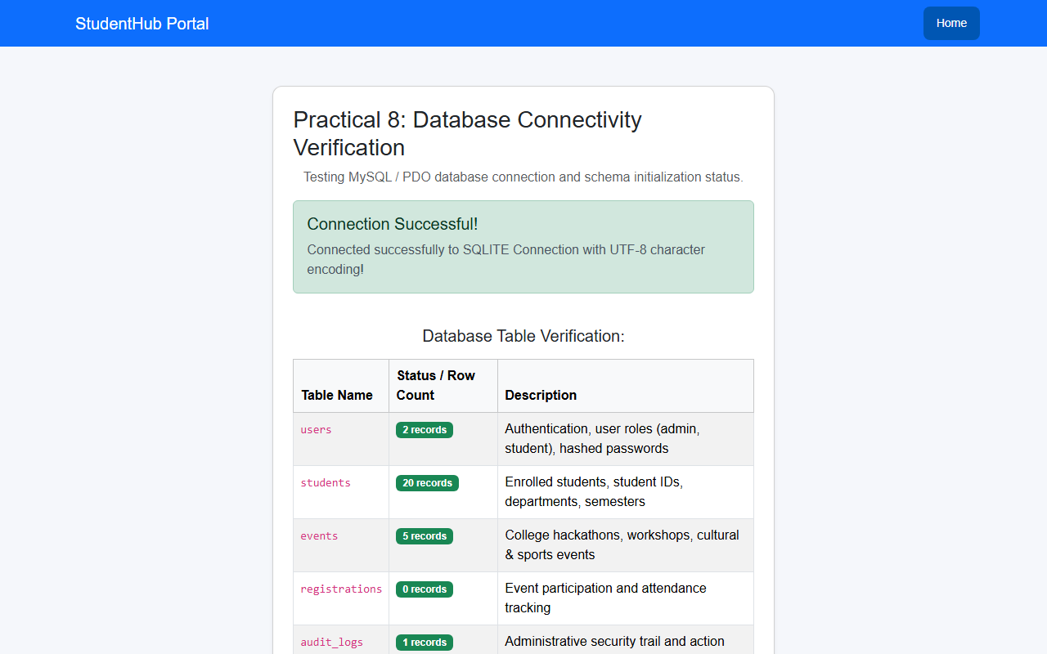
Question & Answer:
1. Is the schema normalized properly?
Ans. Yes. The relational database schema is normalized up to Third Normal Form (3NF). Data is separated into logical tables: users, students, events, registrations, and audit_logs, eliminating data redundancy and update anomalies.
2. Are primary keys and foreign keys correctly defined?
Ans. Yes. Every table defines an auto-incrementing integer Primary Key (id). Foreign keys link students to users (user_id), and registrations to events (event_id) and students (student_id) with ON DELETE CASCADE and ON DELETE SET NULL constraints to maintain referential integrity.
3. Is the database connection handled securely?
Ans. Yes. Database connectivity is handled through a centralized script (config/db.php) using PHP Data Objects (PDO) and MySQLi. Exception error handling (PDO::ERRMODE_EXCEPTION), UTF-8 character encoding (utf8mb4), and disabled emulation of prepared statements ensure robust and secure operations.
Conclusion / Learning Outcome:
In this practical, a normalized relational database schema was designed and implemented for StudentHub. Foreign key constraints and indexes were established across users, students, events, registrations, and audit_logs. A unified connection handler (config/db.php) supporting PDO and MySQLi prepared statements was created and validated with a diagnostic test script (test_db.php).
Github link :- https://github.com/07vish/sh.git

