PRACTICAL – 11
Problem Definition: Create a student management module to add, view, edit, delete, search and filter student records. All database operations must use MYSQLi statements and clear success/failure messages.
Output:
Student Management CRUD Interface with Search & Department Filter:
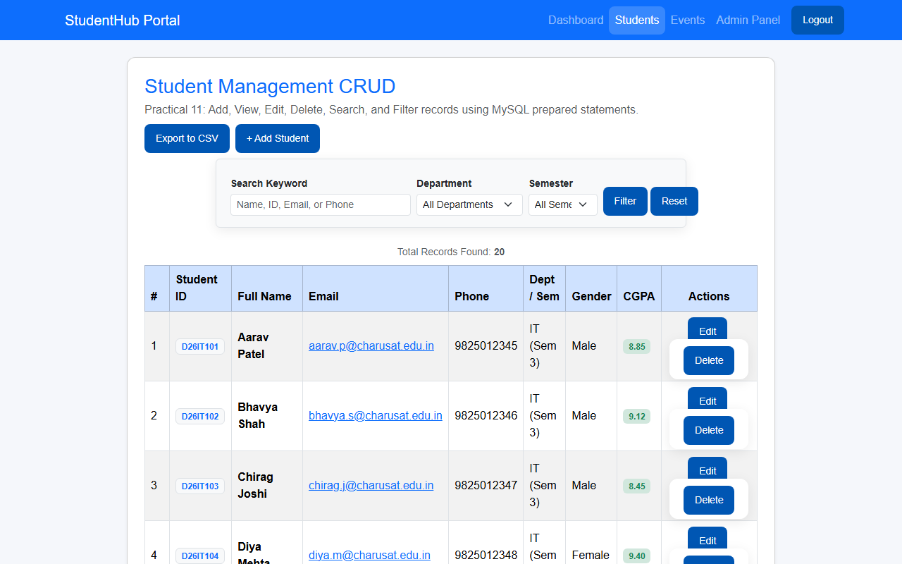
Question & Answer:
1. Are SELECT, INSERT, UPDATE, and DELETE operations working?
Ans. Yes. All four CRUD operations are fully functional using MySQL prepared statements. Students can be viewed in a responsive table (SELECT), created via an interactive modal (INSERT), edited in place (UPDATE), and removed (DELETE) with immediate UI feedback.
2. Is search by name/email/course implemented?
Ans. Yes. The management module includes search functionality filtering across student ID, name, email, and phone number using SQL LIKE queries, alongside dropdown filters for department and semester.
3. Are delete operations confirmed before execution?
Ans. Yes. Delete buttons trigger a JavaScript confirmation modal/dialog (confirm()) before issuing the deletion request, preventing unintentional data deletion.
Conclusion / Learning Outcome:
Practical 11 delivered a complete data management module for student records in PHP and MySQL. Prepared statements were utilized across all SQL operations to ensure SQL injection protection. Additional features including multi-parameter search, department filtering, Bootstrap modal dialogs, and CSV data export were implemented and verified.
Github link :- https://github.com/07vish/sh.git

