PRACTICAL – 12
Problem Definition: Develop event management functionality for admin users. Admin can add, view, update, delete, and upload event posters with file type and file size validation.
Output:
Event Management CRUD with File Upload & Validation:
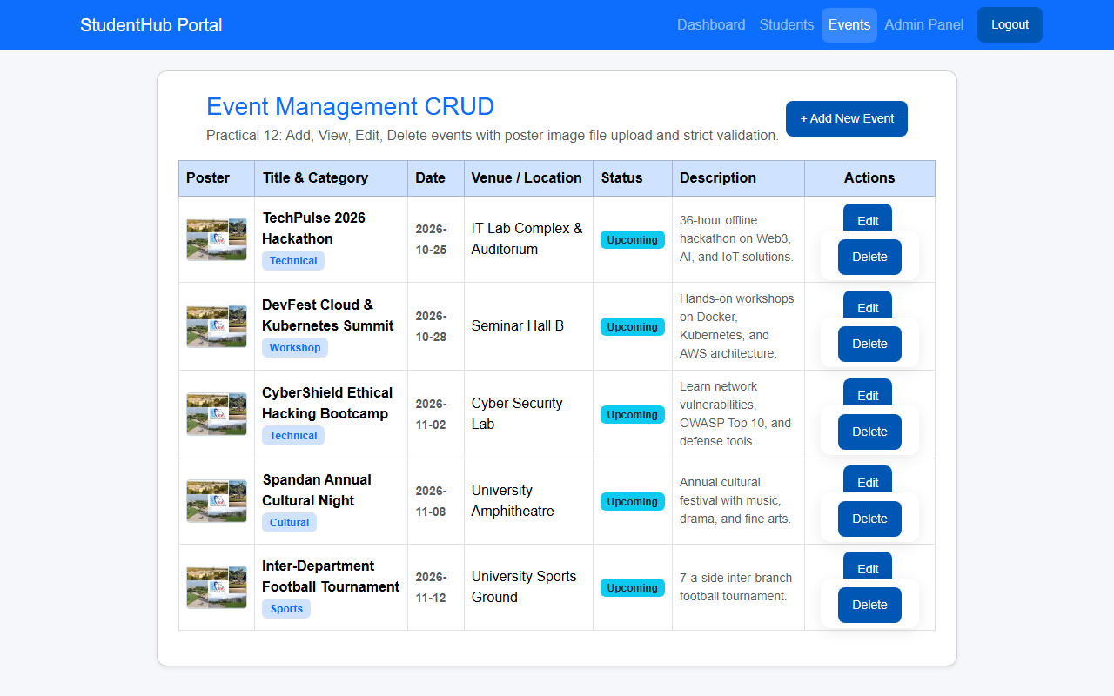
Question & Answer:
1. Are add, update, and delete functionalities implemented correctly?
Ans. Yes. Administrators can create new events with dates and venues, update existing event parameters, and delete obsolete events using prepared statements with comprehensive validation.
2. Is the UI linked with the database correctly?
Ans. Yes. The user interface directly reflects the contents of the events table. Each event card or table row displays dynamically fetched database values including titles, categories, dates, locations, status tags, and poster thumbnails.
3. Are poster uploads validated for type and size?
Ans. Yes. File uploads are validated server-side using finfo_file() to ensure legitimate MIME types (JPEG, PNG, WebP) and enforce a maximum file size limit of 2 MB. Uploaded files are renamed using unique identifiers (uniqid()) to prevent filename collisions.
4. Are success and failure messages displayed?
Ans. Yes. Clear dismissible Bootstrap alert boxes are displayed after every action, providing immediate confirmation of success or detailed explanations of upload/validation failures.
Conclusion / Learning Outcome:
In this practical, a secure content and event management module was built. Server-side multipart file uploads were implemented with MIME type verification, file size enforcement, and safe disk storage. Event records were managed through prepared statement CRUD queries with automatic thumbnail rendering and old file cleanup.
Github link :- https://github.com/07vish/sh.git

