PRACTICAL – 9
Problem Definition: Implement secure user registration by inserting user details into MySQL using MYSQLi. Validate input on frontend and backend, check duplicate email/username, hash passwords using password_hash(), and display appropriate messages.
Output:
Secure User Registration with Password Hashing & Duplicate Checks:
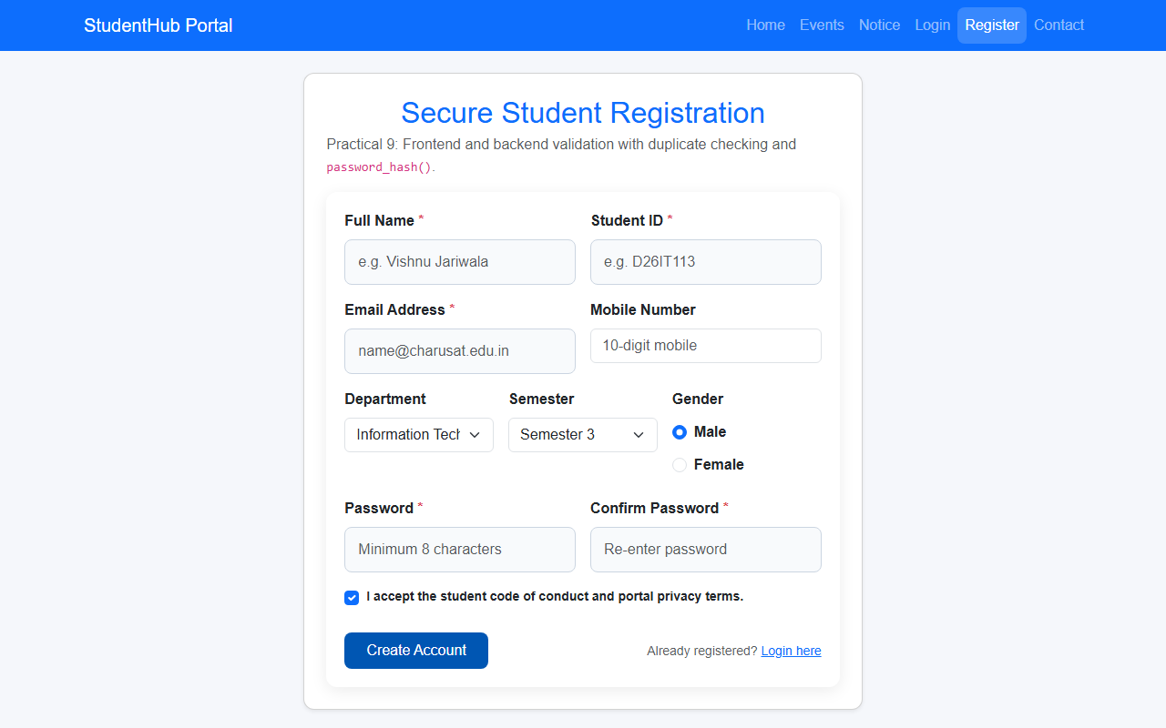
Question & Answer:
1. Is password_hash() used before storing passwords?
Ans. Yes. Passwords are never stored in plain text. Instead, passwords are hashed using PHP's native password_hash($password, PASSWORD_DEFAULT), which generates strong, salted hashes (Bcrypt/Argon2) protecting user credentials from unauthorized exposure.
2. Is duplicate email/username checked?
Ans. Yes. Prior to inserting records, the backend executes a parameterized query (SELECT id FROM users WHERE email = ?) to check if the email or student ID already exists. If a match is found, an error message is returned and duplicate registration is prevented.
3. Are frontend and backend validations consistent?
Ans. Yes. Frontend regex validations for name, email, student ID, and mobile number are mirrored on the server side in PHP. Even if a user bypasses client-side checks, backend validation ensures only clean and valid data reaches the database.
Conclusion / Learning Outcome:
Practical 9 implemented a secure user registration workflow following modern web security standards. Key achievements included prepared statement parameterized queries for duplicate checking, one-way cryptographic password hashing using password_hash(), atomic database transactions across users and students tables, and audit logging of new account creations.
Github link :- https://github.com/07vish/sh.git

