Technical Report
Student Name: Wong Zheng Chyi Student ID: M44100433

1. Introduction
An operating system (OS) manages hardware and software resources while providing services to application programs. Two key OS functions are process scheduling and deadlock management. This project implements an educational Java simulator with an FCFS Process Scheduling module and a Deadlock Detection module, helping users understand CPU scheduling, resource allocation, and deadlock detection without interacting with the actual operating system.

2. Process Scheduling Module
This module implements First Come First Served (FCFS) scheduling. Users add processes by entering Process ID, Arrival Time, and Burst Time. Processes are stored in an ArrayList, sorted by arrival time, and executed in FCFS order. For each process, the simulator calculates Start Time, Completion Time, Waiting Time, and Turnaround Time, then displays the results with averages in a formatted table.
Waiting Time = Start Time − Arrival Time
Turnaround Time = Completion Time − Arrival Time

3. Deadlock Detection Module
This module models resource allocation using a Wait-For Graph, where each process holds one resource and requests another. Graph edges are drawn from waiting processes to the processes holding their requested resources. Depth First Search (DFS) then detects cycles: a cycle indicates a deadlock, which the program reports along with the cycle path; no cycle means no deadlock is detected.

4. Testing Results
Test Case | Input | Expected Result
FCFS | P1(0,5), P2(1,3), P3(2,2) | Correct execution order and waiting/turnaround times  [Figure 1, 2, 3]
No Deadlock | P1:R1->R2, P2:R3->R4 | No Deadlock Detected  [Figure 4, 5, 6]
Deadlock | P1:R1->R2, P2:R2->R1 | Deadlock Detected  [Figure 7, 8, 9]
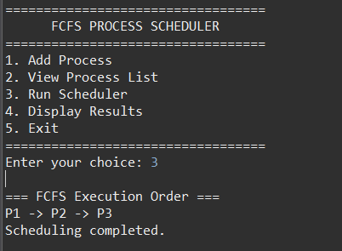
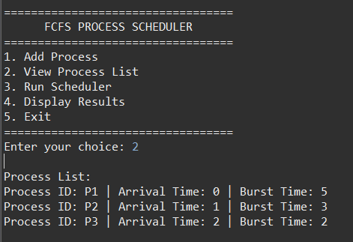

Figure 1: FCFS Scheduler - FCFS Process List
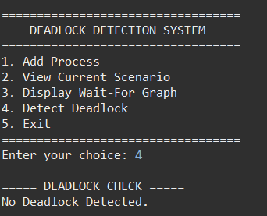
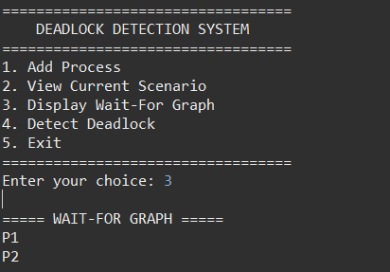
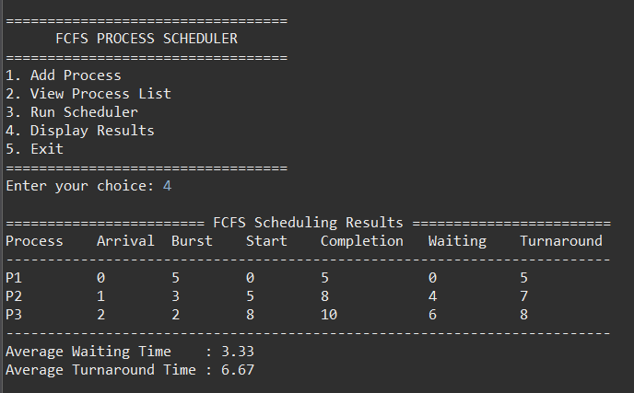
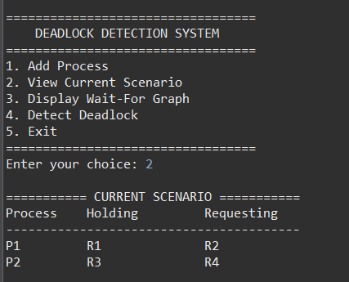
Figure 3: FCFS Scheduler - FCFS Scheduling Result
Figure 4: Deadlock Detection - Resource Allocation
Figure 2: FCFS Scheduler - FCFS Execution Order
Figure 6: Deadlock Detection - Deadlock Detected Result

Figure 5: Deadlock Detection - Wait-For Graph

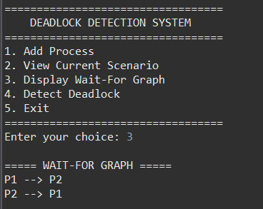
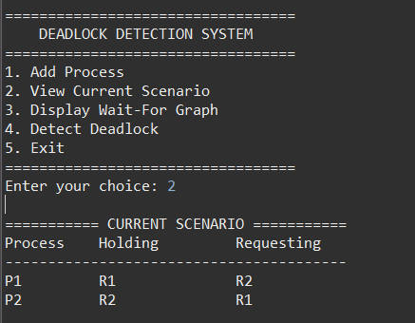
Figure 8: Deadlock Detection - Wait-For Graph
Figure 7: Deadlock Detection - Resource Allocation

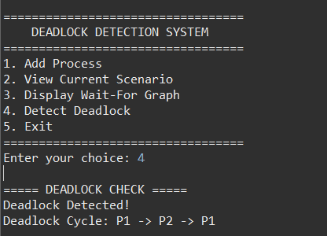

Figure 9: Deadlock Detection – Deadlock Detection Result

5. Conclusion
This project successfully demonstrates two important operating system concepts: FCFS process scheduling and deadlock detection. The simulator calculates scheduling statistics accurately and detects deadlocks using a Wait-For Graph and DFS. Through this project, a better understanding of CPU scheduling, resource allocation, and graph algorithms was achieved. Future improvements may include Round Robin scheduling, Priority Scheduling, support for multiple resources, and a graphical user interface.

