EntityBLUE 8.1.1
Welcome to EntityBLUE, a 2 person chat that bypasses network, works instantly, and is secure.
There are several constraints:
- It only works between 2 users (as of right now)
- The two people must be on the same campus.
- It is not an instant setup, Read the instructions below!
Otherwise enjoy and spread this around as your heart desireth. I, null_ will continue to improve and debug this program so stay tuned for more updates and software drops.
Let me know about any errors you encounter or features you would like added by emailing entitybluehelp@gmail.com.
made by null_

Here is how to setup.
- First, you and your friend, open the .html, and input a username: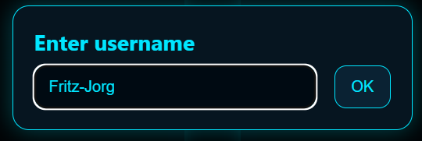

- You should see something like this pop up, allow all permissions: 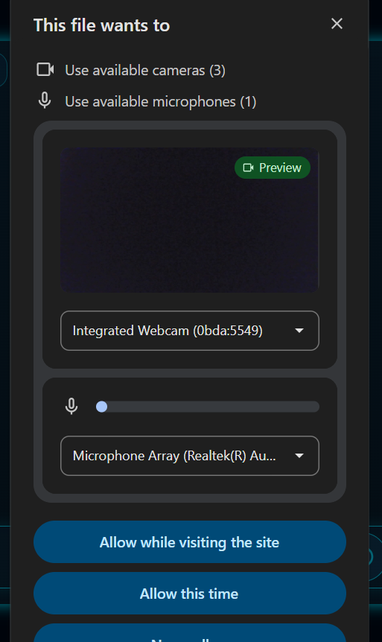

- You should see your cheery face in the left panel now. Hit the wifi icon at the top center: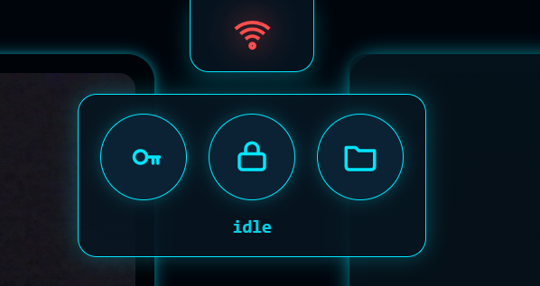

- Now click the key icon. This will download a file to your computer. Take that file and email it to your friend. The file should look something like this: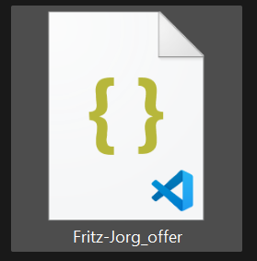

- Your friend will take that file they were sent and download it. They now need to click the lock button:

- This will open their file explorer, and they should navigate to the file they downloaded and select it. Once they hit enter, a response file will be downloaded to their laptop that should look something like this:
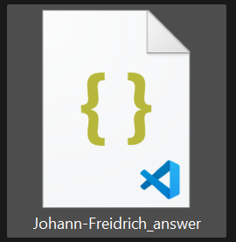

- They should email this file back to you. You should click on the lock icon, select the file, and hit enter.
- The Wi-Fi icon should turn green, and you should see your friend pop up on the right screen:
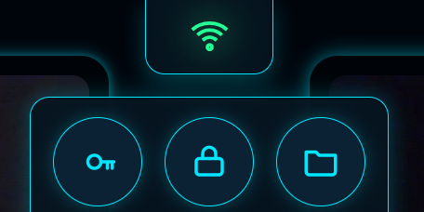

- You’re set up! I am now going to explain some of the features.
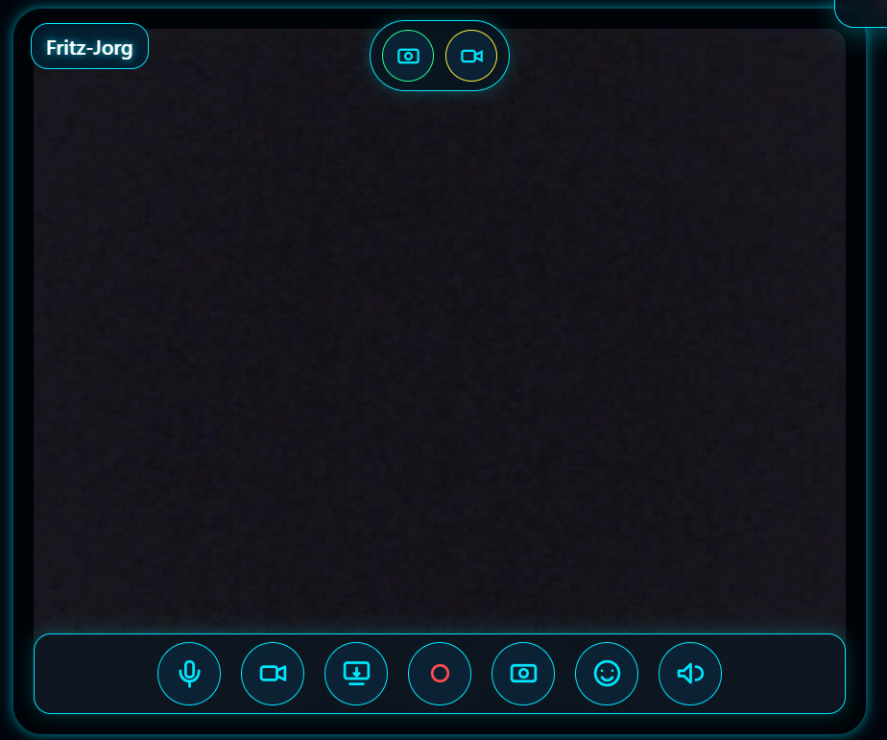
Sound Board
Emoji Reaction
Take a Screenshot
Record Video
Share Screenn
Turn off video
Mute Audio
Capture Video as GIF
Capture Photo as GIF

The Soundboard is a library of sound effects:
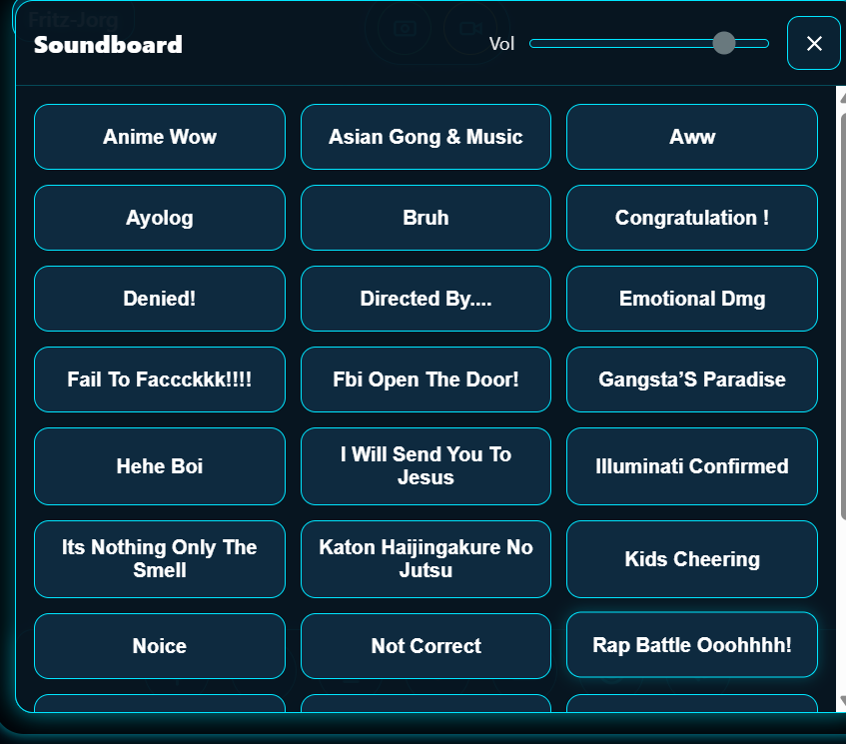
The Emoji Reaction is a choice of reaction effects that will play over the video stream:
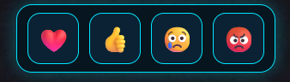

This is the Chat Mechanics:
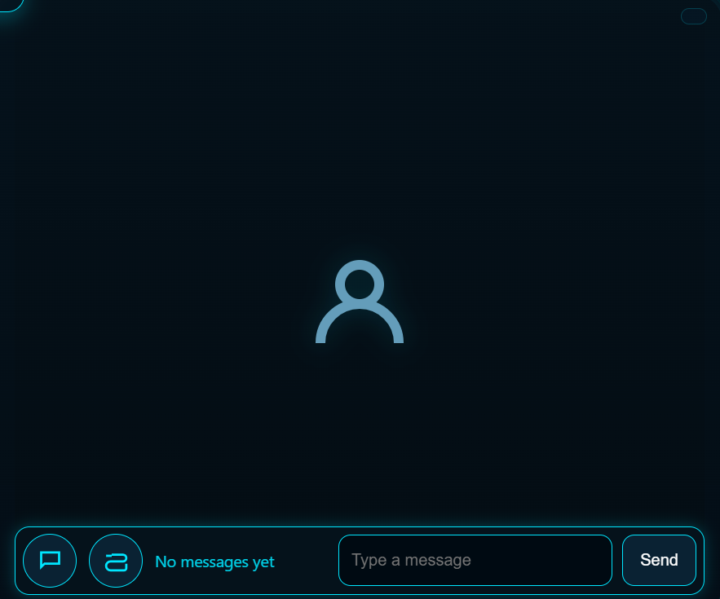
Send
Message box
Attach GIF
Expand/ Close Chat
IMPORTANT! To export GIFS from the in-chat camera, you must go to the Wi-Fi icon again, click the file icon, and select a media folder (or create a new one).

To add new sound effects, take your .mp3 and convert it to a base64 string using https://base64.guru/converter/encode/audio/mp3 . Open EntityBlue8.1.1.html in Notepad or some other text editor and find the line:
/* Paste the object into SFX_BUNDLE in your HTML */
const SFX_BUNDLE = {
Paste the Base64 string below this line.

Yes this is vibe coded
made by null_
Version 8.1.1 9/4/2025

