080419android Sticky Scheduler*
Project Description

Submitted to:

Prof. Ma. Rowena C. Solamo
Faculty Member
Department of Computer Science
College of Engineering
University of the Philippines, Diliman

Submitted by:
Buera, Louie
Cabiles, Jiggs
Palaganas, Genesis Ian

In partial fulfillment of Academic Requirements
for the course
CS 191 Software Engineering I
of the
1st Semester, AY 2014-2015

*name subject to change
Unique Reference:
The documents are stored in the https://github.com/080419android/scheduler
https://github.com/080419android/scheduler/blob/master/Documents/080419aSSProjDesc_v_1_0_0.odt

Document Purpose:
This document aims to present the scope, goal and information flow of the project

Target Audience:
Students, preferably of the collegiate level

Revision Control:
Revision Date | Person Responsible | Version  Number | Modification
08/26/2014 | Palaganas, Genesis Ian | 1.0 | Initial Document
08/27/2014 | Palaganas, Genesis Ian | 1.1 | Added some description to major input and output
08/28/2014 | Palaganas, Genesis Ian | 1.2 | Revised formatting for Entities, Major Inputs, Major Outpus and Major Functionalities. Also added more detailed information on said parts.
09/09/2014 | Palaganas, Genesis Ian | 1.3 | Made some revisions on context diagram

Project Title: 080419android Sticky Scheduler*

Description: As the project name suggests it is a scheduler for the android platform. It aims to assists students specially in the collegiate level to manage their time. It's core features are as follows: Scheduler, Calendar integration and Location Based Functionalities**.

*Project name subject to change
**May or may not be implemented depending on platform limitations

Context Diagram:
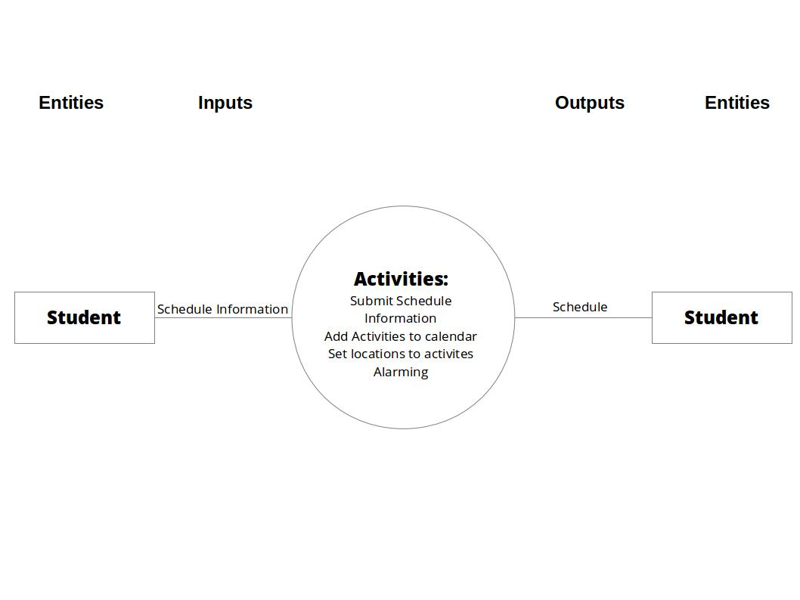

Place here the Context Diagram. Make sure that the diagram is grouped as one and text does not wrap around the diagram.

Entities:

Student/User | The end user of the app. The one to input the information needed and the one that will see and use the information

Major Inputs:

Schedule information | This includes the following:  - Task Title  - Time and Date  - Location  - Remind time and date  - When the user will be reminded of a certain task  - Notes  - Notes being added information the user wants to add

Major Outputs:

Schedule | The collection of previously inputted tasks. This is displayed to the user through a User Interface

Major Functionalities:

Scheduler | Accepts input Schedule Information (see Major Inputs) from user then displays it as a schedule through a user interface in addition to the calender.  This also allows to delete and modify tasks that had already been entered.
Calendar Integration | Schedule information will be added to a calendar service (preferably Google Calendar). Also other activities that already exist in the calendar will be added to the Scheduler
Location Based Functionalities | The app will use the user's current location to do certain tasks such as alerting the user for not being in the location of a certain tasks during the set time and date of the task.
Widget | A widget will be included for easy access to the Schedule and Scheduler

