080419android Sticky Scheduler*
Project Description

Submitted to:

Prof. Ma. Rowena C. Solamo
Faculty Member
Department of Computer Science
College of Engineering
University of the Philippines, Diliman

Submitted by:
Buera, Louie
Cabiles, Jiggs
Palaganas, Genesis Ian

In partial fulfillment of Academic Requirements
for the course
CS 191 Software Engineering I
of the
1st Semester, AY 2014-2015

*name subject to change
Unique Reference:
The documents are stored in the https://github.com/080419android/scheduler
https://github.com/080419android/scheduler/blob/master/Documents/080419aSSProjDesc_v_1_0_0.odt

Document Purpose:
This document aims to present the scope, goal and information flow of the project

Target Audience:
Students, preferably of the collegiate level

Revision Control:
Revision Date | Person Responsible | Version  Number | Modification
08/26/2014 | Palaganas, Genesis Ian | 1.9 | Initial Document

Project Title: 080419android Sticky Scheduler*

Description: As the project name suggests it is a scheduler for the android platform. It aims to assists students specially in the collegiate level to manage their time. It's core features are as follows: Scheduler, Calendar integration and Location Based Functionalities**.

*Project name subject to change
**May or may not be implemented depending on platform limitations

Context Diagram:
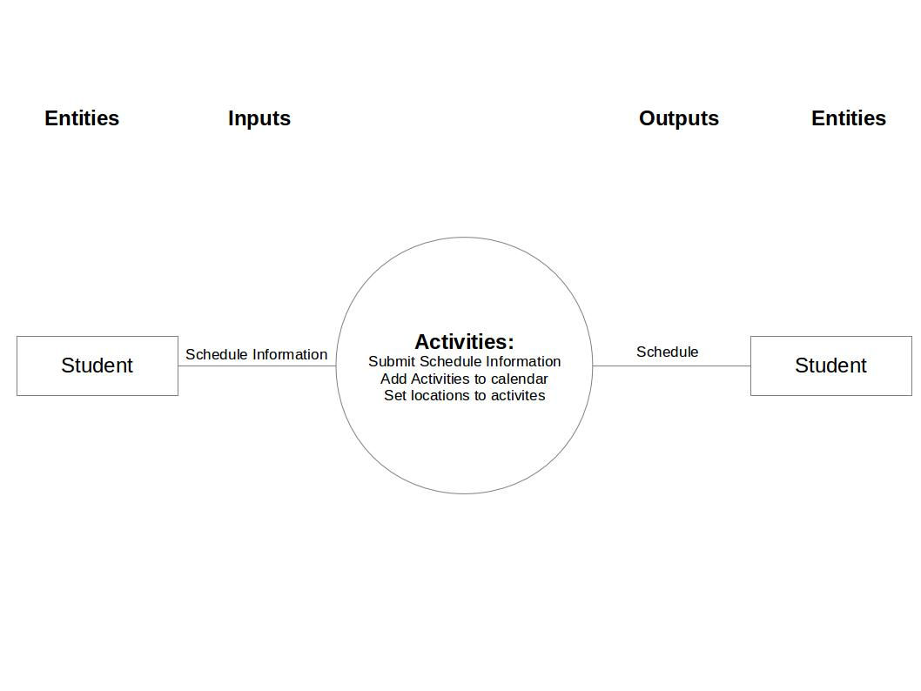

Place here the Context Diagram. Make sure that the diagram is grouped as one and text does not wrap around the diagram.

Entities:

Student

Major Inputs:
Schedule information – The schedule contains task including the following the information: Task name, task description, task location and task time and date information.

Major Outputs:

Schedule – The collection of previously inputted tasks. This is displayed to the user through a User Interface

Major Functionalities:
- Scheduler
- Calendar Integration
- Location Based Functionalities

