Paradox Are OK

Bryan Gough

url: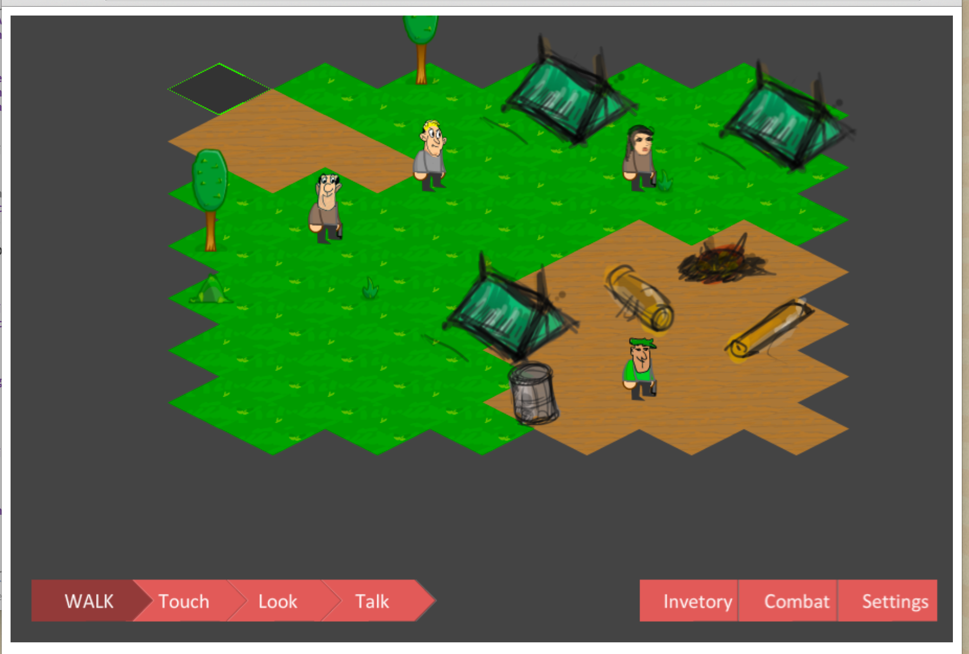

Azure