Read the text aloud!
Living with a Host Family

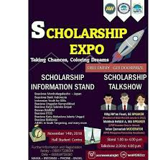
Each year, over half a million students leave their native countries to study English in America. Many international students decide to live with a host family while they are studying in America. A host family offers room and board to international students. There are a lot of advantages to live with a host family, so each year thousands of students choose to stay with one.



One advantage is that host families help students when they arrive. The families meet students at the airport and drive them to their new homes. They show the students how to get to school and help them understand the bus lines. Another advantage is the cost. It is usually cheaper to stay with a family than to live in an apartment. The cost of room and board with host families varies from city to city. In New York, for example, room and board is more expensive than in Oklahoma.

The biggest advantage to live with a host family is that students can experience American culture and improve their English. Students participate in daily activities with the family. They eat meals together and go grocery shopping. They get to know about American lifestyles, and while they are doing this, they are speaking and improving their English.

Students enjoy their stay with a host family. However, sometimes there are problems. These problems are usually because of cultural misunderstandings. Something that is acceptable in one culture may not be okay in another culture. For example, a student from Ghana was always late for the family dinner. In her culture, it was rude to be early or on time, but in American culture, it is not polite to be late. A Japanese student was shocked to find that the family’s pet dog lived inside the house. It sometimes slept on his bed. Even worse to him, the family washed the dog dish in the dishwasher with the other dishes. Finally, a host family with an Indonesian student thought he was rude because he didn’t help with any housework. These are examples of cultural misunderstanding.

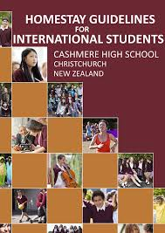
What can a student do to prevent problems? It is very important to ask questions. In American culture, it is good to ask questions. Students should ask questions about family rules. It is important to know about these. You need to understand what you can and cannot do in your new family.

Some good questions are:
- What should I call you?
- What time is dinner?
- What time does the family go to bed?
- Can I watch TV after the family goes to bed?
- Can I use the telephone for local calls? Can I make long-distance calls?
- Can I bring my friends home? Can they come in my bedroom?
It is also acceptable to ask your host family to explain something again if you don’t understand the first time. If you are not sure, it is always better to ask. You can ask politely:
- Excuse me, I don’t understand. Can you repeat that?
- I’m sorry. I don’t understand. Can you write it down for me?
Finally, you need to keep your host family informed. You must tell them if you have any food allergies. You should also tell them if you don’t like certain food. Make sure you let them know if you will miss dinner, or if you are going away for the weekend. If you have a problem, talk about it. The most important part of any friendship is communication. So don’t be shy – communicate and enjoy your stay!
Source: Mc Entire, Jo. 2005. Read Ahead: Reading and Life Skills Development. New York: Pearson Education.

*The End*

