COGNIZANCE CLUB ACTIVITY

TASK-1

NAME: YESHWANTH A

ROLL No.: 21263

DEPARTMENT: CSE(I)

SECTION: C

Create A Repository:

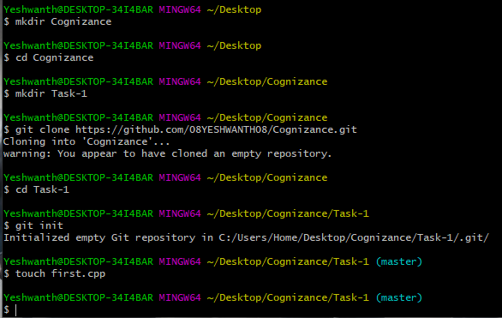

Git Add:

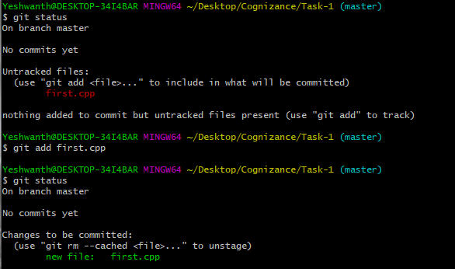

Git Status:



Git Commit:

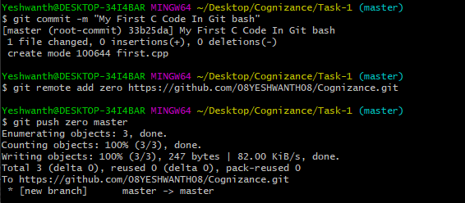

Git Checkout:

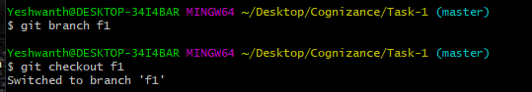

Git Checkout –b:



Git Clone:

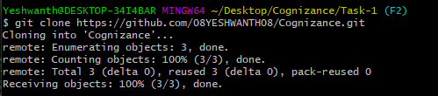

Git Fetch:

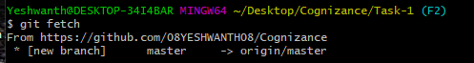

Git Commit –a:

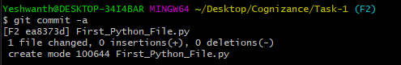

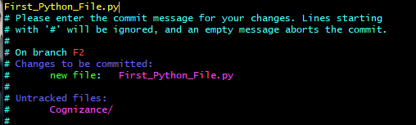

Git Push:

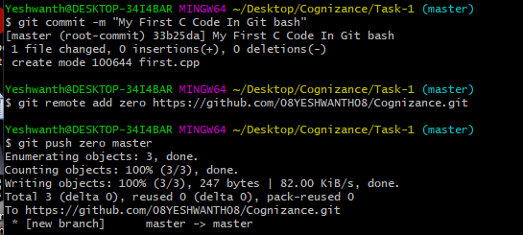

Git Merge:



Git Pull:

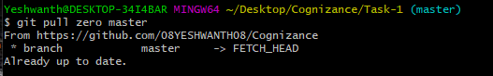

Git Reset:

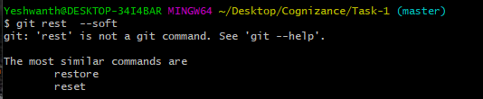

Git Rebase:

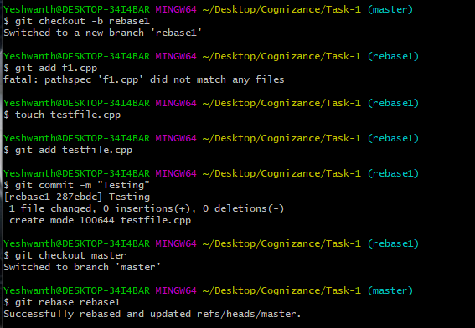

Git config—list-show-origin:

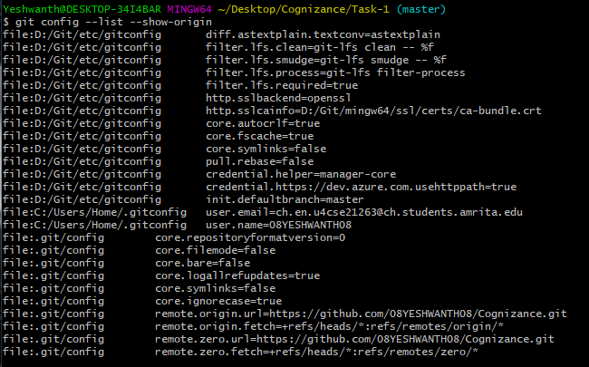

Fork Command:

