COGNIZANCE CLUB ACTIVITY

TASK-8

NAME: YESHWANTH A

ROLL No.: 21263

DEPARTMENT: CSE(I)

SECTION: C

Task-8-1:

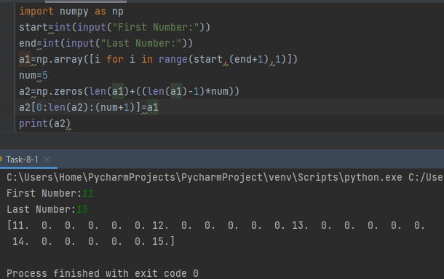

Task-8-2:

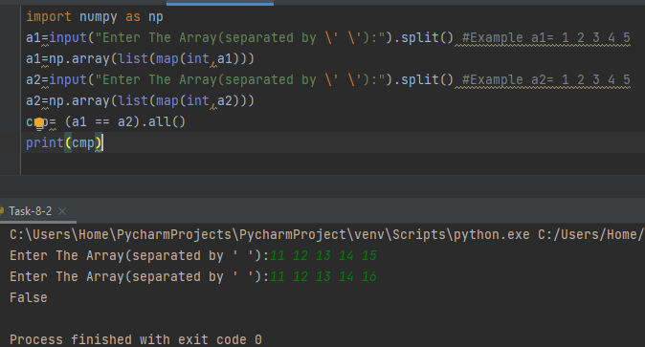

Task-8-3:

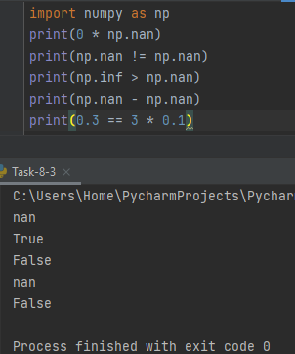

Task-8-4:

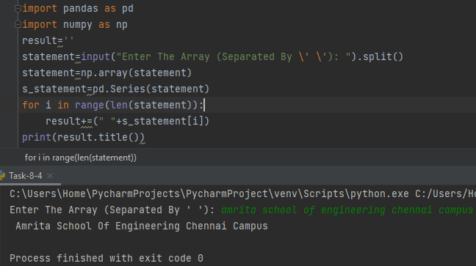

Task-8-5:

