COGNIZANCE CLUB ACTIVITY

TASK-5

NAME: YESHWANTH A

ROLL No.: 21263

DEPARTMENT: CSE(I)

SECTION: C

Part-A

Flag-1- flag{f1irst_fl@g_h3r3}

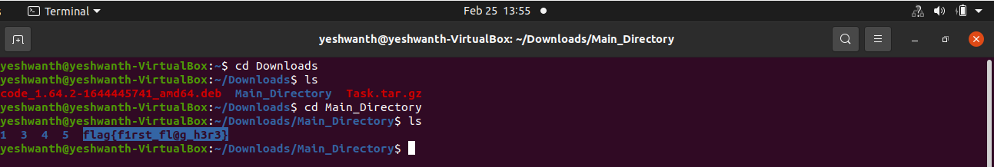

Flag-2- flag{gr3p_finds_fl@gs!}

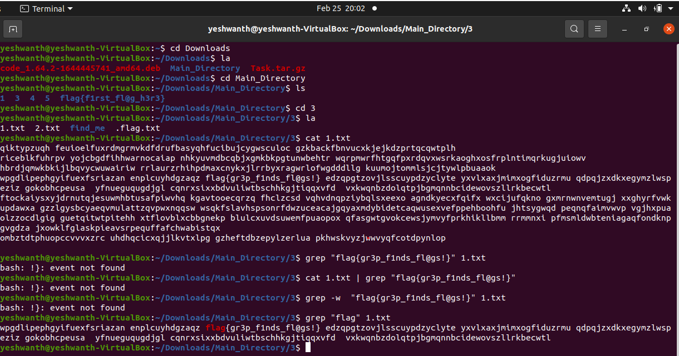

Flag-3- flag{Y0u_f)und_m3!}

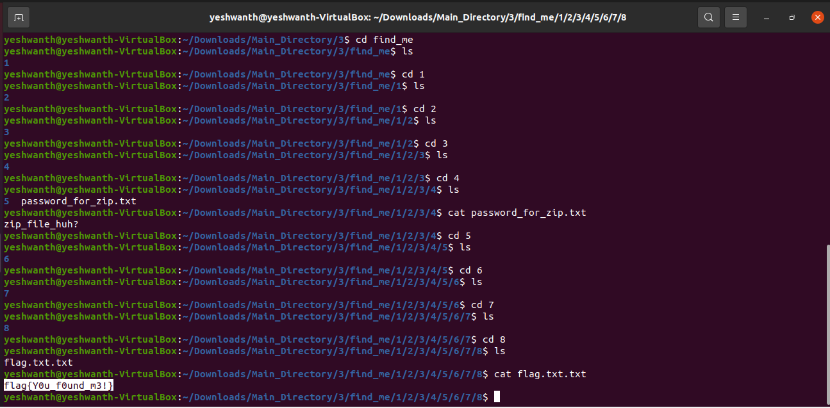

Flag-4- flag{m3ow_m3ow_cat!}

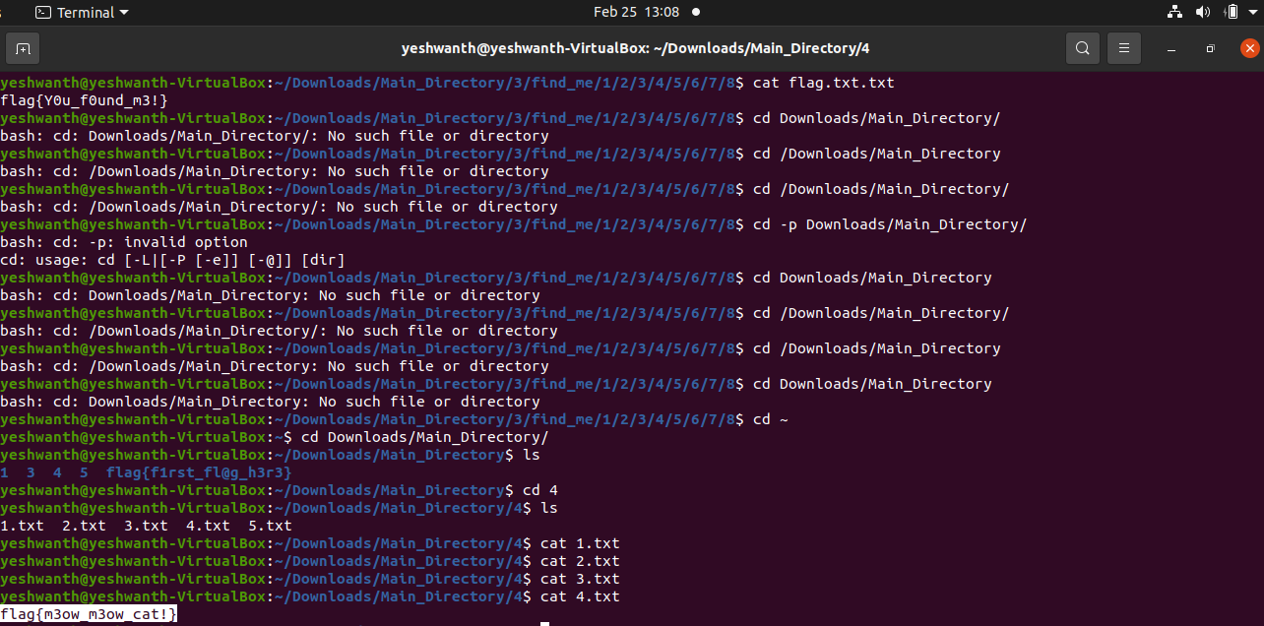

Flag-5- flag{3x3cut10n_d0n3!}

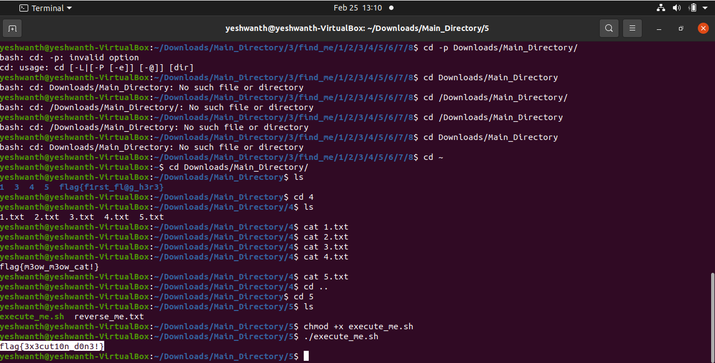

Flag-6- flag{t@c_15_fun!}

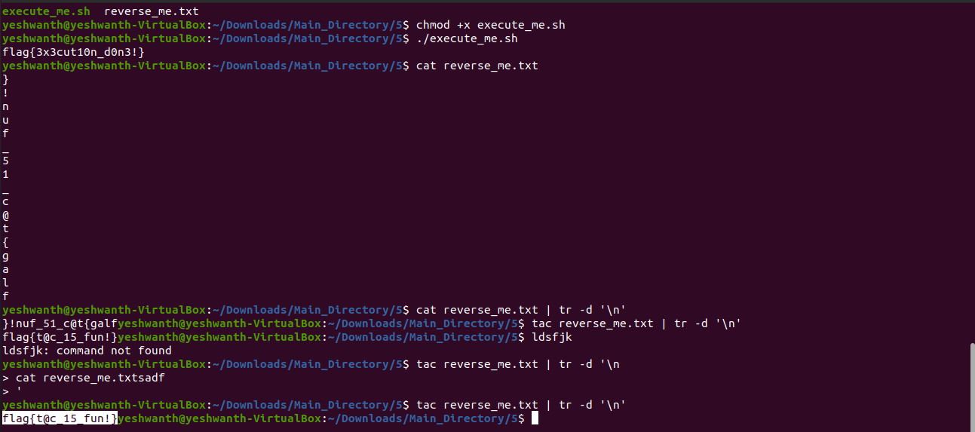

Flag-7- ‘.flag{Y0u_f0und_th3_hidd3n_dir!}’

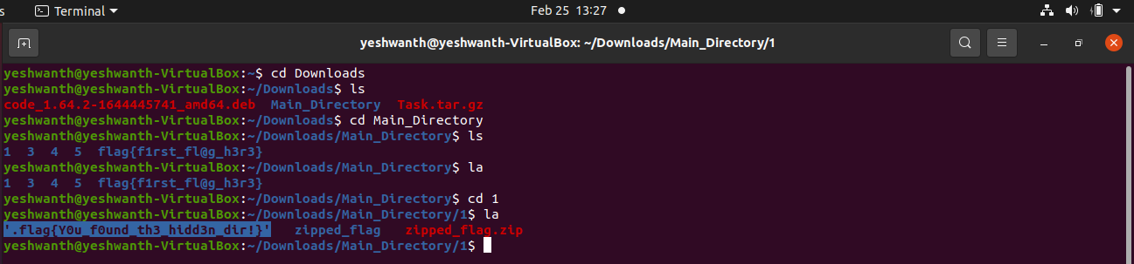

Flag-8- flag{hidden_fil3!}

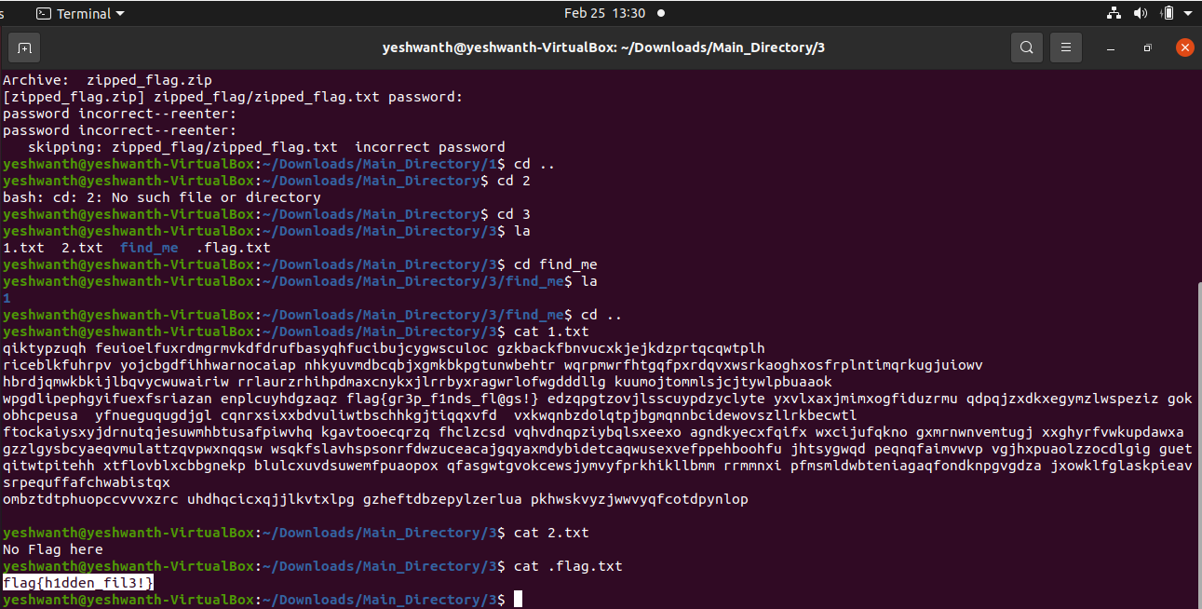

Flag-9- flag{t3xt_15_n0t_h1dd3n!}

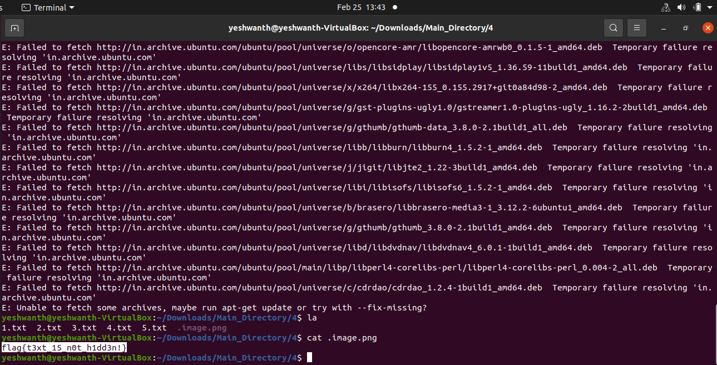

Flag-10- flag{d1ff_c0mm@nd15_u53ful!}

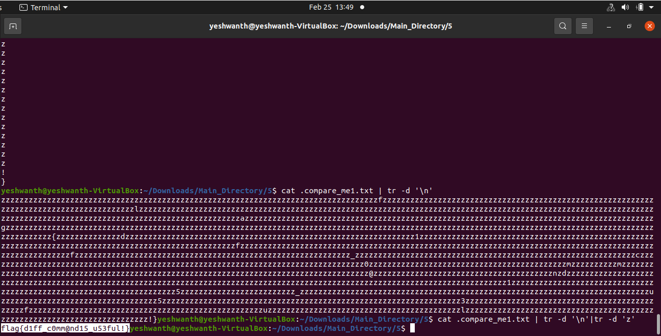

Flag-11- flag{e@5y_p@ssw0rd!}

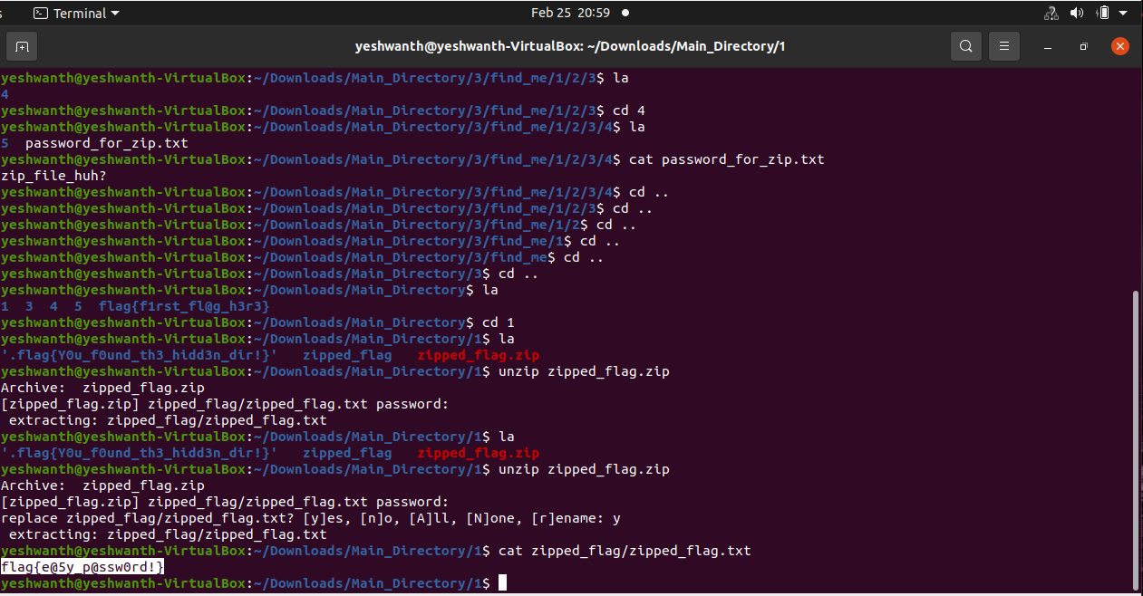

Other Basic Commands

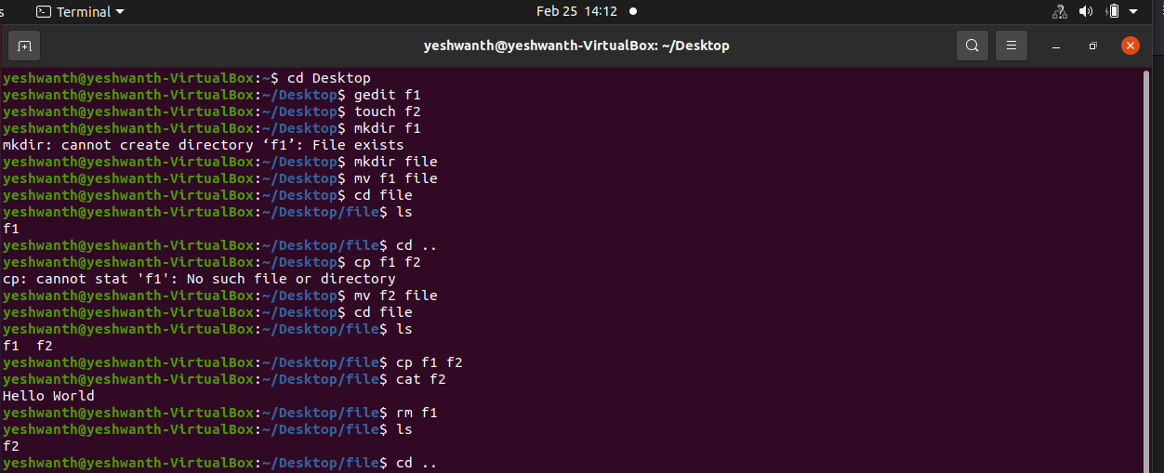

PART-B

1. Write a bash script to echo your name 25 times

#!/bin/bash

for i in {1..25}

do

echo "Yeshwanth"

done

1. What command should I use to display the **first** 30 entries of syslog file?

sudo head -30 <filename>

1. What command should I use to display the **last** 30 entries of syslog file?

sudo tail -30 <filename>

1. What command should I use to arrange the entries of a file
   * Alphabetically
   * Reverse order
   * Numerical order

Alphabetical Order:

sort <filename>

Reverse Order:

sort –r <filename>

Numerical Order:

sort –n <filename>

1. Copee is a hard-working cop. He found a case and almost at the verge of cracking it. It could be his best breakthrough. He has the list of criminals but lots of duplicates are there. He needs to find the only one that is **different.** He sought your help. How will you sort this issue?

sort –u <filename>

1. What are the Three parts of file's permission?

Read, Write and Execute are the three parts of file’s permission.

Read enables the user to read a file.

Write enables the user to write a file.

Execute enables the user to execute the content in a file.