南华大学
计算机科学与技术学院
实 验 报 告

（ 20 ~20 学年度 第 学期 ）

课程名称 | 编译原理
实验名称 | 词法分析器

姓名 | 叶旭明 | 学号 | 20184351145

专业 | 软件工程 | 班级 | 本18软卓01班

地点 |  | 教师 | 王杰

1.实验目的及要求

软件、硬件环境
Win10
Jdk1.8
IDEA 2019.3.3

2.实验步骤

设置词法分析业务模型，设置好一个简单的UI界面

3. 实验内容

流程图 、程序
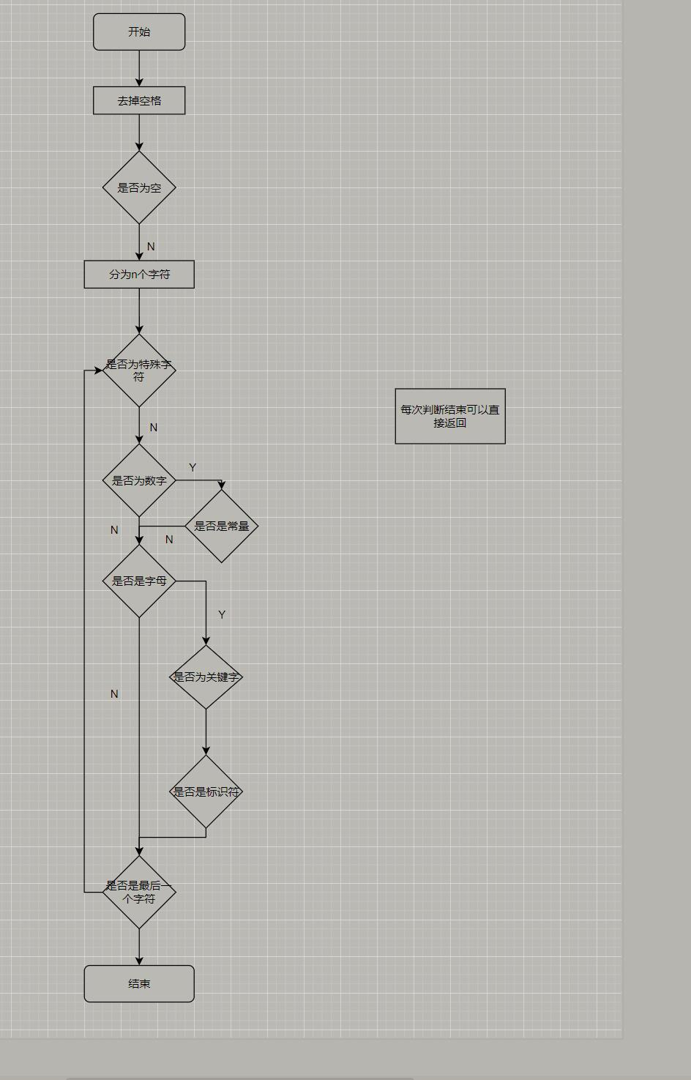

package sample;
import javax.jnlp.ClipboardService;
import java.io.BufferedReader;
import java.io.File;
import java.io.FileReader;
import java.io.IOException;
import java.util.ArrayList;
import java.util.Iterator;
import java.util.List;
public class Analyze {
static int i;
public static List<String> AnalyzeWords(List<String> li){
//String url = filename;
List<String> result = new ArrayList<>();
List<String> lines = li;
Iterator<String> iterator = lines.iterator();
while (iterator.hasNext()) {
String temp = iterator.next();
temp = temp.trim();
if(!temp.isEmpty() && !temp.equals("\r\n") && !temp.equals("\t")) {
char[] chars = temp.toCharArray();
for (i = 0; i < chars.length; ) {
String FUHAO = "";
if(i + 1 < chars.length) {
FUHAO = (chars[i]) + Character.toString(chars[i + 1]);
}
if (chars[i] == ' ') {
i = i + 1;
}
else if (chars[i] == '+' || chars[i] == '-' || chars[i] == '*' || chars[i] == '/' || chars[i] == '=') {
result.add("(" + "4," + chars[i] + ")");
i++;
}
else if (chars[i] == ',' || chars[i] == ';' || chars[i] == '{' || chars[i] == '}' || chars[i] == '(' || chars[i] == ')') {
result.add("(" + "5," + chars[i] + ")");
i++;
}
else if (FUHAO.equals("<=") || FUHAO.equals(">=") || FUHAO.equals("!=") || FUHAO.equals("==")) {
result.add("(" + "4," + FUHAO + ")");
i += 2;
}
else if (Character.isDigit(chars[i])) {//整数
int j;
StringBuilder consts = new StringBuilder();
consts.append(chars[i]);
for (j = i + 1; j < chars.length; j++) {
if (!Character.isDigit(chars[j]) && chars[j] != '.')
break;
else
consts.append(chars[j]);
}
result.add("(" + "3," + consts + ")");
i = j;
}
else if (Character.isLetter(chars[i]) || chars[i] == '_') {
StringBuilder buffer = new StringBuilder();
int j;
buffer.append(chars[i]);
for (j = i + 1; j < chars.length; j++) {
if ((!Character.isLetter(chars[j]) && chars[j] != '_' && !Character.isDigit(chars[j])))
break;
buffer.append(chars[j]);
}
String tom = new String(buffer);
if(Word.contains(tom)){
result.add("(" + "1," + tom + ")");
}
else {
result.add("(" + "2," + tom + ")");
}
i = j;
}
else {
i++;
}
}
}
}
return result;
}
public static List<String> read(String url){
File file = new File(url);
String sb = null;
List<String> list = new ArrayList<>();
try{
BufferedReader br = new BufferedReader(new FileReader(file));
while ((sb = br.readLine()) != null){
list.add(sb);
}
} catch (IOException e) {
e.printStackTrace();
}
return list;
}
}

package sample;
import java.io.BufferedReader;
import java.io.File;
import java.io.FileReader;
import java.io.IOException;
import java.util.ArrayList;
import java.util.List;
public class Word {
public static File file;
public static List<String> stringList;
public static boolean contains(String str){
if(stringList.contains(str)){
return true;
}
return false;
}
static{
String sb = null;
file = new File("word.txt");
stringList = new ArrayList<>();
try{
BufferedReader br = new BufferedReader(new FileReader(file));
while ((sb = br.readLine()) != null){
stringList.add(sb);
}
} catch (IOException e) {
e.printStackTrace();
}
}
}

UI设计
package sample;
import javafx.fxml.FXML;
import javafx.scene.control.Button;
import javafx.scene.control.Label;
import javafx.scene.control.TextArea;
import javafx.scene.control.TextField;
import javafx.stage.FileChooser;
import javafx.stage.Stage;
import java.io.*;
import java.util.List;
import java.util.stream.Collectors;
import java.util.stream.Stream;
public class Controller {
public Button SaveAndExit;
public Button choose;
public TextArea fileReceive;
public TextArea fileShow;
public Label Status;
public TextField FileSave;
@FXML
private Button start;
public void Btn_start_onclick(){
FileChooser fileChooser = new FileChooser();
Stage stage = new Stage();
fileChooser.setTitle("选择文件");
File file = fileChooser.showOpenDialog(stage);
byte[] bytes = new byte[16*10*1024];
try (DataInputStream dataStream = new DataInputStream(new BufferedInputStream(new FileInputStream(file)))){
dataStream.read(bytes);
fileReceive.appendText(new String(bytes));
Status.setText("总字数" + fileReceive.getText().length());
}catch (IOException e){
e.printStackTrace();
}
}
public void Btn_Run_Analyze(){
Status.setText("正在执行");
List<String> strlist = Stream.of(fileReceive.getText().split("\n"))
.collect(Collectors.toList());
List<String> result = Analyze.AnalyzeWords(strlist);
StringBuilder sb = new StringBuilder();
for (String temp:result
) {
sb.append(temp + "\n");
}
fileShow.setText(sb.toString());
Status.setText("完成");
}
}
package sample;
import javafx.application.Application;
import javafx.fxml.FXMLLoader;
import javafx.scene.Parent;
import javafx.scene.Scene;
import javafx.stage.Stage;
public class Main extends Application {
@Override
public void start(Stage primaryStage) throws Exception{
Parent root = FXMLLoader.load(getClass().getResource("sample.fxml"));
primaryStage.setTitle("Hello World");
primaryStage.setScene(new Scene(root, 700, 700));
primaryStage.show();
}
public static void main(String[] args) {
launch(args);
}
}

4.实验结果

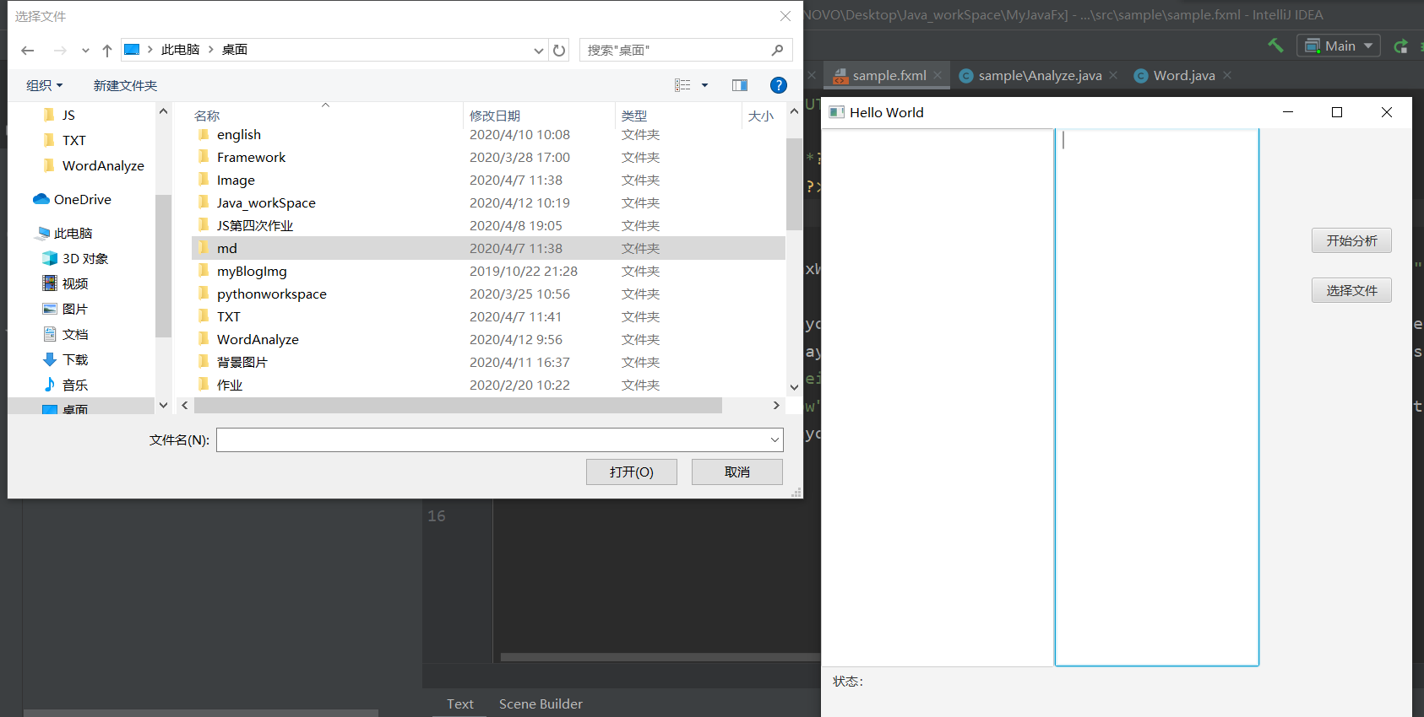

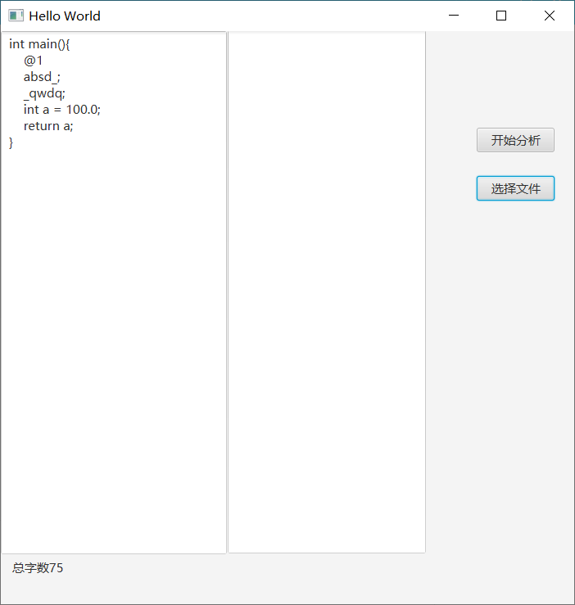

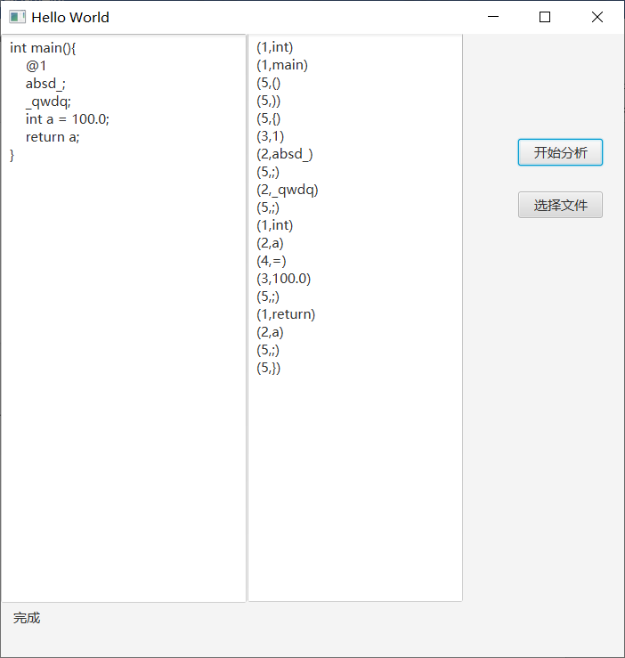
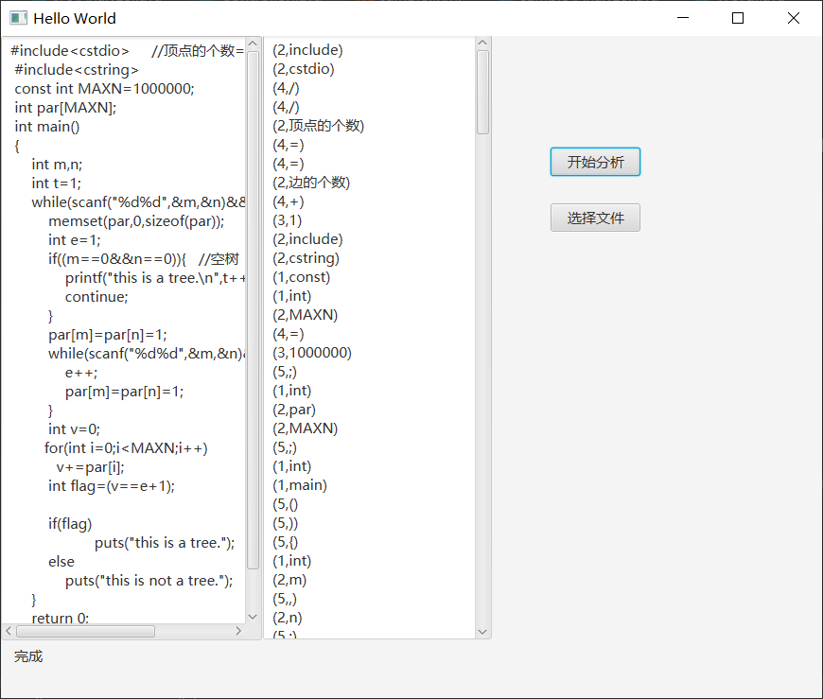
5. 实验总结分析

词法分析器只能简单分析，不能够查错，但是支持多种文件格式（文件加密类除外），该词法分析器使用了java FX 编辑可视化界面；

在做程序之前应当适度做好准备，比如流程图、问题分析、业务逻辑、接口和业务逻辑。不能够想当然，这样分析不全面。

