Ravi Yadav
11717020
Lab 3
Set C

Q. Create a virtual machine using vsphere web client then
a. Modify the existing configuration of the virtual machine
b. Ensure that only three users can have simultaneous access to this virtual machine

Setp 1. Need to go on vmwarehol.com and the need to search for lab 1910 and then need to login to that to access that lab.
Step 2. After that need to open google chrome available on that lab and then need to login that portal using user name administrator@vsphere.local and password “VMware1!”.
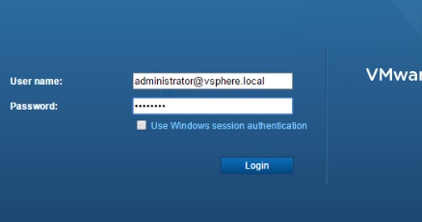

Step 3. After then we need to go to essx-01>> New virtual machine>>New Virtual Machine 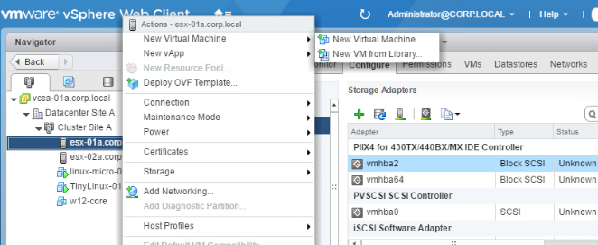
Step 4. Here select creation type
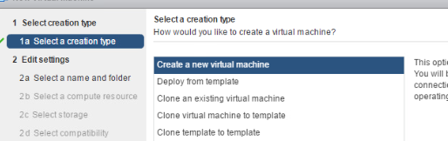
Step 5. After that need to name virtual machine and select datacentre
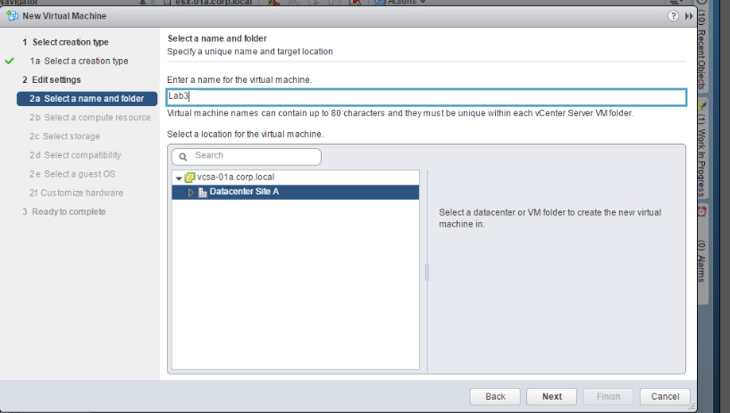

Step 6. After that need to select compute resource
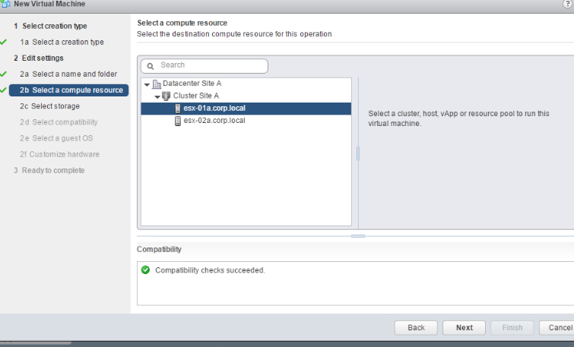
Step 7. Need to select storage
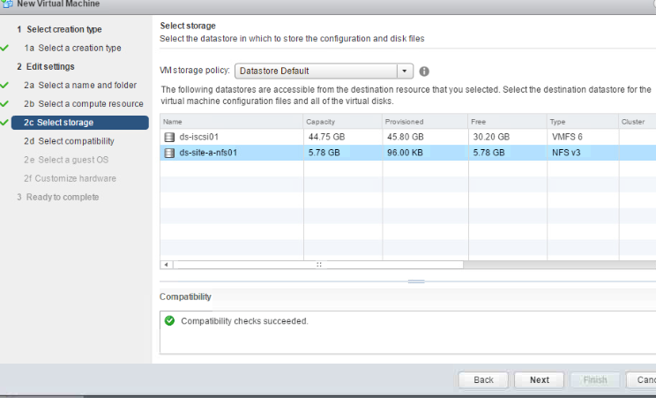

Step 8. Need to select compatibility
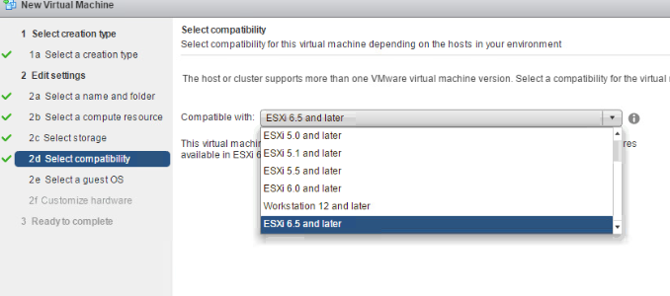
Step 9. Need to select guest Os
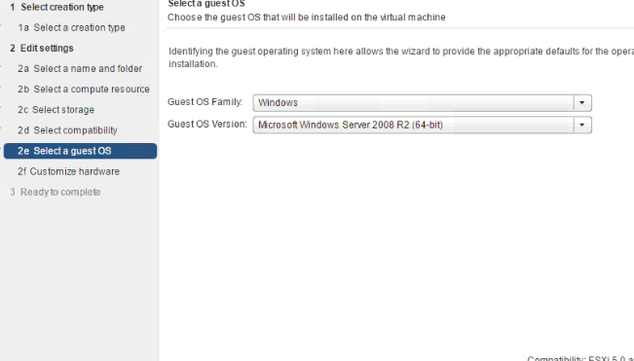

Step 10. Need to customize hardware
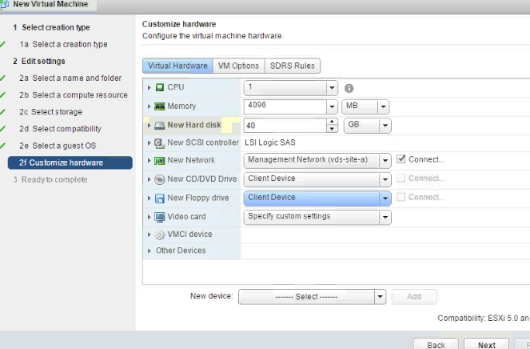
Step 11. Now virtual machine is created and all details are shown and need to click on finish
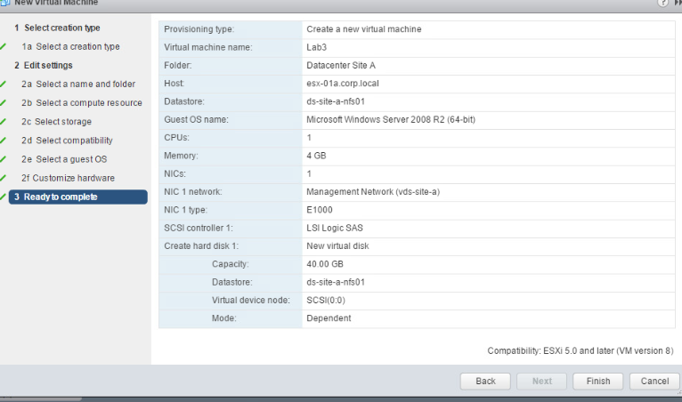
Here is the new virtual machine named Lab 3
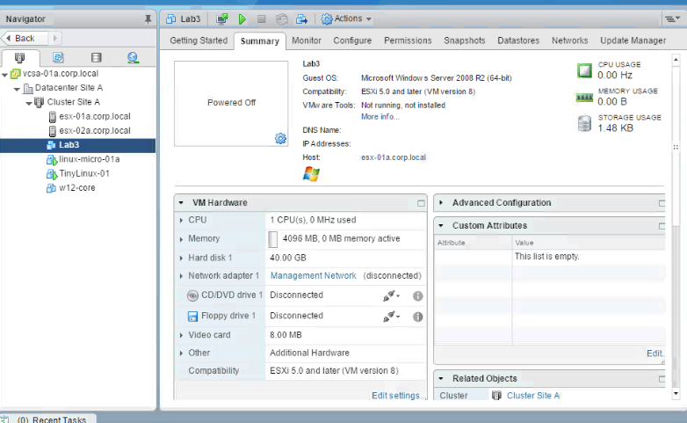
- Modify the existing configuration of the virtual machine
- And need to go on configure tab to modify existing configurations and modify as we want
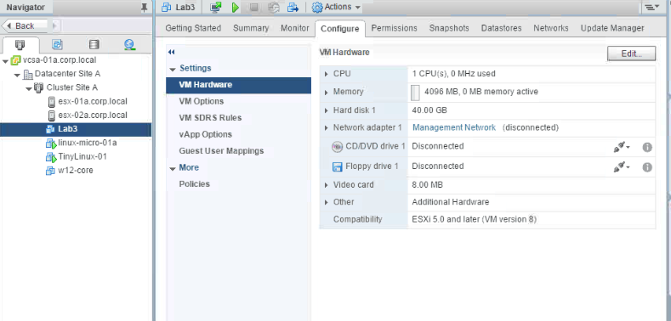
- Ensure that only three users can have simultaneous access to this virtual machine
- Need to go to action then edit setting
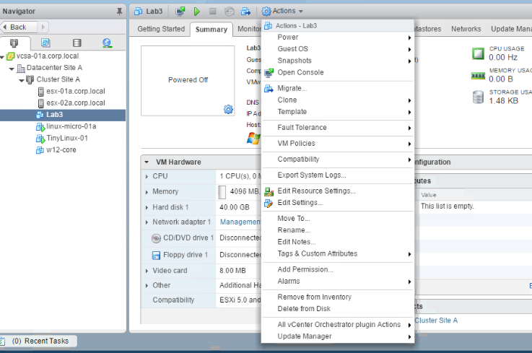
- Then need to got VM options
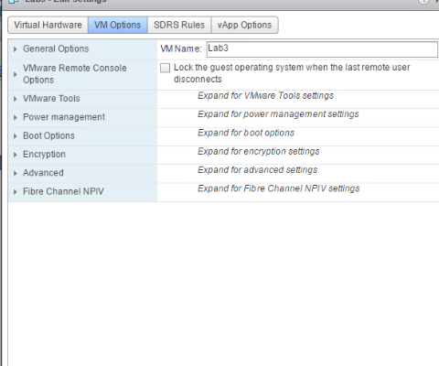
- Then need to click on VMware remote console option
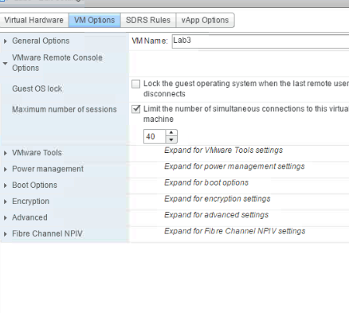
- Now go to maximum maximum numbers of sessions and set ‘Three’ (03)
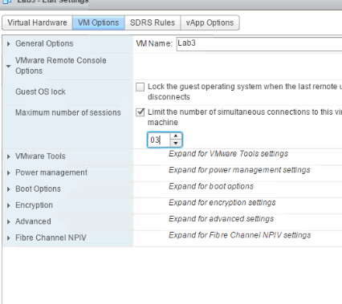
Now when we will try to access more then 3 this error will pop up
