Capstone Project Proposal

CMU-SE450 Capstone Project I

**Design Project Proposal**

**University Review**

**Submitted by**

**Nguyen Van Minh Toi**

**Nguyen Huu Thien**

**Ho Xuan Sang**

**Huynh Thi Quy Thuong**

**Approved by**

**Dr. Ha Thi Nhu Hang**

Proposal Review Panel Representative:

Name Signature Date

Capstone Project 1- Mentor:

Name Signature Date

**University Reviews**

**1. Introduction**

University Reviews website :

Search:

o Candidates can search according to their major. Are intending to apply to universities, but there is no orientation or questions are not specifically answered. To avoid the lack of information or misunderstanding about the industry and the school is planning to apply greatly affect the future and career or take too much time.

Post topic:

o Candidates can post topics related to schools, majors, tuition fees ... Students come to answer questions, be a place to exchange and learn with each other.

o Students who do not have the experience and direction in the industry will answer questions, share learning experiences through the comments of alumni, or students of the above course.

Help orient the right career with interests as well as the ability of you intend to participate in admission to a certain university.

The website we will review and evaluate universities over the country.

**2. Problem Definition**

For students who intend to apply to college or university:

* According to statistics from kenh14.vn and giaoduc.net. Every year, more than 640,000 candidates register to enter the university. Currently, Vietnam has about 224 universities.
* With a huge number of candidates, and so many universities, it is difficult for a candidate to choose a major into the desired school. The information is not integrated. Students who want to know information about any school must immediately go to that school. They only talk generally about the school, little mention about issues such as facilities, the feeling of students studying at that school,...
* Many university and college students still cannot succeed because they choose a major that is not in the right forte, with the right interest. According to the survey by the career-oriented admissions department of the schools, there are 15-20% of new graduates know they choose the wrong career.

For students at the school:

* The students at the school mainly study at school to get the basic knowledge, but many of them still do not have the ability to self-improve, have no direction in the majors, or do not understand the subject they choose. How, what are my strengths ...
* To solve the above problems, we created a website review of all the universities across the country.

When a candidate chooses a major, our website will:

o Provide all subject information.

o Compile a list of all schools with that discipline and organized by region (North, Central, South or province / city) or tuition rate, rating. And each will provide the following information:

* Benchmark entry, tuition in the last 3 years.
* About the school.
* There are video interviews with students and facilities at that school.
* There are topics about the school, a place to exchange and answer questions between students who have been studying at the school and candidates.

In addition, our website also provides "MBTI Test" to help candidates understand their personalities, interests, strengths, weaknesses ... From the results, MBTI will help candidates choose the appropriate industry. , more suitable for yourself.

Candidates will have complete information and university comparison. Help candidates make decisions that are right for themselves.

Students at the school can exchange and learn about specific directions and experiences of their seniors.

**3. Current Status of Art**

Studying at university is now very popular, almost all high school students after graduation want to study further at universities, along with the need to choose the right school to the study. That student wants to listen to the practical experiences of other students who have learned through.

Recognize the importance, our team has designed the website with an easy interface, use, and access, to meet the needs. it helps students in supporting decision making, in addition to helping students have the most overview of the university environment.

|  |  |  |  |
| --- | --- | --- | --- |
| Function | TAIWAN STUDY IN | Edu2Review | University Reviews |
| Search school | X | X | X |
| * By industry | (Show only school names whose names match the keywords) | X | X |
| * According to the region | X | X | X |
| * Tuition |  |  | X |
| Sorted by rating |  | X | X |
| MBTI test |  |  | X |
| View benchmarks and tuition |  |  | X |
| View information about majors |  | X | X |
| School introduction | Basic information | X | X |
| Video interviewing the students are studying and facilities at the school. |  |  | X |
| Post topics about the school such as tuition fees, subjects, learning experience, .... . |  |  | X |
| Arrange topics according to each topic |  |  | X |
| Arrange topics according to evaluate |  |  | X |
| Comment |  | X | X |
| Evaluate |  | X | X |

**4. Engineering Approach (including solution alternatives)**

**4.1 System context diagram:**

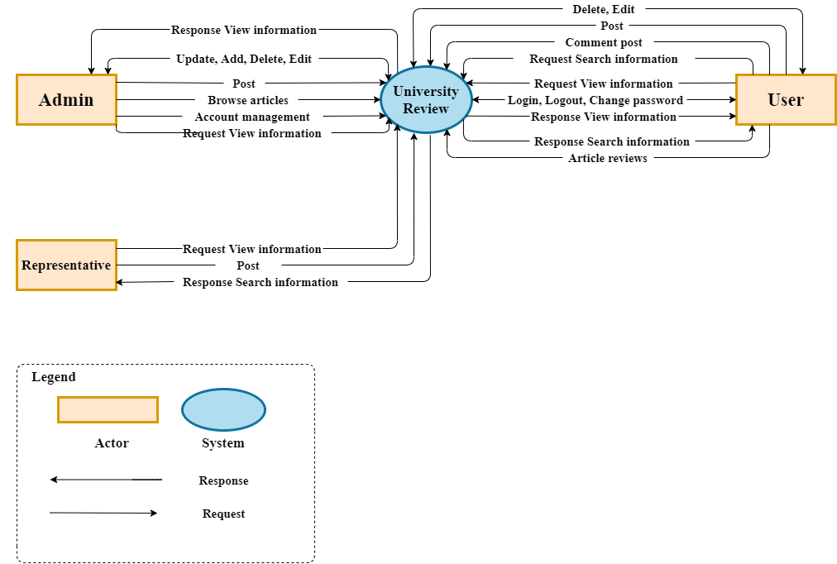

*Figure 1: System Context Overview*

**4.2 System context description**

|  |  |  |
| --- | --- | --- |
| **Role** | **System context** | **Description** |
| User | Request | Users can login, log out, change passwords, view information, post articles, comment, delete, edit your articles and rate other articles. |
| Admin | Request | Admin can account management, update, add, delete, edit all of topic, browse articles, post and view information. |
| Representative | Request | Representative can post and view information about their university . |

**4.3** **Technical Constraints**

To increase performance, and reduce weight for team site using the latest frameworks in web development:

* + Programming languages ​​and supporting libraries: JavaScript, React JS, Redux-saga, axios.
  + CMS: Keystone JS.
  + Database: noSQL (MongoDB).

**5. Tasks and Deliverables**

**5.1 Task:**

|  |  |  |  |  |
| --- | --- | --- | --- | --- |
| **No** | **Task Name** | **Duration** | **Start** | **Finish** |
| **1** | **Initial** | **6** | **13-August-20** | **18-August-20** |
| 1.1 | Create Proposal Document | 6 | 13-August-2020 | 18-August-2020 |
| **2** | **Start Up** | **10** | **19-8-20** | **28-8-20** |
| 2.1 | Project’s Kick-off Meeting | 1 | 19-August-20 | 19- August -20 |
| 2.2 | Discuss about project ideal | 2 | 20- August -20 | 21- August -20 |
| 2.3 | Create documents for project | 7 | 22- August -20 | 28- August -20 |
| **3** | **Development** | **95** | **29-** August **-20** | **28-November-20** |
| *3.1* | *Sprint 1* | 25 | 29- August -20 | 22-September-20 |
| *3.2* | *Sprint 2* | 25 | 23- September -20 | 12-October-20 |
| *3.3* | *Sprint 3* | 25 | 13- October -20 | 7- November -20 |
| *3.4* | *Sprint 4* | 20 | 8- November -20 | 28- November -20 |
| **4** | **Project Meeting** | **2** | **29- November -20** | **30- November -20** |
| **5** | **Final Release** | **2** | **01-December-20** | **02- December -20** |
|  | **Duration** | **115** |  |  |

**5.2 Deliverables:**

Document:

|  |  |
| --- | --- |
| **Name Document** | **Responsible** |
| Proposal | Thien , Thuong, Sang, Toi |
| Project plan | Thien, Thuong |
| Design UI | Thien, Thuong |
| SRS | Thien, Thuong, Sang, Toi |
| Test plan | Sang, Toi |

Sotfware:

|  |  |
| --- | --- |
| **Phase** | **Responsible** |
| Sprint 1 | Thuong, Sang, Thien |
| Sprint 2 | Thuong, Sang, Thien |
| Sprint 3 | Thien, Toi |
| Sprint 4 | Sang, Toi |
| Final | Toi |

**6. Project Management**

**6.1 Scrum process:**

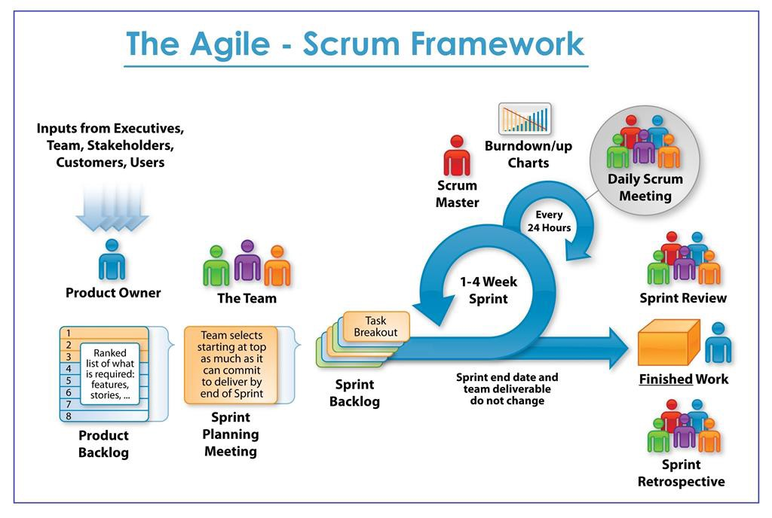

* Scrum is an iterative and incremental agile software development framework for managing software projects and product or application development.
* Scrum focuses on project management institutions where it is difficult to plan ahead.
* Mechanisms of empirical process control, where feedback loops that constitute the core management technique are used as opposed to traditional command-and-control management.
* Its approach to planning and managing projects is by bringing decision-making authority to the level of operation properties and certainties.
* Benefit of the methodology:
  + Project can respond easily to change.
  + Problems are identified early.
  + Customer gets most beneficial work first.
  + Work done will better meet the customer’s needs.

Improved productivity. Ability to maintain a predictable schedule for delivery.

**6.2 Human Resource:**

|  |  |  |  |
| --- | --- | --- | --- |
| **Full name** | **Phone** | **Email** | **Position** |
| Hang, Ha Thi Nhu | 0707121301 | hatnhuhang@duytan.edu.vn | Mentor |
| Toi, Nguyen Van Minh | 0902257132 | minhtoi2799@gmail.com | Product Owner |
| Thien, Nguyen Huu | 0783533812 | huuthiennguyen1999@gmail.com | Scrum Master |
| Sang, Ho Xuan | 0362982905 | hsang19999@gmail.com | Member |
| Thuong, Huynh Thi Quy | 0333633770 | quythuong0405@gmail.com | Member |

**6.3 Sprint backlog**

|  |  |  |
| --- | --- | --- |
| **Sprint** | **Story Name (Coding)** | **Name Of Developer** |
| **Sprint 1** | Login user | Thuong |
| Forgot password | Thuong |
| Registration | Thuong |
| Design main page | Thien |
| See the post (read and review) | Sang |
| Test | Sang |
| **Sprint 2** | Design form | Thuong |
| Detail topic(add, update, delete) | Thien |
| Comment (delete, add, rating) | Sang |
| Test | Sang |
| **Sprint 3** | Edit personal information | Thien |
| + Anonymity or identity | Toi |
| + edit personal information | Thien |
| Create form "MBTI Test" | Toi |
| Test | Toi |
| **Sprint 4** | Filter, search the post | Sang |
| search by name | Sang |
| filtered by degree | Toi |
| filter by tuition | Toi |
| Filtered by update time | Toi |
| Test | Toi |

**6.4 Cost Estimate**

|  |  |  |  |  |
| --- | --- | --- | --- | --- |
| **No** | **Criteria** | **Milestone** | **Working hours** | **Cost(2.3$/hour)** |
| 1 | Initial | INI | 72 | $165.6 |
| 2 | Start Up | STU | 120 | $176 |
| 3 | Development |  | (4hour/day) |  |
| 3.1 | Sprint1 | SPR1 | 100 | $230 |
| 3.2 | Sprint2 | SPR2 | 100 | $230 |
| 3.3 | Sprint3 | SPR3 | 100 | $230 |
| 3.4 | Sprint4 | SPR4 | 80 | $184 |
| 4 | Other Cost | OTH |  | $200 |
| 5 | Project Meeting | PM | 24 | $55.2 |
| 6. | Final Release | FR | 24 | $55.2 |
|  | **TOTAL** |  | 620 | $1626 |

* **Description:**

|  |  |  |
| --- | --- | --- |
| **Description** | **Amount** | **Unit** |
| Number of members | 4 | Person |
| Number of working hour per day | 4 | Hour |
| The cost per hour | $2.3 | USD |

* **Explain:**
* Working hours = Number of working hour per day * Number of members * Number of days.

= 4 * 4 * Number of days

*Number of days: Initial: 8

Start Up: 10

Development (SPR1): 25

Development (SPR2): 25

Development (SPR3): 25

Development (SPR4): 20

Project meeting: 2

Final release: 2

* Cost = Working hours * The cost per member per hour.

= Working hours * 2.3

**7. Conclusion**

Identify students wishing to consult and listen to real feelings and opinions from students or alumni who have been studying at universities, to help guide careers, as well as support to make the final decision for the most suitable university for students nationwide.

In order to meet that need, the CSE.04 team came up with the idea of ​​building a website to synthesize common topics, school events that students in the school want to share, along with a review of summary information. about the school such as the scores over the current years, the facilities - infrastructure, the staff, the faculty ... of all universities in Vietnam.

The users of the website here are not only students, but also faculty staff, parents, or anyone interested in activities in the school.

And the ultimate purpose of the website is to help users get the most overview of the fields and universities they are wondering, help connect students together, improve the quality of teaching, and bring the mission. from each university to students from many different regions.

The team has planned this project, the product will be officially launched within 3 months, the total cost for the whole project as mentioned above is 1626 $, with the current web assist technologies to increase performance in UX / UI, bringing the most convenience to users.

8. References

9. Attachment: Final Design Requirement Form