

International School

**Capstone Project 1**

CMU-SE 450/CMU-IS 450/CMU-CS450

**Database Design Document**

**Version 1.0**

**Date: Oct 25, 2020**

**UNIVERSITY REVIEWS**

**Submitted by**

**Nguyen Van Minh Toi**

**Nguyen Huu Thien**

**Ho Xuan Sang**

**Huynh Thi Quy Thuong**

**Approved by**

**Proposal Review Panel Representative:**

Name Signature Date

**Capstone Project 1- Mentor:**

_______________________

Name Signature Date

**Dr.Ha Thi Nhu Hang**

**PROJECT INFORMATION**

|  |  |  |  |
| --- | --- | --- | --- |
| Project acronym | URs | | |
| Project Title | University reviews | | |
| Start Date | August 13, 2020 | End Date | December 05, 2020 |
| Lead Institution | International School, Duy Tan University | | |
| Project Mentor &contact details | Dr. Ha Thi Nhu Hang  Email: [hatnhuhang@duytan.edu.vn](mailto:hatnhuhang@duytan.edu.vn)  Tel: 0707121301 | | |
| Product Owner | Toi, Nguyen Van Minh  Email: [minhtoi2799@gmail.com](mailto:minhtoi2799@gmail.com)  Tel: 0902257132 | | |
| Scrum Master | Thien, Nguyen Huu  Email: [huuthiennguyen1999@gmail.com](mailto:huuthiennguyen1999@gmail.com)  Tel: 0783533812 | | |
| Team members | Name | Email | Tel |
| Toi, Nguyen Van Minh | minhtoi2799@gmail.com | 0902257132 |
| Thien, Nguyen Huu | huuthiennguyen1999@gmail.com | 0783533812 |
| Sang, Ho Xuan | hsang19999@gmail.com | 0362982905 |
|  | Thuong, Huynh Thi Quy | quythuong0405@gmail.com | 0333633770 |

|  |  |  |  |
| --- | --- | --- | --- |
| **DOCUMENT NAME** | | | |
| **Document Title** | Database Design Document | | |
| **Author(s)** | C1SE.04 Team | | |
| **Role** | Sang, Xuan Ho  Toi, Nguyen Van Minh | | |
| **Date** | 14 – Sep – 2020 | **File name:** | Database Design v1.0 |
| **URL** |  | | |
| **Access** |  | | |

**REVISION HISTORY**

| **Version** | **Date** | **Comments** | **Author** | **Approval** |
| --- | --- | --- | --- | --- |
| 1.0 | Oct 20, 2020 | Initial Release | Toi, Nguyen Van Minh |  |

|  |  |  |  |
| --- | --- | --- | --- |
| **Document Approval**  The following signatures are required for approval of this document | | | |
| **Mentor** | Dr. Ha Thi Nhu Hang | **Signature:** |  |
| **Date:** |  |
| **Signature:** |  |
| **Date:** |  |
| **Scrum Master** | Nguyen Huu Thien | **Signature:** |  |
| **Date:** |  |
| **Team Member(s)** | Nguyen Van Minh Toi | **Signature:** |  |
| **Date:** |  |
| Huynh Thi Quy Thuong | **Signature:** |  |
| **Date:** |  |
| Ho Xuan Sang | **Signature:** |  |
| **Date:** |  |

Contents

**1.** **Introduction** 5

**1.1**. **Purpose** 5

**1.2 Target** 5

**2.** **Required hardware and software** 5

**3.** **Database design decision** 5

**3.1.** **Mapping rules** 5

**3.2.** **Additional object** 6

**3.3** **Entity relationship chart:** 6

**4.** **Relational Models** 8

**5.** **Detail of the tables** 9

1. **Introduction**
   1. **Purpose**

* Provide a list of priority features, containing short descriptions of all desired functions in the project.
* Contains a complete list of all requirements under consideration, priority order and other key features that facilitate planning and prioritization.

## **1.2 Target**

Develop website for users to get more information about the university.

1. **Required hardware and software**

This section provides an overview of the hardware and software architecture. Below are descriptions of the technology components of the University Review website

|  |  |
| --- | --- |
| **Technology components of the University Review website** | |
| **Attribute** | **Description** |
| **Database** | MomgoDB |
| **Software** | React, Node Js |
| **Hardware** | Computer |

1. **Database design decision**
   1. **Mapping rules**

When mapping entities to tables, the following rules apply:

* Entities are mapped to tables in a one-to-one manner
* Properties are mapped to columns in a one-to-one manner
* One-to-many relationships are mapped to a foreign key
* For 1 - 1 association: sets the primary key, one of the two relations to another to create a foreign key.
* With 1 - n association: set the primary key, one relationship into many relationships that create a foreign key
* With n - n link: create a sub table, then set the primary key of the two tables to create a foreign key of the sub table.
  1. **Additional object**

The following table lists the database objects (tables or columns) that are not derived from the entity, but have been added to the database design for the purposes listed below. This includes intersection tables used to map many-to-many relationships.

* 1. 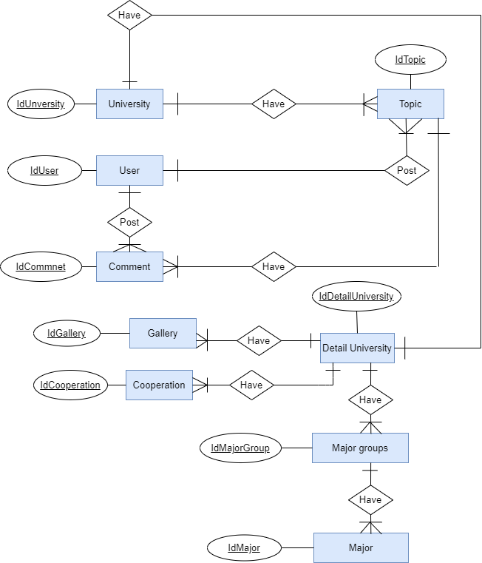 **Entity relationship chart:**

Figure 01: URs entity relationship chart

1. 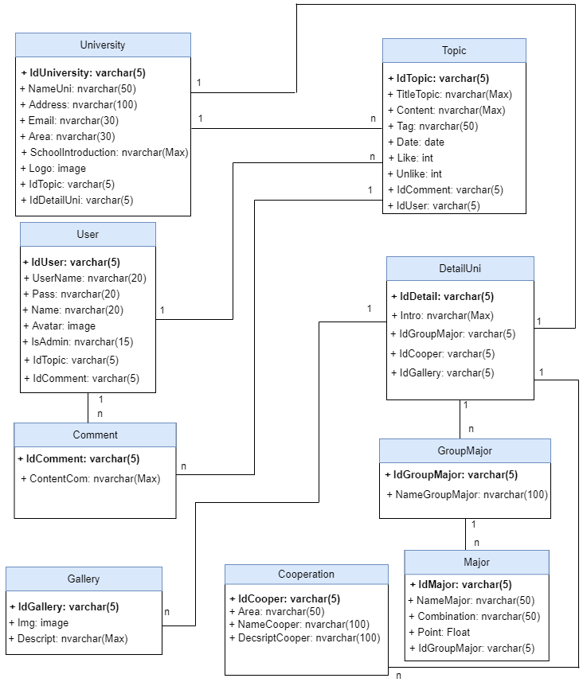**Relational Models**

**Figure 02:** URs relational model

1. **Detail of the tables**

**Table 01: University**

|  |  |  |  |  |
| --- | --- | --- | --- | --- |
| ID | Field | Datatypes | Constraint | Desription |
| 01 | IdUniversity | Varchar(5) | Primary key | This field is associated with the Topic table, the DetailUni table |
| 02 | NameUni | Nvarchar(50) |  | Name of the university |
| 03 | Address | Nvarchar(100) |  | Address of the university |
| 04 | Email | Nvarchar(30) |  | Email of the university |
| 05 | Area | Nvarchar(30) |  | Area of the university |
| 06 | SchoolIntroduction | Nvarchar(1000) |  | Introduction about the university. |
| 07 | Logo | Image |  | Logo of the university |
| 08 | IdTopic | Varchar(5) | Foreign key | This field is linked to the Topic table, helping to define IdTopic in the Database. |
| 09 | IdDetailUni | Varchar(5) | Foreign key | This field is linked to the DetailUni table, helping to define IdDetailUni in the Database. |

**Table 02 : Topic**

|  |  |  |  |  |
| --- | --- | --- | --- | --- |
| ID | Field | Datatypes | Constraint | Desription |
| 01 | IdTopic | Varchat(5) | Primary key | This field is associated with the Comment table, the User table |
| 02 | TitleTopic | Nvarchar(100) |  | The title of the topic |
| 03 | Content | Nvarchar(10000) |  | The content of the topic |
| 04 | Tag | Nvarchar(50) |  | topic's tag |
| 05 | Date | Date |  | Post topic date |
| 06 | Like | Integer |  | User likes topic |
| 07 | Unlike | Integer |  | User unlike topic |
| 08 | IdComment | Varchar(5) | Foreign key | This field is linked to the Comment table, helping to define IdComment in the Database. |
| 09 | IdUser | Varchar(5) | Foreign key | This field is linked to the User table, helping to define IdUser in the Database. |

**Table 03: User**

|  |  |  |  |  |
| --- | --- | --- | --- | --- |
| ID | Field | Datatypes | Constraint | Desription |
| 01 | IdUser | Varchar(5) | Primary key | This field is associated with the Comment table, the Topic table |
| 02 | UserName | Nvarchar(20) |  | Username of the user |
| 03 | Pass | Nvarchar(20) |  | Password of the user |
| 04 | Name | Nvarchar(20) |  | Name of the user |
| 05 | Avatar | Image |  | User avatar |
| 06 | IsAdmin | Nvarchar(15) |  | Authentication has what rights in a database... |
| 07 | IdTopic | Varchar(5) | Foreign key | This field is linked to the Topic table, helping to define IdTopic in the Database. |
| 08 | IdComment | Varchar(5) | Foreign key | This field is linked to the Comment table, helping to define IdComment in the Database. |

**Table 04: Comment**

|  |  |  |  |  |
| --- | --- | --- | --- | --- |
| ID | Field | Datatypes | Constraint | Desription |
| 01 | IdComment | Varchar(5) | Primary key | This field is associated with the Topic table, the User table |
| 02 | ContentComm | Nvarchar(Max) |  | the content of the comment |

**Table 05: DetailUni**

|  |  |  |  |  |
| --- | --- | --- | --- | --- |
| ID | Field | Datatypes | Constraint | Desription |
| 01 | IdDetail | Varchar(5) | Primary key | This field is associated with the GroupMajor table, the Cooper table, and the Gallery table |
| 02 | Intro | Nvarchar(Max) |  | Content introduced about the school |
| 03 | IdGroupMajor | Varchar(5) | Foreign key | This field is linked to the Topic table, helping to define IdTopic in the Database. |
| 04 | IdCooper | Varchar(5) | Foreign key | This field is linked to the Cooper table, helping to define IdCooper in the Database. |
| 05 | IdGallery | Varchar(5) | Foreign key | This field is linked to the Gallery table, helping to define IdGallery in the Database. |

**Table 06: GroupMajor**

|  |  |  |  |  |
| --- | --- | --- | --- | --- |
| ID | Field | Datatypes | Constraint | Desription |
| 01 | IdGroupMajor | Varchar(5) | Primary key | This field is associated with the DetailUni table |
| 02 | Img | Image |  | Photos of school activities |
| 03 | Descript | Nvarchar(Max) |  | Describe the activities at the school |

**Table 07: Cooperation**

|  |  |  |  |  |
| --- | --- | --- | --- | --- |
| ID | Field | Datatypes | Constraint | Desription |
| 01 | IdCooper | Varchar(5) | Primary key | This field is associated with the DetailUni table |
| 02 | Area | Nvarchar(50) |  | Area associated with a partner |
| 03 | NameCooper | Nvarchar(100) |  | Partner name |
| 04 | DesrciptCooper | Nvarchar(100) |  | Information about the partner |

**Table 08: Major**

|  |  |  |  |  |
| --- | --- | --- | --- | --- |
| ID | Field | Datatypes | Constraint | Desription |
| 01 | IdMajor | Varchar(5) | Primary key | This field is associated with the GroupMajor table |
| 02 | NameMajor | Nvarchar(50) |  | Name of major. |
| 03 | Combination | Nvarchar(50) |  | Combination of major |
| 04 | Point | Float |  | The most recent year benchmark |
| 05 | IdGroupMajor | Varchar(5) | Foreign key | This field is linked to the GroupMajor table, helping to define IdGroupMajor in the Database. |